------------------------------------------------------------------------------------------

**Practical No:** 21

**Title:** Develop a program to implement Broadcast Receiver.

class: TYCO Roll No: 12

*<?***xml version="1.0" encoding="utf-8"***?>*<**LinearLayout xmlns:android="http://schemas.android.com/apk/res/android"  
 xmlns:app="http://schemas.android.com/apk/res-auto"  
 xmlns:tools="http://schemas.android.com/tools"  
 android:layout_width="match_parent"  
 android:layout_height="match_parent"  
 android:orientation="vertical"  
 tools:context=".MainActivity"**>  
  
 <**Button  
 android:id="@+id/buton"  
 android:layout_width="wrap_content"  
 android:layout_height="wrap_content"  
 android:text="intent filter Register button"** />  
 <**Button  
 android:id="@+id/buton1"  
 android:layout_width="wrap_content"  
 android:layout_height="wrap_content"  
 android:text="send Data"** />  
  
</**LinearLayout**>

// Java code for Custom Intent

**package** com.example.custom_int_demo;  
**import** androidx.appcompat.app.AppCompatActivity;  
**import** android.content.BroadcastReceiver;  
**import** android.content.Context;  
**import** android.content.Intent;  
**import** android.content.IntentFilter;  
**import** android.os.Bundle;  
**import** android.view.View;  
**import** android.widget.Button;  
**import** android.widget.Toast;  
  
  
**public class** MainActivity **extends** AppCompatActivity {  
 @Override  
 **protected void** onCreate(Bundle savedInstanceState) {  
 **super**.onCreate(savedInstanceState);  
 setContentView(R.layout.***activity_main***);  
Button button = findViewById(R.id.***buton***);  
 Button send = findViewById(R.id.***buton1***);  
  
 **send**.setOnClickListener(**new** View.OnClickListener() {  
 @Override  
 **public void** onClick(View v) {  
 Intent intent=**new** Intent(**"com.example.ndd.CUSTOM_INTENT"**);  
 sendBroadcast(intent);  
 }  
 }); ***// it going to send action and data to register receiver***

**button**.setOnClickListener(**new** View.OnClickListener() {  
 @Override

**public void** onClick(View v) {  
 registerReceiver(**mMessageReceiver**,**new** IntentFilter(**"com.example.ndd.CUSTOM_INTENT"**));  
  
 } ***// register receiver using custom broadcast action*** });  
  
  
 } *// end of on Create* **private** BroadcastReceiver **mMessageReceiver** =**new** BroadcastReceiver() {  
 @Override  
 **public void** onReceive(Context context, Intent intent) {  
  
 Toast.*makeText*(getApplicationContext(),intent.getAction(),Toast.***LENGTH_LONG***).show();  
 } ***// take data from intent as action and print on Toast***  
 };  
  
  
  
} *// end of Main*

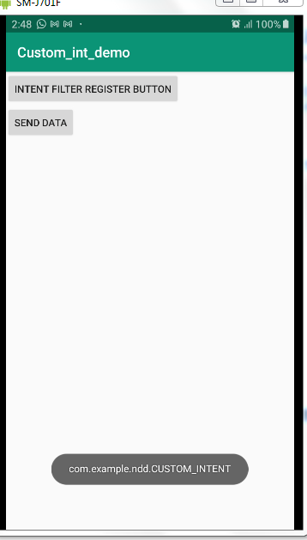

Fig. Broadcast Receiver