------------------------------------------------------------------------------------------

**Practical No:** 05

**Title:** Develop a program to implement linear layout and absolute layout.

class: TYCO Roll No: 12

1. Linear layout

<LinearLayout xmlns:android="http://schemas.android.com/apk/res/android"

android:layout_width="fill_parent"

android:layout_height="wrap_content"

android:orientation="vertical"> <!-- Vertical Orientation set -->

<!-- Child Views(In this case 2 Button) are here -->

<Button

android:layout_width="wrap_content"

android:layout_height="wrap_content"

android:text="Button1"

android:id="@+id/button"

android:background="#358a32" />

<Button

android:layout_width="wrap_content"

android:layout_height="wrap_content"

android:text="Button2"

android:id="@+id/button2"

android:background="#0058b6" />

</LinearLayout>

**Vertical**

<LinearLayout xmlns:android="http://schemas.android.com/apk/res/android"

android:layout_width="fill_parent"

android:layout_height="wrap_content"

android:orientation="vertical"> <!-- Vertical Orientation set -->

<Button

android:layout_width="wrap_content"

android:layout_height="wrap_content"

android:text="Button1"

android:id="@+id/button"

android:background="#358a32" />

<Button

android:layout_width="wrap_content"

android:layout_height="wrap_content"

android:text="Button2"

android:id="@+id/button2"

android:background="#0058b6" />

</LinearLayout>

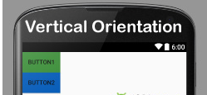

Fig. Vertical

***Horizontal***

<LinearLayout xmlns:android="http://schemas.android.com/apk/res/android"

android:layout_width="fill_parent"

android:layout_height="wrap_content"

android:orientation="horizontal"> <!-- Horizontal Orientation set -->

<Button

android:layout_width="wrap_content"

android:layout_height="wrap_content"

android:text="Button1"

android:id="@+id/button"

android:background="#358a32" />

<Button

android:layout_width="wrap_content"

android:layout_height="wrap_content"

android:text="Button2"

android:id="@+id/button2"

android:background="#0058b6" />

</LinearLayout>

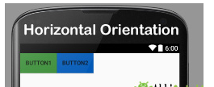

Fig. Horizontal

1. **Absolute Layout**

*<?***xml version="1.0" encoding="utf-8"***?>*<**AbsoluteLayout xmlns:android="http://schemas.android.com/apk/res/android"  
 xmlns:app="http://schemas.android.com/apk/res-auto"  
 xmlns:tools="http://schemas.android.com/tools"  
 android:layout_width="match_parent"  
 android:layout_height="match_parent"  
 android:background="#03A9F4"  
 tools:context=".MainActivity"**>  
  
  
 <**Button  
 android:id="@+id/b1"  
 android:layout_width="wrap_content"  
 android:layout_height="wrap_content"  
 android:layout_x="15dp"  
 android:layout_y="25dp"  
 android:background="#FF9800"  
 android:text="Button"**></**Button**>  
  
 <**Button  
 android:id="@+id/b2"  
 android:layout_width="wrap_content"  
 android:layout_height="wrap_content"  
 android:layout_x="13dp"  
 android:layout_y="152dp"  
 android:text="Click me"**></**Button**>  
  
  
</**AbsoluteLayout**>

------------------------------------------------------------------------------------------------

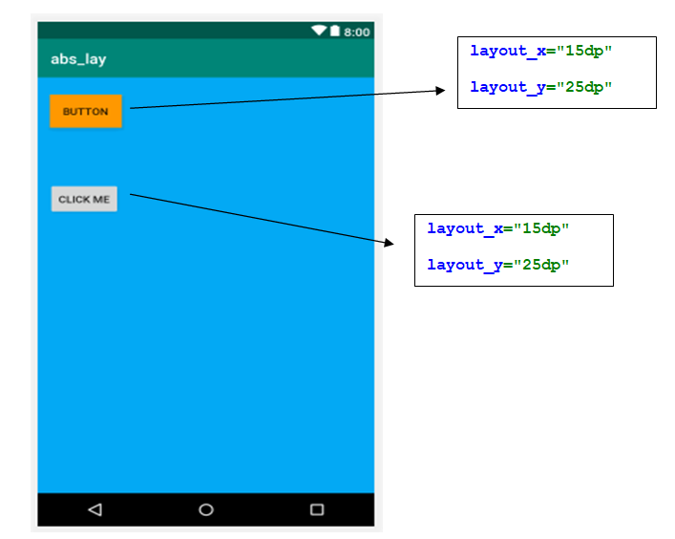

Fig. Absolute Layout