------------------------------------------------------------------------------------------

**Practical No:** 06

**Title:** Develop a program to implement Frame layout, Table layout and Relative layout

class: TYCO Roll No: 12

1. Frame Layout

*<?***xmlversion="1.0"encoding="utf-8"***?>*<**FrameLayout xmlns:android="http://schemas.android.com/apk/res/android"  
 xmlns:app="http://schemas.android.com/apk/res-auto"  
 xmlns:tools="http://schemas.android.com/tools"  
 android:layout_width="match_parent"  
 android:layout_height="match_parent"  
 tools:context=".MainActivity"**>  
  
 <**Button  
 android:layout_width="wrap_content"  
 android:layout_height="wrap_content"  
 android:text="Button1"  
 android:id="@+id/b1"** ></**Button**>  
  
 <**Button  
 android:layout_width="wrap_content"  
 android:layout_height="wrap_content"  
 android:text="Button2"  
 android:id="@+id/b2"  
 android:layout_gravity="top|center"** ></**Button**>  
  
 <**Button  
 android:layout_width="wrap_content"  
 android:layout_height="wrap_content"  
 android:id="@+id/b3"  
 android:text="Button3"  
 android:layout_gravity="top|right"** ></**Button**>  
  
 <**Button  
 android:layout_width="wrap_content"  
 android:layout_height="wrap_content"  
 android:id="@+id/b4"  
 android:text="Button4"  
 android:layout_gravity="left|center_vertical"** ></**Button**>  
  
 <**Button  
 android:layout_width="wrap_content"  
 android:layout_height="wrap_content"  
 android:id="@+id/b5"  
 android:text="Button5"  
 android:layout_gravity="center"** ></**Button**>

<**Button  
 android:layout_width="wrap_content"  
 android:layout_height="wrap_content"  
 android:id="@+id/b6"  
 android:text="Button6"  
 android:layout_gravity="right|center_vertical"** ></**Button**>  
  
  
 <**Button  
 android:layout_width="wrap_content"  
 android:layout_height="wrap_content"  
 android:id="@+id/b7"  
 android:text="Button7"  
 android:layout_gravity="left|bottom"** ></**Button**>  
  
  
 <**Button  
 android:layout_width="wrap_content"  
 android:layout_height="wrap_content"  
 android:id="@+id/b8"  
 android:text="Button8"  
 android:layout_gravity="center|bottom"** ></**Button**>  
  
 <**Button  
 android:layout_width="wrap_content"  
 android:layout_height="wrap_content"  
 android:id="@+id/b9"  
 android:text="Button"  
 android:layout_gravity="right|bottom"** ></**Button**>  
  
  
  
</**FrameLayout**>

////////////////////////////////////////////////////////////////////////////////////////////////////////////////////

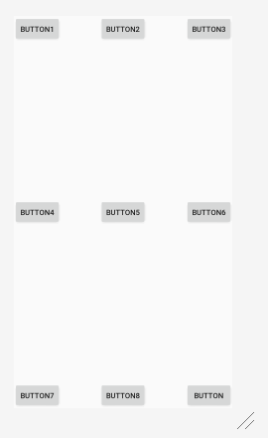

Fig. Frame Layout

1. Table Layout

*Activity_main.xml*

*<?***xml version="1.0" encoding="utf-8"***?>*<**TableLayout xmlns:android="http://schemas.android.com/apk/res/android"  
 xmlns:app="http://schemas.android.com/apk/res-auto"  
 xmlns:tools="http://schemas.android.com/tools"  
 android:layout_width="match_parent"  
 android:layout_height="match_parent"  
 tools:context=".MainActivity"**>

<**TableRow**>  
 <**Button  
 android:layout_height="wrap_content"  
 android:layout_width="wrap_content"  
 android:id="@+id/b1"  
 android:layout_column="1"  
 android:text="b1"**></**Button**>  
 <**Button  
 android:layout_height="wrap_content"  
 android:layout_width="wrap_content"  
 android:id="@+id/b2"  
 android:layout_column="2"  
 android:text="b1"**></**Button**>  
 </**TableRow**>

<**TableRow**>  
  
 <**Button  
 android:layout_height="wrap_content"  
 android:layout_width="wrap_content"  
 android:id="@+id/b3"  
 android:layout_column="1"  
 android:text="b3"**></**Button**>  
  
 <**Button  
 android:layout_height="wrap_content"  
 android:layout_width="wrap_content"  
 android:id="@+id/b4"  
 android:layout_column="2"  
 android:text="b4"**></**Button**>  
  
 </**TableRow**>  
  
</**TableLayout**>

///////////////////////////////////////////////////////////////////////////////////////////////////////////

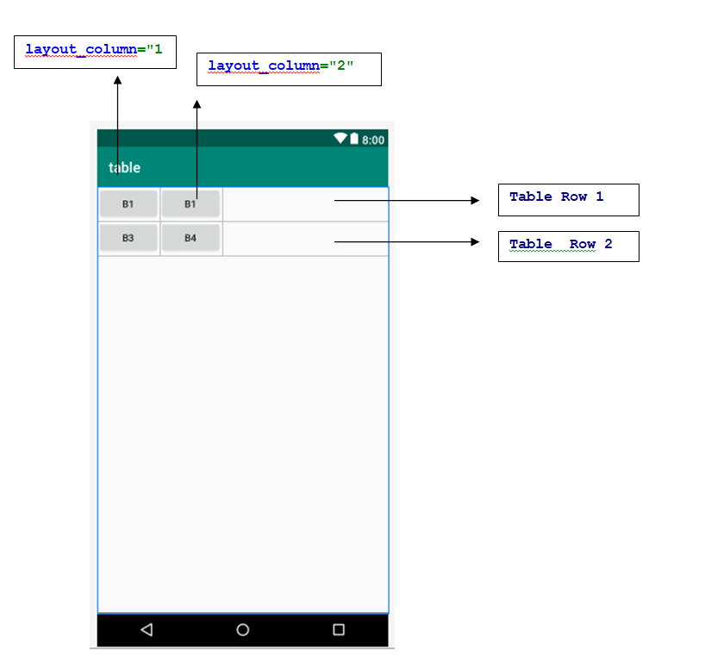

**Fig. Table Layout**

1. Relative Layout

**//CODE OF** MainActivity.java

**package** com.example.login2;  
**import** androidx.appcompat.app.AppCompatActivity;  
**import** android.os.Bundle;  
**import** android.view.View;  
**import** android.widget.Button;  
**import** android.widget.EditText;  
**import** android.widget.TextView;  
**import** android.widget.Toast;  
  
**public class** MainActivity **extends** AppCompatActivity {  
  
 **private** Button **btn**;  
 **private** EditText **e1**,**e2**;  
 **private int counter**=3;  
  
 @Override  
 **protected void** onCreate(Bundle savedInstanceState) {  
 **super**.onCreate(savedInstanceState);  
 setContentView(R.layout.***activity_main***);  
  
 **btn**=(Button)findViewById(R.id.***b1***);  
 **e1**=(EditText)findViewById(R.id.***et1***);  
 **e2**=(EditText)findViewById(R.id.***et2***);  
  
 *//final String user =e1.getText().toString();  
 //final String passw=e2.getText().toString();* **btn**.setOnClickListener(**new** View.OnClickListener() {  
 @Override  
 **public void** onClick(View v) {  
  
 validate(**e1**.getText().toString(),**e2**.getText().toString());  
  
 }  
 }); *// On click Listener Finish* }  
  
 **private void** validate (String uname,String passw)  
 {  
 **if** ((uname.equals(**"admin"**)) && (passw.equals(**"pass"**)) )  
 {  
 Toast.*makeText*(getApplicationContext(),**"Login Successful"**,Toast.***LENGTH_LONG***).show();  
 }  
 **else** {  
 **counter**--;  
 Toast.*makeText*(getApplicationContext(), **"Login Not Successful Attempt Remaining "**+String.*valueOf*(**counter**), Toast.***LENGTH_LONG***).show();  
 **if**(**counter**==0) {  
 Toast.*makeText*(getApplicationContext(), **"Login Button Disbaled"**, Toast.***LENGTH_LONG***).show();  
 **btn**.setEnabled(**false**);  
 }  
 }  
  
 }  
}

*<!-- activity_main.xml -->*

*<?***xml version="1.0" encoding="utf-8"***?>*<**RelativeLayout xmlns:android="http://schemas.android.com/apk/res/android"  
 xmlns:app="http://schemas.android.com/apk/res-auto"  
 xmlns:tools="http://schemas.android.com/tools"  
 android:layout_width="match_parent"  
 android:layout_height="match_parent"  
 tools:context=".MainActivity"**>  
  
 <**TextView  
 android: id="@+id/tv1"  
 android:layout_width="wrap_content"  
 android:layout_height="wrap_content"  
 android:background="#E91E63"  
 android:freezesText="false"  
 android:text="@string/user_name"  
 android:textSize="24sp"  
 app:fontFamily="@font/asul"  
 android:layout_marginLeft="6mm"  
 android:layout_marginTop="4mm"** ></**TextView**>  
  
 <**EditText  
 android:id="@+id/et1"  
 android:layout_width="200dp"  
 android:layout_height="40dp"  
 android:layout_toRightOf="@id/tv1"  
 android:background="#FFEB3B"  
 android:inputType="text"  
 android:layout_marginLeft="4mm"  
 android:layout_marginTop="4mm"** ></**EditText**>  
 <**TextView  
 android:id="@+id/tv2"  
 android:layout_width="wrap_content"  
 android:layout_height="wrap_content"  
 android:background="#E91E63"  
 android:freezesText="false"  
 android:text="@string/password"  
 android:textSize="24sp"  
 app:fontFamily="@font/asul"  
 android:layout_marginLeft="6mm"  
 android:layout_marginTop="12mm"  
 android:layout_marginStart="6mm"**></**TextView**>  
  
 <**EditText  
 android:id="@+id/et2"  
 android:layout_width="200dp"  
 android:layout_height="40dp"  
 android:layout_toRightOf="@id/tv2"  
 android:background="#FFEB3B"  
 android:inputType="textPassword"  
 android:layout_marginLeft="6mm"  
 android:layout_marginTop="12mm"  
 android:autofillHints=""  
 android:layout_toEndOf="@id/tv2"  
 android:layout_marginStart="6mm"**></**EditText**>  
  
 <**Button  
 android:id="@+id/b1"  
 android:layout_width="wrap_content"  
 android:layout_height="wrap_content"  
 android:text="Login"  
 android:layout_marginTop="22mm"  
 android:layout_marginLeft="30mm"** />  
</**RelativeLayout**>

///////////////////////////////////////////////////////////////////////////

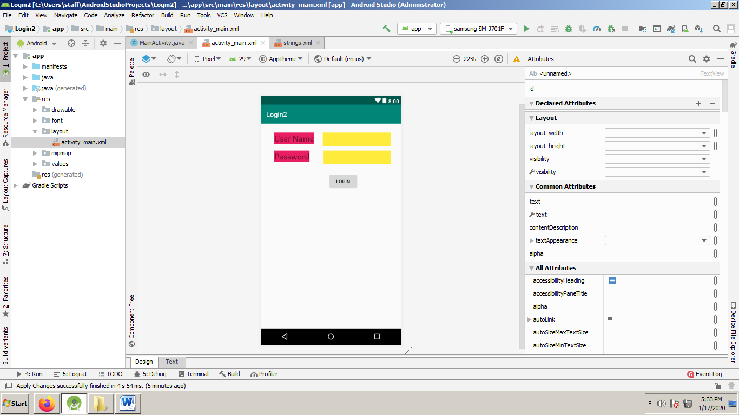

Fig. Relative Layout