------------------------------------------------------------------------------------------

**Practical No:** 08

**Title:** Develop a program to implement Auto Complete Text View

class: TYCO Roll No: 12

**//MainActivity.java**

**package** com.example.toggle;  
  
**import** androidx.appcompat.app.AppCompatActivity;  
  
**import** android.os.Bundle;  
**import** android.widget.ArrayAdapter;  
**import** android.widget.AutoCompleteTextView;  
  
**public class** MainActivity **extends** AppCompatActivity {  
  
 String[] **fruit**={**"Apple"**,**"Mango"**,**"Banana"**,**"Kiwi"**,**"Apineapple"**,**"watermelaon"**};  
  
 @Override  
 **protected void** onCreate(Bundle savedInstanceState) {  
 **super**.onCreate(savedInstanceState);  
 setContentView(R.layout.***activity_main***);  
  
 AutoCompleteTextView atc=(AutoCompleteTextView) findViewById(R.id.***a1***);  
  
 ArrayAdapter adapter=**new** ArrayAdapter(**this**,android.R.layout.***select_dialog_item***,**fruit**);  
  
 atc.setAdapter(adapter);  
 atc.setThreshold(1);  
 atc.setAdapter(adapter);  
  
  
 }  
}

Activity_main.xml

*<?***xml version="1.0" encoding="utf-8"***?>*<**RelativeLayout xmlns:android="http://schemas.android.com/apk/res/android"  
 xmlns:app="http://schemas.android.com/apk/res-auto"  
 xmlns:tools="http://schemas.android.com/tools"  
 android:layout_width="match_parent"  
 android:layout_height="match_parent"  
 tools:context=".MainActivity"**>  
  
 <**AutoCompleteTextView  
 android:layout_width="200dp"  
 android:layout_height="wrap_content"  
 android:hint="Enter the Fruit"  
 android:id="@+id/a1"**></**AutoCompleteTextView**>  
  
  
  
</**RelativeLayout**>

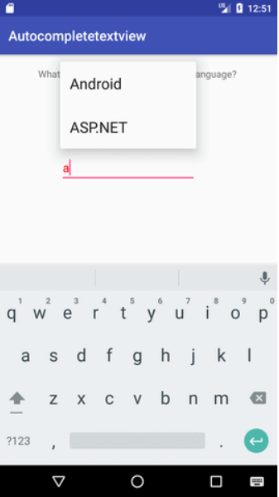

Fig. Auto Complete Text View