------------------------------------------------------------------------------------------

**Practical No:** 09

**Title:** Develop a program to implement Button, Image Button and Toggle Button

class: TYCO Roll No: 12

1. Button

**// Java Code**

**package** com.example.button_demo;  
**import** androidx.appcompat.app.AppCompatActivity;  
  
**import** android.os.Bundle;  
**import** android.view.View;  
**import** android.widget.Button;  
**import** android.widget.EditText;  
**import** android.widget.ImageButton;  
**import** android.widget.TextView;  
**import** android.widget.Toast;  
  
**public class** MainActivity **extends** AppCompatActivity **implements** View.OnClickListener {  
  
 Button **bt1**,**bt2**,**bt3**,**bt4**;  
 ImageButton **img_btn**;  
 EditText **et1**,**et2**;  
 String **str1**,**str2**;  
 **int res**;  
  
 @Override  
 **protected void** onCreate(Bundle savedInstanceState) {  
 **super**.onCreate(savedInstanceState);  
 setContentView(R.layout.***activity_main***);  
  
 **bt1**=(Button)findViewById(R.id.***b1***); *// Button xml id bind with Button class object* **bt2**=(Button)findViewById(R.id.***b2***);  
 **bt3**=(Button)findViewById(R.id.***b3***);  
 **bt4**=(Button)findViewById(R.id.***b4***);  
 **img_btn**=(ImageButton)findViewById(R.id.***img1***) ;  
 **et1**=(EditText)findViewById(R.id.***e1***); *// EDit text box* **et2**=(EditText)findViewById(R.id.***e2***);  
;  
 **bt1**.setOnClickListener(**this**);

**bt2**.setOnClickListener(**this**);  
 **bt3**.setOnClickListener(**this**);  
 **bt4**.setOnClickListener(**this**);  
 **img_btn**.setOnClickListener(**this**);  
 }  
  
 @Override  
 **public void** onClick(View v) {  
  
 **switch**(v.getId()) *// V is the Curernt View of Screen* {  
 **case** R.id.***b1***:  
 **str1**=**et1**.getText().toString();  
 **str2**=**et2**.getText().toString();  
 **res**=Integer.*parseInt*(**str1**)+ Integer.*parseInt*(**str2**);  
 Toast.*makeText*(**this**,**"Addition "**+**res**,Toast.***LENGTH_SHORT***).show();  
 **break**;  
  
 **case** R.id.***b2***:  
 **str1**=**et1**.getText().toString();  
 **str2**=**et2**.getText().toString();  
 **res**=Integer.*parseInt*(**str1**)- Integer.*parseInt*(**str2**);  
  
 Toast.*makeText*(**this**,**"Substration is "**+**res**,Toast.***LENGTH_SHORT***).show();  
 **break**;  
  
 **case** R.id.***b3***:  
 **str1**=**et1**.getText().toString();  
 **str2**=**et2**.getText().toString();  
 **res**=Integer.*parseInt*(**str1**)* Integer.*parseInt*(**str2**);  
 Toast.*makeText*(**this**,**" Multiplication is "**+**res**,Toast.***LENGTH_SHORT***).show();  
 **break**;

**case** R.id.***b4***:  
 **str1**=**et1**.getText().toString();  
 **str2**=**et2**.getText().toString();  
 **if**(**str1**.equals(**""**) && **str2**.equals(**""**))  
 {  
 Toast.*makeText*(**this**,**"Plz Enetr the Number"**, Toast.***LENGTH_SHORT***).show();  
 }  
 **else** {  
 **res** = Integer.*parseInt*(**str1**) / Integer.*parseInt*(**str2**);  
 Toast.*makeText*(**this**, **" Division is "** + **res**, Toast.***LENGTH_SHORT***).show();  
 }  
 **break**;  
  
 **case** R.id.***img1*** :  
  
 Toast.*makeText*(getApplication(),**"You Have Click on Image "**,Toast.***LENGTH_SHORT***).show();  
  
 **break**;  
  
 }  
  
 }  
}

// XML

*<?***xml version="1.0" encoding="utf-8"***?>*<**LinearLayout xmlns:android="http://schemas.android.com/apk/res/android"  
 xmlns:app="http://schemas.android.com/apk/res-auto"  
 xmlns:tools="http://schemas.android.com/tools"  
 android:layout_width="match_parent"  
 android:layout_height="match_parent"  
 android:orientation="vertical"  
 tools:context=".MainActivity"**>  
  
 <**EditText  
 android:layout_width="match_parent"  
 android:layout_height="wrap_content"  
 android:inputType="number"  
 android:id="@+id/e1"**></**EditText**>  
  
 <**EditText  
 android:layout_width="match_parent"  
 android:layout_height="wrap_content"  
 android:inputType="number"**

**android:id="@+id/e2"**></**EditText**>  
 <**Button  
 android:layout_width="400px"  
 android:layout_height="wrap_content"  
 android:id="@+id/b1"  
 android:text="Addition"  
 android:layout_marginTop="100px"  
 android:layout_gravity="center"** >  
 </**Button**>  
  
 <**Button  
 android:layout_width="420px"  
 android:layout_height="wrap_content"  
 android:id="@+id/b2"  
 android:text="Substration"  
 android:layout_gravity="center"**

>  
 </**Button**>  
  
 <**Button  
 android:layout_width="400px"  
 android:layout_height="wrap_content"  
 android:id="@+id/b3"  
 android:text="Multiplication"  
 android:layout_gravity="center"** >  
 </**Button**>  
 <**Button  
 android:layout_width="400px"  
 android:layout_height="wrap_content"  
 android:id="@+id/b4"  
 android:text="Division"  
 android:layout_gravity="center"** >  
 </**Button**>  
 <**ImageButton  
 android:layout_width="620px"  
 android:layout_height="wrap_content"  
 android:id="@+id/img1"  
 android:src="@drawable/submit"  
 android:layout_gravity="center"** ></**ImageButton**>  
  
</**LinearLayout**>

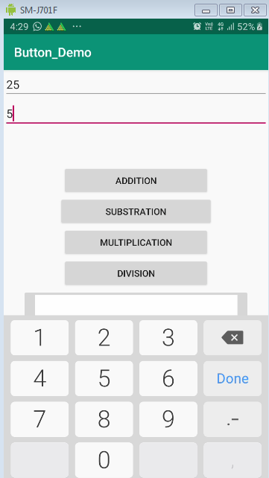

Fig. Button

***<?*xml version="1.0" encoding="utf-8"*?>*<RelativeLayout xmlns:android="http://schemas.android.com/apk/res/android"  
 xmlns:app="http://schemas.android.com/apk/res-auto"  
 xmlns:tools="http://schemas.android.com/tools"  
 android:layout_width="match_parent"  
 android:layout_height="match_parent"  
 tools:context=".MainActivity">  
  
 <ToggleButton  
 android:layout_width="wrap_content"  
 android:layout_height="wrap_content"  
 android:id="@+id/tg1"  
 android:textOff=" OFF"  
 android:textOn=" ON"  
 android:drawableStart="@drawable/selector"  
 android:drawableLeft="@drawable/selector"  
 android:layout_marginLeft="150dp"  
 ></ToggleButton>  
  
 <ImageView  
 android:layout_width="match_parent"  
 android:layout_height="match_parent"  
 android:layout_marginTop="60dp"  
 android:id="@+id/image_v"  
 ></ImageView>  
  
</RelativeLayout>**

**\*\*\*\*\*\*\*\*\*\*\*\*\*\*\*\*\*\*\*\*\*\*\*\*\*\*\*\*\*\*\*\*\*\*\*\*\*\*\*\*\*\*\*\*\*\*\*\*\*\*\*\*\*\*\*\*\*\*\*\*\*\*\*\*\*\*\*\*\*\*\*\*\*\*\*\*\*\*\*\*\*\*\*\*\*\*\*\*\*\***

**/// Selector.xml ////**

*<?***xml version="1.0" encoding="utf-8"***?>*

<**selector xmlns:android="http://schemas.android.com/apk/res/android"**>  
  
 <**item android:state_checked="true" android:drawable="@drawable/ic_power_on"**></**item**>

<**item android:state_checked="false" android:drawable="@drawable/ic_power_off"**></**item**>  
  
</**selector**>

**\*\*\*\*\*\*\*\*\*\*\*\*\*\*\*\*\*\*\*\*\*\*\*\*\*\*\*\*\*\*\*\*\*\*\*\*\*\*\*\*\*\*\*\*\*\*\*\*\*\*\*\*\*\*\*\*\*\*\*\*\*\*\*\*\*\*\*\*\*\*\*\*\*\*\*\*\*\*\*\*\*\*\*\*\*\*\*\*\*\*\*\*\*\*\*\*\*\*\*\*\*\*\*\*\*\*\*\*\*\*\*\*\*\*\*\*\*\*\*\*\*\*\*\*\*\*\*\*\***

**// JAVA CODE**

**package** com.example.tg_demo;  
  
**import** androidx.appcompat.app.AppCompatActivity;  
  
**import** android.os.Bundle;  
**import** android.view.View;  
**import** android.widget.ImageView;  
**import** android.widget.ToggleButton;  
  
**public class** MainActivity **extends** AppCompatActivity {  
  
 ToggleButton **tg_bt**;  
 ImageView **img_v**;  
  
 @Override  
 **protected void** onCreate(Bundle savedInstanceState) {  
 **super**.onCreate(savedInstanceState);  
 setContentView(R.layout.***activity_main***);  
  
 **tg_bt**=(ToggleButton)findViewById(R.id.***tg1***);  
 **img_v**=(ImageView)findViewById(R.id.***image_v***);  
  
 **img_v**.setImageDrawable(getResources().getDrawable(R.drawable.***light_off***));

**tg_bt**.setOnClickListener(**new** View.OnClickListener() {  
 @Override  
 **public void** onClick(View v) {

**if**(**tg_bt**.isChecked())  
 {  
 **img_v**.setImageDrawable(getResources().getDrawable(R.drawable.***light_on***));  
 }  
 **else** {  
 **img_v**.setImageDrawable(getResources().getDrawable(R.drawable.***light_off***));  
 }  
 }  
 });  
  
  
 }  
}

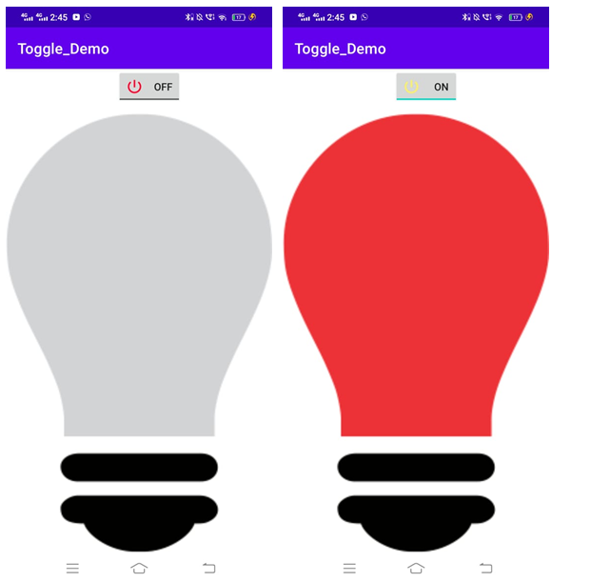

**Fig. Toggle Button**