**Software Development for Portable devices**

**Simple Android Application Development**

**Calculator App**

**Name: Rohit N Kurup**

**BITS ID: 2021WA86597**

**GitHub Link: https://github.com/Rohit-N-Kurup/Calculator.git**

**Screenshots:**

**1. App Icon**

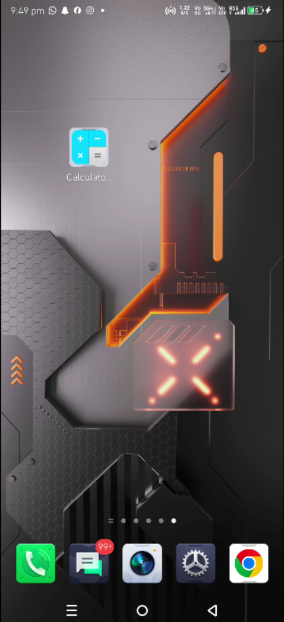

**2. Splash Screen**

**3. Opening screen**

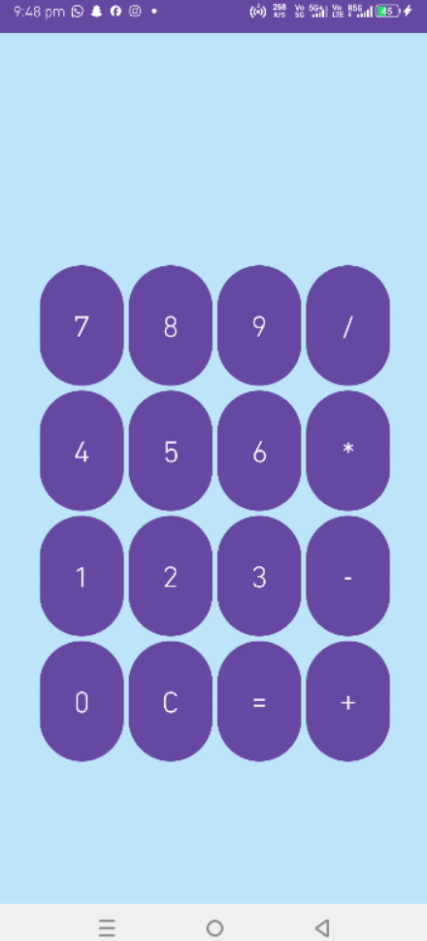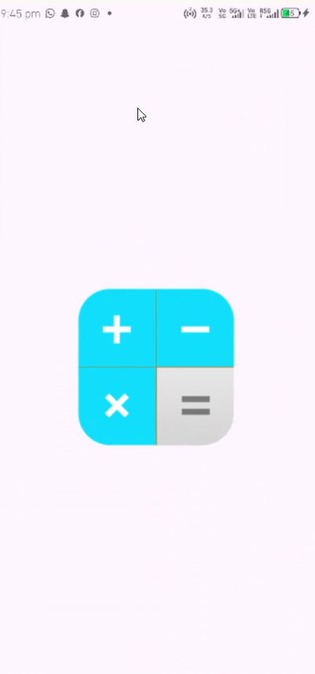

**4. Calculation Screen**

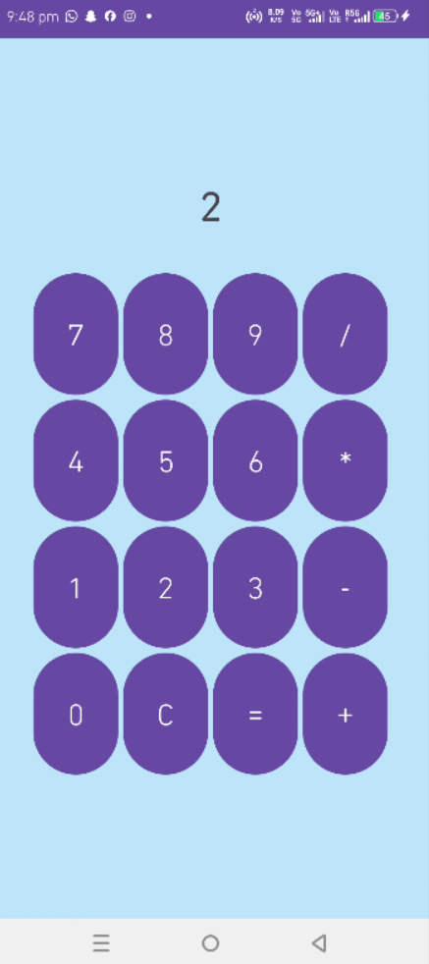

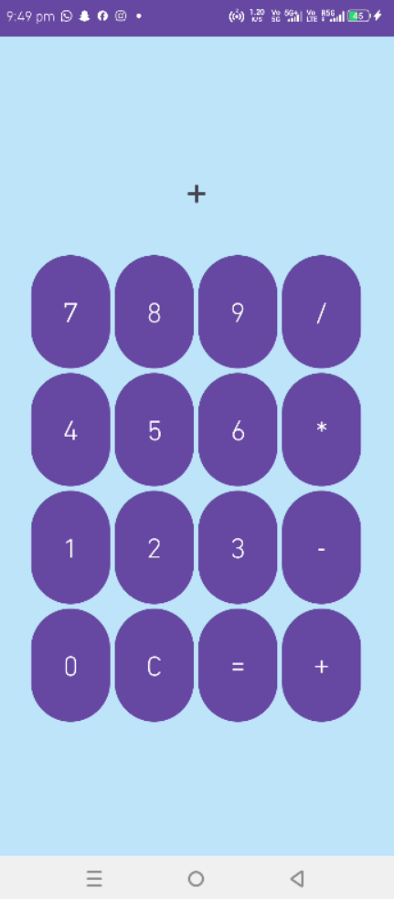

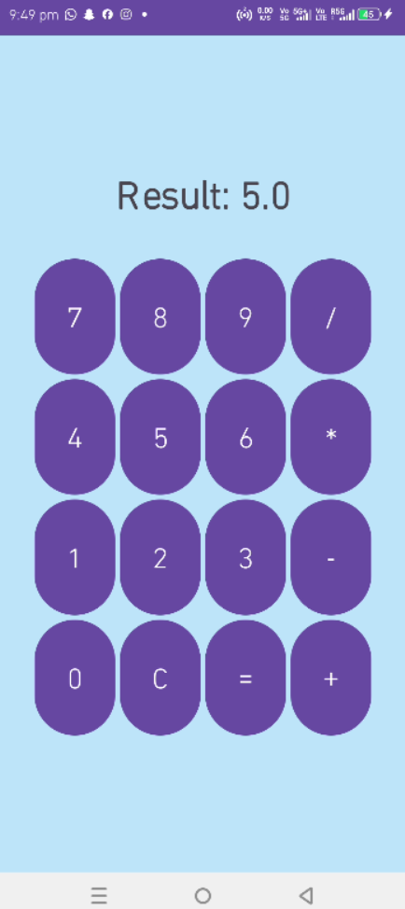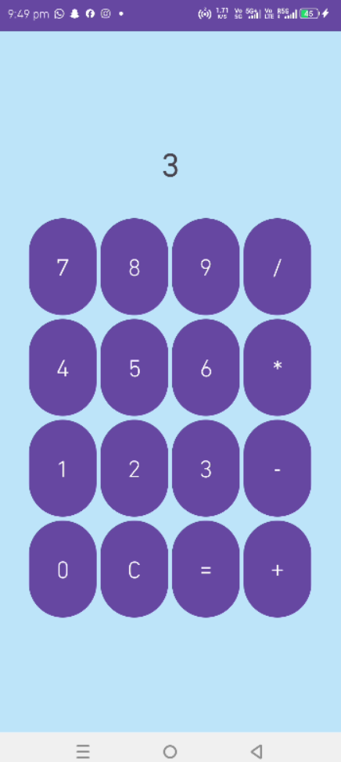**4. Calculation Screen(Contd) 5.Result Screen**