# Q1: Star Topology using Hub and Switch

## Network Topology Design

* + **Steps:**
    - Drag a hub and a switch onto the workspace.
    - Add 3–5 PCs.
    - Connect PCs to the hub and switch using **straight-through cables**.

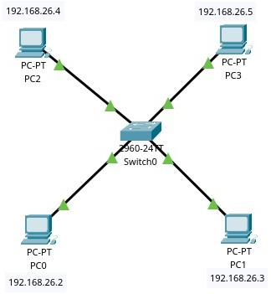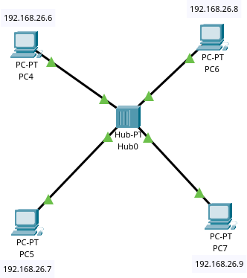

## IP Address Configuration of PCs

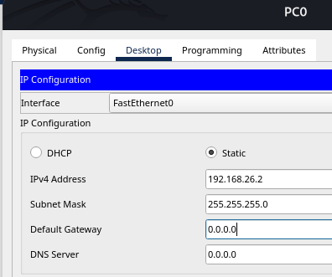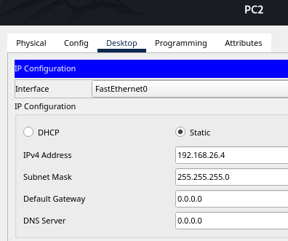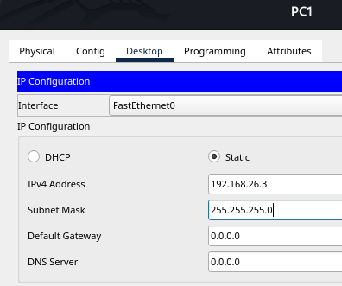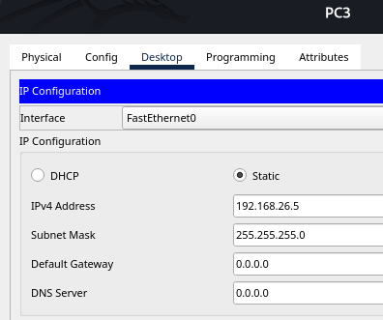

## A screenshot of a computer program AI-generated content may be incorrect.Ping Testing

1. Real-Time and Simulation Mode

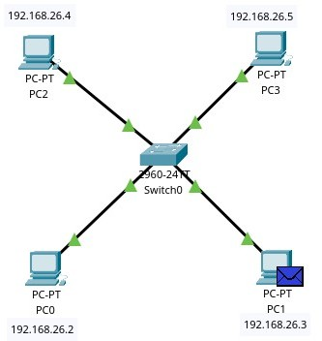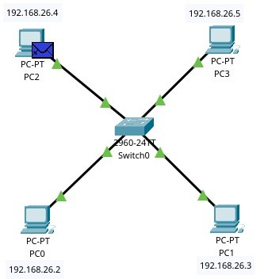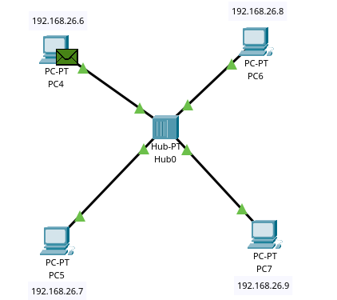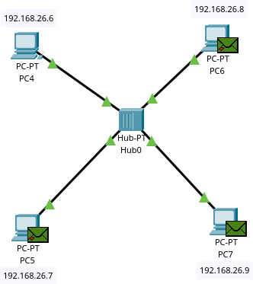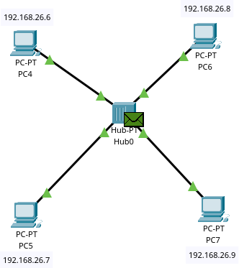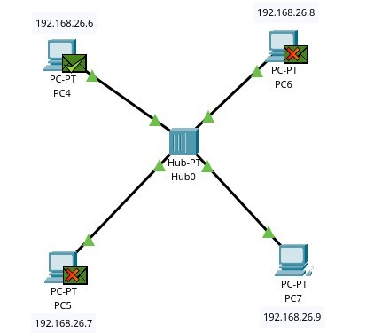

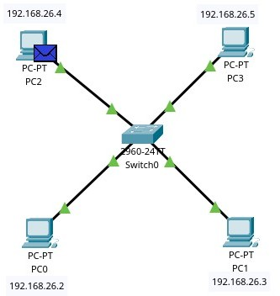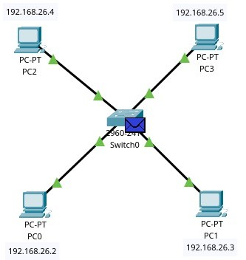





## Comparison: Hub vs Switch

|  |  |  |
| --- | --- | --- |
| **Feature** | **Hub** | **Switch** |
| Type | Layer 1 (Physical) | Layer 2 (Data Link) |
| Traffic Type | Broadcasts to all ports | Unicast to destination MAC |
| Speed | Slower | Faster due to frame switching |
| Security | Low | High |

1. **Advantages & Disadvantages of Star Topology**

Advantages:

* + Easy to install and manage
  + Single cable failure doesn’t affect others
  + Easy to add/remove devices Disadvantages:
  + Central device failure (hub/switch) brings down network
  + Requires more cable length

## Q2: Bus Topology using Switch Design & Steps

* + Arrange PCs in a line.
  + Connect each PC to the same switch using straight-through cables.
  + Set IPs in the same subnet.

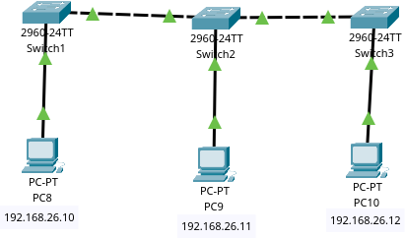

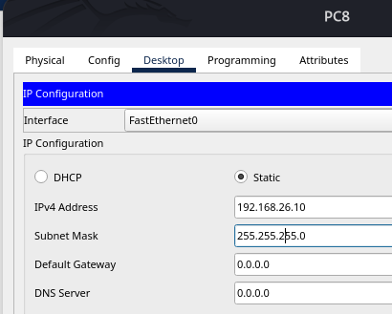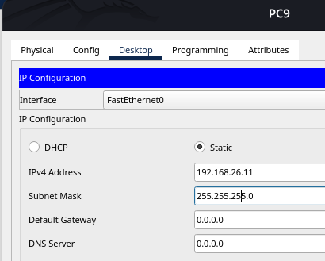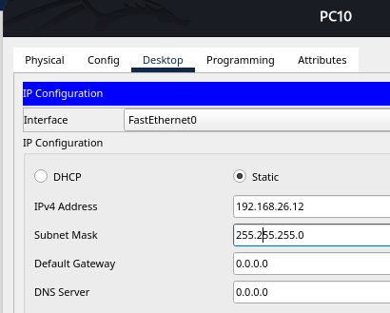

## Ping testing

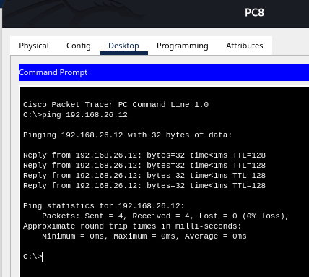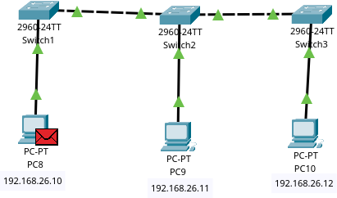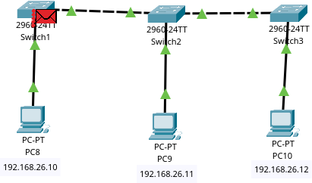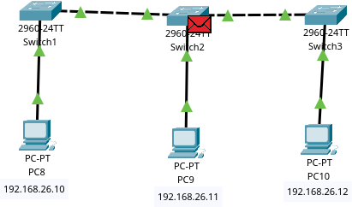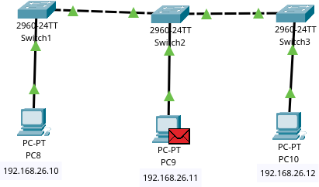

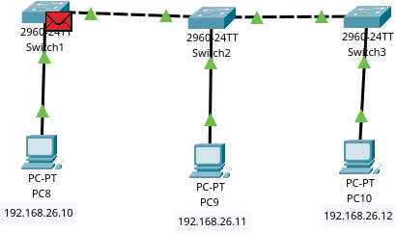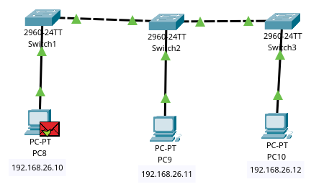

**Advantages:**

* + Easy to implement for small networks
  + Less cable length than star

## Disadvantages:

* + Network performance degrades with traffic
  + Entire network goes down if main cable fails

# Q3: Ring Topology using Switch

## Design & Steps

* + Connect each PC to a switch.
  + Use multiple switches in a loop to simulate ring topology.
  + Assign proper IPs.

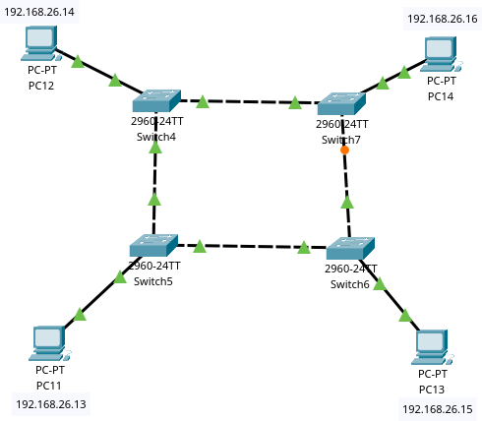

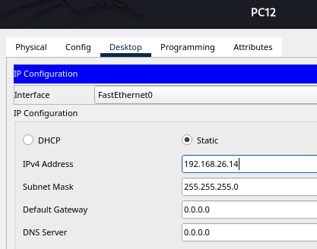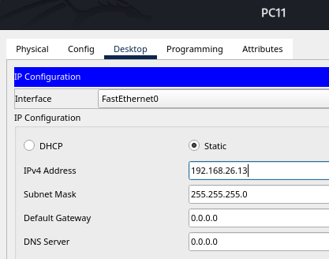

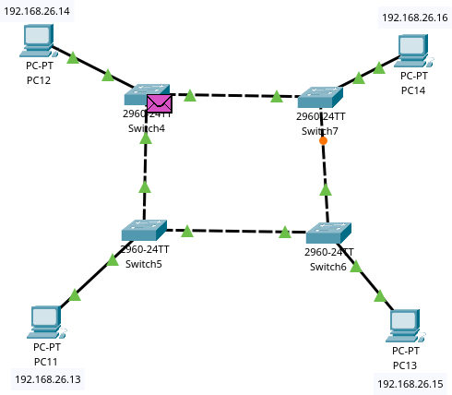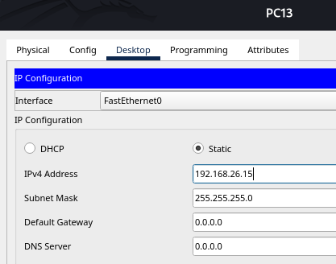 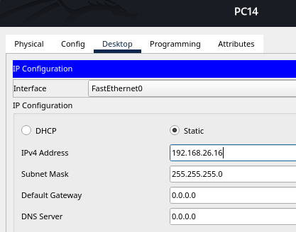

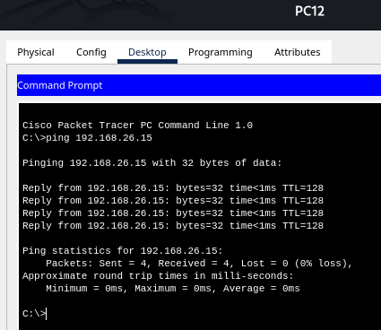

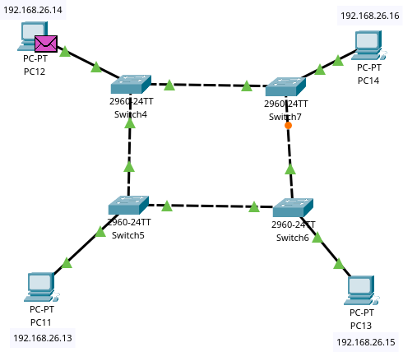

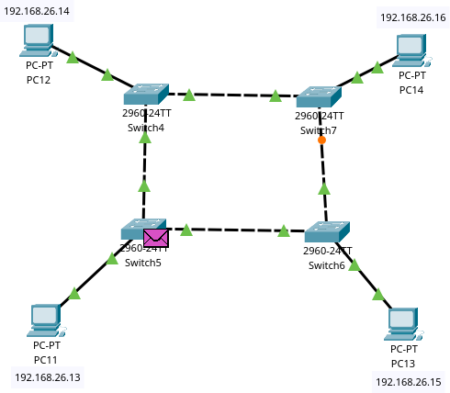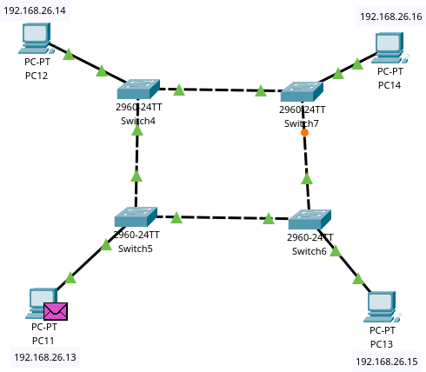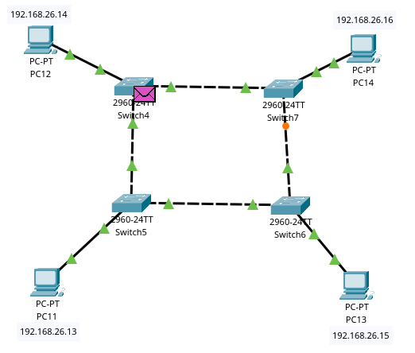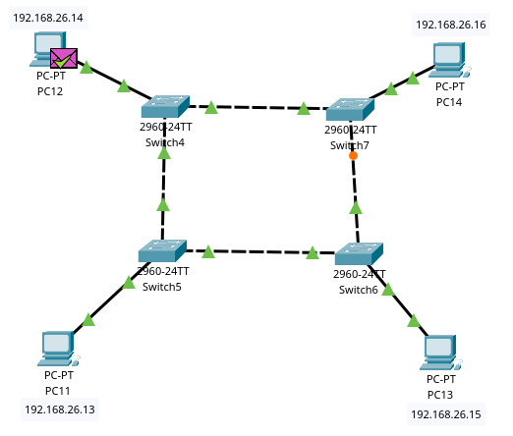

## Advantages:

1. Predictable network load
2. Easy fault isolation

## Disadvantages:

1. A single node failure can disrupt the entire network
2. More difficult to configure

# Q4: Mesh Topology using Switch

## Design & Steps

* + Connect each PC to every other PC via individual switches.
  + Use **crossover cables** between switches if needed.

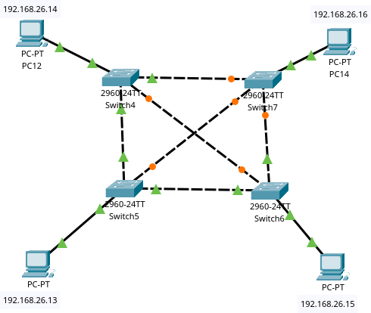



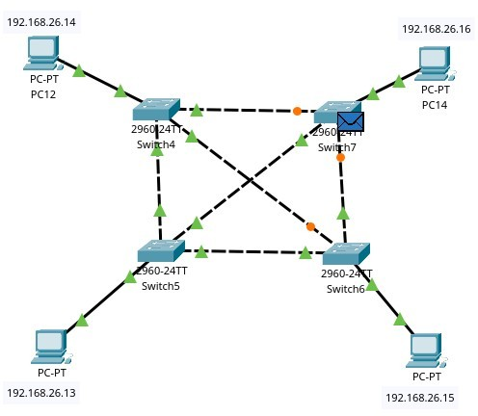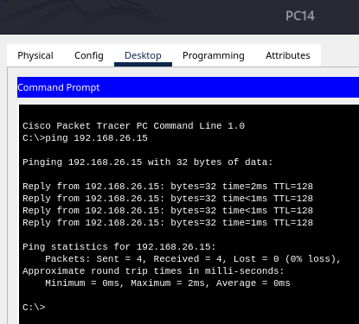



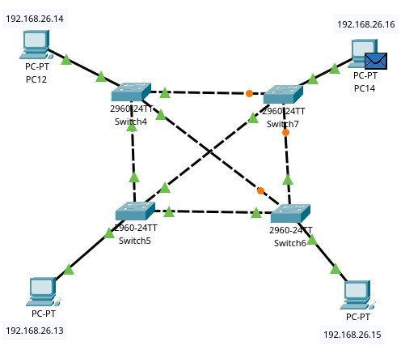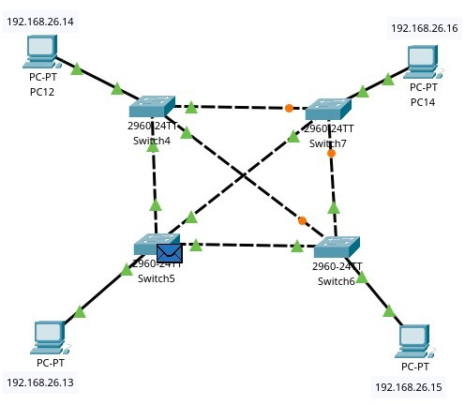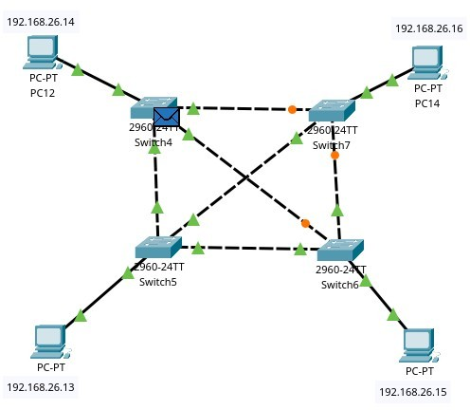

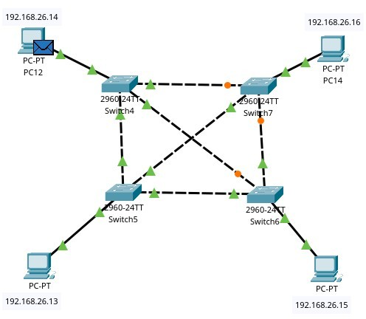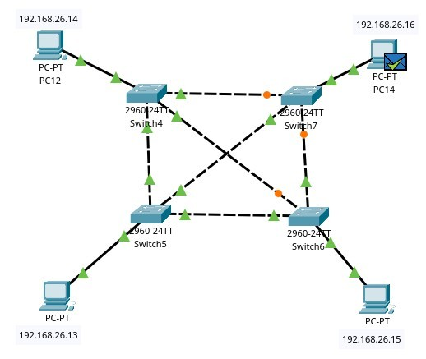

## Advantages:

1. High fault tolerance
2. Robust and reliable

## Disadvantages:

1. Complex setup
2. High cabling cost

# Q5: Hybrid Topology using Switch

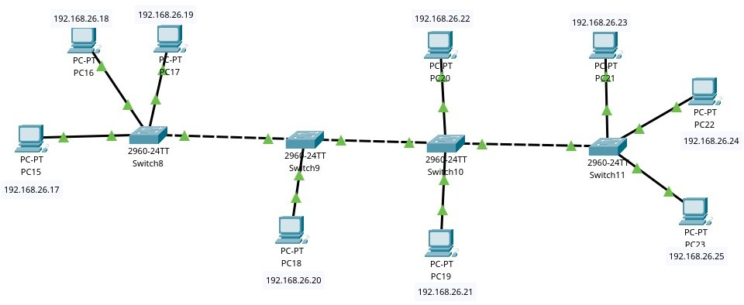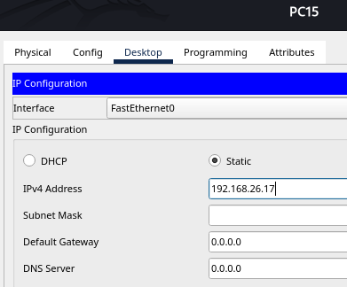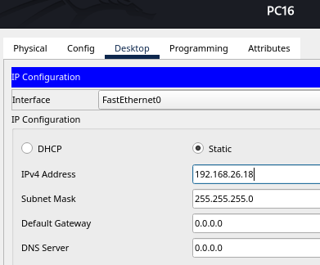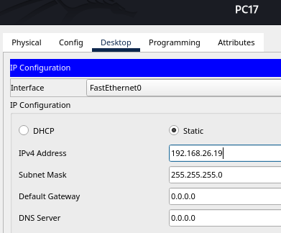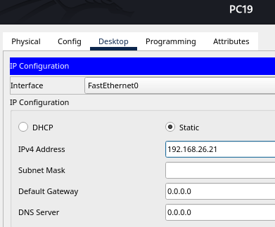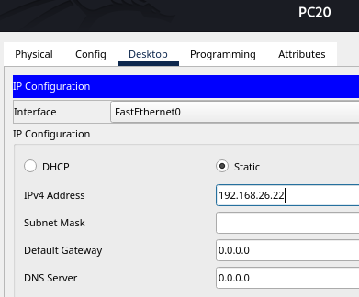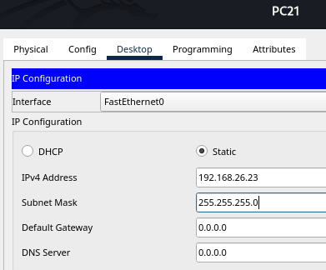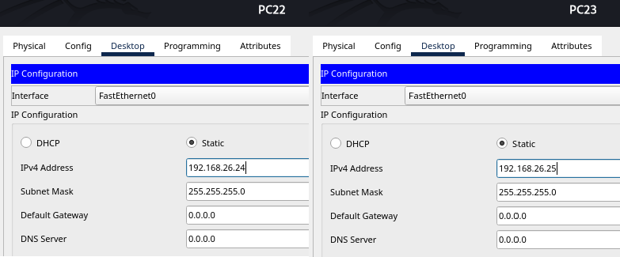

## Design & Steps

* + Combine star and ring (or any two) using switches and hubs.
  + Configure IPs from appropriate subnets.

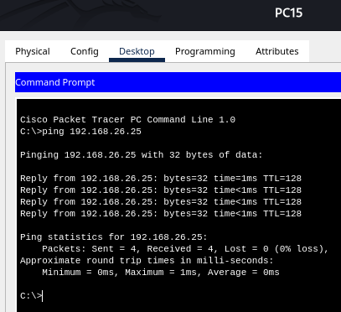

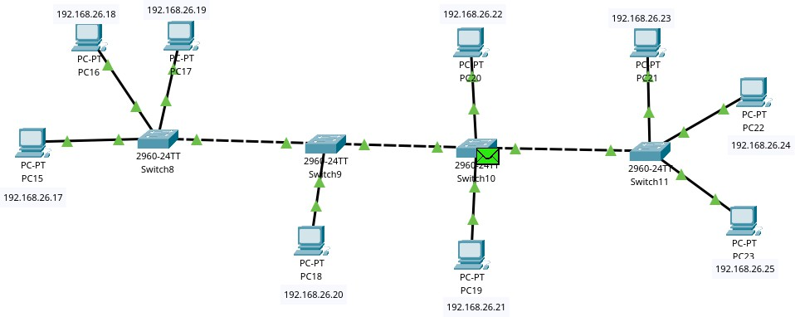

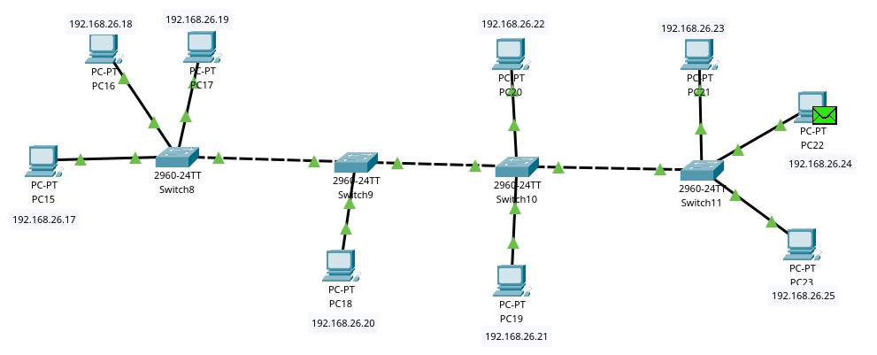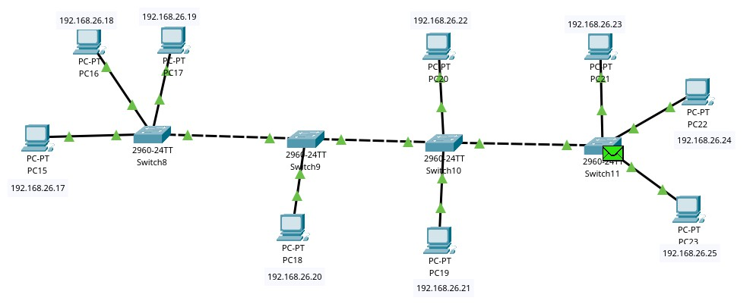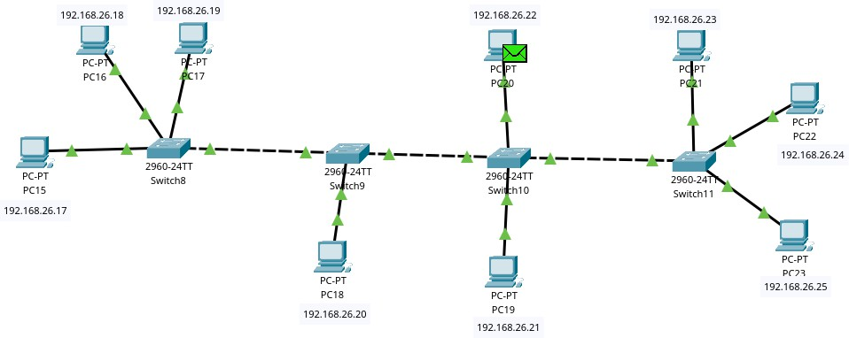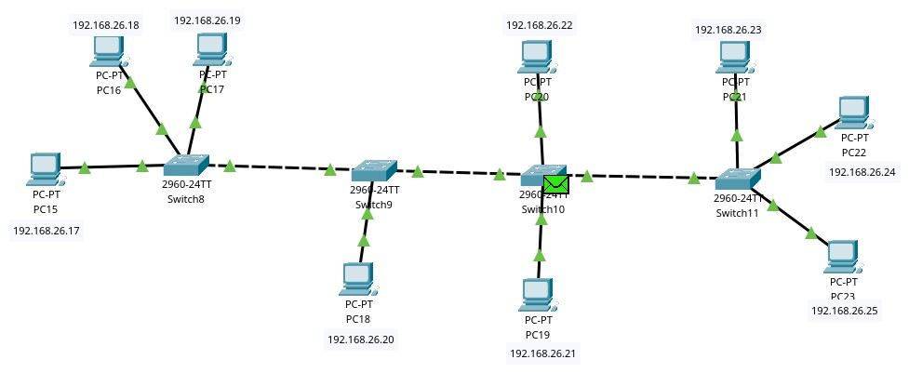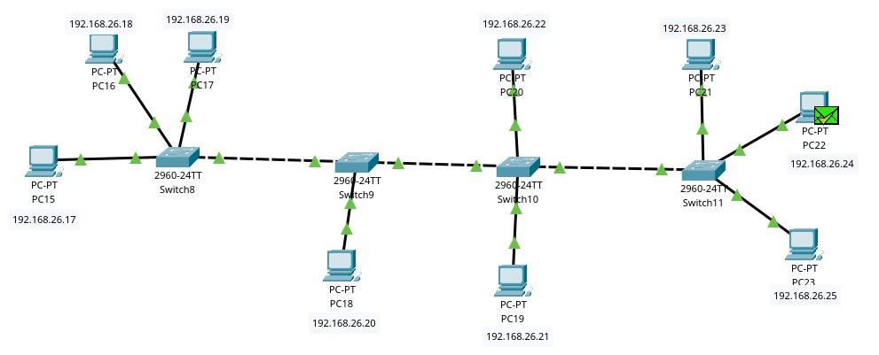

## Advantages:

1. Flexible
2. Scalable and fault-tolerant

## Disadvantages:

1. Complex design
2. Difficult to manage