**Department of Computer Engineering**

**TE Computer-B (2024-25 Sem I)**

**Computer Networks and Security**

**CNS Simulation Assignment 1: VLAN Configuration**

**[CO1-CO2, BT: L3 (Apply)] [Max Marks: 10]**

**Date of Assignment 11th July 2025 Last Date of Submission: 21st July 2025**

**Demonstrate of Virtual LAN (VLAN) using Packet Tracer**

**Objective:** To configure and demonstrate Virtual LANs (VLANs) using Cisco Packet Tracer by creating two VLANs and testing inter-VLAN communication through a router.

**IP Address Series:** 192.168.1.1 to 192.168.1.254 for VLAN1 (Device 1 and 2)

192.168.47.1 to 192.168.47.254 for VLAN2 (Device 3 and 4)

**Steps Involved:**

1. 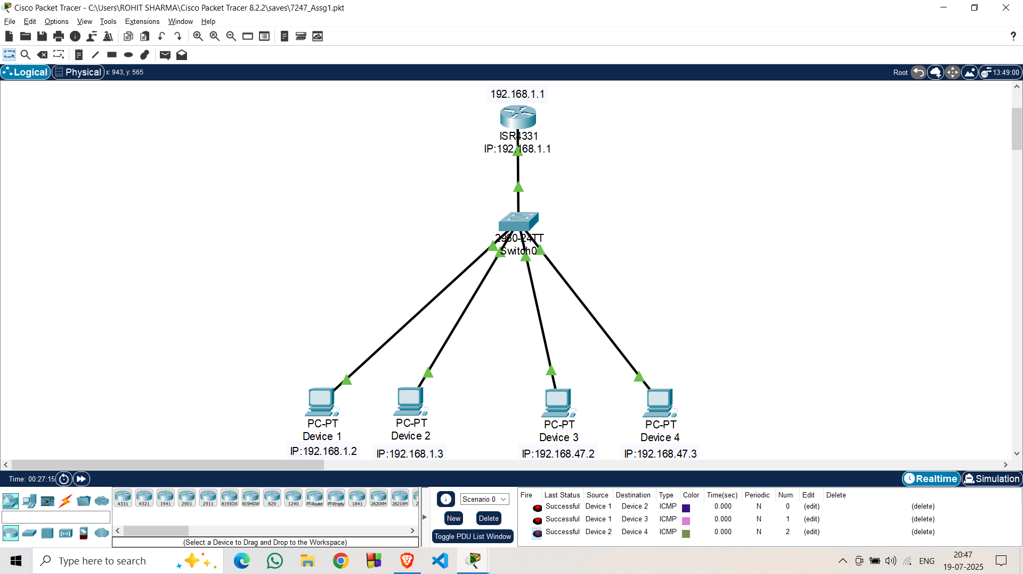**Network Topology:** 1 Router, 1 Switch, 4 PCs (2 in VLAN1, 2 in VLAN47), Cabling
2. **IP Address Configuration of PCs:**

Device 1: IP – 192.168.1.2, Subnet Mask – 255.255.255.0, Gateway – 192.168.1.1

Device 2: IP – 192.168.1.3, Subnet Mask – 255.255.255.0, Gateway – 192.168.1.1

Device 3: IP – 192.168.47.2, Subnet Mask – 255.255.255.0, Gateway – 192.168.47.1

Device 4: IP – 192.168.47.3, Subnet Mask – 255.255.255.0, Gateway – 192.168.47.1

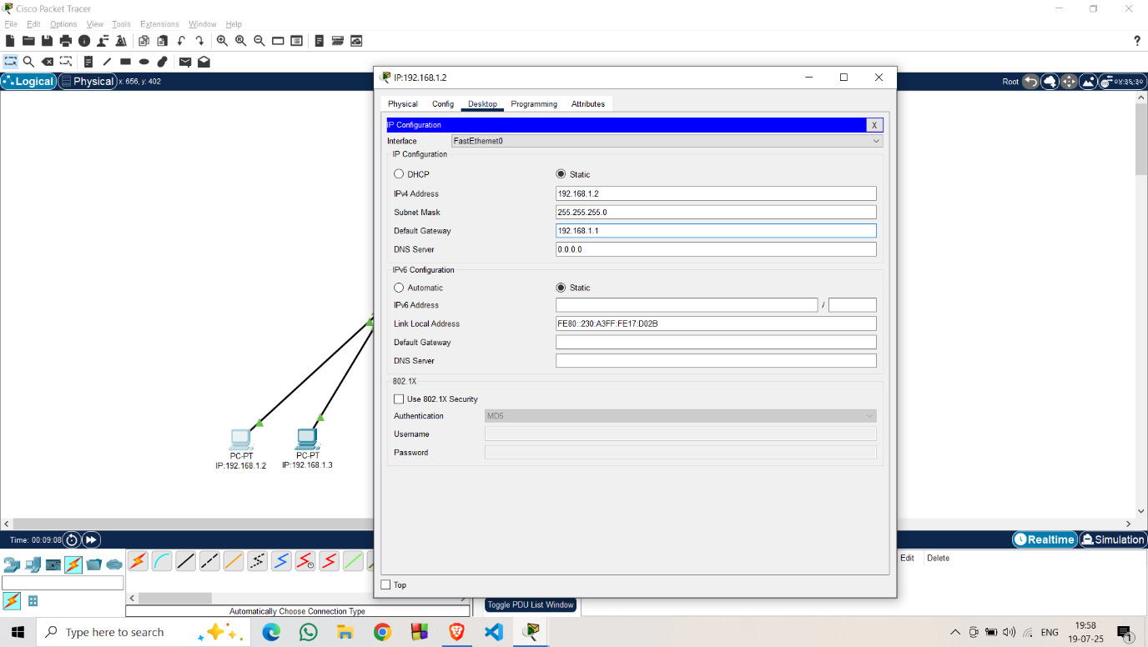

1. **Configuration of VLAN Database at Switch:**

* Go to Switch0 > Config > VLAN Database, enter VLAN Number 47, VLAN Name RohitSharma, and click Add.
* 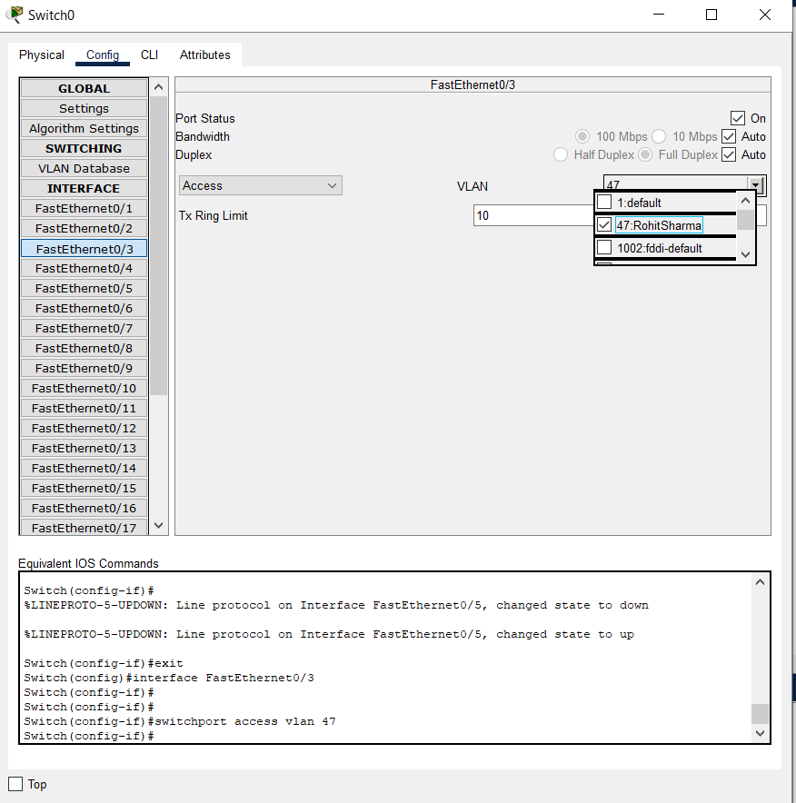A screenshot of a computer

  AI-generated content may be incorrect.Select GigaEthernet0/3, set mode to Access, and assign it to VLAN 47: RohitSharma from the dropdown.

**4.Configuration of router**

* Go to **Router CLI**, enter: enable → configure terminal
* Create sub interface for VLAN 1: interface GigabitEthernet0/0.1 → encapsulation dot1Q 1 → ip address 192.168.1.1 255.255.255.0 → exit
* Create sub interface for VLAN 47: interface GigabitEthernet0/0.47 → encapsulation dot1Q 47 → ip address 192.168.47.1 255.255.255.0 → exit
* Activate main interface: interface GigabitEthernet0/0 → no shutdown → exit

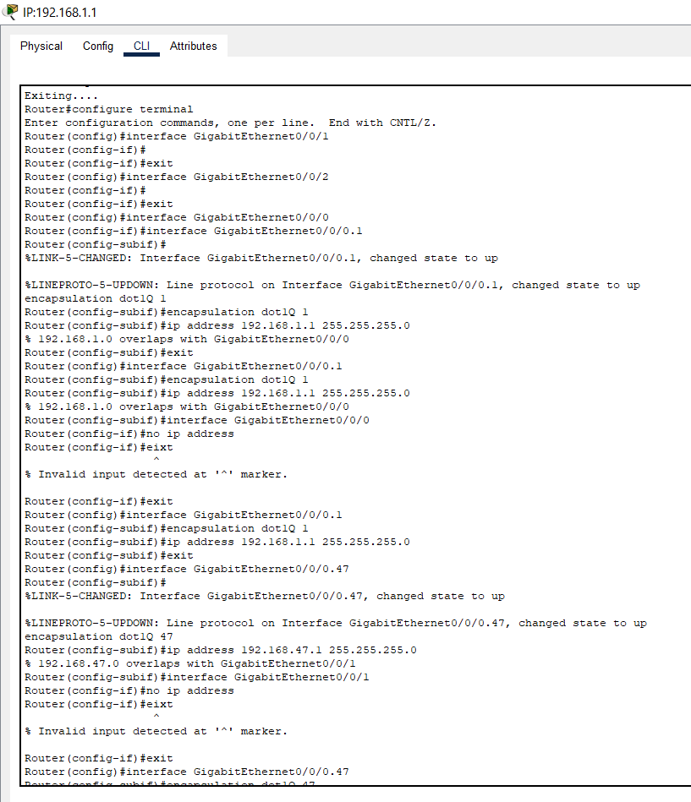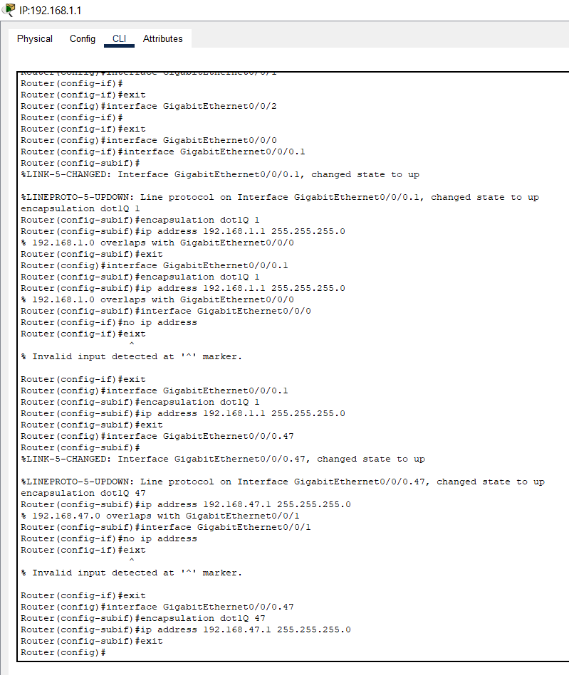

**5.Ping Testing:**

* On PC1, open Command Prompt and ping PC2 (same VLAN): ping 192.168.1.3 — Successful reply received**.**
* On PC1, ping the Router sub interface for VLAN 47: ping 192.168.47.1 — Successful, confirming router reachability.
* On PC2, ping PC1 (same VLAN): ping 192.168.1.2 — Successful reply.
* On PC2, ping PC3 and PC4 (different VLAN): ping 192.168.47.3 and ping 192.168.47.2 — Both successful, confirming inter-VLAN routing.

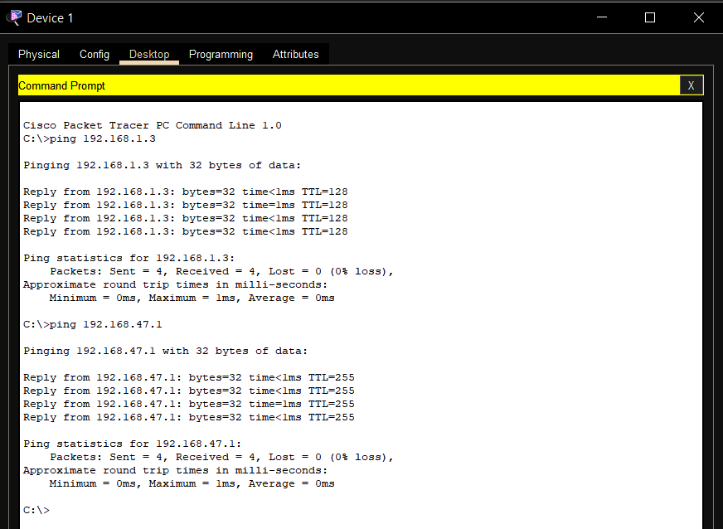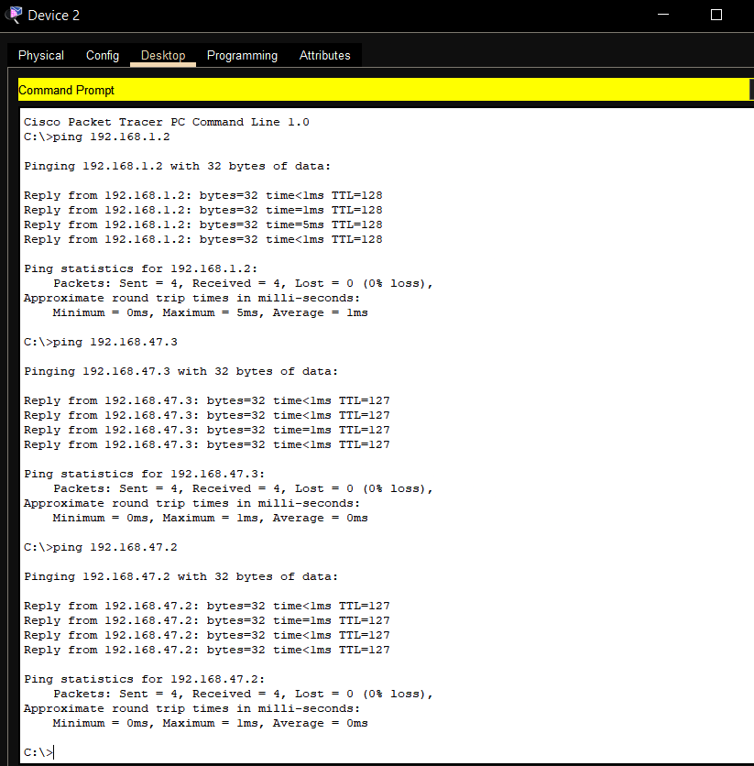

**6.Real Mode Simulation and Event Simulation:**

* At the bottom-right, click Simulation Mode.
* Now click the “Add Simple PDU” (envelope icon) from the bottom-left toolbar.
* Click on Device 1 (192.168.1.2), then click on Device 2 (192.168.1.3).
* This drops a simulated ping (ICMP packet) between the two devices.
* After a few steps, the simulation should complete and show packet delivery. Message changes to: Last Status: Successful | Source: Device 1 | Destination: Device 2 | Type: ICMP
* At the bottom-right, click the Simulation tab.
* Click the Add Simple PDU tool (envelope icon in the bottom-left toolset).
* First, click on Device 1 (192.168.1.2), then click on Device 2 (192.168.1.3) to create a simulated ping.
* Press the Capture/Forward button to step through the packet's path.
* Green dots/arrows will appear showing the packet flow from source to destination.
* A computer diagram of a computer network

  AI-generated content may be incorrect.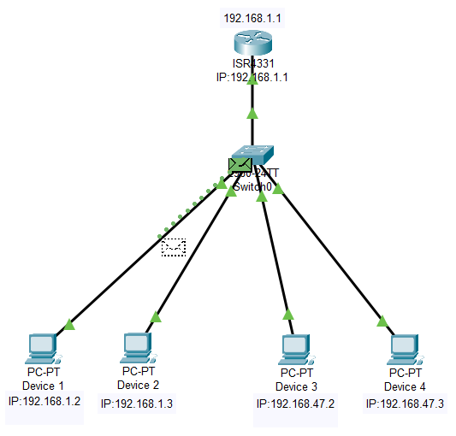We will see events updating live in the Event List Panel (right side).

