**Computer Networks and Security Lab**

**Practical Assignment 1**

**Problem Definition:** Setup a wired LAN using Layer 2 Switch. It includes preparation of cable, testing of cable using line tester configuration machine using IP addresses, testing using PING utility and demonstrating the PING packets captured traces using Wireshark Packet Analyser Tool.

**Student Roll Number: 7347**

**Name: Rohit Sharma**

**Date of Assignment: 11 July 2025**

**Demo I: Connect Two Computer in LAN using Crossover Cable**

**Step1:** Prepare Crossover Cable using Cabling Standard 568A and 568B

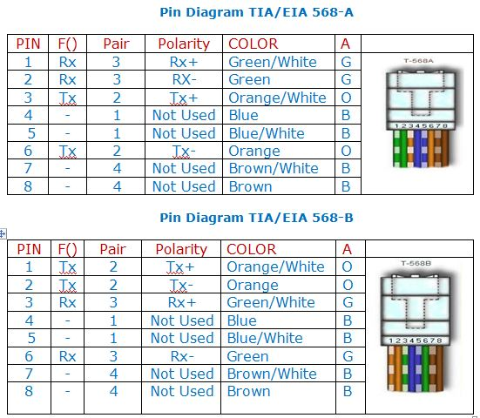

Step2:

**Step 2:** Connect two Computer using Crossover Cable as shown in Figure below

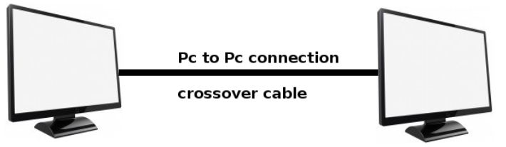

Configure IP Address

IP Address: 192.168.1.47 IP Address: 192.168.1.54

Subnet Mask: 255.255.255.0 Subnet Mask: 255.255.255.0

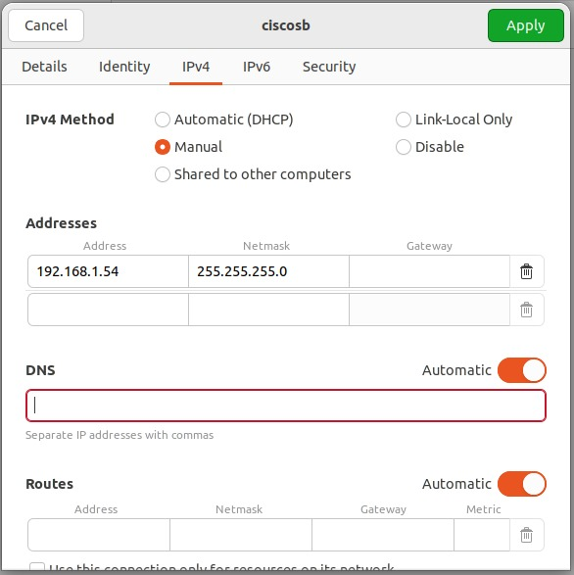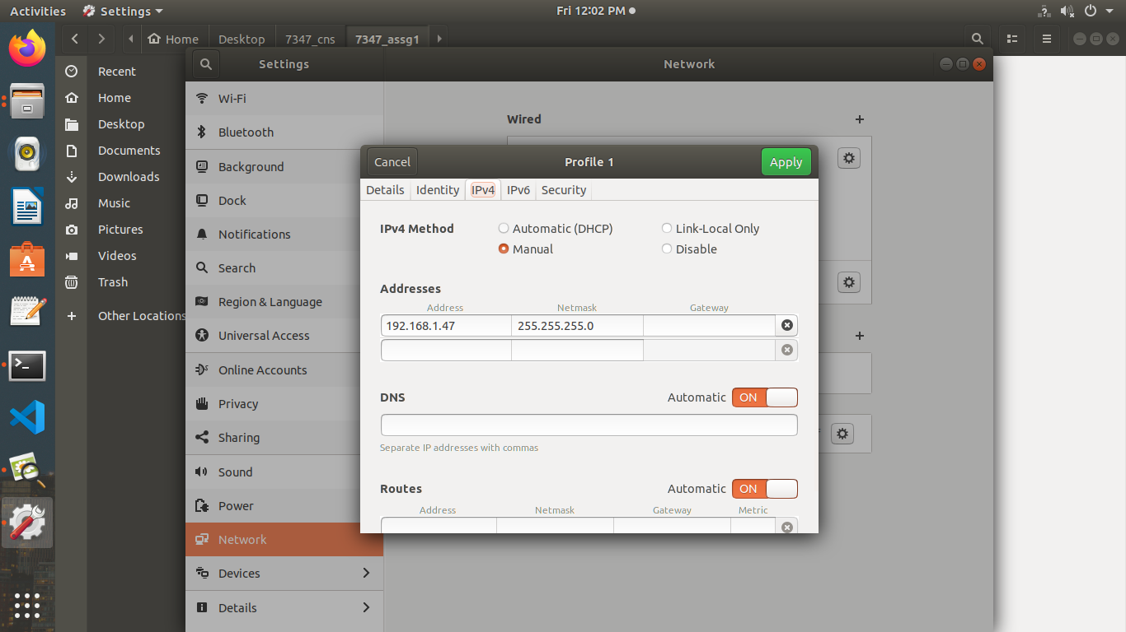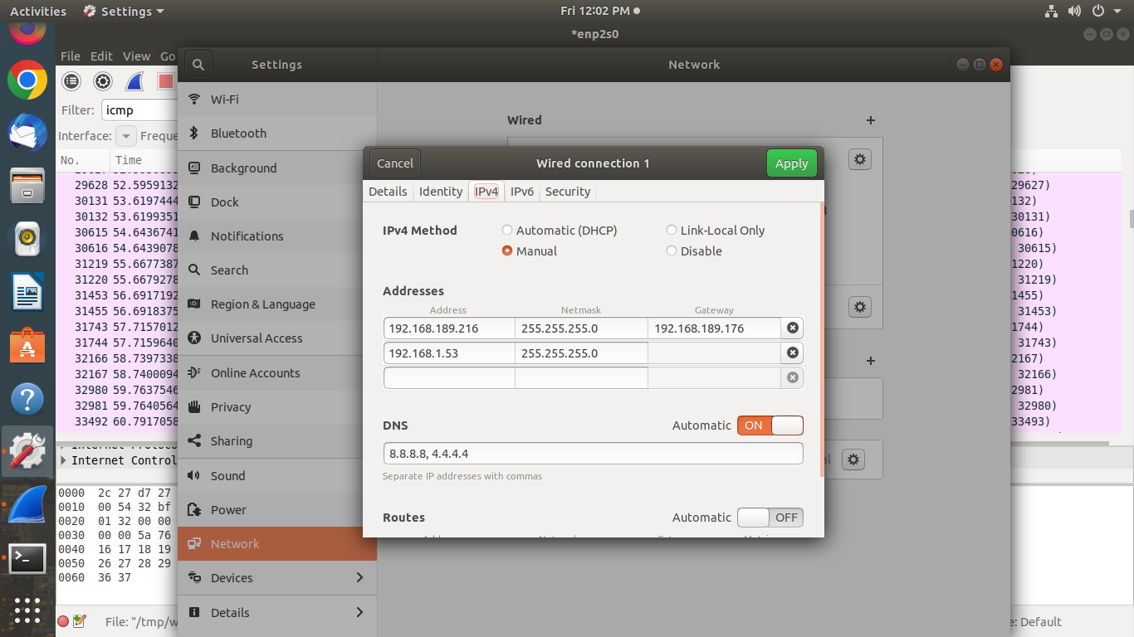

**Step3**: Test the connectivity of Host using ping command

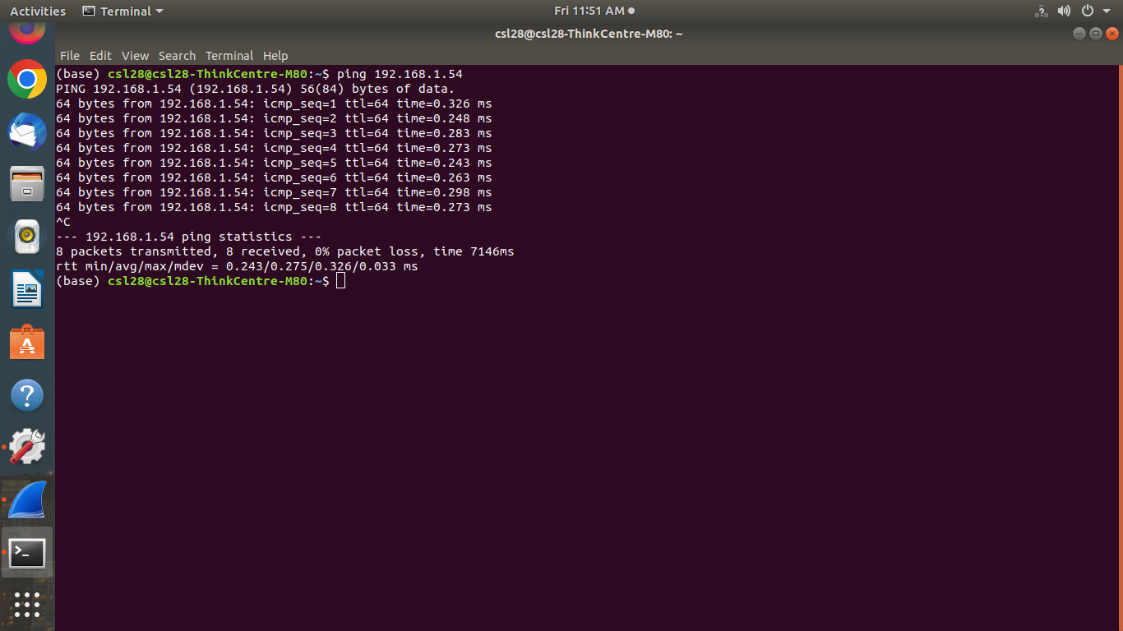

**Step4**: Capture the traces of ping using Wireshark Protocol Analyzer

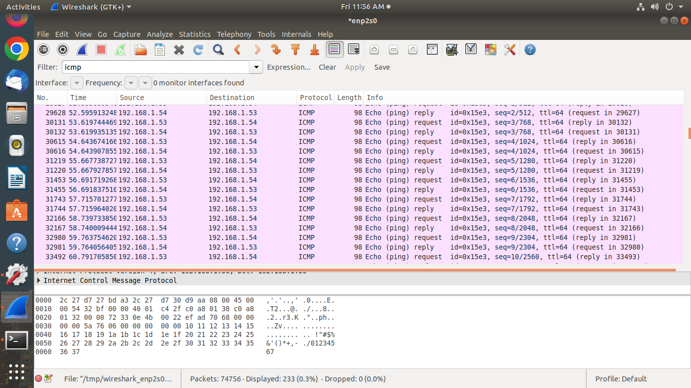

**Demo II: Connect Four Computer in LAN using straight through twisted pair Cable and switch**

**Step1:** Prepare Straight through twisted pair Cable using Cabling Standard 568A or 568B



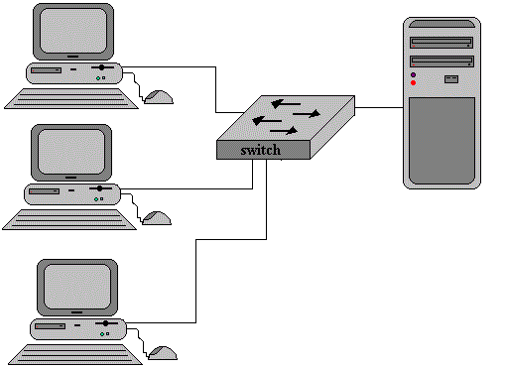**Step2:** Connect Four Computer in LAN using Straight through twisted pair Cable and switch as shown in figure below

Configure IP Address

IP Address: 192.168.1.53**(Server)**

Subnet Mask: 255.255.255.0

IP Address: 192.168.1.54

Subnet Mask: 255.255.255.0

IP Address: 192.168.1.47

Subnet Mask: 255.255.255.0





**Step3:** Test the connectivity of Host using ping command

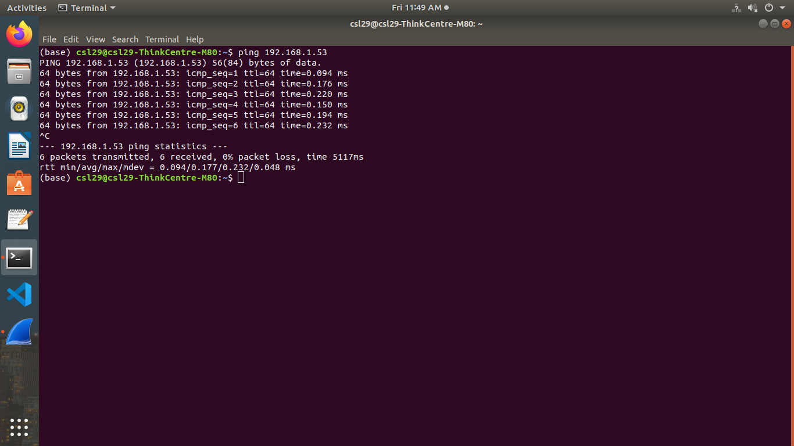

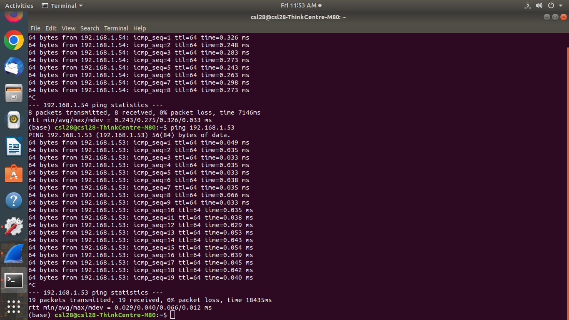

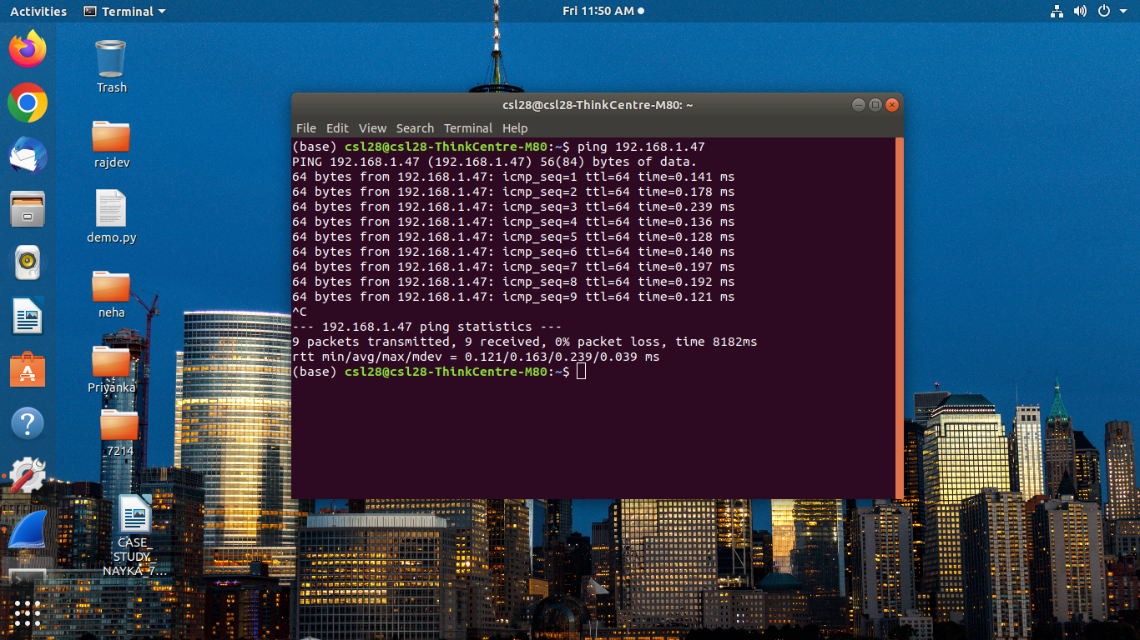

**Step4**: Capture the traces of ping using Wireshark Protocol Analyzer

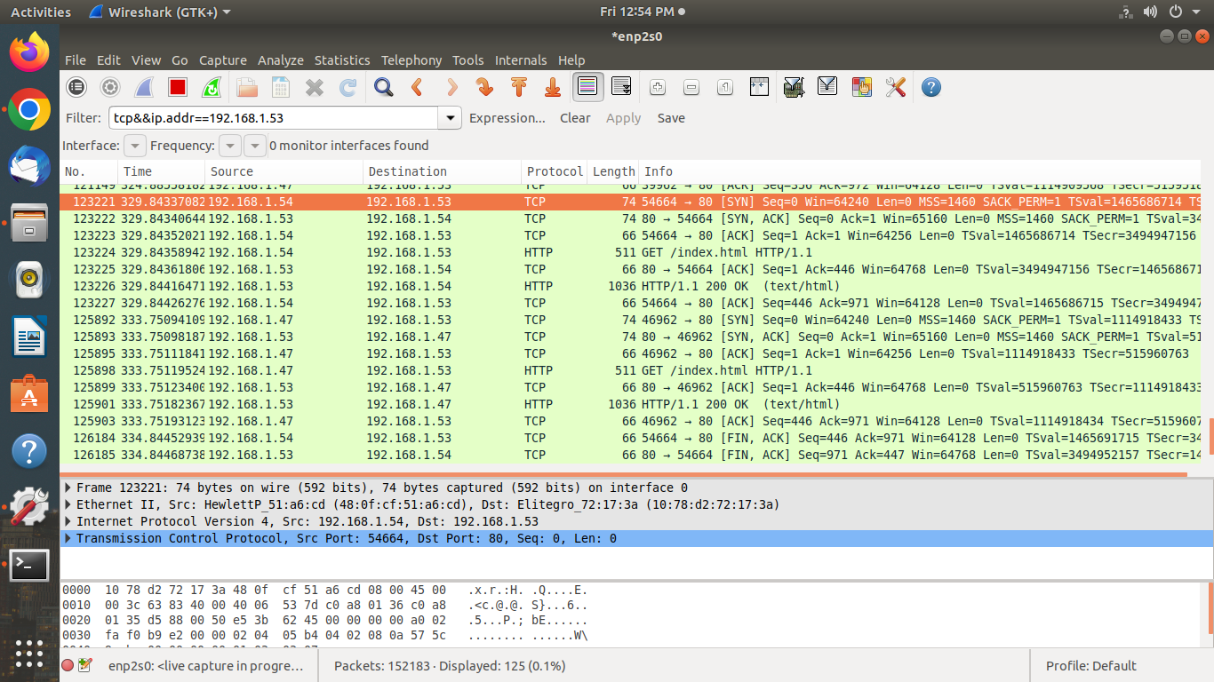

**Demo III: Testing of Web Server Over LAN Set in DemoII**

**Follow following Steps**

1. Installation of Web Server on one Computer – Apache2 or Tomcat7
2. Install the server – sudo apt-get install apache2
3. Start web server - /etc/init.d/apache2 start
4. Create the web page and store in /var/www/html
5. Access the web pages from client machines 1/2/3

**Access Web Page:** http:\\192.168.1.53\index.html

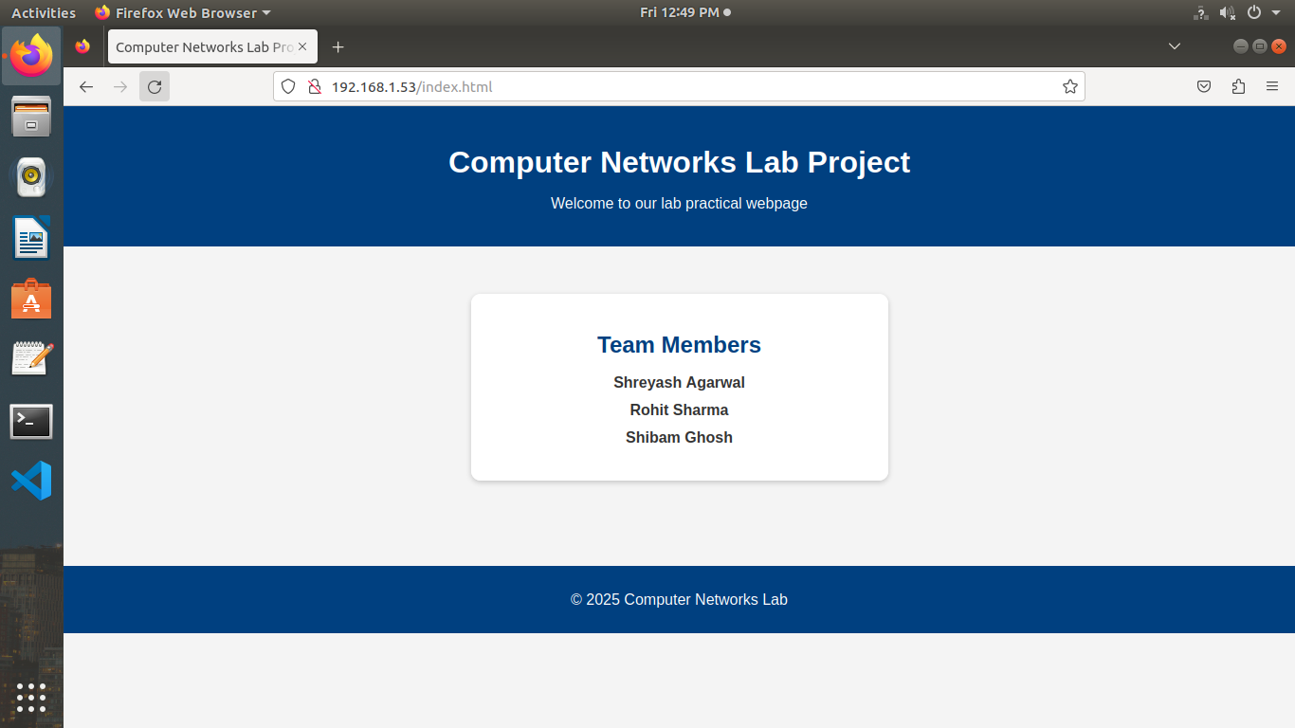

**Test the web server by accessing web pages stored on server and capture the traces of http, tcp, ip and Ethernet-II using Wireshark**

