A Project Report on
Civic Issue Classification System

Submitted By
Rohit Sharma 7347
Submitted as a partial fulfillment towards Term II of
T.E. Computer Engineering



ARMY INSTITUTE OF TECHNOLOGY
Department of Computer Engineering



Savitribai Phule Pune University
2025-26

ARMY INSTITUTE OF TECHNOLOGY
Department of Computer Engineering

C E R T I F I C A T E

This is to certify that Rohit Sharma (University Exam Seat No. T400220293) of Army Institute of Technology, Dighi, Pune has successfully completed the project titled “Civic Issue Classification System” and submitted this report as partial fulfillment of Term – II for the award of Third Year of Bachelor of Computer Engineering from Savitribai Phule Pune University, Pune, during the Academic Year 2025–26.

Prof. Rushali Katkar Dr. S. R. Dhore
Project Guide H.O.D.

ACKNOWLEDGMENT

I would like to express my sincere gratitude to everyone who supported me in completing this mini project on Civic Issue Classification using Data Science and Big Data Analytics. This project helped me gain practical knowledge of machine learning and natural language processing.
I am especially thankful to my project guide, Prof. Rushali Katkar, for her valuable guidance, suggestions, and continuous support throughout the project. Her direction played a key role in improving the quality of my work.
I would also like to thank the Army Institute of Technology, Pune, for providing the necessary resources and a supportive learning environment.
I acknowledge the open-source community and developers of tools such as Pandas, NumPy, NLTK, and Scikit-learn for enabling efficient implementation of this project. Finally, I thank my friends and peers for their support and motivation during the project. This project has enhanced my understanding of data science and encouraged me to explore the field further.

TABLE OF CONTENTS

Chapter 1: Introduction 6
1.1 Background 6
1.2 Problem Statement 6
1.3 Proposed System 6
Chapter 2: Objectives 7
2.1 To develop an automated civic issue classification system 7
2.2 To apply Natural Language Processing (NLP) techniques 7
2.3 To perform feature extraction using TF-IDF 7
2.4 To build and compare multiple machine learning models 7
2.5 To evaluate model performance using standard metrics 7
Chapter 3: Literature Review 8
3.1 Text Classification Using Machine Learning 8
3.2 Civic Issue Classification and Smart City Applications 8
Chapter 4: Dataset Description 9
4.1 Dataset Overview 9
4.2 Data Characteristics and Insights 9
Chapter 5: Data Preprocessing 10
5.1 Text Merging (Title + Description) 10
5.2 Lowercasing 10
5.3 Tokenization (NLTK) 10
5.4 Stopword Removal 10
5.5 Lemmatization 11
5.6 Final Processed Text Creation 11
Chapter 6: Exploratory Data analysis 13
6.1 WordCloud Visualization 13
6.2 Frequency Distribution of Words 13
6.3 Category Distribution 14
6.4 Observations 15
Chapter 7: Feature Extraction 16
7.1 TF-IDF Vectorization 16
7.2 Why TF-IDF is Used 16
7.3 Feature Size (5000 Max Features) 16
Chapter 8: Model Building 17
8.1 Training Process & Data Split 17
8.2 Logistic Regression 17
8.3 Support Vector Machine (SVM) 17
8.4 Random Forest Classifier 17
8.5 Naive Bayes 17
Chapter 9: Models Evalutation 18
9.1 Test Cases and Results 18
9.2 Evaluation Metrics 18
9.3 Models Performance Comparison 19
9.4 Performance Heatmaps 19
19
20
10 Conclusion 20

Chapter 1: Introduction

1.1 Background
In rapidly growing urban areas, effective management of civic issues is crucial for maintaining infrastructure and ensuring public safety. Citizens frequently report problems such as electrical faults, water supply disruptions, sanitation concerns, and public safety hazards. Traditionally, these complaints are handled manually, which often leads to delays, inefficiencies, and inconsistencies in classification. The increasing volume of complaints further complicates the process, making it necessary to adopt automated and intelligent solutions.

1.2 Problem Statement
Manual classification of civic complaints is time-consuming and prone to human error. It becomes difficult for authorities to prioritize and respond to issues efficiently, especially when dealing with large datasets of unstructured textual information. There is a need for a system that can automatically analyze and classify complaints into relevant categories, ensuring faster processing and better resource allocation.

1.3 Proposed System
The Civic Issue Classification System is designed to automate the classification of civic complaints using machine learning and Natural Language Processing (NLP) techniques. The system processes textual data from issue titles and descriptions, performs preprocessing steps such as tokenization, stopword removal, and lemmatization, and converts the data into numerical form using TF-IDF vectorization. Multiple machine learning models, including Logistic Regression, Support Vector Machine (SVM), Random Forest, and Naive Bayes, are used to classify the issues. This automated approach enhances efficiency, reduces manual effort, and supports faster decision-making in civic administration.

Chapter 2: Objectives

2.1 To develop an automated civic issue classification system
The primary objective of this project is to design a system that can automatically classify civic complaints based on textual input. This reduces dependency on manual processes, minimizes human error, and ensures faster handling of large volumes of complaints submitted by citizens.

2.2 To apply Natural Language Processing (NLP) techniques
This objective focuses on processing unstructured text data using NLP methods such as tokenization, stopword removal, and lemmatization. These techniques help clean and standardize the data, making it suitable for analysis and improving the performance of machine learning models..

2.3 To perform feature extraction using TF-IDF
The project aims to convert textual data into numerical form using TF-IDF vectorization. This technique assigns importance to words based on their frequency and relevance, enabling the model to better understand and differentiate between different types of civic issues.

2.4 To build and compare multiple machine learning models
Different machine learning algorithms such as Logistic Regression, Support Vector Machine (SVM), Random Forest, and Naive Bayes are implemented. The objective is to compare their performance and identify the most suitable model for accurate civic issue classification.

2.5 To evaluate model performance using standard metrics
The models are evaluated using performance metrics like accuracy, precision, recall, and F1-score. This helps in understanding the effectiveness of each model and ensures that the system provides reliable and consistent classification results.

Chapter 3: Literature Review

3.1 Text Classification Using Machine Learning
Text classification is an important area in data science and Natural Language Processing (NLP), commonly performed using supervised machine learning algorithms such as Naive Bayes, Logistic Regression, and Support Vector Machines (SVM). These models are effective for handling large textual datasets due to their simplicity and efficiency.
Naive Bayes is widely used because of its probabilistic approach and strong performance with high-dimensional data. Logistic Regression is suitable for binary classification and offers easy interpretability, while SVM is known for its robustness and ability to handle complex decision boundaries.
Feature extraction techniques like TF-IDF are essential for converting text into numerical form by measuring word importance within documents. Combining TF-IDF with machine learning models has proven effective in tasks such as spam detection, sentiment analysis, and document classification.

3.2 Civic Issue Classification and Smart City Applications
With the growth of smart city initiatives, there is increasing focus on automating civic complaint management using machine learning and NLP. These systems aim to improve governance by enabling faster response times and better decision-making.
Studies have analyzed citizen feedback from social media and complaint portals using text mining techniques to classify issues into categories like transportation, sanitation, water supply, and public safety. Machine learning models trained on labeled data help in accurately predicting complaint categories.
Advanced methods such as RNNs and BERT offer higher accuracy but require more computational resources, while traditional models remain efficient and easier to implement. This project builds on these approaches by using NLP preprocessing, TF-IDF, and machine learning models to support efficient civic issue management.

Chapter 4: Dataset Description

4.1 Dataset Overview
- The dataset consists of 2000 records of civic and non-civic issues
- Each record contains the following attributes:
  - ID – Unique identifier for each entry
  - Issue Title – Short summary of the complaint
  - Description – Detailed explanation of the issue
  - Label – Binary value (1 = Civic Issue, 0 = Non-Civic Issue)
  - Category – Type of issue (e.g., Electrical, Water Supply, Public Safety, etc
- The dataset includes both structured (Label, Category) and unstructured data (text fields).
- Distribution of data:
  - Civic Issues: 1155
  - Non-Civic Issues: 845
- The dataset is used for training and testing machine learning models.

4.2 Data Characteristics and Insights
- The dataset contains textual data of varying lengths, suitable for NLP tasks.
- Supports:
  - Binary classification (Civic vs Non-Civic)
- Some records contain blank or inconsistent category values, requiring preprocessing.
- The text includes real-world language, including informal expressions and variations.
- Presence of noise and irrelevant words, which are handled using preprocessing techniques.
- Categories such as Electrical and Water Supply appear more frequently.
- The dataset reflects real civic complaint scenarios, making it practical for model training.

.

Chapter 5: Data Preprocessing

5.1 Text Merging (Title + Description)
In the initial stage of preprocessing, the textual information from the Issue Title and Description columns is combined to form a single unified text field. This step is essential because the title alone may not provide sufficient context, while the description contains detailed information about the issue. By merging both fields, the system ensures that all relevant information is captured in one place, improving the model’s ability to understand and classify the complaint accurately. The merged text is stored in a new column named “Text”, which serves as the base input for all subsequent preprocessing steps. This integration enhances contextual richness and reduces the chances of losing important semantic meaning during analysis.
df["Text"] = df["Issue Title"] + df["Description"]

5.2 Lowercasing
After merging the text, the entire dataset is converted into lowercase format. This step is crucial for maintaining uniformity in textual data, as words with different cases (for example, “Water” and “water”) would otherwise be treated as separate tokens. Lowercasing helps in reducing redundancy and ensures consistency across the dataset, which ultimately improves the efficiency of tokenization and feature extraction. It also simplifies the vocabulary size, making the model training process more effective and computationally efficient.
df["Text"] = df["Text"].str.lower()

5.3 Tokenization (NLTK)
Tokenization is the process of breaking down the text into smaller units called tokens, typically words. In this project, tokenization is performed using the Natural Language Toolkit (NLTK), which is a widely used library for NLP tasks. Each sentence is split into individual words, enabling the system to analyze the structure and frequency of terms more effectively. This step forms the foundation for further preprocessing tasks such as stopword removal and lemmatization. By converting raw text into tokens, the model can better interpret the linguistic patterns present in the data.
from nltk.tokenize import word_tokenize
df["Tokens"] = df["Text"].apply(word_tokenize)

5.4 Stopword Removal
Once the text is tokenized, common words known as stopwords are removed from the dataset. Stopwords include frequently occurring words such as “the”, “is”, “and”, which do not carry significant meaning for classification tasks. Removing these words helps in reducing noise and focusing only on meaningful terms that contribute to identifying the nature of the issue. This step improves the quality of the dataset and enhances the performance of machine learning models by eliminating irrelevant information and reducing dimensionality.
from nltk.corpus import stopwords
stop_words = set(stopwords.words('english'))
clean_tokens = []
for words in df["Tokens"]:
filtered_words = []
for word in words:
if word.isalpha() and word not in stop_words:
filtered_words.append(word)
clean_tokens.append(filtered_words)
df["Tokens"] = clean_tokens

5.5 Lemmatization
Lemmatization is applied to reduce words to their base or root form, ensuring that different variations of a word are treated as a single term. For example, words like “running”, “runs”, and “ran” are converted to their base form “run”. In this project, the WordNet Lemmatizer from NLTK is used for this purpose. This step helps in normalizing the text data and reducing the vocabulary size, which improves the efficiency and accuracy of the classification models. Lemmatization preserves the contextual meaning of words better than stemming, making it more suitable for this application.
from nltk.stem import WordNetLemmatizer
lemmatizer = WordNetLemmatizer()
lemmatized_words = []
for words in df["Tokens"]:
lemmatized_row = []
for word in words:
lemmatized_row.append(lemmatizer.lemmatize(word))
lemmatized_words.append(lemmatized_row)
df["Tokens"] = lemmatized_words

5.6 Final Processed Text Creation
In the final step of preprocessing, the cleaned and lemmatized tokens are combined back into a single string to create the final processed text. This step ensures that the data is in a format suitable for feature extraction techniques such as TF-IDF. Additionally, all processed words are collected into a list for further analysis, such as generating word clouds and frequency distributions. The resulting column, “processed_text”, represents the fully preprocessed dataset and serves as the input for model training and evaluation.
processed_text = []
allwords = []
for words in df["Tokens"]:
sentence = ""
for word in words:
sentence += " " + word
allwords.append(word)
processed_text.append(sentence)
df["processed_text"] = processed_text

Chapter 6: Exploratory Data analysis

6.1 WordCloud Visualization
WordCloud is a visual representation of the most frequently occurring words in the dataset, where the size of each word indicates its frequency or importance. In this project, a WordCloud is generated using the fully processed text data. This helps in quickly identifying dominant terms related to civic issues such as “road”, “water”, “electricity”, and “safety”. The visualization provides an intuitive understanding of the dataset and highlights key problem areas reported by citizens. It also helps in validating whether preprocessing steps like stopword removal and lemmatization have been effective in retaining meaningful words.

from wordcloud import WordCloud
import matplotlib.pyplot as plt
wordcloud = WordCloud(width=800, height=400, background_color='white') \
.generate(' '.join(allwords))
plt.imshow(wordcloud, interpolation='bilinear')
plt.axis('off')
plt.title("WordCloud Visualization")
plt.show()

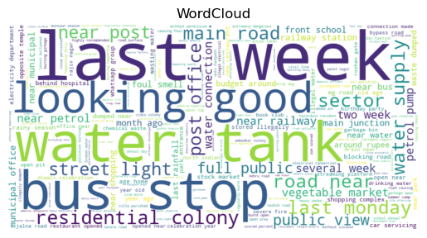
6.2 Frequency Distribution of Words
Frequency distribution analysis is performed to identify the most common words in the dataset. This is achieved using the FreqDist function from NLTK, which counts the occurrence of each word. The top frequent words are then plotted using a bar graph. This visualization helps in understanding the prominence of specific terms and provides insights into common civic problems. It also aids in feature selection and ensures that the model focuses on relevant keywords during classification.

from nltk.probability import FreqDist
freq_dist = FreqDist(allwords)
freq_dist.plot(20)
plt.title("Top 20 Frequent Words")
plt.show()

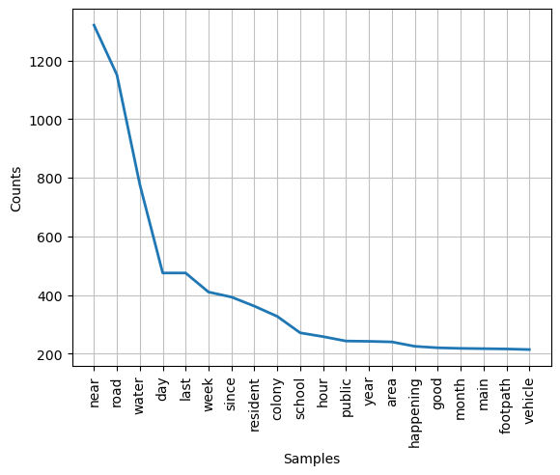

6.3 Category Distribution
Category distribution analysis helps in understanding how different types of civic issues are represented in the dataset. A pie chart or bar graph can be used to visualize the number of issues in each category such as Electrical, Water Supply, Public Safety, Transportation, and others. This analysis reveals whether the dataset is balanced or skewed toward certain categories. It also helps in identifying dominant problem areas and ensures that the model is trained on diverse data.
import seaborn as sns
plt.figure(figsize=(8,5))
sns.countplot(x="Category", data=df)
plt.xticks(rotation=45)
plt.title("Category Distribution")
plt.show()
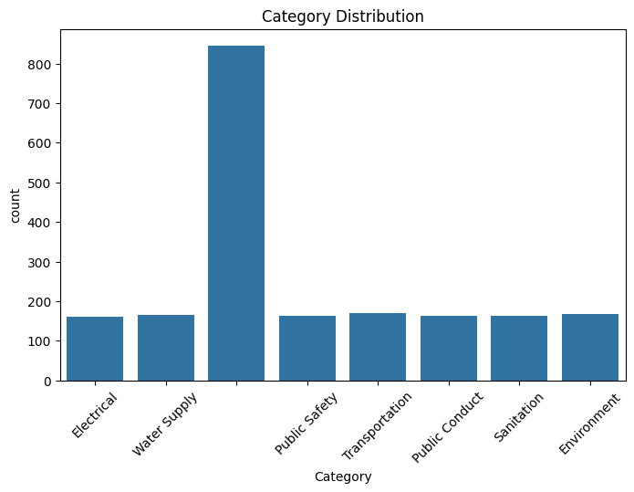
t

6.4 Observations
The Exploratory Data Analysis reveals several important insights about the dataset. The WordCloud and frequency distribution indicate that words related to infrastructure, utilities, and safety are most common, reflecting real-world civic concerns. The category distribution shows that certain categories, such as Electrical and Water Supply, appear more frequently than others, indicating a slight imbalance in the dataset. Overall, the dataset captures a wide range of civic issues, making it suitable for training machine learning models. The preprocessing steps have successfully reduced noise and highlighted meaningful patterns, which contribute to improved model performance.

Chapter 7: Feature Extraction

7.1 TF-IDF Vectorization
Feature extraction is a crucial step in transforming textual data into a numerical format that can be understood by machine learning models. In this project, TF-IDF (Term Frequency–Inverse Document Frequency) vectorization is used to convert the processed text into feature vectors. TF-IDF calculates the importance of each word in a document relative to the entire dataset. Words that appear frequently in a specific document but less frequently across all documents are assigned higher weights. The processed text column is passed into the TF-IDF vectorizer, which generates a matrix of numerical values representing each document. This matrix is then used as input for training the classification models.
from sklearn.feature_extraction.text import TfidfVectorizer
tfidf = TfidfVectorizer(max_features=5000)
X = tfidf.fit_transform(df['processed_text'])
Y = df['Label']

7.2 Why TF-IDF is Used
TF-IDF is used because it effectively captures the importance of words in a document while reducing the impact of commonly occurring words that may not carry meaningful information. Unlike simple word count methods, TF-IDF assigns lower weights to frequently occurring words across all documents and higher weights to words that are unique and relevant to specific documents. This improves the ability of machine learning models to distinguish between different classes. Additionally, TF-IDF helps in reducing noise and dimensionality, making it a reliable and widely used technique for text classification tasks such as civic issue identification.

7.3 Feature Size (5000 Max Features)
In this project, the TF-IDF vectorizer is configured to use a maximum of 5000 features, meaning that only the top 5000 most important words (based on frequency and relevance) are selected from the dataset. Limiting the feature size helps in reducing computational complexity and prevents the model from being overwhelmed by unnecessary or less important words. It also helps in improving model performance by focusing only on the most significant features. This balance between feature richness and efficiency ensures that the classification models remain both accurate and scalable.

Chapter 8: Model Building

8.1 Training Process & Data Split
The dataset is divided into training and testing sets using an 80-20 split, where 80% of the data is used to train the models and 20% is used for evaluation. This ensures that the models are tested on unseen data, providing a reliable measure of performance.
from sklearn.model_selection import train_test_split
X_train, X_test, Y_train, Y_test = train_test_split(
X, Y, test_size=0.2, random_state=42
)

8.2 Logistic Regression
Logistic Regression is a simple and efficient algorithm used for binary classification. It estimates the probability of a data point belonging to a particular class and is widely used due to its interpretability and speed.
from sklearn.linear_model import LogisticRegression
lr = LogisticRegression()
lr.fit(X_train, Y_train)

8.3 Support Vector Machine (SVM)
Support Vector Machine is effective for high-dimensional data such as text. It works by finding an optimal boundary (hyperplane) that separates different classes with maximum margin.
from sklearn.svm import SVC
svc = SVC()
svc.fit(X_train, Y_train)

8.4 Random Forest Classifier
Random Forest is an ensemble learning method that constructs multiple decision trees and combines their outputs to improve accuracy and reduce overfitting.
from sklearn.ensemble import RandomForestClassifier
rfc = RandomForestClassifier(n_estimators=100)
rfc.fit(X_train, Y_train)

8.5 Naive Bayes
Naive Bayes is a probabilistic classifier that assumes independence between features. It is particularly effective for text classification tasks due to its simplicity and fast computation.
from sklearn.naive_bayes import MultinomialNB
nb = MultinomialNB()
nb.fit(X_train, Y_train)

Chapter 9: Models Evalutation
The final testing results are compared with the actual values to evaluate model performance using metrics such as Accuracy, Precision, and Recall.

9.1 Test Cases and Results
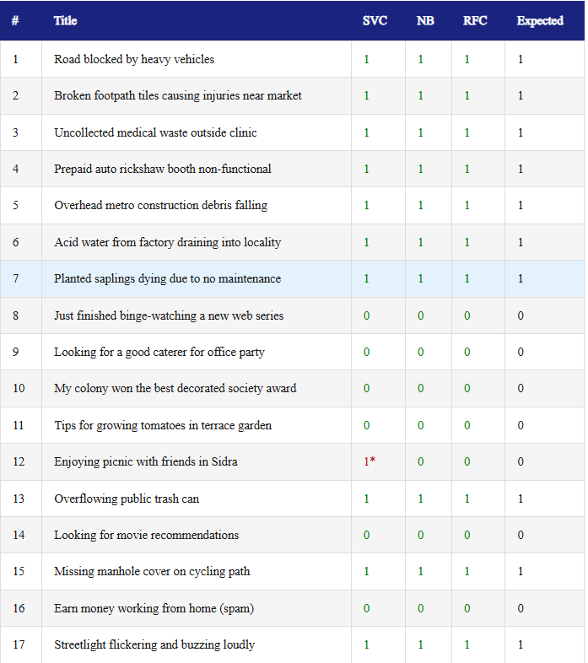

9.2 Evaluation Metrics
Model | Accuracy | Precision | Recall
Logistic Regression | 1.00 | 1.00 | 1.00
Naïve Bayes | 1.00 | 1.00 | 1.00
SVC | 0.94 | 0.91 | 1.00
RFC | 1.00C | 1.00 | 1.00

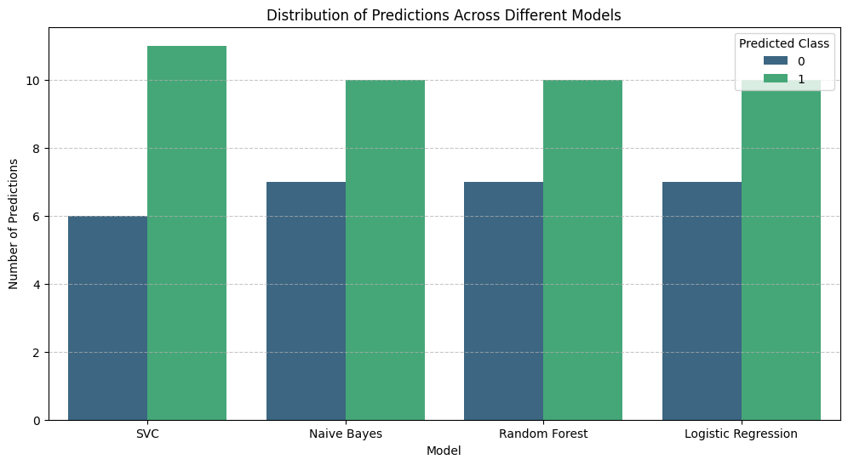
9.3 Models Performance Comparison

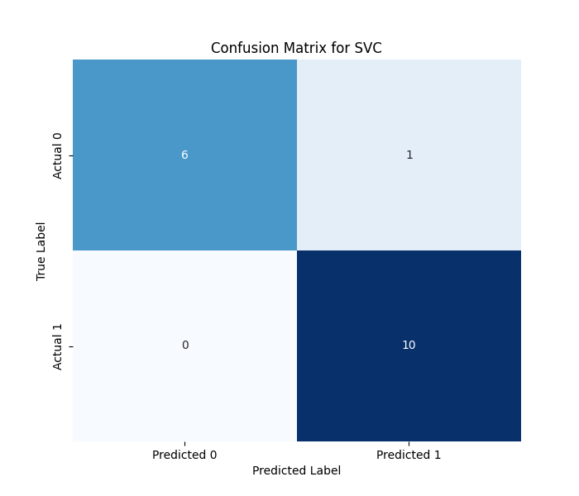
9.4 Performance Heatmaps
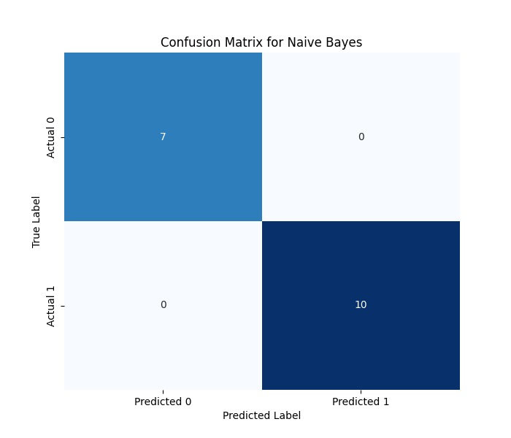
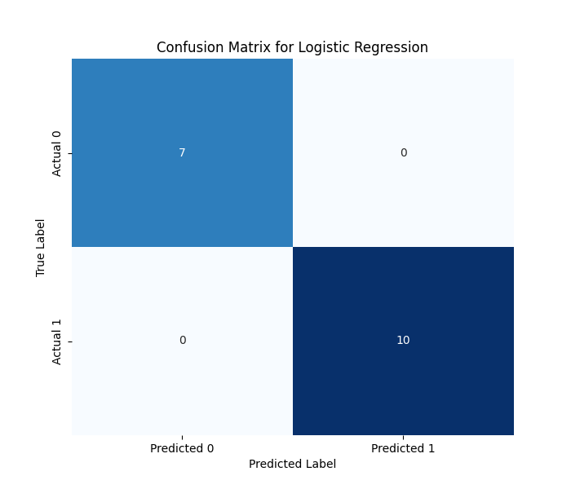
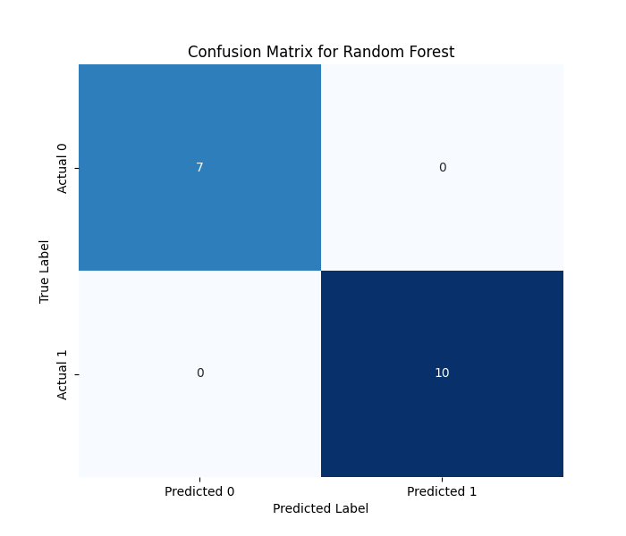

10 Conclusion
The Civic Issue Classification System successfully demonstrates the application of Natural Language Processing (NLP) and machine learning techniques for automating the classification of civic complaints. By preprocessing textual data and applying TF-IDF feature extraction, the system effectively converts unstructured text into meaningful numerical representations suitable for model training.
Multiple machine learning models, including Logistic Regression, Support Vector Machine (SVM), Random Forest, and Naive Bayes, were implemented and evaluated. The models achieved high accuracy, precision, and recall, indicating strong performance in identifying and classifying civic issues. Notably, the system achieved perfect recall, ensuring that no critical civic issues were missed during prediction.
The results highlight that machine learning models can significantly improve the efficiency of handling large volumes of complaints by reducing manual effort and minimizing errors. The system can assist municipal authorities in prioritizing issues, improving response time, and enhancing public service delivery.
Overall, this project validates the effectiveness of data-driven approaches in solving real-world problems and contributes to the development of intelligent and automated civic management systems. Future enhancements can further improve scalability, accuracy, and real-time applicability.

