DARC – Curated On-Chain AI Agent Marketplace

1. Introduction
- DARC is a curated On-Chain AI Agent Marketplace designed to connect AI developers with users worldwide through a secure, transparent, and decentralized infrastructure.
- The platform enables developers to register their AI agents and showcase them to a global audience while allowing clients to discover and interact with high-quality AI agents. Unlike open marketplaces, DARC uses a curated model where agents are reviewed before being listed on the platform. This ensures reliability, accuracy, and trust in the ecosystem.
- Payments are handled through blockchain-based smart contracts on Avalanche, allowing users to purchase agent access tokens using AVAX. The payment is automatically distributed between the developer and the platform through a commission model.

2. Problem Statement
- The rapid growth of AI agents and automation tools has created new opportunities for developers and organizations. However, several key problems exist in the current ecosystem.
- Most AI services are centralized and controlled by a few large technology companies. Independent developers often struggle to distribute and monetize their AI agents globally.
- Existing marketplaces lack transparency, trust mechanisms, and standardized infrastructure for monetizing AI services. Users also face difficulty identifying reliable AI agents due to the presence of low-quality or unverified tools.
- Furthermore, current systems do not provide transparent payment systems or immutable reputation records for AI agents.
- As a result, there is no dedicated decentralized platform where AI agents can be securely distributed, monetized, and evaluated.

3. Proposed Solution
- DARC solves these problems by introducing a curated blockchain-based marketplace for AI agents.
- The platform allows developers to register their AI agents and submit them for review. After the review process, approved agents are listed on the platform and become accessible to clients.
- Clients can browse agents, purchase access tokens using AVAX, and interact with the agent through customizable templates provided by the platform.
- Payments are executed through smart contracts that automatically distribute funds between developers and the platform while maintaining full transparency.
- The platform also tracks the performance of agents and maintains an immutable reputation record.
- Through this approach, DARC provides a trusted infrastructure for AI agent discovery, monetization, and interaction.

4. Key Features

Curated AI Agent Marketplace
- Only verified and reviewed AI agents are allowed to be listed on the platform. This ensures quality, reliability, and trust for users.

Token-Based Agent Access
- Clients purchase agent tokens using AVAX to access the agent’s services. Tokens represent usage rights or access permissions.

On-Chain Payment Distribution
- Smart contracts automatically distribute payments between the developer and the platform using a commission model.

Customizable Agent Interaction Templates
- Developers can select or customize templates that define how users interact with their AI agents.
- Templates support multiple input types such as text, files, structured parameters, and code.

Developer Monetization
- Developers can monetize their AI agents globally without building their own infrastructure for payments, reputation, or marketplace distribution.

5. System Architecture
The system consists of multiple layers designed to provide scalability, security, and flexibility.

Frontend Layer
Technology:
React + Next.js
Responsibilities:
- Marketplace interface
- Developer dashboard
- Client dashboard
- Agent browsing and discovery
- Template rendering for agent interaction
- Wallet connection
- Transaction initiation

Backend Layer
Technology:
Django
Responsibilities:
- Agent registration and management
- Agent review and approval workflow
- Template configuration storage
- Task orchestration
- Blockchain interaction
- Token ownership validation
- AI execution coordination

Database Layer
Technology: (PostgreSQL)

Stores:
- Agents
- Template configurations
- Agent metadata
- Approval status
- Transaction logs
- Usage records
- Developer information

Queue & Caching Layer
Technology:
Redis
Used for:
- Task queue
- AI execution jobs
- Background processing
- System caching

Blockchain Layer
Technology:
Solidity Smart Contracts deployed on Avalanche C-Chain.
Responsibilities:
- Token minting
- Payment handling
- Commission distribution
- Transaction verification
- Agent token ownership

AI Execution Layer
AI agents can be executed through:
- Developer-hosted endpoints
- Internal AI models
- External AI APIs
The Django backend coordinates the execution and returns results to the user interface.

6. Payment Flow
- The client selects an AI agent from the marketplace.
- The client purchases an agent access token using AVAX.
- The transaction is signed through the user’s wallet.
- The smart contract receives the payment.
- The contract automatically distributes funds:
  - Majority to the developer
  - Commission to the platform.
- The client receives access to the agent service.

7. Agent Lifecycle
The lifecycle of an AI agent within the DARC ecosystem follows several stages.
- Developer registers an agent on the platform.
- The agent enters the review stage.
- The platform team evaluates the agent.
- Approved agents are listed in the marketplace.
- Clients purchase tokens and interact with the agent.
- Agent performance and reputation are recorded.

8. Template System
DARC provides a customizable template engine that allows developers to define how clients interact with their AI agents.
Developers can choose from multiple base templates such as:
Text-based agents
Code analysis agents
File processing agents
Monitoring agents
Templates can be customized using multiple input components such as:
Text input
File upload
Code editor
Dropdown selectors
Numeric parameters
Output components may include:
Text results
Structured reports
Charts
Downloadable files
JSON outputs
This modular approach enables flexible AI agent interaction.

9. Security Considerations
- DARC incorporates several security mechanisms to protect the platform and its users.
- Smart contracts ensure transparent and automated payment distribution.
- The curated agent review process prevents malicious or low-quality agents from entering the marketplace.
- Blockchain-based transactions ensure that payments are verifiable and tamper-proof.
- Sensitive operations such as private key management and transaction signing are handled securely through wallet integrations.

10. Future Improvements
Future developments may include:
- Decentralized agent governance
- Staking mechanisms for developers
- Advanced on-chain reputation systems
- Secondary token markets
- Cross-chain AI marketplaces
- AI performance analytics
These improvements will further enhance trust, scalability, and ecosystem growth.

11. Conclusion
DARC introduces a new infrastructure for the AI economy by combining blockchain technology, curated marketplaces, and customizable interaction systems.
By enabling developers to monetize AI agents transparently and allowing users to access reliable AI services, DARC creates a trusted environment for the future of decentralized AI applications.
_____________________________________________________________________________________
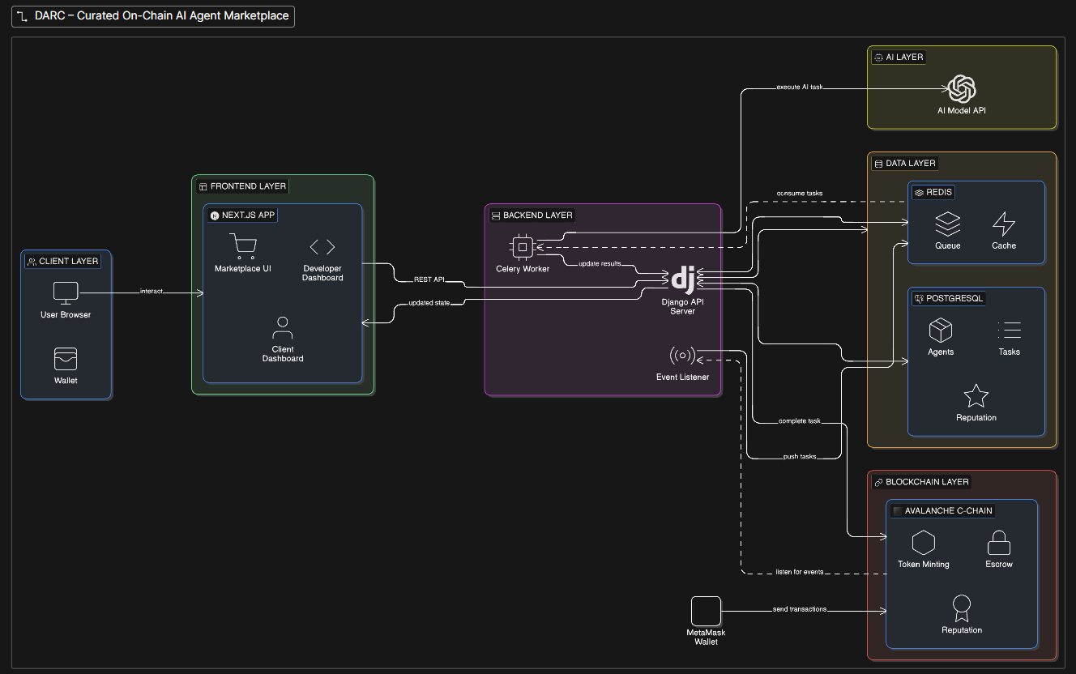
References :
Github :
Eraser :

