------------------------------------------------------------------------------------------------------------------------- Assignment 1 : Simple SQL Query with a single table with where clause -------------------------------------------------------------------------------------------------------------------------- Northwind database

Sample table :Products

-ProductID

-ProductName

-SupplierID

-CategoryID

-QuantityPerUnit

-UnitPrice

-UnitsInStock

-UnitsOnOrder

-ReorderLevel

-Discontinued

CREATE DATABASE my_db;

USE my_db;

CREATE SEQUENCE MySupplierID START WITH 100;

CREATE SEQUENCE MYCategoryID START WITH 250;

CREATE TABLE Products( ProductID int IDENTITY(1,1) PRIMARY KEY,

ProductName varchar(50) DEFAULT 'Product',

SupplierID int DEFAULT NEXT VALUE FOR MySupplierID,

CategoryID int DEFAULT NEXT VALUE FOR MYCategoryID,

QuantityPerUnit int DEFAULT 500,

UnitPrice decimal(5,2) DEFAULT 0,

UnitsInStock int DEFAULT 0,

UnitsOnOrder int DEFAULT 0,

ReorderLevel int DEFAULT 100,

Discontinued bit DEFAULT 0

);

INSERT INTO Products ( ProductName, UnitPrice, UnitsInStock, UnitsOnOrder, Discontinued)

VALUES ('Product1',5,0,200,0),

('Product2',10,10,0,0),

('Product3',15,20,20,1),

('Product4',20,10,10,0),

('Product5',25,0,50,1),

('Product6',35,30,0,1),

('Product7',30,100,100,0),

('Product8',5,20,200,0),

('Product9',100,1,500,0),

('Product10',450,0,0,1),

('Product11',100,0,10,0),

('Product12',10,0,50,0);

SELECT * FROM Products;

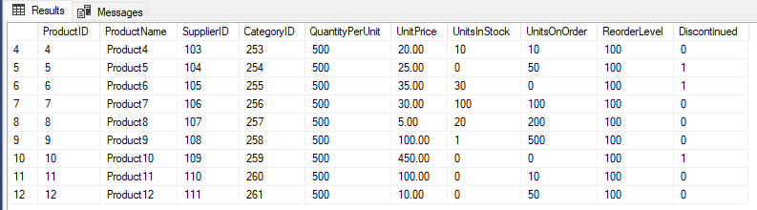

Q1. Write a query to get a Product list (id, name, unit price) where current products cost less than $20.

SELECT ProductID, ProductName, UnitPrice

FROM Products WHERE UnitPrice < 20;

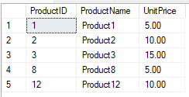

Q2. Write a query to get Product list (id, name, unit price) where products cost between $15 and $25.

SELECT ProductID, ProductName, UnitPrice

FROM Products WHERE UnitPrice BETWEEN 15 AND 25;

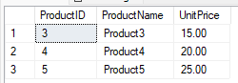

Q3. Write a query to get Product list (name, unit price) of above average price.

SELECT * FROM Products;

SELECT AVG(UnitPrice) AS PriceAverage FROM Products;

SELECT ProductName, UnitPrice

FROM Products WHERE UnitPrice > (SELECT AVG(UnitPrice) FROM Products);

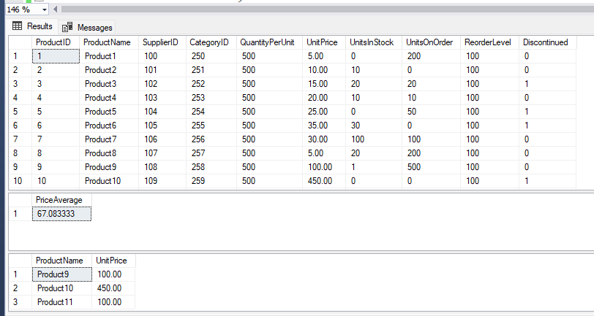

Q4. Write a query to get Product list (name, unit price) of ten most expensive products.

SELECT TOP 10 ProductName, UnitPrice

FROM Products

ORDER BY UnitPrice DESC

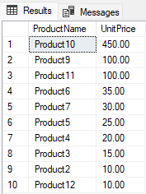

Q5. Write a query to count current and discontinued products

SELECT ProductName, UnitsOnOrder, UnitsInStock

FROM Products WHERE UnitsInStock < UnitsOnOrder;

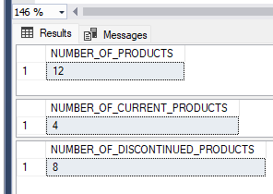

Q6. Write a query to get Product list (name, units on order , units in stock) of stock is less than the quantity on order.

SELECT ProductName, UnitsOnOrder, UnitsInStock

FROM Products WHERE UnitsInStock < UnitsOnOrder;

