-------------------------------------------------------------------------------------------------------------------------- Assignment 2 : Retrieve data using join with where clause -------------------------------------------------------------------------------------------------------------------------- Sample table1: salesman

-salesman_id

-name -city

-commission

-- Sample table2: customer

-customer_id

-cust_name

-city

-grade -salesman_id

-- Sample table3: orders

-ord_no

-purch_amt

-ord_date

-customer_id

-salesman_id

CREATE DATABASE Company_db;

USE Company_db;

CREATE TABLE salesman(

Salesman_id int IDENTITY(1,1) PRIMARY KEY,

Full_name varchar(50) DEFAULT 'anonymous',

City varchar(50) DEFAULT 'ahmedabad',

Commission decimal(5,2) DEFAULT 20

);

SELECT * FROM salesman;

CREATE TABLE customer(

Customer_id int IDENTITY(1,1) PRIMARY KEY,

Cust_name varchar(50) DEFAULT 'anonymous',

City varchar(50) DEFAULT 'ahmedabad',

Grade int,

Salesman_id int FOREIGN KEY REFERENCES salesman(Salesman_id)

);

SELECT * FROM customer;

CREATE TABLE orders (

Ord_no int IDENTITY(1,1) PRIMARY KEY,

Purch_amt decimal(10,2),

Ord_date date,

Customer_id int FOREIGN KEY REFERENCES customer(Customer_id),

Salesman_id int FOREIGN KEY REFERENCES salesman(Salesman_id)

);

SELECT * FROM orders;

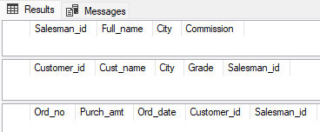

INSERT INTO salesman ( Full_name, Commission)

VALUES ('Person1',10),

('Person4',20),

('Person5',30);

INSERT INTO salesman ( Full_name, City,Commission)

VALUES ('Person2','junagadh',40),

('Person3','mumbai',50);

SELECT * FROM salesman;

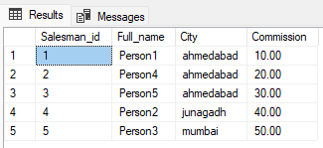

INSERT INTO customer ( CUST_name, City,grade, Salesman_id)

VALUES ('CUST1','ahmedabad',400,1),

('CUST2','mumbai',500,5),

('CUST3','ahmedabad',100,1),

('CUST4','kolkata',200,3),

('CUST5','ahmedabad',400,1),

('CUST6','junagadh',300,5),

('CUST7','anand',400,1),

('CUST8','mumbai',500,2),

('CUST9','ahmedabad',300,1),

('CUST10','mumbai',500,5);

INSERT INTO customer ( grade, Salesman_id)

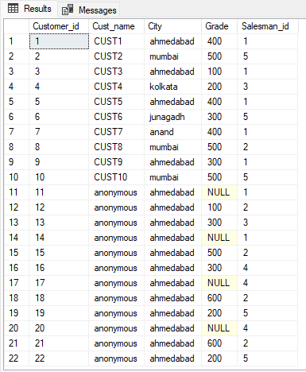VALUES (NULL,1),

(100,2),

(300,3),

(NULL,1),

(500,2),

(300,4),

(NULL,4),

(600,2),

(200,5),

(NULL,4),

(600,2),

(200,5);

SELECT * FROM customer;

INSERT INTO orders( Purch_amt, Ord_date, Customer_id, Salesman_id)

VALUES (200.00 ,'2023-01-01',22,5),

(1200.00,'2023-01-01',2,4),

(2200.00,'2023-01-02',21,5),

(2050.00,'2023-01-02',20,3),

(2005.00,'2023-01-03',1,1),

(7200.00,'2023-01-04',3,2),

(2900.00,'2023-01-05',12,2),

(2000.00,'2023-01-05',11,5),

(200.00 ,'2023-01-05',9,3),

(100.00 ,'2023-01-06',6,3),

(2200.00,'2023-01-07',10,5),

(200.00 ,'2023-01-08',8,1),

(2030.00,'2023-01-09',5,1),

(4200.00,'2023-01-10',4,1),

(9200.00,'2023-01-10',7,4),

(1000.00,'2023-01-11',8,5),

(800.00 ,'2023-01-12',10,5),

(3000.00,'2023-01-12',2,2),

(20.00 ,'2023-01-12',12,4),

(100.00 ,'2023-01-12',3,3),

(300.00 ,'2023-01-13',13,2),

(2000.00,'2023-01-13',15,3),

(600.00 ,'2023-01-13',14,1);

SELECT * FROM orders;

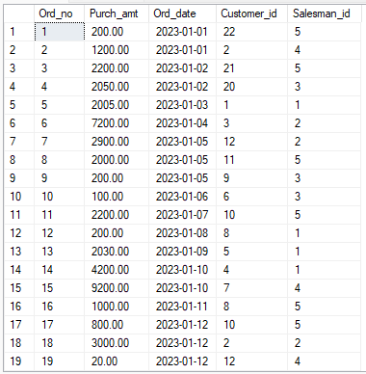

Q1 write a SQL query to find the salesperson and customer who reside in the same city. Return Salesman, cust_name and city.

SELECT Full_name as salesman, Cust_name as customer, customer.City as city

FROM customer INNER JOIN salesman

ON salesman.City = customer.City;

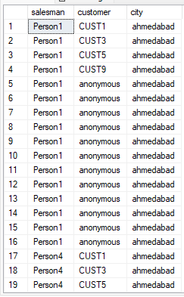

Q2 write a SQL query to find those orders where the order amount exists between 500 and 2000. Return ord_no, purch_amt, cust_name, city.

SELECT Ord_no, Purch_amt, Cust_name, customer.City as city

FROM orders INNER JOIN customer

ON orders.Customer_id = customer.Customer_id

WHERE Purch_amt > 2000;

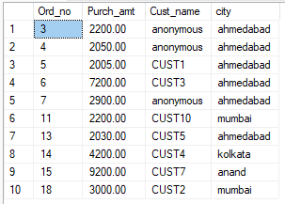

Q3 write a SQL query to find the salesperson(s) and the customer(s) he represents. Return Customer Name, city, Salesman, commission.

SELECT Cust_name as customer, customer.City as city,Full_name as salesman, Commission

FROM customer INNER JOIN salesman

ON salesman.Salesman_id = customer.Salesman_id;

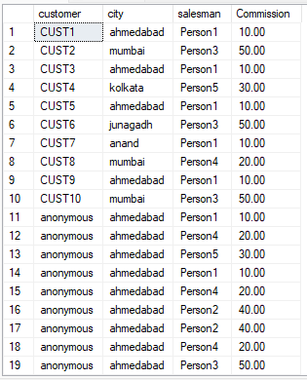

Q4 write a SQL query to find salespeople who received commissions of more than 12 percent from the company. Return Customer Name, customer city, Salesman, commission.

SELECT Cust_name as customer, customer.City as city,Full_name as salesman, Commission

FROM customer INNER JOIN salesman

ON salesman.Salesman_id = customer.Salesman_id

WHERE Commission > 12;

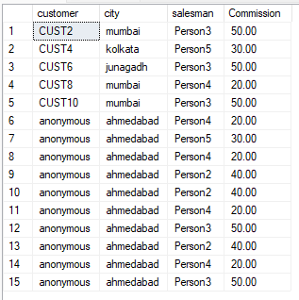

Q5 write a SQL query to locate those salespeople who do not live in the same city where their customers live and have received a commission of more than 12% from the company. Return Customer Name, customer city, Salesman, salesman city, commission.

SELECT Cust_name as customer, customer.City as customers_city,Full_name as salesman, salesman.City as salesmans_city,Commission

FROM customer INNER JOIN salesman

ON salesman.Salesman_id = customer.Salesman_id

WHERE salesman.City != customer.City AND Commission > 12;

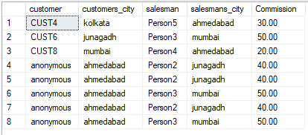

Q6 write a SQL query to find the details of an order. Return ord_no, ord_date, purch_amt, Customer Name, grade, Salesman, commission.

SELECT

Ord_no,

Ord_date,

Purch_amt,

Cust_name,

Grade,

Full_name as salesman,

Commission

FROM customer

JOIN salesman

ON salesman.Salesman_id = customer.Salesman_id

JOIN orders

ON orders.Customer_id = customer.Customer_id;

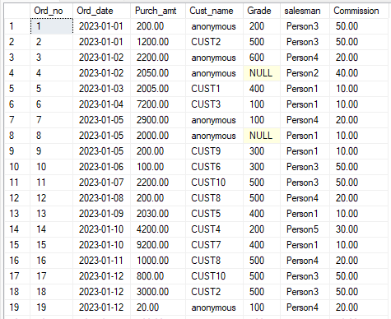

Q7 Write a SQL statement to join the tables salesman, customer and orders so that the same column of each table appears once and only the relational rows are returned.

SELECT

salesman.Salesman_id,

salesman.City,

customer.Customer_id,

Ord_no,

Purch_amt,

Ord_date,

Cust_name,

Grade,

Full_name as salesman,

Commission

FROM customer

JOIN salesman

ON salesman.Salesman_id = customer.Salesman_id

JOIN orders

ON orders.Customer_id = customer.Customer_id;

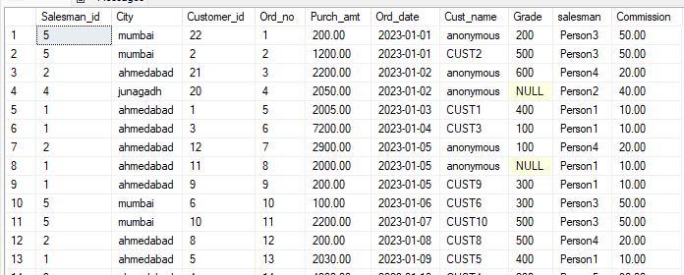

Q8 write a SQL query to display the customer name, customer city, grade, salesman, salesman city. The results should be sorted by ascending customer_id.

--The ORDER BY keyword sorts the records in ascending order by default.

SELECT Cust_name as customer, customer.City as customer_city,

Grade,Full_name as salesman, salesman.City as salesman_city

FROM customer INNER JOIN salesman

ON salesman.Salesman_id = customer.Salesman_id

ORDER BY Customer_id ASC;

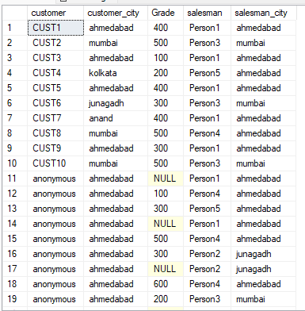

Q9 write a SQL query to find those customers with a grade less than 300. Return cust_name, customer city, grade, Salesman, salesmancity. The result should be ordered by ascending customer_id.

--The ORDER BY keyword sorts the records in ascending order by default.

SELECT Cust_name as customer, customer.City as customer_city,

Grade,Full_name as salesman, salesman.City as salesman_city

FROM customer INNER JOIN salesman

ON salesman.Salesman_id = customer.Salesman_id

WHERE Grade < 300

ORDER BY Customer_id ASC;

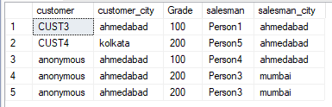

Q10 Write a SQL statement to make a report with customer name, city, order number, order date, and order amount in ascending order according to the order date to determine whether any of the existing customers have placed an order or not.

SELECT

Cust_name,

customer.City,

Ord_no,

Ord_date,

Purch_amt

FROM customer

LEFT JOIN orders

ON orders.Customer_id = customer.Customer_id

ORDER BY Ord_date ASC;

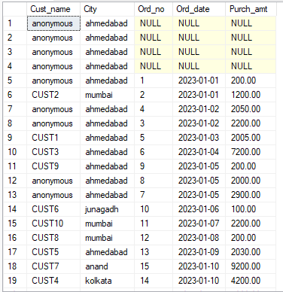

-- Additional Code

INSERT INTO orders

VALUES (200.00 , '2023-01-01',22,NULL),

(99999.99 ,'2023-01-02',20,NULL);

SELECT * FROM orders;

Q11 Write a SQL statement to generate a report with customer name, city, order number, order date, order amount, salesperson name, and commission to determine if any of the existing customers have not placed orders or if they have placed orders through their salesman or by themselves.

SELECT

Ord_no,

Ord_date,

Purch_amt,

Cust_name,

Grade,

Full_name as salesman,

Commission

FROM orders

LEFT JOIN salesman

ON salesman.Salesman_id = orders.Salesman_id

RIGHT JOIN customer

ON orders.Customer_id = customer.Customer_id

ORDER BY Ord_date ASC;

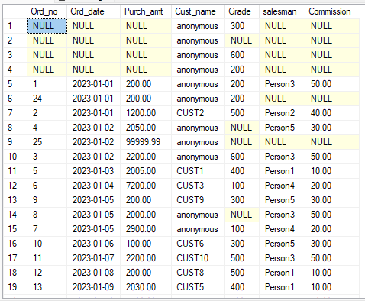

Q12 Write a SQL statement to generate a list in ascending order of salespersons who work either for one or more customers or have not yet joined any of the customers.

SELECT Full_name as salesman_name, Cust_name as customer_name

FROM salesman LEFT JOIN customer

ON salesman.Salesman_id = customer.Salesman_id

ORDER BY salesman.Full_name;

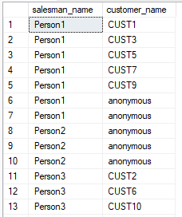

Q13 write a SQL query to list all salespersons along with customer name, city, grade, order number, date, and amount.

SELECT Full_name AS sales_person , Cust_name AS customer_name,

salesman.City, Grade, Ord_no, Ord_date,Purch_amt

FROM orders

JOIN customer

ON orders.Customer_id = customer.Customer_id

JOIN salesman

ON salesman.Salesman_id = orders.Salesman_id

ORDER BY Full_name ASC;

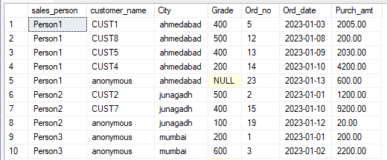

Q14 Write a SQL statement to make a list for the salesmen who either work for one or more customers or yet to join any of the customers. The customer may have placed, either one or more orders on or above order amount 2000 and must have a grade, or he may not have placed any order to the associated supplier.

SELECT Full_name AS sales_person , Cust_name AS customer_name,

salesman.City, Grade, Ord_no, Ord_date,Purch_amt

FROM salesman

JOIN customer

ON salesman.Salesman_id=customer.Salesman_id

JOIN orders

ON orders.Customer_id= customer.Customer_id

WHERE Purch_amt < 2000

UNION

SELECT Full_name AS sales_person , Cust_name AS customer_name,

salesman.City, Grade, Ord_no, Ord_date,Purch_amt

FROM salesman

JOIN customer

ON salesman.Salesman_id=customer.Salesman_id

JOIN orders

ON orders.Customer_id= customer.Customer_id

WHERE Purch_amt >= 2000

AND Grade IS NOT NULL;

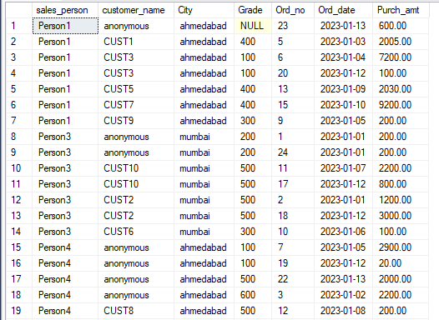

Q15 Write a SQL statement to generate a list of all the salesmen who either work for one or more customers or have yet to join any of them. The customer may have placed one or more orders at or above order amount 2000, and must have a grade, or he may not have placed any orders to the associated supplier.

SELECT Full_name AS sales_person , Cust_name AS customer_name,

salesman.City, Grade, Ord_no, Ord_date,Purch_amt

FROM salesman

JOIN customer

ON salesman.Salesman_id=customer.Salesman_id

JOIN orders

ON orders.Customer_id= customer.Customer_id

WHERE Purch_amt < 2000

UNION ALL

SELECT Full_name AS sales_person , Cust_name AS customer_name,

salesman.City, Grade, Ord_no, Ord_date,Purch_amt

FROM salesman

JOIN customer

ON salesman.Salesman_id=customer.Salesman_id

JOIN orders

ON orders.Customer_id= customer.Customer_id

WHERE Purch_amt >= 2000

AND Grade IS NOT NULL;

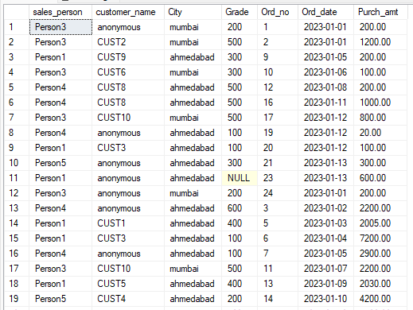

Q16 Write a SQL statement to generate a report with the customer name, city, order no. order date, purchase amount for only those customers on the list who must have a grade and placed one or more orders or which order(s) have been placed by the customer who neither is on the list nor has a grade.

SELECT Cust_name, City, Ord_no, Ord_date, Purch_amt

FROM customer

LEFT JOIN orders

ON customer.Customer_id = orders.Customer_id

WHERE Grade IS NOT NULL AND Ord_no IS NOT NULL

UNION

SELECT Cust_name, City, Ord_no, Ord_date, Purch_amt

FROM customer

LEFT JOIN orders

ON customer.Customer_id = orders.Customer_id

WHERE Grade IS NULL AND Ord_no IS NULL;

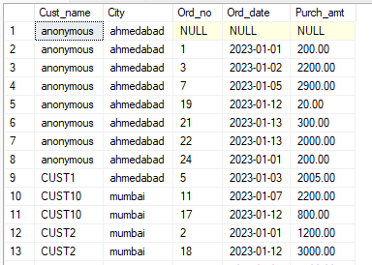

Q17 Write a SQL query to combine each row of the salesman table with each row of the customer table.

SELECT * FROM salesman CROSS JOIN customer;

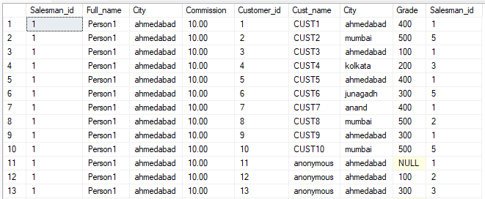

Q18 Write a SQL statement to create a Cartesian product between salesperson and customer, i.e. each salesperson will appear for all customers and vice versa for that salesperson who belongs to that city.

SELECT *

FROM salesman

CROSS JOIN customer

WHERE salesman.City IS NOT NULL;

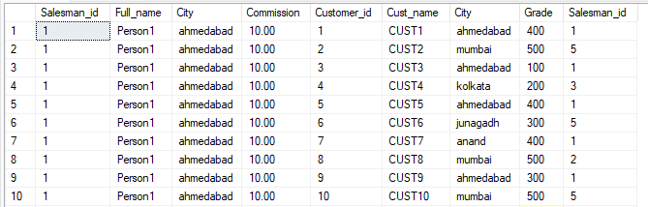

Q19 Write a SQL statement to create a Cartesian product between salesperson and customer, i.e. each salesperson will appear for every customer and vice versa for those salesmen who belong to a city and customers who require a grade.

SELECT *

FROM salesman

CROSS JOIN customer

WHERE salesman.City IS NOT NULL

AND Grade IS NOT NULL;

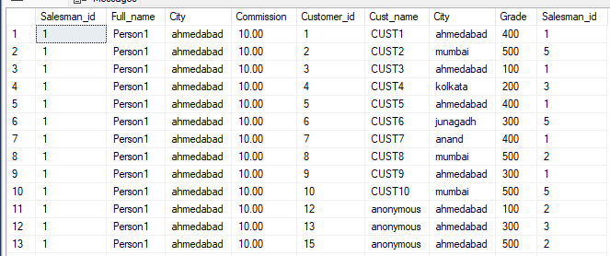

Q20 Write a SQL statement to make a Cartesian product between salesman and customer i.e. each salesman will appear for all customers and vice versa for those salesmen who must belong to a city which is not the same as his customer and the customers should have their own grade.

SELECT *

FROM salesman

CROSS JOIN customer

WHERE salesman.City != customer.City

AND Grade IS NOT NULL;

