-------------------------------------------------------------------------------------------------------------------------- Assignment 4 : Create Stored procedure in Northwind database to insert or update a record in a table --------------------------------------------------------------------------------------------------------------------------

NorthWind database

https://raw.githubusercontent.com/microsoft/sql-server-samples/master/samples/databases/northwind-pubs/instnwnd.sql

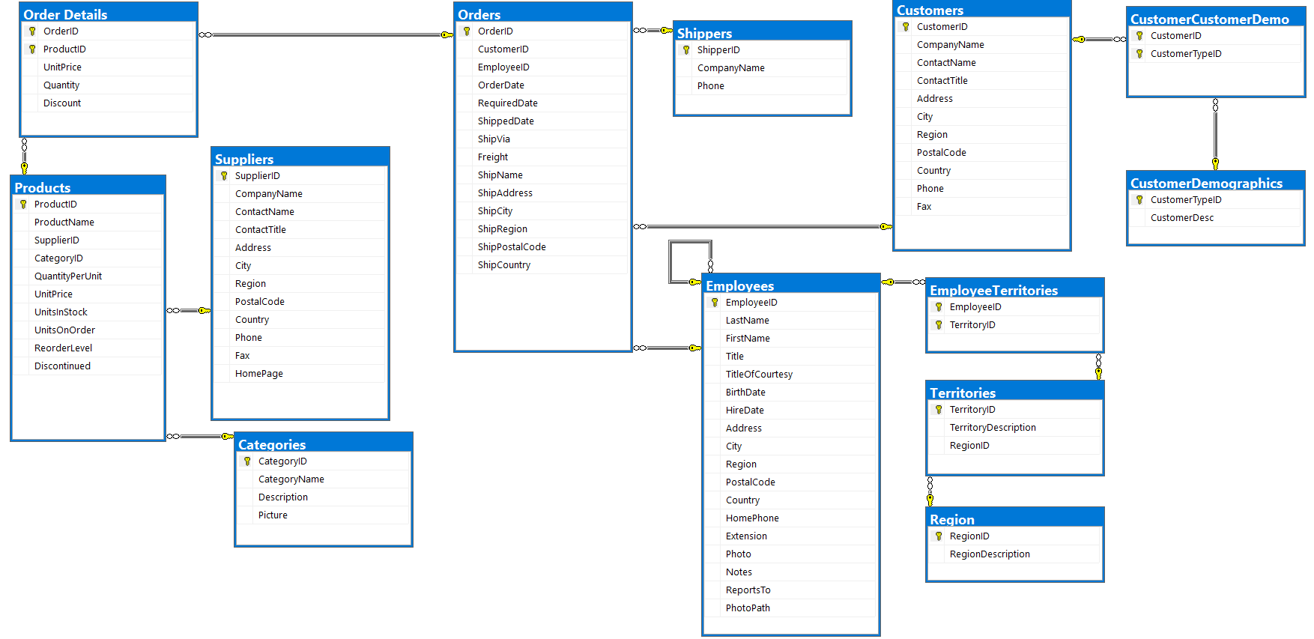

Q1 Create a stored procedure in the Northwind database that will calculate the average value of Freight for a specified customer.
Then, a business rule will be added that will be triggered before every Update and Insert command in the Orders controller, and will use the stored procedure to verify that the Freight does not exceed the average freight. If it does, a message will be displayed and the command will be canceled.

SELECT * FROM Orders;

CREATE PROCEDURE Freight_customer_avg
@CustomerID NCHAR(5)
AS
BEGIN
SELECT CustomerID, AVG(Freight) AS AVG_Freight
FROM Orders
GROUP BY CustomerID
HAVING CustomerID = @CustomerID;
END
GO

Freight_customer_avg 'BOLID';

DROP PROCEDURE Freight_customer_avg;

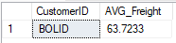

Q2 write a SQL query to Create Stored procedure in the Northwind database to retrieve Employee Sales by Country.

CREATE PROCEDURE Sales_by_country
AS
BEGIN
SELECT Orders.EmployeeID, COUNT(Customers.CustomerID) AS NUMBER_OF_SALES
FROM Orders
JOIN Employees
ON Employees.EmployeeID = Orders.EmployeeID
JOIN Customers
ON Customers.CustomerID = Orders.CustomerID
GROUP BY Orders.EmployeeID
ORDER BY Orders.EmployeeID
END
GO

Sales_by_country
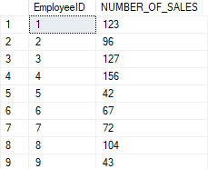

CREATE PROCEDURE Sales_by_country
@EmployeeID INT
AS
BEGIN
SELECT Orders.EmployeeID, COUNT(Customers.CustomerID) AS NUMBER_OF_SALES
FROM Orders
JOIN Employees
ON Employees.EmployeeID = Orders.EmployeeID
JOIN Customers
ON Customers.CustomerID = Orders.CustomerID
GROUP BY Orders.EmployeeID
HAVING Orders.EmployeeID = @EmployeeID;
END
GO

Sales_by_country 1
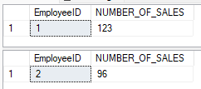
GO
Sales_by_country 2
GO

Q3 write a SQL query to Create Stored procedure in the Northwind database to retrieve Sales by Year.

CREATE PROCEDURE Sales_by_year
@Orderyear INT
AS
BEGIN
SELECT @Orderyear AS "Order Year" , (SELECT COUNT(YEAR(OrderDate)) FROM Orders WHERE YEAR(OrderDate) = YEAR(Orders.OrderDate)) AS "Sales";
END
GO
Sales_by_year 1996;
DROP PROCEDURE Sales_by_year;

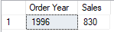

Q4 write a SQL query to Create Stored procedure in the Northwind database to retrieve Sales By Category.

CREATE PROCEDURE Sales_by_categories
AS
BEGIN
SELECT Products.CategoryID, COUNT(OrderID) AS "Sales"
FROM Categories
JOIN Products
ON Products.CategoryID = Categories.CategoryID
JOIN [Order Details]
ON [Order Details].ProductID = Products.ProductID
GROUP BY Products.CategoryID;
END
GO

Sales_by_categories

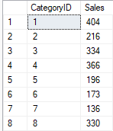

Q5. write a SQL query to Create Stored procedure in the Northwind database to retrieve Ten Most Expensive Products.

CREATE PROCEDURE Ten_Most_Expensive_Products
AS
BEGIN
SELECT TOP 10 ProductName, UnitPrice
FROM Products
ORDER BY UnitPrice DESC;
END
GO
Ten_Most_Expensive_Products;

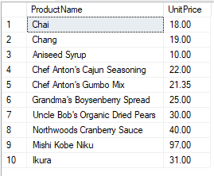

Q6. write a SQL query to Create Stored procedure in the Northwind database to insert Customer Order Details.

CREATE PROCEDURE INSERT_ORDER_DETAILS
@OrderID INT,
@ProductID INT,
@UnitPrice MONEY,
@Quantity SMALLINT,
@Discount REAL
AS
BEGIN
INSERT INTO [Order Details]
VALUES (@OrderID, @ProductID, @UnitPrice, @Quantity, @Discount);
END
GO

INSERT_ORDER_DETAILS 10254,12, 15, 13, 0.05;

Q7. write a SQL query to Create Stored procedure in the Northwind database to update Customer Order Details.

CREATE PROCEDURE UPDATE_ORDER_DETAILS
@OrderID INT,
@UnitPrice MONEY,
@Quantity SMALLINT,
@Discount REAL
AS
BEGIN
UPDATE [Order Details]
SET UnitPrice = @UnitPrice,
Quantity = @Quantity,
Discount = @Discount
WHERE OrderID = @OrderID;
END
GO
DROP PROCEDURE UPDATE_ORDER_DETAILS;

UPDATE_ORDER_DETAILS 10254, 13, 13, 0.05;

