-------------------------------------------------------------------------------------------------------------------------- Assignment 3 : Retrieve data using Group By clause -------------------------------------------------------------------------------------------------------------------------- Sample table1:Department
-dept_id
-dept_name

Sample table2: Employee
-emp_id
-dept_id
-mngr_id
-emp_name
-salary

CREATE DATABASE COMPANY;
USE COMPANY;
CREATE TABLE DEPARTMENT (
DEPT_ID INT IDENTITY(1,1) PRIMARY KEY,
DEPT_NAME VARCHAR(25)
);
CREATE TABLE EMPLOYEE (
EMP_ID INT IDENTITY(1,1) PRIMARY KEY,
DEPT_ID INT FOREIGN KEY REFERENCES DEPARTMENT(DEPT_ID),
MNGR_ID INT,
EMP_NAME VARCHAR(25) DEFAULT 'INTERN',
SALARY DECIMAL(10,2) DEFAULT 330000 -- MINIMUM WAGES lpa
);

INSERT INTO DEPARTMENT (DEPT_NAME)
VALUES ('PHP'),
('JAVA'),
('.NET');

INSERT INTO EMPLOYEE (DEPT_ID, MNGR_ID,EMP_NAME,SALARY)
VALUES (1,1,'EMP1',440000),
(2,1,'EMP2',440000),
(1,2,'EMP3',440000),
(3,1,'EMP4',440000),
(3,1,'EMP5',440000),
(1,2,'EMP6',440000),
(1,1,'EMP7',550000),
(3,1,'EMP8',550000),
(1,1,'EMP9',550000),
(2,1,'EMP10',660000),
(2,1,'EMP11',660000),
(2,2,'EMP12',1200000),
(2,2,'EMP13',550000),
(1,1,'EMP14',440000),
(3,1,'EMP15',330000),
(2,2,'EMP16',330000),
(3,1,'EMP17',100000);

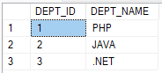

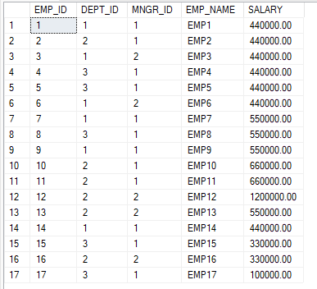

Q1. write a SQL query to find Employees who have the biggest salary in their Department.

SELECT DEPT_ID, MAX(SALARY) AS EMPLOYEE_SALARY
FROM EMPLOYEE
GROUP BY DEPT_ID;

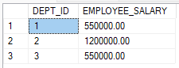

DELETE FROM EMPLOYEE
WHERE EMP_ID = 5;
SELECT * FROM EMPLOYEE;

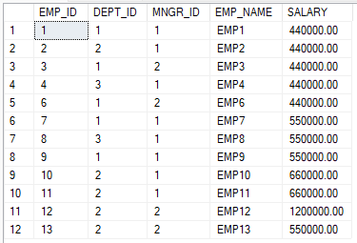

Q2. write a SQL query to find Departments that have less than 3 people in it.

SELECT DEPT_ID, COUNT(DEPT_ID)
FROM EMPLOYEE
GROUP BY DEPT_ID
HAVING COUNT(DEPT_ID) < 3;

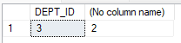

Q3. write a SQL query to find All Department along with the number of people there.

SELECT DEPT_ID, COUNT(*) AS EMPLOYEE_COUNT
FROM EMPLOYEE
GROUP BY DEPT_ID;
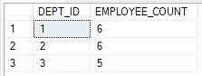

Q4. write a SQL query to find All Department along with the total salary there.

SELECT DEPT_ID, SUM(SALARY) AS EMPLOYEE_SALARY
FROM EMPLOYEE
GROUP BY DEPT_ID;
