FastAPI

⚡ 1. FastAPI Fundamentals
🔹 What is FastAPI?
- Modern Python web framework for APIs
- Built on:
  - Starlette → web handling
  - Pydantic → validation

2. Request Handling & Validation (VERY IMPORTANT)
🔹 Why Important?
- Auto validation
- Clean API contracts
- Prevents bad data

🔁 3. Async Programming (Core Advantage)
- FastAPI is async-first

🔹 When to use async?
- DB calls
- External APIs
- File handling
🔹 When NOT needed?
- CPU-heavy tasks (use background workers instead)
🧩 4. Dependency Injection (Game-Changer)
🔹 Use Cases
- DB connections
- Auth
- Shared logic
🗄️ 5. Database Integration
🔹 Options
- SQL: PostgreSQL, MySQL
- NoSQL: MongoDB

🔐 6. Authentication & Security
🔹 Common Methods
- JWT (most used)
- OAuth2
- API Keys

🔹 Example (JWT Flow)
- User logs in
- Server returns token
- Token used in requests

🔹 FastAPI Tools
- OAuth2PasswordBearer
- Depends()

7. Background Task

8. Middleware
9. API testing

Folder Structure(only-for-Routes)
app/
├── main.py
├── routers/
├── models/
├── schemas/
├── services/
├── db/
└── core/

  - FastAPI Fundamentals
What is FastAPI? (Simple Understanding)
👉 FastAPI = Tool to build APIs using Python
- You write Python functions
- FastAPI converts them into APIs
- Users can call them using HTTP (GET, POST, etc.)

🧠 1. What is Async Programming?
👉 Async = Do multiple things at the same time without waiting
🔹 Real-life Example
Imagine:
- You order food 🍔
- Instead of standing at the counter doing nothing
- You go sit, scroll phone, talk
👉 That’s async
🔹 Opposite (Sync)
- You order food
- You stand there and wait
- Do nothing else
👉 That’s synchronous

⚙️ 2. Synchronous vs Asynchronous (Core Difference)
🔴 Synchronous (Blocking)
def task():
print("Start")
time.sleep(5) # waits
print("End")
👉 Problem:
- It blocks everything
- No other request handled

🟢 Asynchronous (Non-blocking)

import asyncio
async def task():
print("Start")
await asyncio.sleep(5) # doesn't block
print("End")
👉 Advantage:
- While waiting → other tasks run

🔥 3. Key Concept (Very Important)
👉 await = “Pause here, but let others run”
👉 async def = “This function supports async behavior”

🧠 4. When Should You Use Async?
Use async when you have:
✅ API calls
✅ Database calls
✅ File reading/writing
✅ Network operations

❌ Don’t use async for:
- Heavy CPU tasks (ML training, image processing)
👉 Use multiprocessing / Celery instead

⚡ Async vs Threading vs Multiprocessing
Type | Use Case
Async | I/O (API, DB, file)
Threading | Light parallel
Multiprocessing | Heavy CPU (ML, image processing)

Authentication

• Who are you? → Authentication
• What can you access? → Authorization
• How do we track you safely? → Tokens / Sessions

1. Middleware — the bouncer at the door
Every request hits your middleware before it reaches your route. Think of it as a hallway every visitor must walk through.
Your current middleware just logs timing. But middleware can do so much more:

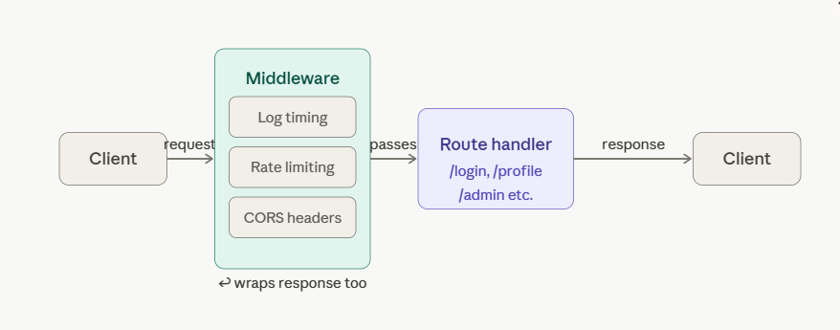

Your call_next(request) is the key — everything before it runs on the way in, everything after runs on the way out.

2. JWT — a self-contained ID card
Forget sessions stored on a server. JWT (JSON Web Token) is like a signed ID card you carry yourself.
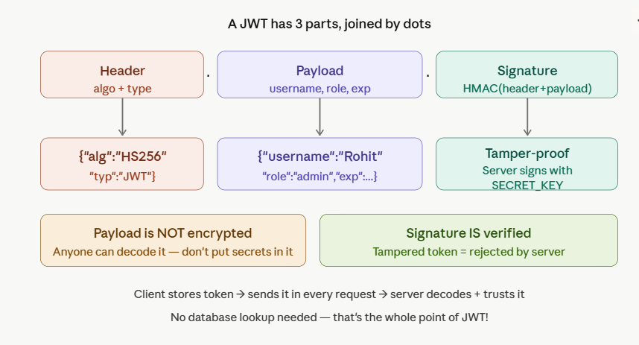

The flow in your code is exactly right — create_token encodes, decode_token verifies the signature, and if anyone tampers with the payload the signature won't match, so it's rejected.

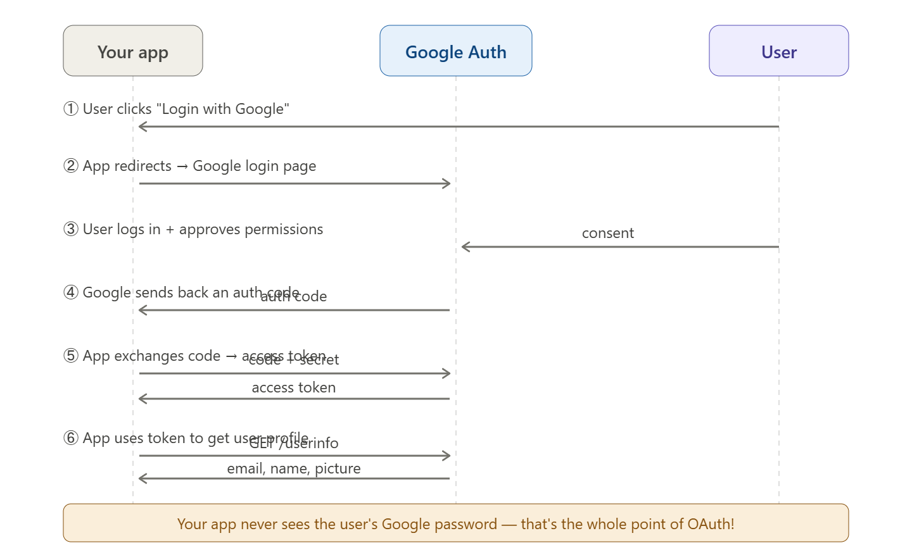

Your simulated /oauth/callback skips steps 1-5 and just fakes the Google response. In a real app you'd use a library like authlib to handle that dance.

