1. **what is the difference between UI and UX? Explain in your own words.**

**Ans.** UX design is all about identifying and solving user problems; UI design is all about creating intuitive, aesthetically-pleasing, interactive interfaces.

UX design usually comes first in the product development process, followed by UI. The UX designer maps out the bare bones of the user journey; the UI designer then fills it in with visual and interactive elements.

UX can apply to any kind of product, service, or experience; UI is specific to digital products and experiences.

1. **what is a frontend developer? Explain the roles and responsibilities in your own words.**

**Ans.** A front-end developer creates websites and applications using web languages such as HTML, CSS, and JavaScript that allow users to access and interact with the site or app. When you visit a website, the design elements you see were created by a front-end developer.

**Responsibilities**

* Use markup languages like HTML to create user-friendly web pages.
* Maintain and improve website.
* Optimize applications for maximum speed.
* Design mobile-based features.
* Collaborate with back-end developers and web designers to improve usability.
* Get feedback from, and build solutions for, users and customers.

1. **who is a backend developer? Explain the roles and responsibilities in your own words.**

**Ans.** Back-end development means working on server-side software, which focuses on everything you can’t see on a website. Back-end developers ensure the website performs correctly, focusing on databases, back-end logic, application programming interface (APIs), architecture, and servers. They use code that helps browsers communicate with databases, store, understand, and delete data.

On a team, back-end developers collaborate with front-end developers, product managers, principal architects, and website testers to build the structure of a website or mobile app. Back-end developers must be familiar with many kinds of tools and frameworks, including languages such as Python, Java, and Ruby. They make sure the back-end performs quickly and responsively to front-end user requests.

Responsibilities

* Participate in the entire application lifecycle, focusing on coding and debugging
* Write clean code to develop functional web applications
* Troubleshoot and debug applications
* Perform UI tests to optimize performance
* Manage cutting-edge technologies to improve legacy applications

1. **Create your own GitHub & LinkedIn accounts. share the screenshot of both of your accounts and share your profile links of GitHub & LinkedIn in the solution.**

**Ans. GitHub link: https://github.com/Rohit-pawar52**

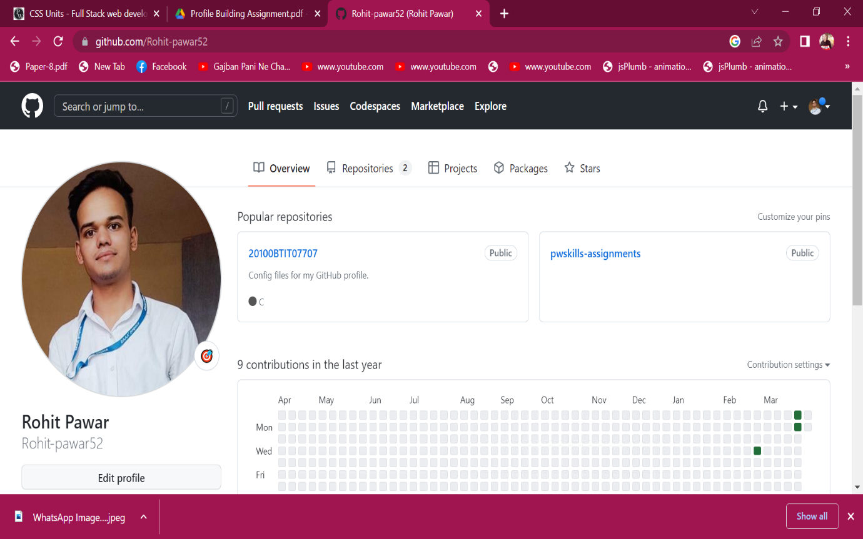

**LinkedIn link:** [**https://www.linkedin.com/in/rohit-pawar-63a52a1b9**](https://www.linkedin.com/in/rohit-pawar-63a52a1b9)

