**SHRI VAISHNAV VIDYAPEETH VISHWAVIDYALAYA**

Think Excellence. Live Excellence.

**SHRI VAISHNAV INSTITUTE OF INFORMATION TECHNOLOGY**

***Department of Information Technology***

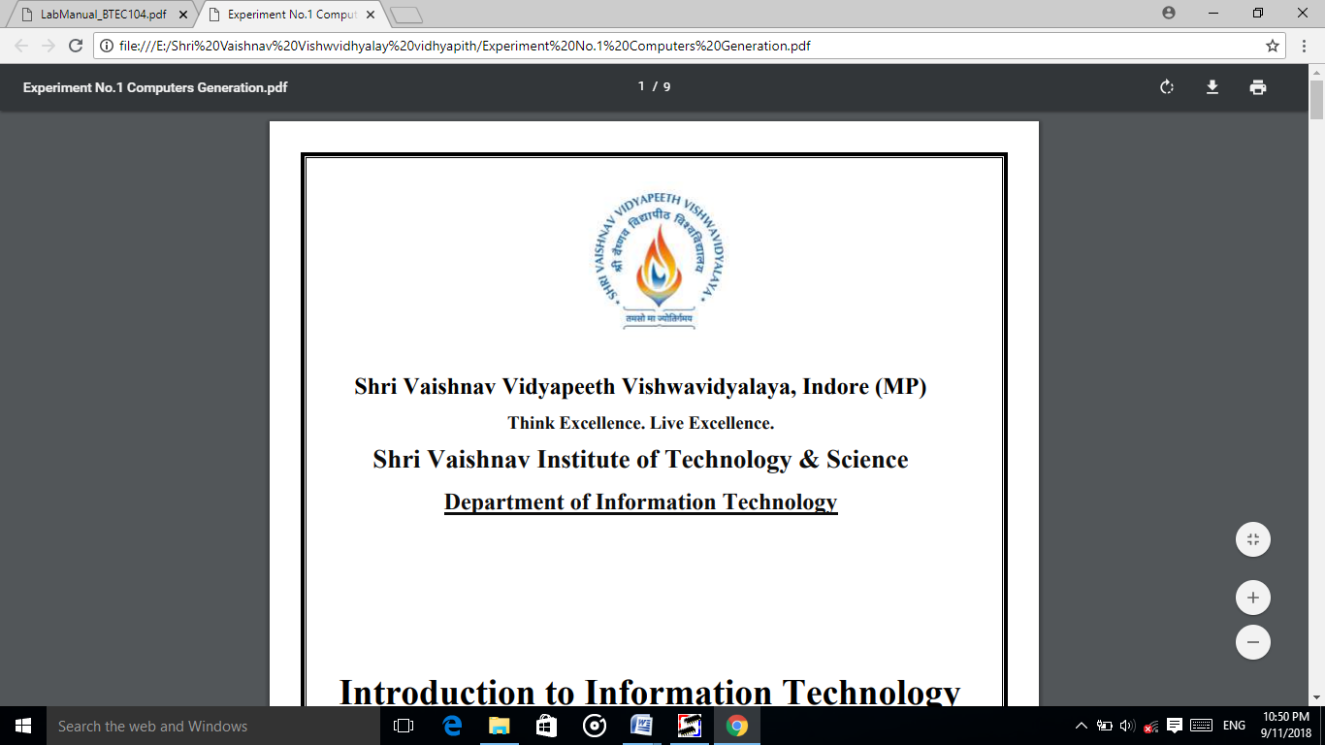

**Python Lab (BTCS407)**

**LAB File**

**Submitted To : Prof. Dinesh Patel**

**Submitted By: Rohit Pawar**

**1810DMTIT04475**

**IT ‘C’**

**CONTENTS**

|  |  |  |
| --- | --- | --- |
| **Sr. No.** | **List of Programs** | **Page No.** |
| 1. | Introduction of Python   * Introduction * History of Python * Features * Installation Process |  |
| 2. | Write a program to demonstrate basic data type in python. |  |
| 3. | Write a program to demonstrate the working of ‘id’ and ‘type’ functions. |  |
| 4. | Write a program to find GCD of two numbers. |  |
| 5. | Write a program to compute distance between two points taking input from the user (Pythagorean Theorem). |  |
| 6. | Write a python Program to find the square root of a number taking input from user (Newton’s Method). |  |
| 7. | Write a program add.py that takes 2 numbers as command line arguments and perform their sum. |  |
| 8. | Write a program to purposefully raise Indentation Error and Correct it. |  |
| 9. | Write a program to find the maximum from a list of numbers. |  |
| 10. | Write aprogram to find all prime numbers within a given range. |  |
| 11. | Write a program to count the numbers of characters in the string and store them in a dictionary data structure. |  |
| 12. | Write a program to multiply matrices using function. |  |
| 13. | Write aprogram to print n terms of Fibonacci seriesusing iteration |  |
| 14. | Write a Python Program to perform Linear Search |  |
| 15. | Write a Python Program to perform Binary Search |  |
| 16. | Write a program to implement following sorting algorithms   * Selection Sort * Insertion Sort * Merge Sort. |  |
| 17. | Write a program to compute the number of characters, words and lines in a file. |  |
| 18. | Write aprogram to implement stack using list. |  |
| 19. | Write aprogram to implement queue using list. |  |
| 20. | Write a program to demonstrate working of classes andobjects. |  |

**Pratical-1**

## Introduction Of python

* **Introduction**

Python is a simple, general purpose, high level, and object-oriented programming language. Python is an interpreted scripting language also. *Guido Van Rossum* is known as the founder of Python programming.

Python programming language (latest Python 3) is being used in web development, Machine Learning applications, along with all cutting edge technology in Software Industry.

Python is a programming language that lets you work quickly and integrate systems more efficiently. There are two major Python versions: **Python 2 and Python 3**. Both are quite different.

* **History of Python**

Python was invented by **Guido van Rossum** in 1991 at CWI in Netherland. The idea of Python programming language has taken from the ABC programming language or we can say that ABC is a predecessor of Python language.

There is also a fact behind the choosing name Python. Guido van Rossum was a fan of the popular BBC comedy show of that time, **"Monty Python's Flying Circus"**. So he decided to pick the name **Python** for his newly created programming language.

Python has the vast community across the world and releases its version within the short period.

* **Features**

1. **Easy to Learn andUse**

Python is easy to learn as compared to other programming languages. Its syntax is straightforward and much the same as the English language. There is no use of the semicolon or curly-bracket, the indentation defines the code block. It is the recommended programming language for beginners.

1. **ExpressiveLanguage**

Python can perform complex tasks using a few lines of code. A simple example, the hello world program you simply type **print("Hello World")**. It will take only one line to execute, while Java or C takes multiple lines.

1. **InterpretedLanguage**

Python is an interpreted language; it means the Python program is executed one line at a time. The advantage of being interpreted language, it makes debugging easy and portable.

1. **Cross-platformLanguage**

Python can run equally on different platforms such as Windows, Linux, UNIX, and Macintosh, etc. So, we can say that Python is a portable language. It enables programmers to develop the software for several competing platforms by writing a program only once.

1. **Free and OpenSource**

Python is freely available for everyone. It is freely available on its official website [www.python.org](https://www.python.org/). It has a large community across the world that is dedicatedly working towards make new python modules and functions. Anyone can contribute to the Python community. The open-source means, "Anyone can download its source code without paying any penny."

1. **Object-OrientedLanguage**

Python supports object-oriented language and concepts of classes and objects come into existence. It supports inheritance, polymorphism, and encapsulation, etc. The object-oriented procedure helps to programmer to write reusable code and develop applications in less code.

1. **Extensible**

It implies that other languages such as C/C++ can be used to compile the code and thus it can be used further in our Python code. It converts the program into byte code, and any platform can use that byte code.

* + **Installation ofPython**

Visit the link [*https://www.python.org/downloads/*](https://www.python.org/downloads/) to download the latest release of [Python](https://www.javatpoint.com/python-tutorial). In this process, we will install Python 3.8.6 on our [Windows operating system](https://www.javatpoint.com/windows). When we click on the above link, it will bring us the following page.

* + **Step - 1: Select the Python's version todownload.**
  + click on the download button.

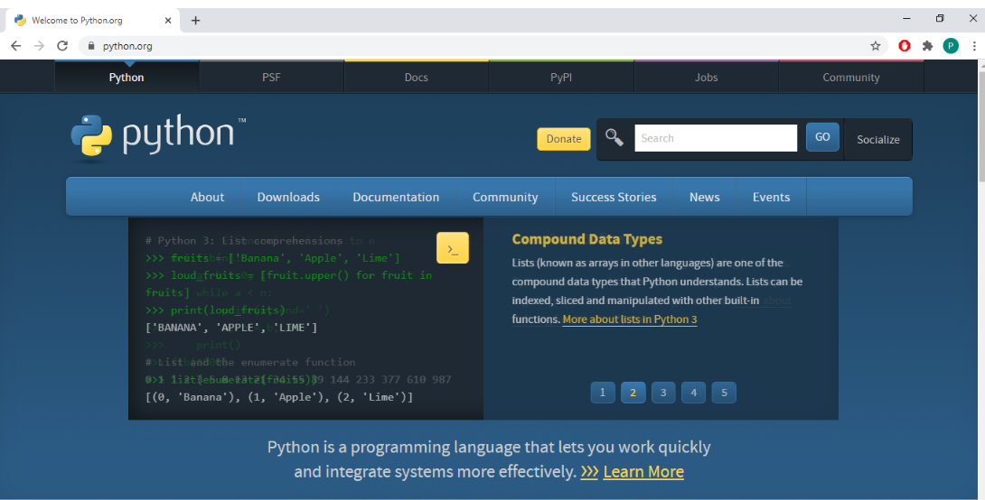

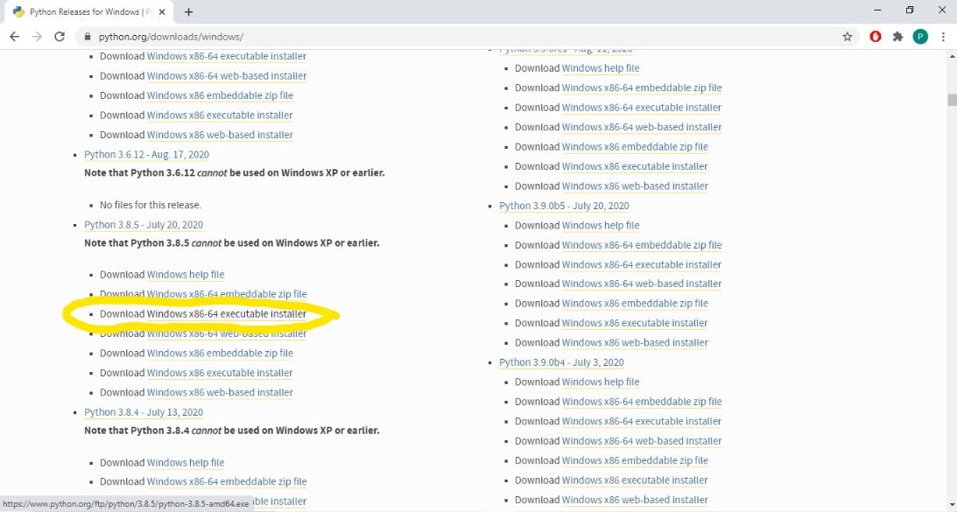

* + **Step - 2: Click on the InstallNow**
  + Double-click the executable file, which is downloaded; the following window will open. Select Customize installation and proceed. Click on the Add Path check box, it will set the Python path automatically.

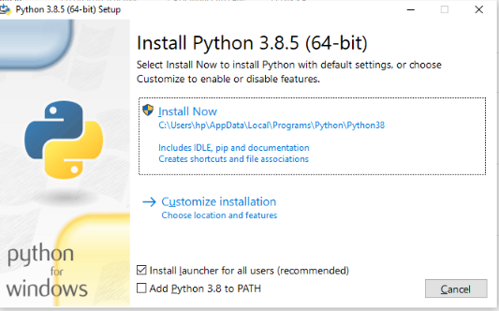

* + We can also click on the customize installation to choose desired location and features.Other important thing is install launcher for the all user must bechecked.
  + **Step - 3 Installation inProcess**

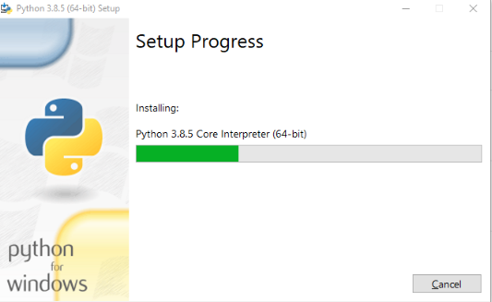

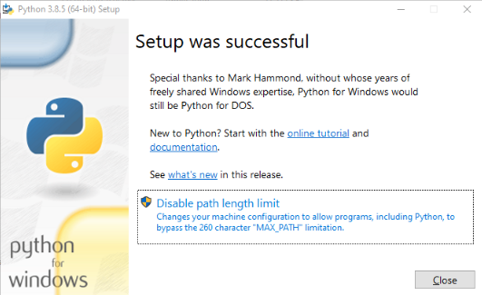

Now, try to run python on the command prompt. Type the command python -version in case of python3.

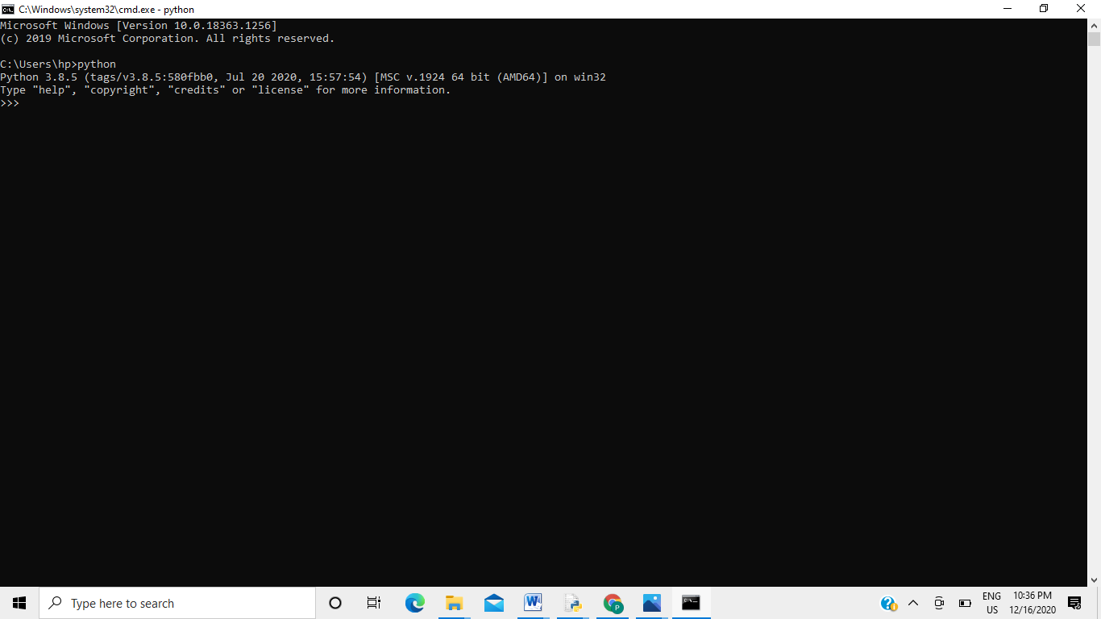

We are ready to work with thePython.

**Practical 2**

**Write a program to demonstrate basic data type in python.**

**Aim:** Write a program to demonstrate basic data type in python.

**Parameter-:** a,n

**Program**

#int ,float data type

a=int(input("Enter no:"))

b=int(a)

c=float(a)

print(a,"in integer form:",b)

print(a,"in float form",c)

#list data type

lst=[]

n=int(input("Enter the length of the list:"))

for i in range(0,n):

x=int(input("Enter value:"))

lst.append(x)

print("List is:")

print(lst)

#String data type

String1 = 'Welcome everyone'

print("String with the use of Single Quotes: ")

print(String1)

String1 = "Hello "

print("\nString with the use of Double Quotes: ")

print(String1)

String1 = '''SVVV "Student"'''

print("\nString with the use of Triple Quotes: ")

print(String1)

String1 = '''Students Studying

in SVVV'''

print("\nCreating a multiline String: ")

print(String1)

#set data type

set1 = set([1, 2, 4, 4, 3, 3, 3, 6, 5])

print("\nSet with the use of Numbers: ")

print(set1)

set1 = set([1, 2, 'Hello', 4, 'SVVV', 6, 'Students'])

print("\nSet with the use of Mixed Values")

print(set1)

# dictionary data type

Dict = {}

print("Empty Dictionary: ")

print(Dict)

Dict = dict({1: 'AAA', 2: 'BBB', 3:'CCC'})

print("\nDictionary with the use of dict(): ")

print(Dict)

Dict = dict([(1, 'Hello'), (2, 'World')])

print("\nDictionary with each item as a pair: ")

print(Dict)

#tupule data type

tuple1 = (0, 1, 2, 3)

tuple2 = ('Hello', 'world')

print("Concatenation of two tuples:")

print(tuple1 + tuple2)

**FILE -:**

2DataType.py

**Output**

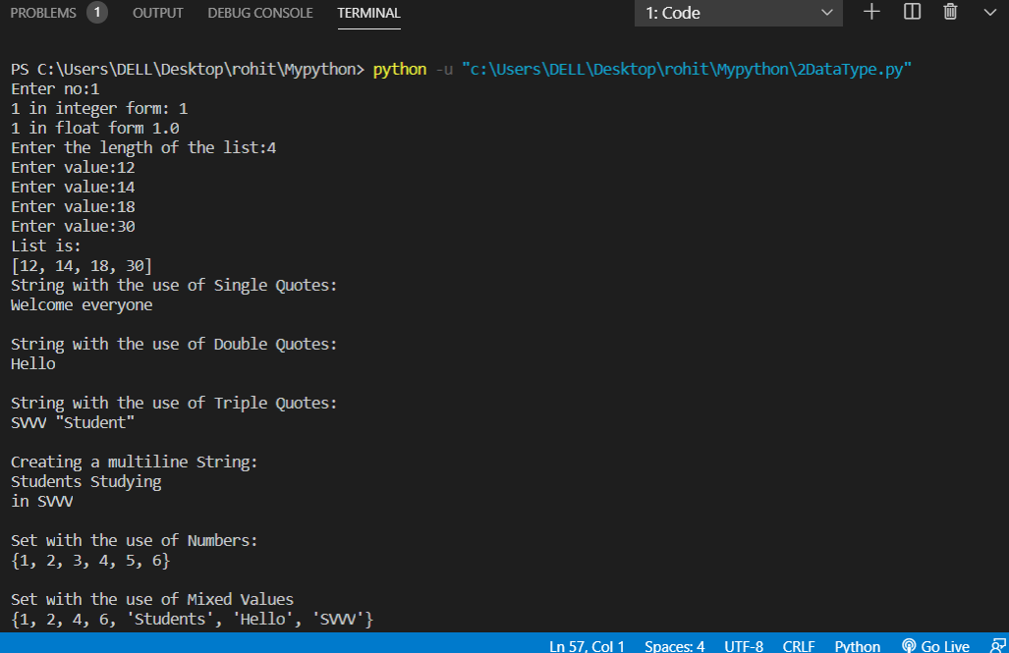

**PRACTICAL 3**

**Write a program to demonstrate basic data type in python.**

**Aim:** Write a program to demonstrate basic data type in python

**Parameter:**

**Program:**

#id() function return the Memory Address of variable

a="rohit"

b="rohit"

print("Address of a",id(a))

print("Address of b",id(b))

if(id(a)==id(b)):

print("Same memory block is Shared by a and b var")

#type() it is used to identify which type of data is contained by the variable

c=[]

d={}

e=()

f=10

g=10.0

print(type(a))

print(type(b))

print(type(c))

print(type(d))

print(type(e))

print(type(f))

print(type(g))

**File-:**

3IDtype.py

**Output**

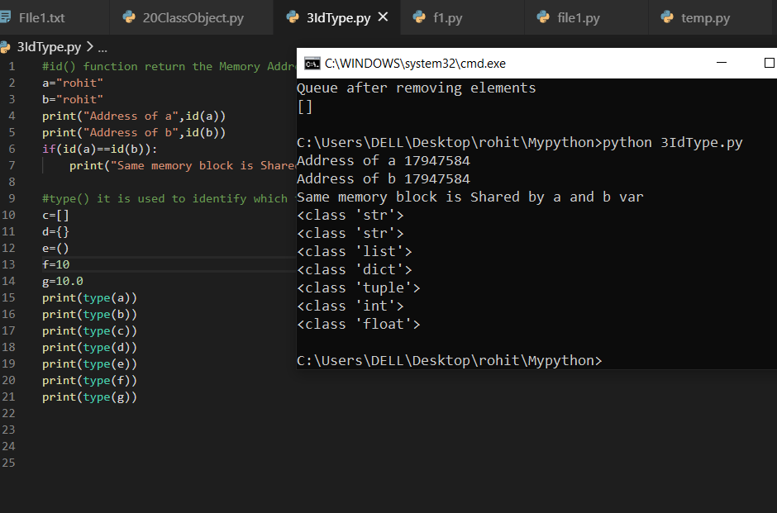

**PRACTICAL 4**

**Write a program to find GCD of two numbers.**

**Aim:** Write a program to find GCD of two numbers.

**Parameter:** a,b

**Program:**

def gcd(a,b):

if (a==0) :

return b

return gcd(b%a,a);

#Taking input

a=int(input("Enter two number for GCD->"))

b=int(input("Enter two number for GCD->"))

#calling gcd() function and printing ans

ans=gcd(a,b)

print("Gcd of",a,"&", b,"is = ",ans)

**FILE:-** 4Gcd.py

**OUTPUT-:**

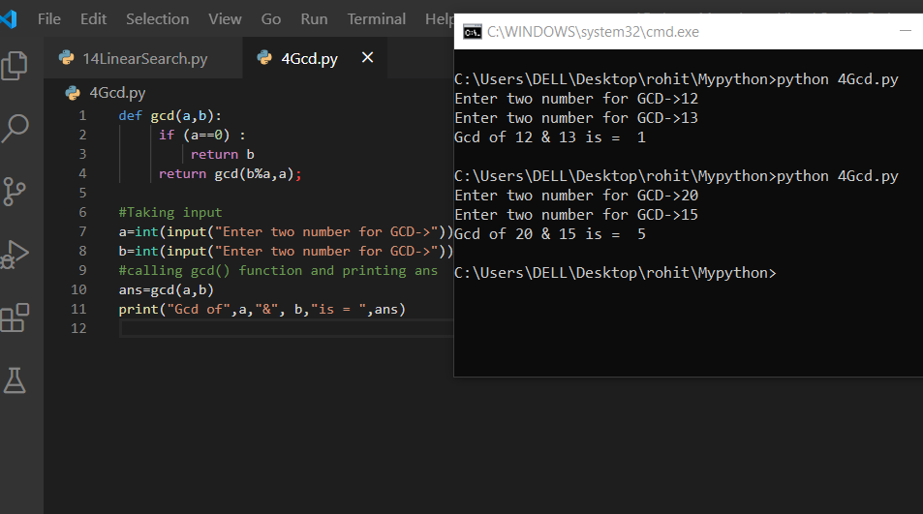

**PRACTICAL 5**

**Write a program to compute distance between two points taking input from the user (Pythagorean Theorem).**

**Aim:** Write a program to compute distance between two points taking input from the user (Pythagorean Theorem).

**Parameter**  x1,x2,y1,y2

**Program**

#distance=((x2-x1)^2 + (y2-y1)^2 )^(1/2)

import math

#taking input x1,y1,x2,y2

x1=int(input("Enter x1 and y1 ->"))

y1=int(input())

x2=int(input("Enter x2 and y2 ->"))

y2=int(input())

#print(x1,y1,x2,y2)

a=x2-x1

b=y2-y1

distance=math.sqrt(a**2 +b**2)

print(distance)

**File:-**

5pythogores.py

**Output-:**

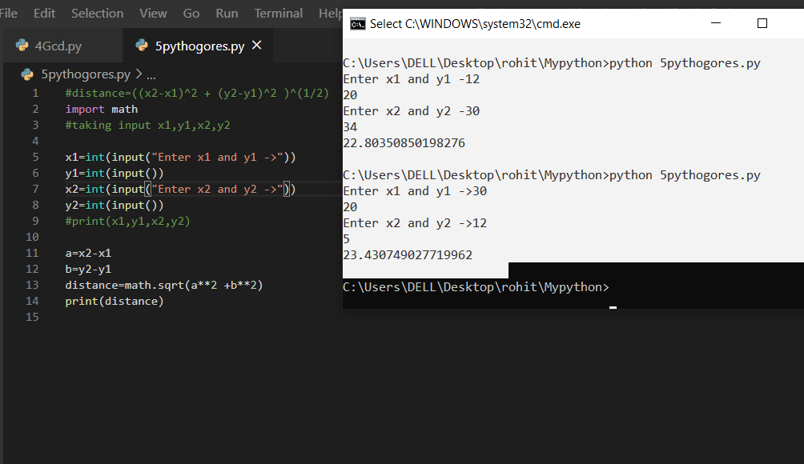

**PRACTICAL 6**

**Write a python Program to find the square root of a number taking input from user (Newton’s Method).**

**Aim:** Write a python Program to find the square root of a number taking input from user (Newton’s Method).

**Parameter** a

**Program**

def squareRoot(a) :

temp = a #a whose root we have to find

l=0.00001

while (1) :

root = 0.5 * (temp + (a / temp))

if (abs(root - temp) < l):

break;

temp = root;

return root

#taking input

a=int(input("ENTER THE VALUE FOR SQRT CALC -"))

ans=squareRoot(a)

print("square root of",a,"is",ans)

**FILE-:**

6sqrtNewton.py

**OUTPUT-:**

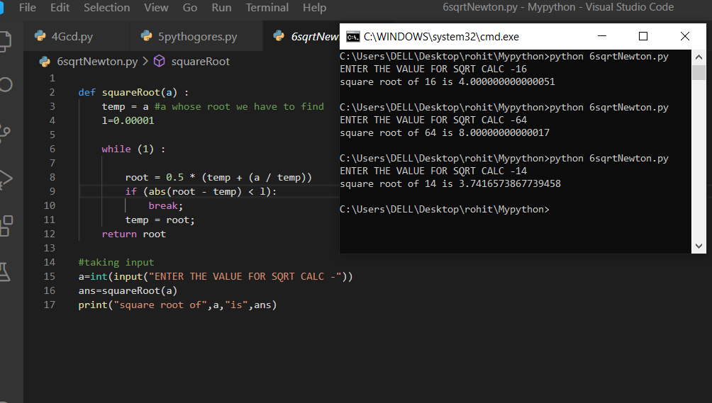

**PRACTICAL 7**

**Write a program add.py that takes 2 numbers as command line arguments and perform their sum.**

**Aim:** Write a program add.py that takes 2 numbers as command line arguments and perform their sum.

**Parameter:** command line parameter

**Program:**

import sys

#taking command line

#arrgument form terminal

print("file name-:",sys.argv[0])

a=int(sys.argv[1])

b=int(sys.argv[2])

#printing sum of a and b

print("sum is",a+b)

**File**

7add.py

**Output**

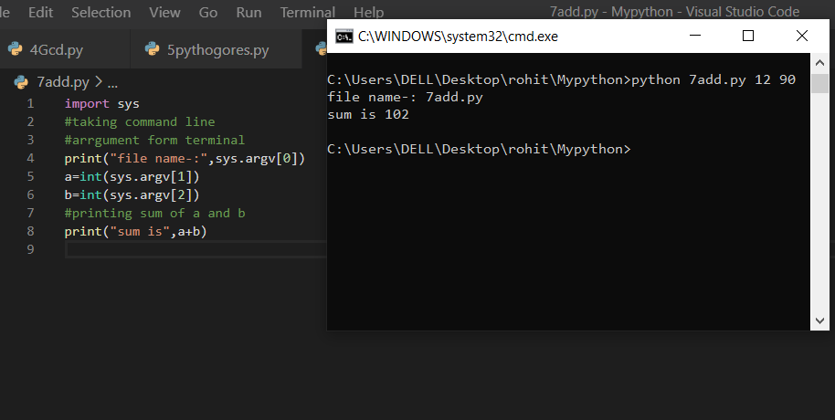

**PRACTICAL 8**

**Write a program to purposefully raise Indentation Error and Correct it.**

**Aim:** Write a program to purposefully raise Indentation Error and Correct it.

**Parameter:** a,b

**Program**

#indentation Error

# wrong code

"""

def multiply(a,b):

mul=a*b

print(mul) #indentation error here

#print is out of the function

"""

#Right code

def multiply(a,b) :

mul=a*b;

print(a*b)

#taking input

a=int(input("enter 2 number for multi"))

b=int(input())

multiply(a,b)

**File:** 8IndentationError.py

**Output**

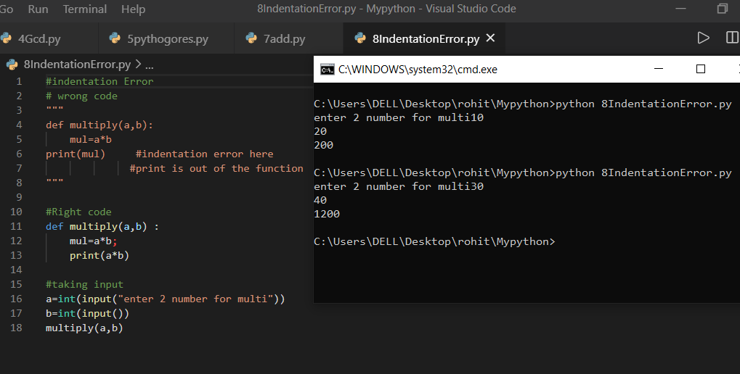

**PRACTICAL 9**

**Write a program to find the maximum from a list of numbers.**

**Aim:** Write a program to find the maximum from a list of numbers.

**Parameter:** n,list

**Program**

#taking input in list

n=int(input("Enter size of list "))

list=[]

for i in range(n) :

list.append(int(input("Enter elements")))

ans=max(list)

print(list,"Max of list is",ans,sep="\n")

**File:** 9MaxNoFromList.py

**Output**

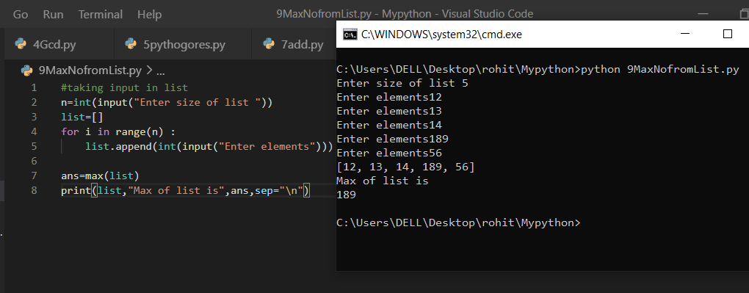

**PRACTICAL 10**

**Write a program to find all prime numbers within a given range.**

**Aim:** Write a program to find all prime numbers within a given range.

**Parameter:** n

**Program**

#prime number in Range

def PrimeSeive(n,list):

prime = [True for i in range(0,n + 1,1)]

for i in range(3,n+1,2) : # we are not checking for

# even as we know all even is non prime except 2

if(prime[i]==True):

list.insert(0,i)

for j in range(i*i,n+1,i):

prime[j]=False

list.insert(0,2)

list.sort()

return list

#taking input

a=int(input("Enter the range upto which you have to find prime number"))

list=[]

list=PrimeSeive(a,list)

print(list

**File:**

10PrimeNoInRange.py

**Output**

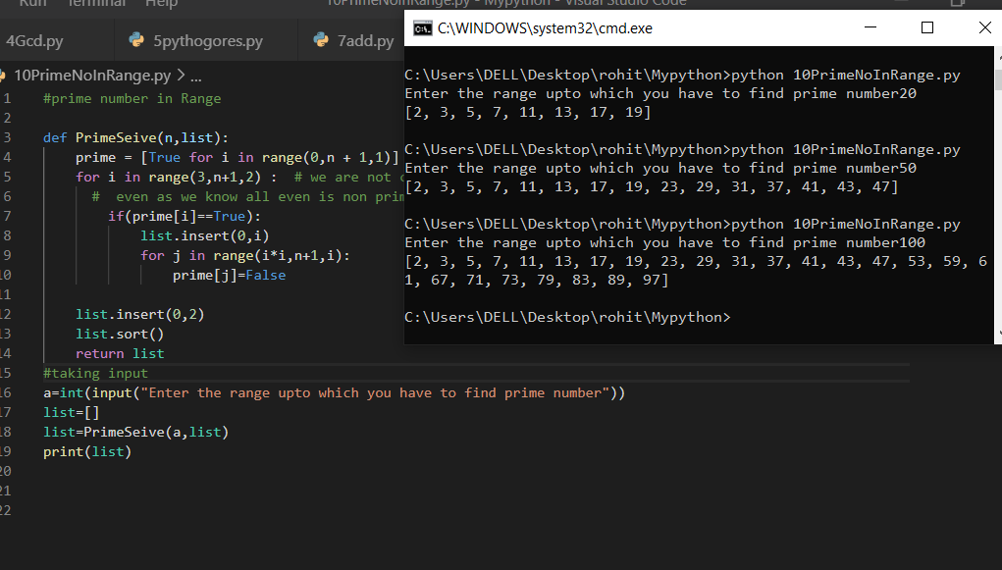

**PRACTICAL 11**

**Write a program to count the numbers of characters in the string and store them in a dictionary data structure.**

**Aim:** Write a program to count the numbers of characters in the string and store them in a dictionary data structure.

**Parameter:** s(string)

**Program**

s=input("Enter a string")

d={}

for i in range(0,len(s)):

if(s[i] in d):

d[s[i]]+=1

else:

d[s[i]]=1

print(d)

**File:** 11CountCharStoreInDec.py

**Output**

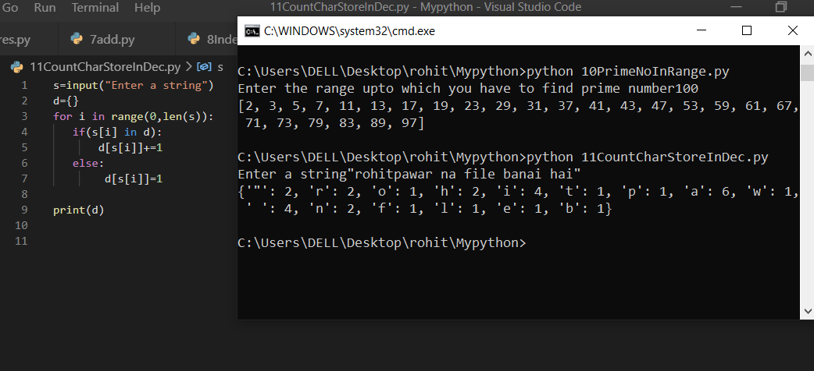

**PRACTICAL 12**

**Write a program to multiply matrices using function.**

**Aim:** Write a program to multiply matrices using function.

**Parameter:** x,y,result

**Program**

x=[list(range(1,4)),list(range(4,7)),list(range(7,10))]

y=[list(range(10,13)),list(range(13,16)),list(range(16,19))]

result=[[0,0,0],[0,0,0],[0,0,0]]

print("Multiplication of",sep="\n",end="\n")

print("X=",x,sep="\n",end="\n")

print("Y",y,sep="\n",end="\n")

for i in range(len(x)):

for j in range(len(y[0]))

for k in range(len(y)):

result[i][j] += x[i][k] * y[k][j]

print("is=",result,sep="\n")

**File:** 12MulUsingFun.py

**Output**

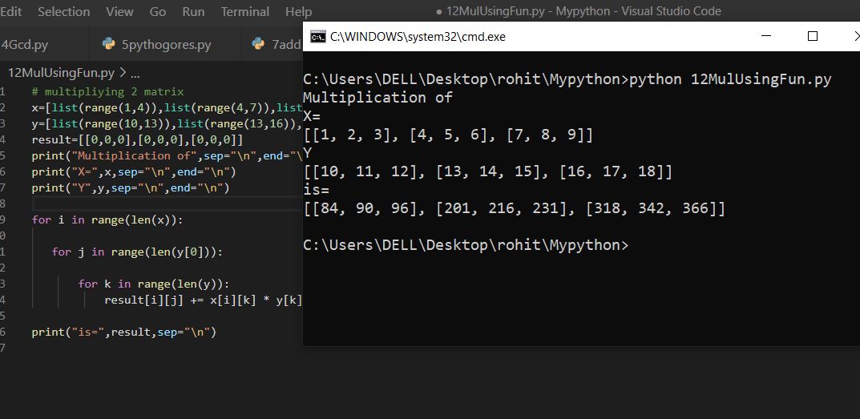

**PRACTICAL 13**

**Write a program to print n terms of Fibonacci series using iteration**

**Aim:** Write a program to print n terms of Fibonacci series using iteration

**Parameter:** a , b

**Programme**

def fibbonaci(n):

a=0

b=1

print("fibbonaci series-->")

for i in range(1,n):

c=a+b

print(a)

a=b

b=c

#printing n terms of fibbonaci

n=int(input("Enter the no. of terms"))

fibbonaci(n)

**File:**

13Fibbonaci.py

**Output**

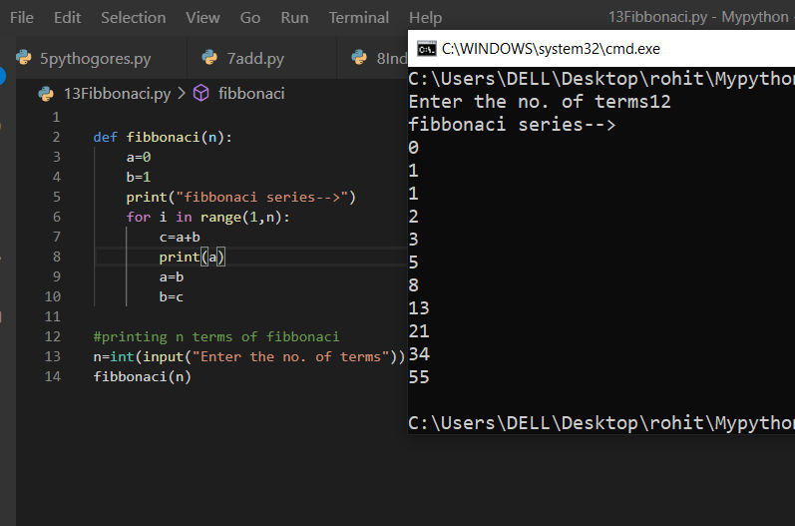

**PRACTICAL 14**

**Write a Python Program to perform Linear Search**

**Aim:** Write a Python Program to perform Linear Search

**Parameter:** s(string) ,find(char)

**Program**

#Linear search programme

s=input("Enter the string -")

find=input("enter the char which you to find -")

index=-1

for i in range(len(s)):

if s[i]==find :

index=i

break

print("Linear search for",find,"done",end=" ")

if index!=-1 :

print(" At index -",index+1)

else:

print(" but ",find," not found -1 ")

**File:**

14LinearSearch.py

**Output**

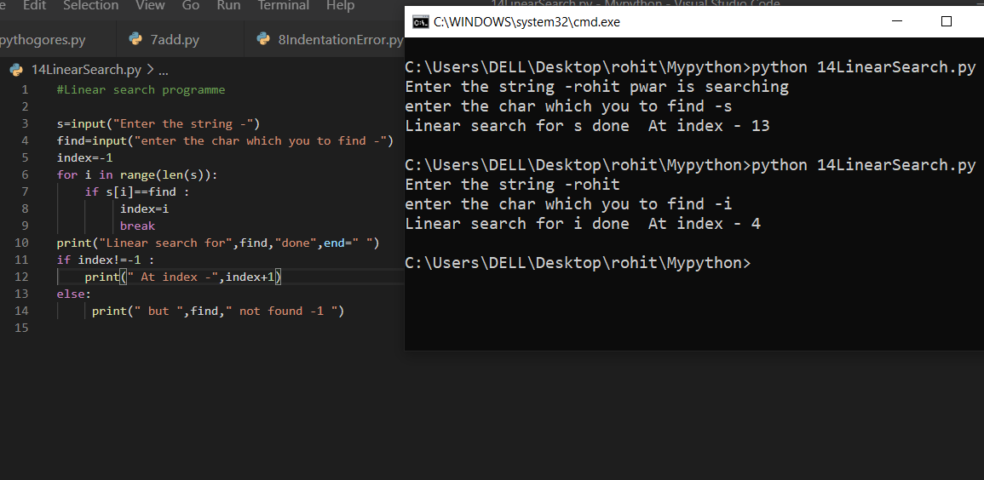

**PRACTICAL 15**

**Write a Python Program to perform Binary Search**

**Aim:** Write a Python Program to perform Binary Search

**Parameter:** list,key(int)

**Program**

#BinarySearch -:it is only applied when int sequence is sorted.

#finding key in the List of Integer sir.

def BinarySearch(l,key):

n=len(l)

left=0

right=n-1

mid=(left+right//2)

while(left<=right):

if l[mid]<key :

left=mid+1

elif l[mid]>key :

right=mid-1

else:

return mid

mid=(left+right)//2

return -1

#taking input in the list

n=int(input("Enter size of list "))

list=[]

for i in range(n) :

list.append(int(input("Enter elements")))

key=int(input("Enter the key"))

list.sort();

print(list);

index=BinarySearch(list,key)

print("BINARY SEARCH HAS BEEN DONE")

if index==-1:

print("key not exist's")

else:

print("KEY INDEX=",index+1)

**FILE**

15Binarysearch.py

**Output**

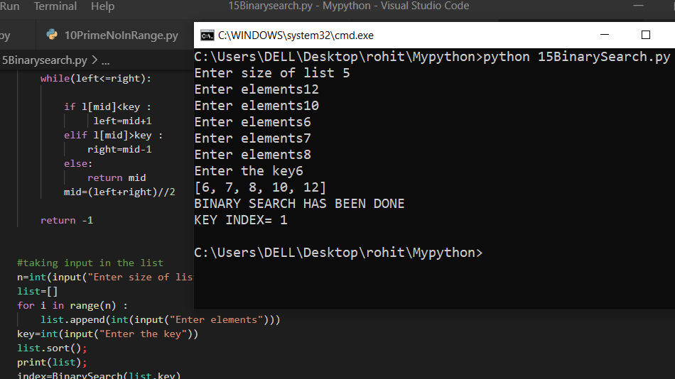

**PRACTICAL 16**

**Write a program to implement following sorting algorithms**

* **Selection Sort**
* **Insertion Sort**
* **Merge Sort**.

**Aim**: Write a program to implement following sorting algorithms

* Selection Sort
* Insertion Sort
* Merge Sort.

**Parameter:** list,n

**Program**

#selection sort logic

def selectionSort(l):

for k in range(0,len(l)):

min=k

for j in range(k+1,len(l)):

if l[min]>l[j] :

min=j

#swap

temp=l[min]

l[min]=l[k]

l[k]=temp

return l

def insertionSort(arr):

for i in range(1, len(arr)):

key = arr[i]

j = i-1

while j >= 0 and key < arr[j] :

arr[j + 1] = arr[j]

j -= 1

arr[j + 1] = key

return arr

def mergeSort(arr,l,r):

if l < r:

m = (l+(r-1))//2

mergeSort(arr, l, m)

mergeSort(arr, m+1, r)

merge(arr, l, m, r)

return arr

def merge(arr,l,m,r):

n1 = m - l + 1

n2 = r- m

L = [0] * (n1)

R = [0] * (n2)

for i in range(0 , n1):

L[i] = arr[l + i]

for j in range(0 , n2):

R[j] = arr[m + 1 + j]

i = 0

j = 0

k = l

while i < n1 and j < n2 :

if L[i] <= R[j]:

arr[k] = L[i]

i += 1

else:

arr[k] = R[j]

j += 1

k += 1

while i < n1:

arr[k] = L[i]

i += 1

k += 1

while j < n2:

arr[k] = R[j]

j += 1

k += 1

#taking input in the list

n=int(input("Enter size of list "))

list=[]

for i in range(n) :

list.append(int(input("Enter elements")))

print("sorting list-->",list)

l=selectionSort(list)

print("sorted list by selection sort",l)

l=insertionSort(list)

print("sorted list by Insertion sort",l)

l=mergeSort(list,0,len(list)-1)

print("sorted list by Merge sort",l)

**File**

16Sort.py

**Output**

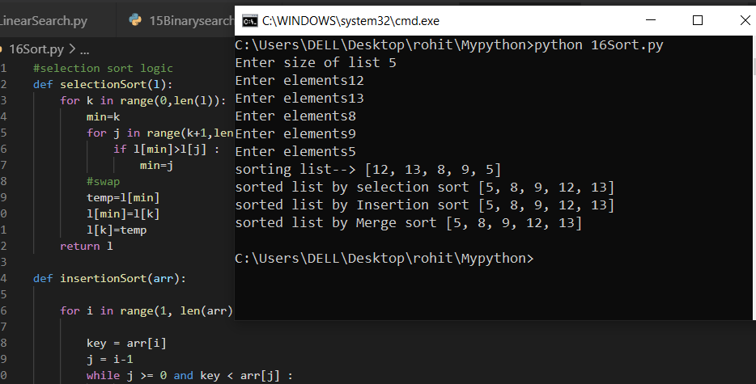

**PRACTICAL 17**

**Write a program to compute the number of characters, words and lines in a file.**

**Aim:** Write a program to compute the number of characters, words and lines in a file.

**Parameter:** file.txt

**Program**

def counter(fname):

num_words = 0

num_lines = 0

num_charc = 0

num_spaces = 0

with open(fname, 'r') as f:

for line in f:

num_lines += 1

word = 'Y'

for letter in line:

if (letter != ' ' and word == 'Y'):

num_words += 1

word = 'N’

elif (letter == ' '):

num_spaces += 1

word = 'Y'

for i in letter:

if(i !=" " and i !="\n")

num_charc += 1

print("Number of words in text file: ", num_words)

print("Number of lines in text file: ", num_lines)

print('Number of characters in text file: ', num_charc)

print('Number of spaces in text file: ', num_spaces)

if __name__ == '__main__':

fname = 'File1.txt'

try:

counter(fname)

except:

print('File not found')

**File**

17FileWordCount.py

**Output**

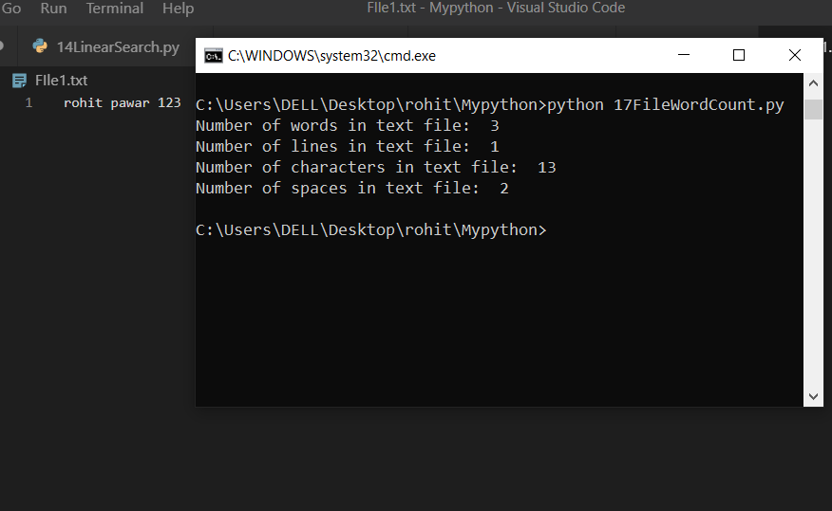

**PRACTICAL 18**

**Write a program to implement stack using list.**

**Aim:** Write a program to implement stack using list.

**Parameter:** list

**Program**

#implementing stack(Last In first OUT) using pop() and append() method

list=[]

#insertion at the last

list.append(10)

print("inserted-:",list)

list.append(10)

print("inserted-:",list)

list.append(20)

print("inserted-:",list)

#POP from last

print("poped-:",list.pop())

print("poped-:",list.pop())

print("poped-:",list.pop())

**File**

18StackList.py

**Output**

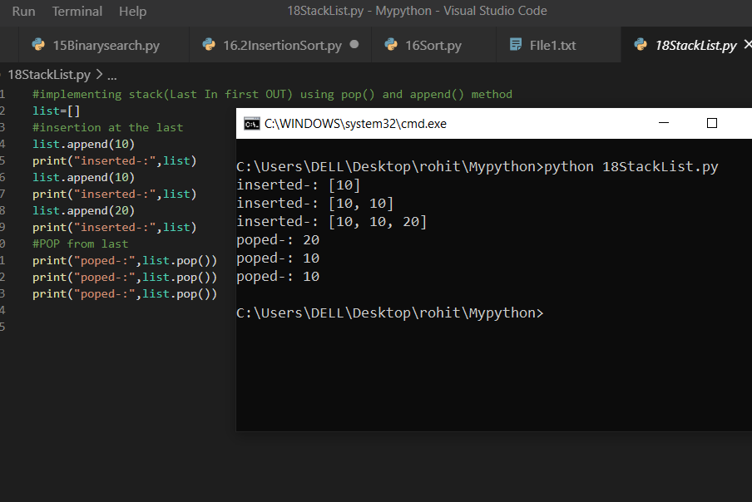

**PRACTICAL 19**

**Write a program to implement queue using list.**

**Aim:** Write a program to implement queue using list.

**Parameter:** queue

**Program**

queue = []

queue.append('a')

queue.append('b')

queue.append('c')

print("Initial queue")

print(queue)

print("\nElements dequeued from queue")

print(queue.pop(0))

print(queue.pop(0))

print(queue.pop(0))

print("\nQueue after removing elements")

print(queue)

**File**

19Queue.py

**Output**

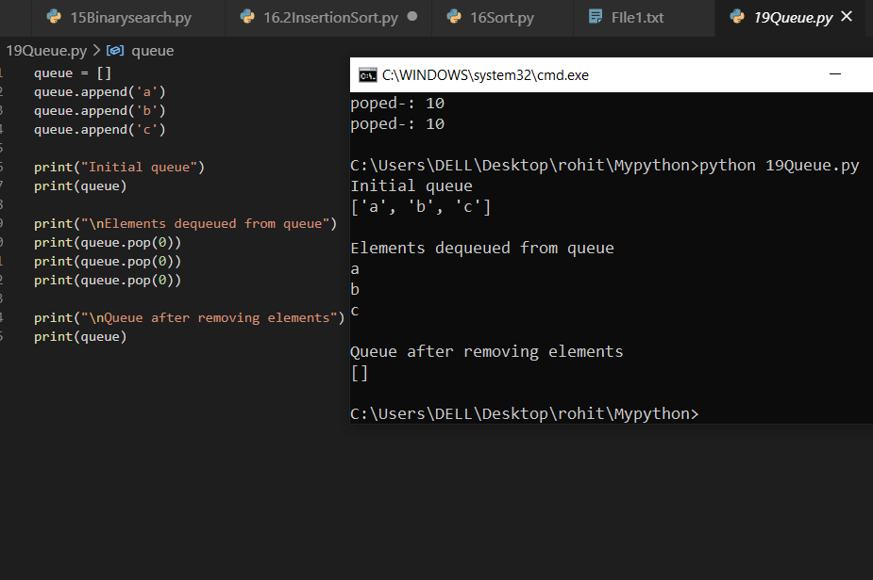

**PRACTICAL 20**

**Write a program to demonstrate working of classes and objects.**

**Aim:** Write a program to demonstrate working of classes and objects.

**Parameter:-** nothing

**Program**

class Rohit:

def __init__(self, name, age):

self.name = name

self.age = age

p1 = Rohit("Rohit",19)

print(p1.name)

print(p1.age)

**File**

20ClassObject.py

**Output**

