DATA SCIENCE PROJECT PLANNING
AND STRATEGY DESIGN
Hypothetical E-Commerce Customer Churn Prediction Project
Prepared by: Rohit Prajapati
Week 1 Internship Deliverable | Data Science with Python

1. Project Background
E-commerce businesses depend on repeat customers, but some customers gradually reduce their activity and eventually stop purchasing. This customer churn can reduce revenue and increase the cost of acquiring replacement customers. The proposed project focuses on planning a data science solution that can analyze historical customer behavior and identify patterns associated with churn.
The project is hypothetical, as required for Week 1, and does not use a real company dataset. Python will be used as the planned analytical environment because its data science ecosystem supports data preparation, visualization, statistical analysis, machine learning, and reporting.

2. Problem Statement and Motivation
The problem is to determine which customer behaviors may indicate a higher likelihood of churn. The motivation is to help an e-commerce business move from a reactive approach toward a proactive approach by identifying customers who may need attention before they leave.
Potential signals include purchase frequency, total spending, recency of the last purchase, number of returns, customer reviews, and measurable engagement such as product views or searches. These variables would be investigated rather than assumed to be predictive.

3. Project Objectives
- Define a clear and measurable customer churn problem.
- Identify relevant customer attributes that could be used as analytical features.
- Design a process for collecting, validating, cleaning, and preparing customer data.
- Plan exploratory analysis to identify meaningful relationships and patterns.
- Select and compare suitable classification approaches for churn prediction.
- Define evaluation measures appropriate for a churn classification problem.
- Translate analytical findings into practical business recommendations.

4. Scope

In Scope
- Customer-level historical data preparation and validation.
- Data cleaning and handling of missing or invalid values.
- Exploratory data analysis and visualization.
- Feature engineering and selection.
- Planning and testing of classification models.
- Model evaluation and interpretation.
- Documentation of findings and recommendations.

Out of Scope
- Production deployment of a live prediction service.
- Direct integration with a company's customer-management system.
- Automated customer messaging or marketing campaigns.
- Use of personally identifiable customer information.
- Guaranteed prediction of future customer behavior.

5. Methodology & Strategy
The project will follow a structured end-to-end data science lifecycle. Each stage will produce an output that becomes the input to the next stage.
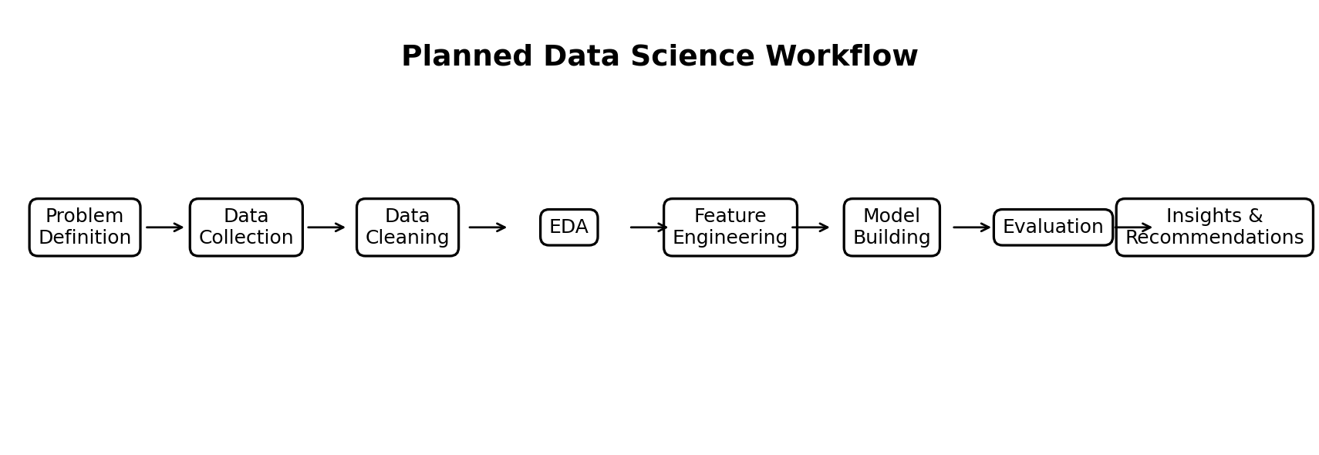
Figure 1. Planned end-to-end data science workflow.

5.1 Data Collection
The hypothetical dataset would be collected from customer order and engagement systems. Candidate fields include customer identifier, purchase dates, number of orders, total spending, average order value, days since last purchase, returns, reviews, and engagement measures such as product views or searches. The target variable would be churn status, defined using a documented business rule such as a specified period of inactivity.

5.2 Data Cleaning and Validation
- Inspect row and column structure, data types, missing values, and summary statistics.
- Remove or resolve duplicate records where appropriate.
- Investigate impossible values such as negative order counts.
- Standardize date formats and convert dates to proper datetime values.
- Handle missing values using an approach appropriate to the variable and business context.
- Check for inconsistent categories and unexpected outliers.
- Document cleaning decisions so the process remains reproducible.

5.3 Exploratory Data Analysis (EDA)
EDA will be used to understand distributions, relationships, and differences between churned and non-churned customers. Planned analyses include churn distribution, order-frequency analysis, spending distribution, recency analysis, returns analysis, and relationships between engagement indicators and churn. Histograms, bar charts, box plots, and correlation visualizations may be used where appropriate.

5.4 Feature Engineering
Raw fields may be transformed into more informative variables. Examples include days since last purchase, average order value, orders per month, return rate, and recent engagement counts. Feature definitions will be documented and checked to avoid using information that would only become available after the prediction point.

5.5 Model Building
The planned target is binary churn classification. Baseline and tree-based approaches may be considered, for example Logistic Regression and Random Forest. The dataset would be split into training and test sets, with preprocessing performed in a reproducible pipeline. Cross-validation may be used during model selection.

5.6 Model Evaluation
Model performance will not be judged using accuracy alone. Precision, recall, F1-score, confusion matrix, and ROC-AUC may be considered. Because failing to identify a genuinely at-risk customer can be costly, recall and the balance between precision and recall will receive particular attention. The final model should also be checked for overfitting and reasonable interpretability.

6. Tools and Technologies
Tool / Library | Purpose | Planned Use
Python | Programming and analysis | Core project language
Pandas | Data manipulation | Loading, cleaning and transforming data
NumPy | Numerical computing | Numerical operations and feature preparation
Matplotlib | Visualization | Charts and exploratory plots
Seaborn | Statistical visualization | EDA visualizations
Scikit-learn | Machine learning | Preprocessing, modeling and evaluation
Jupyter / Google Colab | Development environment | Interactive analysis and experimentation
Git / GitHub | Version control | Project files and reproducibility

7. Timeline — 34 Hours
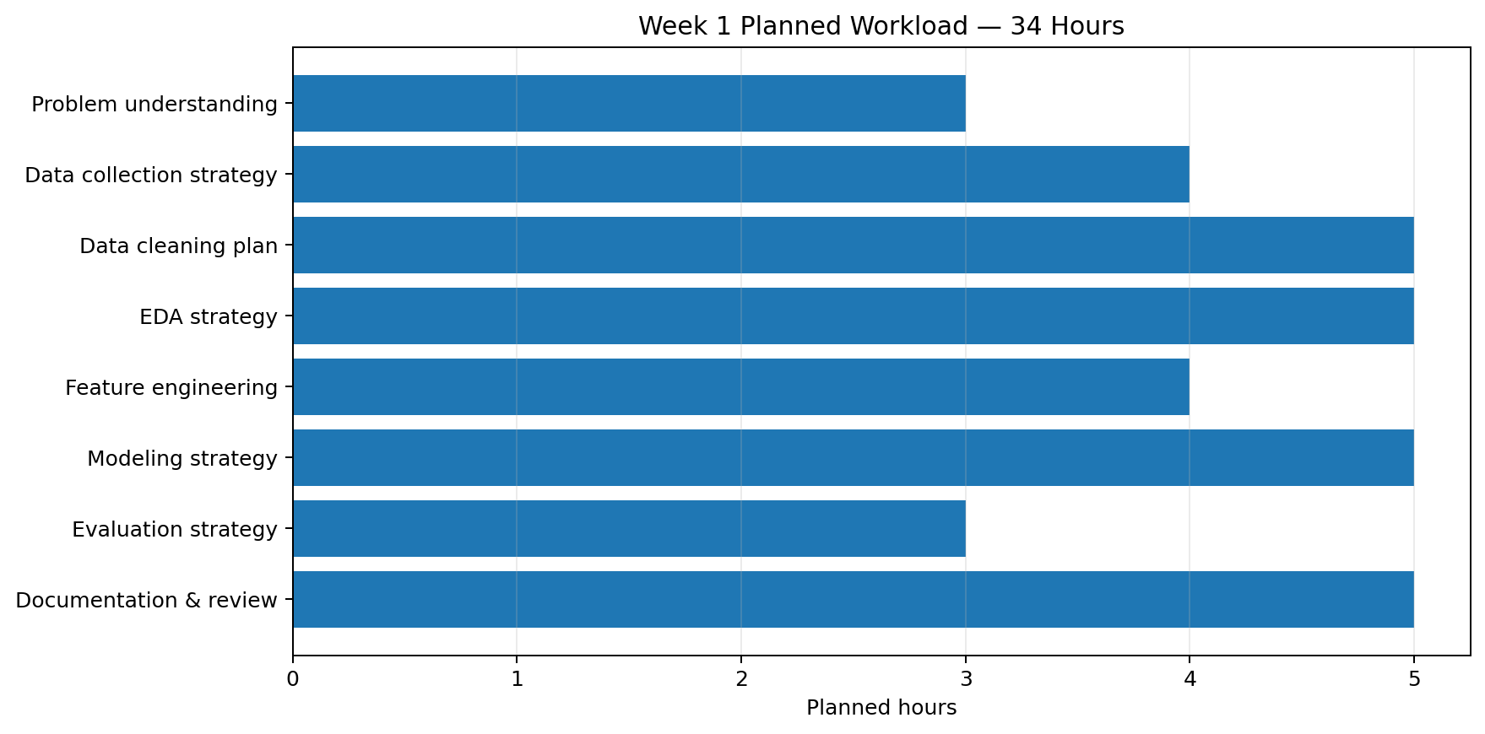
Figure 2. Planned allocation of 34 hours for the Week 1 project plan.
Activity | Hours | Main Output
Problem understanding | 3 | Problem statement and business context
Data collection strategy | 4 | Required fields and data sources
Data cleaning plan | 5 | Validation and cleaning strategy
EDA strategy | 5 | Questions, metrics and visualization plan
Feature engineering | 4 | Candidate derived features
Modeling strategy | 5 | Candidate models and training approach
Evaluation strategy | 3 | Metrics and validation plan
Documentation & review | 5 | Final report, diagrams and quality check

8. Expected Outcomes
- A clear, reproducible plan for an e-commerce churn analysis project.
- A defined set of potential customer behavior features and a churn target.
- A documented strategy for data preparation and exploratory analysis.
- A justified plan for selecting and evaluating classification models.
- Actionable customer-behavior patterns that can be investigated for retention opportunities.
- A foundation for later hands-on Python and machine learning tasks.

9. Anticipated Challenges and Mitigation
Challenge | Risk | Mitigation
Missing data | Can reduce reliability. | Profile missingness and choose documented imputation or exclusion rules.
Incorrect values | Can create misleading patterns. | Apply validation rules and investigate anomalies.
Class imbalance | Model may favor the majority class. | Use suitable metrics, stratification and class-weighting/resampling where justified.
Overfitting | Model may perform well only on training data. | Use train/test separation and cross-validation.
Data leakage | Future information can make results unrealistically strong. | Define a prediction point and restrict features to information available before it.
Privacy | Customer data may contain sensitive information. | Use minimum necessary data, anonymization and controlled access.

10. Quality and Reproducibility Strategy
All assumptions, feature definitions, cleaning decisions, and evaluation criteria will be documented. The analysis will be organized into reproducible Python notebooks or scripts. Version control through Git and GitHub will be used for project files where applicable. Results will be reviewed for consistency before being communicated.

11. Conclusion
This Week 1 plan establishes a structured approach to a hypothetical e-commerce customer churn prediction project. It covers the complete analytical lifecycle from problem definition and data strategy through cleaning, exploration, feature engineering, modeling, evaluation, and recommendations. The planned workflow is designed to create a strong foundation for later hands-on Python and machine learning tasks.

12. Report Submission Description (200+ Words)
This report presents a detailed project plan and strategy for a hypothetical E-Commerce Customer Churn Prediction project as part of Week 1 of the Data Science internship. The purpose of the project is to design a structured approach for identifying customer behavior that may be associated with churn and to plan how Python-based data science methods could be used to support this problem. The report begins by defining the business background, motivation, problem statement, project objectives, and scope. It then explains the planned data science methodology, including data collection, data validation and cleaning, exploratory data analysis, feature engineering, model building, and model evaluation. Potential customer attributes such as purchase frequency, spending, last purchase recency, returns, reviews, and measurable engagement are considered as candidate features. The report also identifies suitable Python tools and libraries, including Pandas, NumPy, Matplotlib, Seaborn, and Scikit-learn, along with Jupyter or Google Colab and Git/GitHub for reproducible work. A 34-hour timeline has been included to allocate realistic effort across the major stages of the project. Strategic diagrams and a timeline chart are included to visually communicate the proposed workflow and workload. Finally, the report discusses expected outcomes and important challenges such as missing data, invalid values, class imbalance, overfitting, data leakage, and privacy. Overall, the deliverable demonstrates an understanding of how a data science project can be planned systematically before technical implementation begins.

