WEEK 2 PROJECT REPORT
Exploratory Data Analysis (EDA) and Visualization Framework
Hypothetical E-Commerce Customer Churn Analysis | Python

1. Introduction to EDA
Exploratory Data Analysis (EDA) is the process of examining and understanding a dataset before building statistical or machine learning models. It helps identify the structure and quality of the data, discover patterns and relationships, detect unusual observations, and form useful questions for further analysis. In this project framework, EDA is planned as a systematic and repeatable process that can be adapted to many datasets. The main focus is to understand what the data contains, whether it is reliable, and which variables may be important for later analysis.

2. Potential Data Types
Data Type | Examples | EDA Approach
Numerical | Age, spending, quantity | Summary statistics, histogram, box plot
Categorical | Gender, region, churn status | Frequency counts, bar chart
Ordinal | Rating levels, satisfaction | Ordered frequencies, grouped charts
Date/Time | Purchase date, login date | Trend analysis, time-series plots
Boolean | Returned: Yes/No | Counts, proportions, comparison plots

3. Data Exploration Techniques

3.1 Initial Data Inspection
The first step is to inspect the dataset using Pandas. The planned checks include shape, column names, data types, sample records, unique values, descriptive statistics, duplicate rows, and missing-value counts. This establishes a basic understanding of the dataset before deeper analysis.

3.2 Missing Data
Missing values will be measured by column and, where appropriate, by row. Depending on the reason and percentage of missingness, possible actions include removing unreliable records, filling numerical values with suitable statistics such as median, or filling categorical values using the mode or an explicit 'Unknown' category. The chosen method will be documented rather than applied blindly.

3.3 Outlier Detection
Outliers will be investigated using box plots, percentile checks, and the Interquartile Range (IQR) method. Extreme values will first be reviewed for business meaning or data-entry errors. Valid unusual observations will be retained where appropriate, while confirmed errors may be corrected or excluded with a documented reason.

3.4 Univariate Analysis
Univariate analysis studies one variable at a time. Numerical variables will be examined using mean, median, standard deviation, minimum, maximum, quartiles, histograms, and box plots. Categorical variables will be examined using frequency counts, percentages, and bar charts.

3.5 Bivariate Analysis
Bivariate analysis examines relationships between two variables. Examples include spending versus churn, order count versus churn, and returns versus churn. Scatter plots, grouped summaries, bar charts, and suitable correlation measures will be used to identify differences and relationships.

3.6 Multivariate Analysis
Multivariate analysis considers several variables together to understand more complex patterns. Correlation heat maps, grouped visualizations, and selected pairwise plots will help identify interactions, redundant variables, and potentially important features.
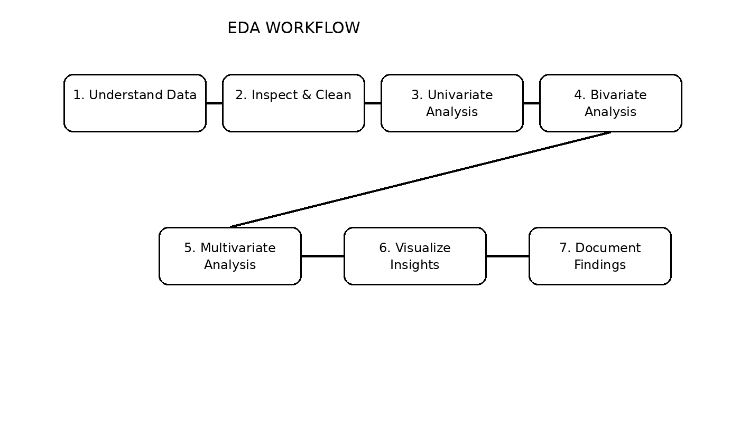
Figure 1: Planned EDA workflow

4. Visualization Strategies
Visualization will be selected according to the question being investigated and the type of variable involved. The objective is not to create as many charts as possible, but to choose clear visualizations that reveal useful patterns.
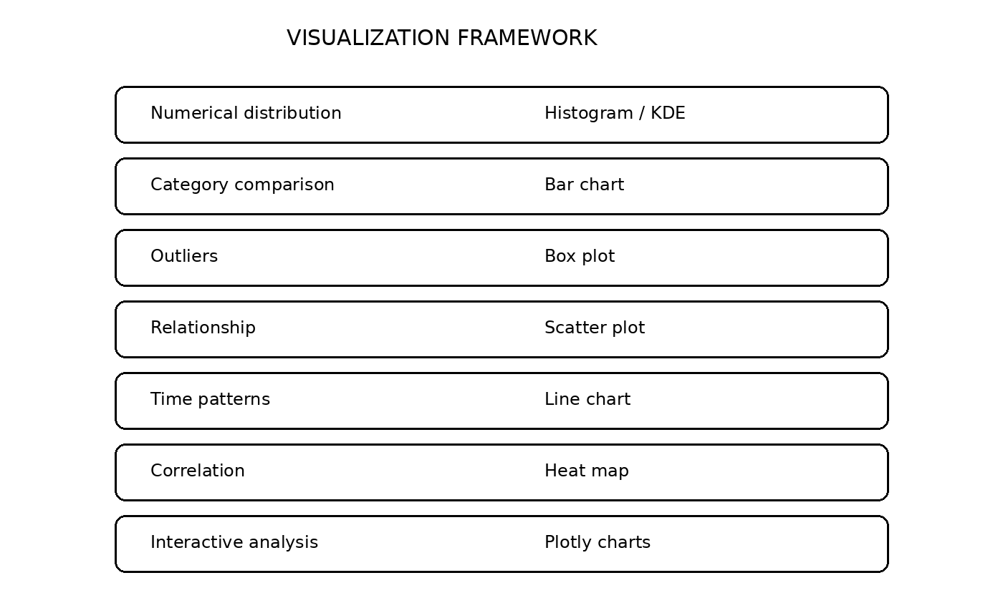
Figure 2: Visualization selection framework
Plot / Chart | Purpose | Example Question
Histogram | Distribution of numerical data | How is customer spending distributed?
Bar chart | Compare categories | Which customer groups have more churn?
Box plot | Spread and outliers | Are there unusual spending values?
Scatter plot | Relationship between numerical variables | Does recency relate to spending?
Line chart | Change over time | How does activity change month to month?
Heat map | Correlation overview | Which numerical variables are strongly related?

5. Python Tools and Libraries
Pandas will be used for loading, inspecting, filtering, cleaning, transforming, and summarizing data. NumPy will support numerical operations. Matplotlib will provide flexible static charts, while Seaborn will simplify statistical visualizations such as distributions, box plots, and correlation heat maps. Plotly can be used when interactive charts are useful. Jupyter Notebook or Google Colab can provide an interactive environment for analysis, while GitHub can be used for version control and project documentation.

6. Reporting and Documentation Plan
EDA findings will be documented in a logical order: project question, dataset overview, data-quality checks, univariate findings, bivariate and multivariate findings, visual insights, key observations, limitations, and recommendations for the next stage. Every important chart will have a meaningful title, labelled axes, and a short interpretation. Important cleaning decisions and assumptions will also be recorded so that another person can understand and reproduce the analysis.

7. Expected Outcomes
The expected outcome is a clear understanding of the dataset's structure, quality, distributions, relationships, and important patterns. The framework should help identify useful variables, data-quality problems, potential trends, and questions that can guide later statistical or machine learning work. For the hypothetical churn project, the EDA stage may reveal customer behaviour patterns associated with inactivity, spending, order frequency, returns, or reviews.

8. Challenges and Mitigation
- Missing or inconsistent values — profile missingness first and use an appropriate documented treatment.
- Outliers — investigate their meaning before removing them.
- Imbalanced categories — report both counts and percentages and avoid misleading comparisons.
- Overcrowded visualizations — use focused charts and clear labels.
- Misleading correlations — treat correlation as an observation, not proof of causation.
- Reproducibility — keep analysis steps documented and maintain project files in GitHub.

9. Planned Work Allocation (30–35 Hours)
Activity | Time
EDA concepts and project questions | 4 hours
Data-type and quality framework | 5 hours
Univariate and bivariate analysis plan | 6 hours
Multivariate analysis and outlier/missing-data strategy | 5 hours
Visualization framework and chart selection | 5 hours
Reporting and documentation structure | 4 hours
Review, refinement, and final submission | 3 hours

10. Conclusion
This Week 2 framework establishes a structured approach for exploratory analysis and visualization using Python. It demonstrates how a data scientist can move from understanding a dataset to identifying quality issues, exploring individual variables, studying relationships, communicating patterns visually, and documenting findings. The framework is intentionally adaptable and can be applied when the actual dataset becomes available in later technical work.

