**Popular No-code development platforms.**

**Hello everyone...**

**Best Top-7 no code and low code plateform**.

1. **Wordpress**
2. Why wordpress?

1.Handles user management.login system,security.

2.Countless integration.

3.Open source, you can build in own custom plugins.

4.many of your project to 10k/month.

Q. How to installed Wordpress.

Step1- Google in search for <https://hi.wordpress.org.>

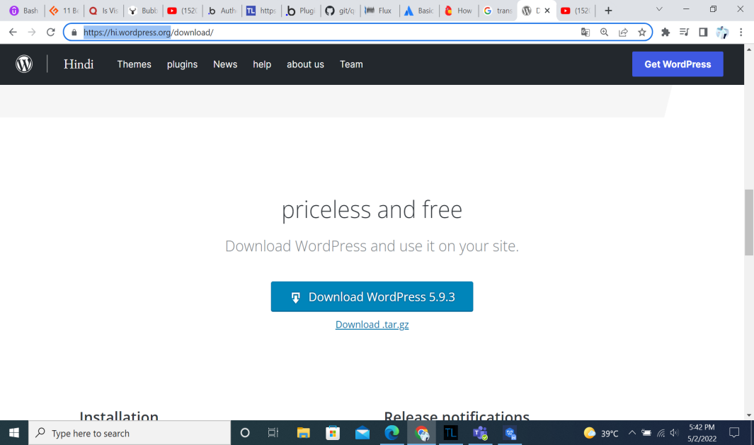

Step2 - Install for web server xammp, wamp.

Step3 - Create a Database in web server.

Step4 - Install Wordpress.

Step5 - Choice language and Database-name,Username,Password,Database host,Table Prefix fill-up field click here Submit button local host data configuration work completed.

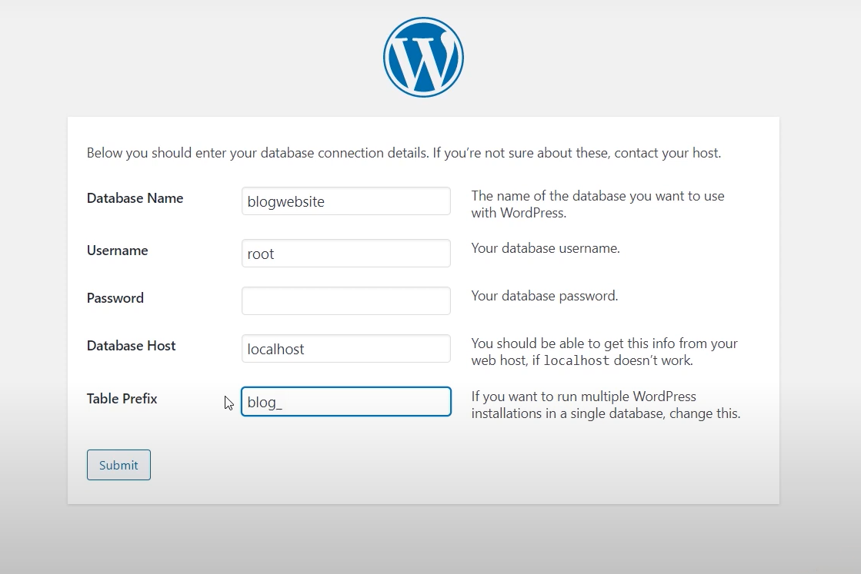

Step6 -Next step for click here “Run the installation” button.

Step7- Admin panel information field Site Title,

Username,Password,Confirm Password Checkbox checked,Your Email,Search Engine Visibility check box unchecked fill and click here Installed WordPress.

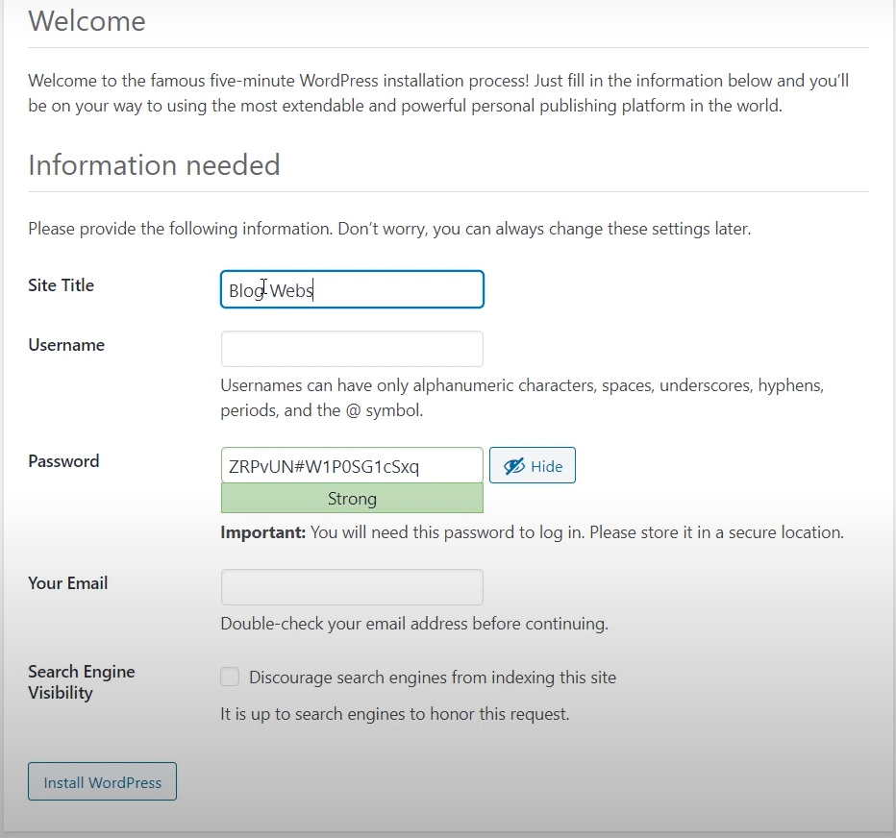

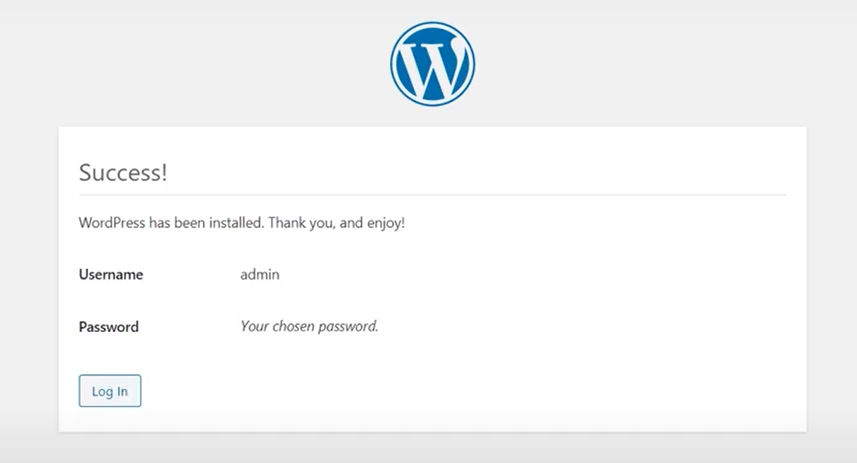

Step8- click here login button show in default web page.

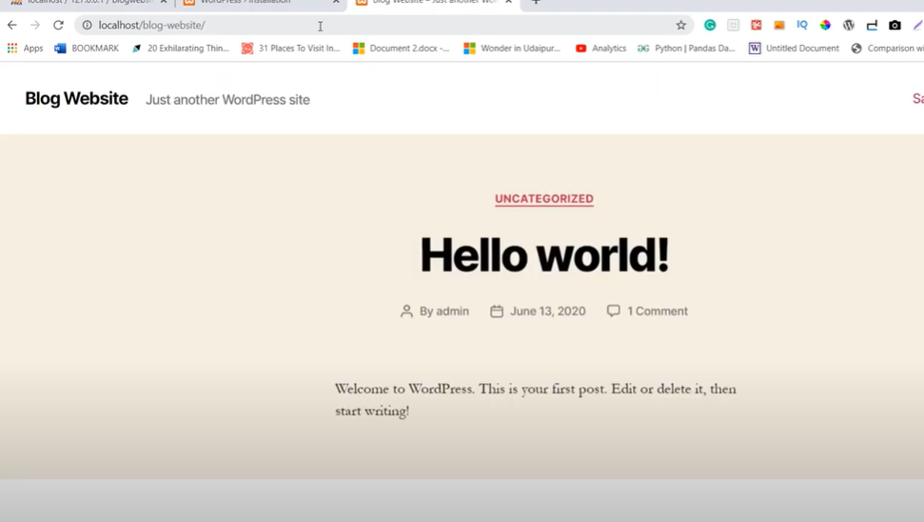

Step9- Show in WordPress login page field username,password fill up click here login button.

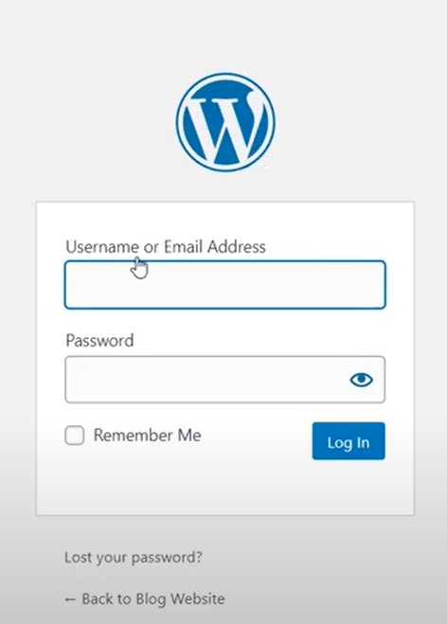

Step10- This is show wordpress admin panel

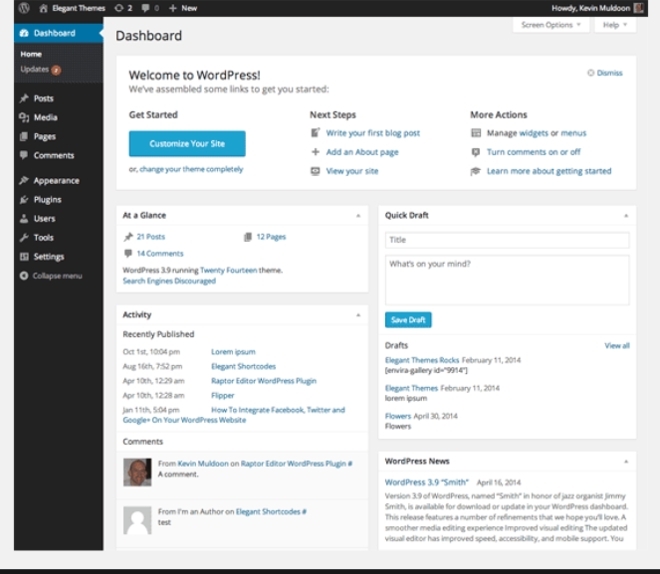

1. **Bubble.io.**

Q.Why buble.io?

1. Build in desktop and mobile apps like Facebook and AirBnB.
2. Bubble hand lest host.
3. Grate management features.
4. Font end and back end tools.
5. Content drag and drop features in bubble.io very easly creating website designing.

Features for bubble.io

* Creating an interactive web page and web app.
* Creating web page content easily drag and drop.
* Building an Auto-complete search on bubble.io
* Customization reset password functionality use to bubble.io.
* Filtering repeating group.
* Bubble.io in plugin used for advance functionality.
* Creating a easily static and dynamic web page,making database

1. **Adalo.**

Q.Why Adalo?

1. Build basic and advanced app.
2. Drag and drop visual builder. Just add the app component you need.
3. Easy to use data base.
4. Beautiful dynamic chart links to user input.
5. Custom formulas.

Features for Adalo:-

* Adalo very easily mobile app development and web development.
* Adalo testing management.
* Work-flow management.
* Adalo is a drag and drop.

**4.Appy Pie.**

Q.Why Appy pie?

1. Android and IOS.
2. Very easy to use.
3. Publish your app to Google and iTunes.

Features of Appy Pie:-

* Appy pie a used to mobile application ,website design development,task automation,chat boat and graphics.
* Create a app to play store to easly lounch.
* Appy pie is built for small businesses and is available in three different pricing plans. They're also a 7-day free trial if you want to test it out before
* Appy pie used to pros and cons. This is pros used for easy to used ,highly flexible, beta testing.Cons used for User experience could be better, Some design layout tamplates look out of dates.

**5.BuildFire.**

Q.Why Buildfire?

1. Easy to use drag and drop interface.
2. App emulator.
3. Extend functionality though plugin marketplace.
4. Buildfire SDK.
5. They handle the infrastructure(the borring stuff.) you focus on your ideas.

Features build fire:

* Graphical user interface.
* Integrate development inverment.
* Easy way desktop mobile responsive web design.
* Creating for mobile app user interfaec very intractive

1. **AppSheet**

Q. Why AppSheet?

1. Inventory management system,Kan-ban management system, to do list, delivery tracking system etc.
2. Powerful components.
3. Service company application.

4.Grate for Logic App.

Feature for AppSheet:

* Data change tracking.
* Easily for app customization.
* A built function is used to work very fast.
* Weekly usage summery reports.
* Creating a custom form.
* Very important line offline working App Sheet.

1. **AppGyver**

Q.Why AppGyver?

1. visual builder called “composer pro” very powerful.
2. Full control over UI
3. Grate with data and application logic.
4. App logic is a visual editor. Construct logic by connecting nodes.

Feature for AppGyver:

* Pixel perfect design AppGyver plateform.
* Powerful theme engine.
* Built with zero lines of code.
* Ultra responsive design.
* Biometric security.
* Handles millions of euros in transactions.
* Maintenance for finland’s national high voltage power grid.
* Appgyver used for offline and online.
* Dataset of over 1 million record synced seamlessly with Maxi-mo interactive native maps.
* Complete ERP system for an electronic motorcycle manufacture.
* App suit orchestrating the entire manufacturing process.

**Conclusion :**

No code development is a plateform used for building application even with a non technical user.It user a visual development interface for creating application without using any coding experience. No code development allows development to make change easily.It is easy to drag and drop the functionality of the application.It also allow development to work efficiently without any risk.

No code development become a solution for the organization to deliver and help inn their project. It is increase its growth day by in the modern word by implementing new techniques in development. It is also helping in the business sector by increasing the software demand and requirement of the resource.