DOCKER DEVOPS ASSIGNMENT
Full-Stack Application Containerization using Docker
Student Name: Rohit Nadageri
Project: Node.js/Express Frontend + Flask Backend
Tools: Docker, Docker Compose, Node.js, Express, Flask

1. Objective
The objective of this assignment is to containerize a full-stack application consisting of a Node.js/Express frontend and a Flask backend using Docker. The application is organized into separate frontend and backend services and is intended to be connected using Docker Compose. The Docker images are built locally and are prepared for publication to Docker Hub.

2. Project Overview
The project contains a To-Do application. The frontend provides a web form for entering an item name and description. The Flask backend provides an API that processes submitted information. Dockerfiles were created for both services and the images were successfully built.

3. Docker Installation and Verification
Docker and Docker Compose were verified from PowerShell. The Docker Engine was also tested using the standard Hello World container.
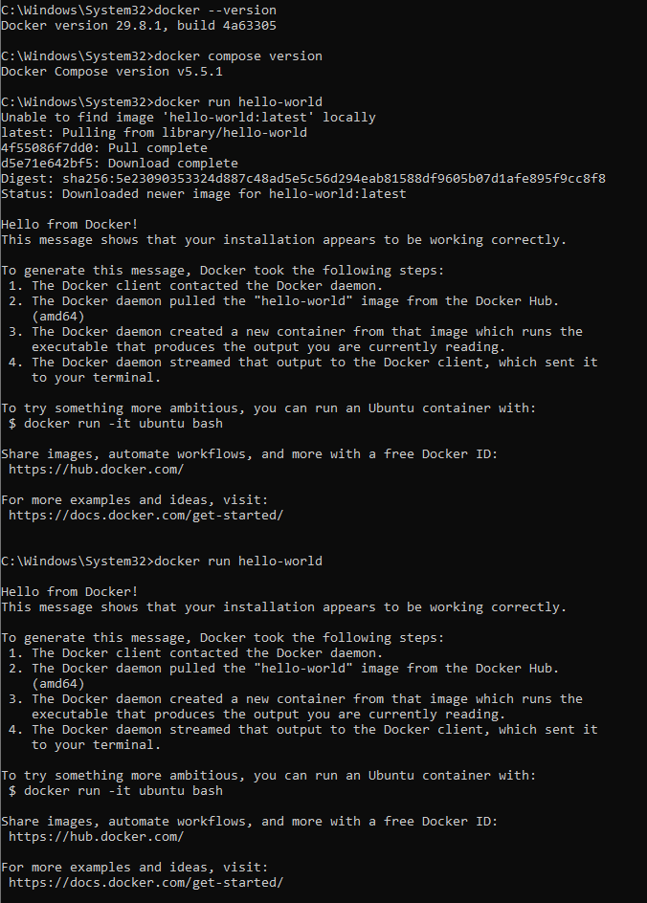
Docker installation and Hello World test

4. Frontend Docker Image
The Node.js/Express frontend was containerized using a Dockerfile based on the Node.js Alpine image. The application dependencies were installed during the Docker build process, and the Express application was exposed on port 3000.
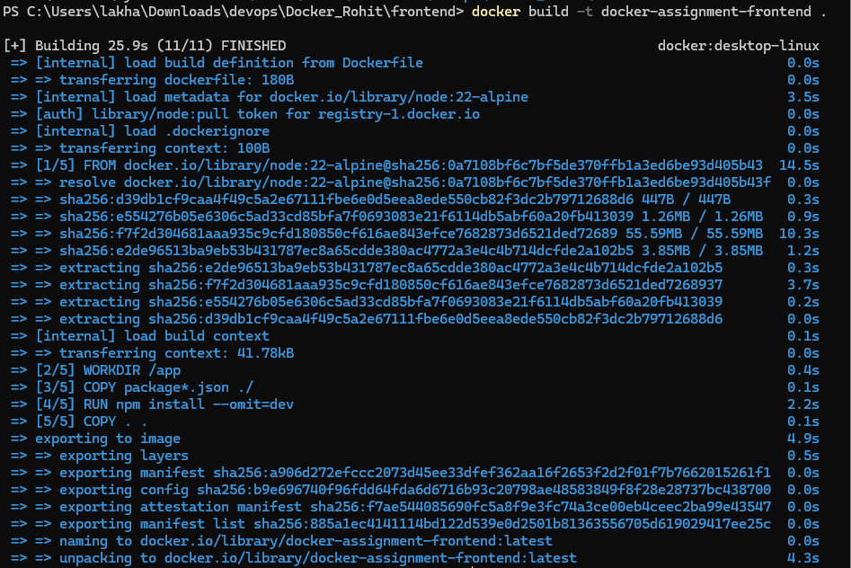
Frontend Docker image build completed successfully

5. Backend Docker Image
The Flask backend was containerized using a Python 3.12 slim base image. The requirements file was copied into the image, dependencies were installed, and the Flask application was configured to run on port 5000.
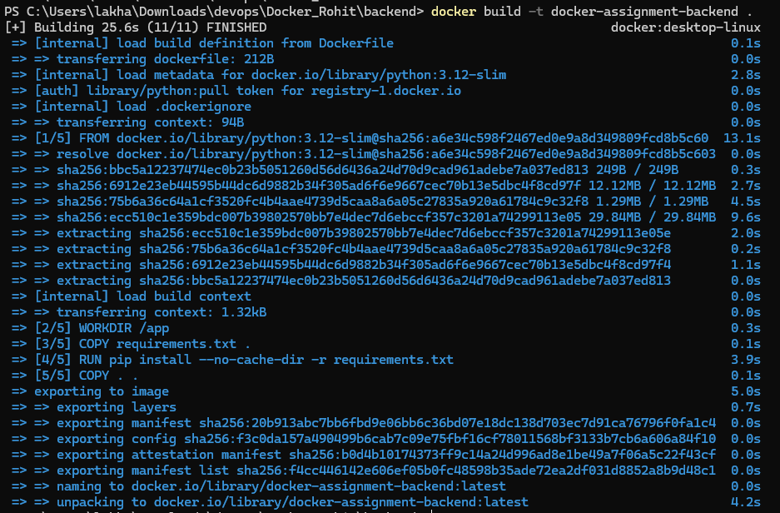
Backend Docker image build completed successfully

6. Docker Images
After the builds completed, the locally available Docker images were checked. Both required application images were present: docker-assignment-frontend:latest and docker-assignment-backend:latest. The Docker Hello World image was also available from the initial Docker installation test.
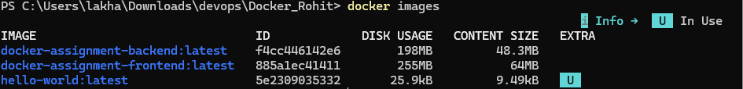
Docker images created successfully

7. Frontend Browser Test
The Node.js/Express frontend was opened in a web browser. The To-Do form contains fields for Item Name and Item Description and a Submit To-Do button.
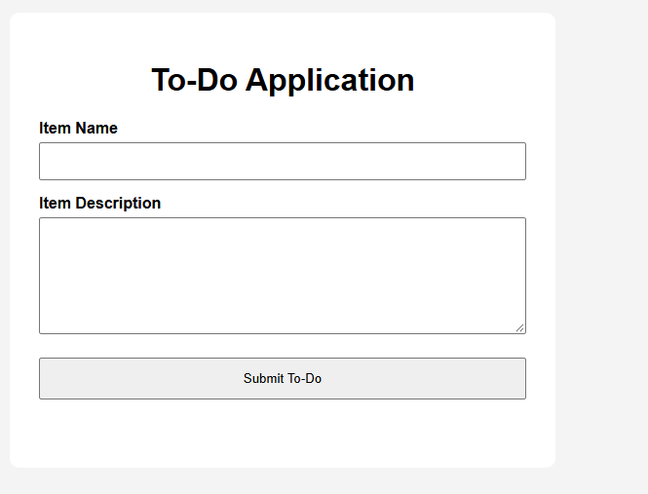
Node.js/Express To-Do frontend running in the browser

8. Flask Backend Test
The Flask backend was tested successfully and returned a JSON response confirming that the Flask backend is running as the Docker Assignment Backend.
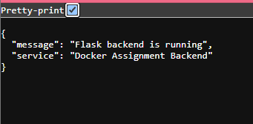
Flask backend response running successfully

9. Docker Compose and Service Integration
The next stage is to configure Docker Compose so that the frontend and backend run together on a shared Docker network. The frontend will communicate with the Flask service using the Compose service name backend and port 5000. The frontend will be exposed to the host through port 3000.

10. Docker Hub Publication
After successful Compose testing, the frontend and backend images must be tagged using the student's Docker Hub username and pushed to Docker Hub.
Frontend image: YOUR_DOCKERHUB_USERNAME/docker-assignment-frontend:1.0
Backend image: YOUR_DOCKERHUB_USERNAME/docker-assignment-backend:1.0

11. GitHub Publication
The complete project source code, Dockerfiles, Docker Compose configuration, .gitignore files and README should be committed and pushed to the student's GitHub repository.
GitHub Repository: YOUR_GITHUB_USERNAME/Docker-DevOps-Assignment

12. Conclusion
The Docker environment was successfully verified, and both the Node.js/Express frontend and Flask backend were successfully built as Docker images. The frontend and backend were also individually verified. The remaining work is to connect both services using Docker Compose, test the complete form-to-backend flow, publish the images to Docker Hub, push the source code to GitHub, and complete the final ZIP submission.
Submission note: Replace the Docker Hub and GitHub placeholders with the actual URLs after those steps are completed.

