

**Walchand College of Engineering, Sangli**

(An Autonomous Institute)

**Department**

Of

**Computer Science and Engineering**

A Project Synopsis

On

**REAL TIME ANALYSIS OF HOME AUTOMATION ENERGY CONSERVATION SYSTEM**

BY

Rohit Uddhav Kumbhare (2014BCS077)

Nayana Namdev Satpute (2015BCS203)

Siddhivinayak Vasant Shanbhag (2014BCS004)

Kanhaiyalal Ramchandar Yadav (2014BCS009)

Under the guidance

Of

**Prof. A.R.Surve**

Guide

Prof. Computer Science & Engg. Dept,

WCE, Sangli.

**2017 - 2018**

**Synopsis Approval**

The project synopsis report entitled **REAL TIME ANALYSIS OF HOME AUTOMATION ENERGY CONSERVATION SYSTEM** submitted by

**Rohit Uddhav Kumbhare (2014BCS077)**

**Nayana Namdev Satpute (2015BCS203)**

**Kanhaiyalal Ramchandar Yadav (2014BCS009)**

**Siddhivinayak Vasant Shanbhag (2014BCS004)**

Is approved as a mega project for the partial fulfilment of the requirement for the award of the degree of Bachelor of Technology in Computer Science and Engineering.

**Prof. A.R.Surve**

Guide

Computer Sci. & Engg. Dept, WCE, Sangli.

**Mr. Swapnil Mahadeshwar**

Co-Guide

Company Name, Pune

Your full name

(Exam Seat Number)

**Dr. B. F. Momin**

HOD

Computer Sci. & Engg. Dept,

WCE, Sangli

Abstract

The issue of wastage of electricity is very paramount in many organisations, even when the electrical appliances are not needed but are still working and consuming huge amount of electricity and doesn’t provide any automation. Therefore we intend to make a project based on automation of electrical appliances which saves user’s time and electricity. The project involves the use of microcontroller, sensor modules and a controller program to give commands to hardware and it also contains a platform through which we have analysed the data using various machine learning algorithm that is been collected by the computer and we are also providing a graphical interface through which each an every user has an account in which the user can observe its usage of appliances , it also contains the administrator profile in which the users are been created and the administrator has the permission to completely shutdown the system also. The analysed data is been sent to the cloud as the data must be observed through various users. Our Project uses the information such as Temperature, Humidity, and Light intensity of environment and according to the information it decides that how the electricity should be provided to the appliances .Once the project is been installed it works on its own. From this project we hope to save electricity and automate the appliances at the maximum level.

**Table Of Contents**

1 **Introduction** 4

1.1 Broad Area 4

1.2 Title of Proposed Project 4

1.3 Introduction to your project 4

1.4 List Of Figures 4

1.5 Acronyms 4

2 **Literature Survey** 4

3 **Problem Statement** 5

4 **Innovation** 5

5 **Significance** 5

5.1 Market Potential 5

5.2 Present State 5

5.3 Results of Project implementation 5

6 **Objective** 5

7 **Methodology** 5

7.1 Hardware Specification 6

7.2 Software Requirements 6

7.3 Technologies or Tools: eg, Java, NS2, Python etc. 6

8 **Status Of Project** 7

8.1 Current Status of Project 7

8.2 Schedule of Remaining Project 7

9 **Conclusion** 7

# Introduction

## Broad Area

**1.1.1 Handicapped people problem**

For handicap persons, it finds so difficult to stand up or go toward window every time in order to open and close curtains of windows or door, so we are here with the project which will save efforts of such people

**1.1.2 Patient’s Problem in Hospital**

We know that it’s not possible for the patient to do much movements. Private hospitals may have their own workers but generally in case of government hospitals, no such facilities are available. So, these project is helpful in such a places.

**1.1.3 Manual Work**

It’s a small part of home automation which will avoid the need of manual tasks

**1.1.4 Wastage of Electricity**

Most of the electrical appliances are been using electricity even when they are not required to be use.So here we are with idea to save energy source**.** As the electrical appliances will work according to user or based on environment changes

## Title of Proposed Project

Real Time Analysis of Home Automation Energy Conservation System

## Introduction to your project

**2.1 Introduction to IOT**

The Internet of things (stylised Internet of Things or IoT) is the [internetworking](https://en.wikipedia.org/wiki/Internetworking) of physical devices, vehicles (also referred to as "connected devices" and "[smart devices](https://en.wikipedia.org/wiki/Smart_device)"), buildings and other items—[embedded](https://en.wikipedia.org/wiki/Embedded_system) with [electronics](https://en.wikipedia.org/wiki/Electronics), [software](https://en.wikipedia.org/wiki/Software), [sensors](https://en.wikipedia.org/wiki/Sensor), actuators, and network that enable these objects to collect and exchange data

Typically, IoT is expected to offer advanced connectivity of devices, systems, and services that goes beyond [machine-to-machine](https://en.wikipedia.org/wiki/Machine_to_machine) (M2M) communications and covers a variety of protocols, domains, and applications. The interconnection of these embedded devices (including [smart objects](https://en.wikipedia.org/wiki/Smart_objects)), is expected to usher in automation in nearly all fields, while also enabling advanced applications like a [smart grid](https://en.wikipedia.org/wiki/Smart_grid),[[13]](https://en.wikipedia.org/wiki/Internet_of_things#cite_note-Smart-IoT-13) and expanding to the areas such as [smart cities](https://en.wikipedia.org/wiki/Smart_city)

**2.2 Introduction to Arduino**

Arduino is an open-source electronics platform based on easy-to-use hardware and software. [Arduino boards](https://www.arduino.cc/en/Main/Products) are able to read inputs - light on a sensor, a finger on a button, or a Twitter message - and turn it into an output - activating a motor, turning on an LED, publishing something online. You can tell your board what to do by sending a set of instructions to the microcontroller on the board. To do so you use the [Arduino programming language](https://www.arduino.cc/en/Reference/HomePage) (based on [Wiring](http://wiring.org.co/)), and [the Arduino Software (IDE)](https://www.arduino.cc/en/Main/Software), based on [Processing](https://processing.org/).

Over the years Arduino has been the brain of thousands of projects, from everyday objects to complex scientific instruments. A worldwide community of makers - students, hobbyists, artists, programmers, and professionals - has gathered around this open-source platform, their contributions have added up to an incredible amount of [accessible knowledge](http://forum.arduino.cc/) that can be of great help to novices and experts alike.

* 1. **Introduction to Dimmer**

**Dimmers** are devices used to lower the brightness of a light. By changing the voltage waveform applied to the lamp, it is possible to lower the intensity of the light output. Dimmers range in size from small units the size of a light switch used for domestic lighting to high power units used in large theatre or architectural lighting installations.

* 1. **Sensors used**

**2.4.1 LDR Sensor**

* Photosensitive resistor module most sensitive to environmental light intensity is generally used to detect the ambient brightness and light intensity.
* Module light conditions or light intensity reach the set threshold, DO port output high, when the external ambient light intensity exceeds a set threshold, the module D0 output low;
* Digital output D0 directly connected to the MCU, and detect high or low TTL, thereby detecting ambient light intensity changes;
* Digital output module DO can directly drive the relay module, which can be composed of a photoelectric switch;
* Analog output module AO and AD modules can be connected through the AD converter, you can get a more accurate light intensity value

**2.3.2 Humidity Sensor**

DHT11 digital temperature and humidity sensor is a calibrated digital signal output temperature and humidity combined sensor, which Application-specific modules capture technology and digital temperature and humidity sensor technology to ensure that products with high reliability and excellent Long-term stability.

* The product has excellent quality, fast response, anti-interference ability, high cost and other advantages.
* Single Wire serial interface that allows quick and easy system integration. Ultra-small size, low power consumption, signal transmission distance Up to 20 meters, making it to the class of applications and even the most demanding applications is the best choice.
* Products for the 4-pin single row Pin package, easy connection.

## List of Figures

**Use case Diagram:**

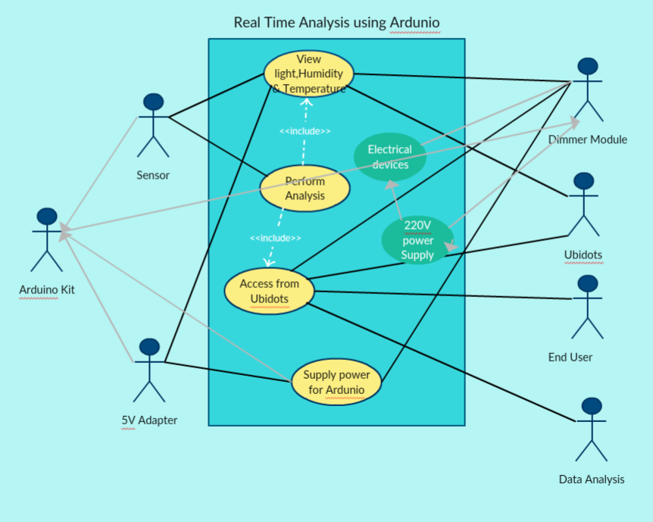

**Sequence Diagram:**

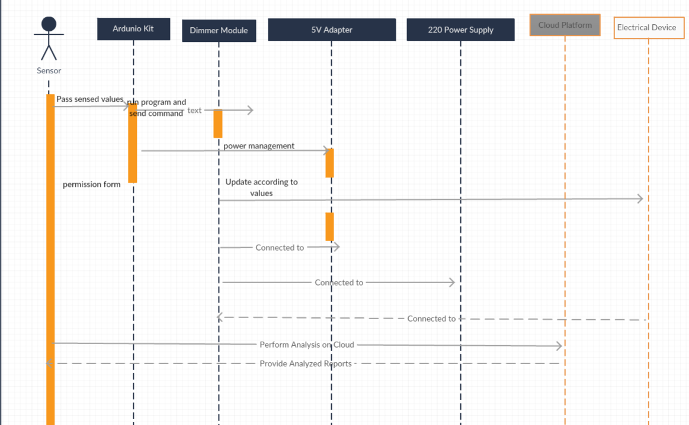

**Activity Diagram:**

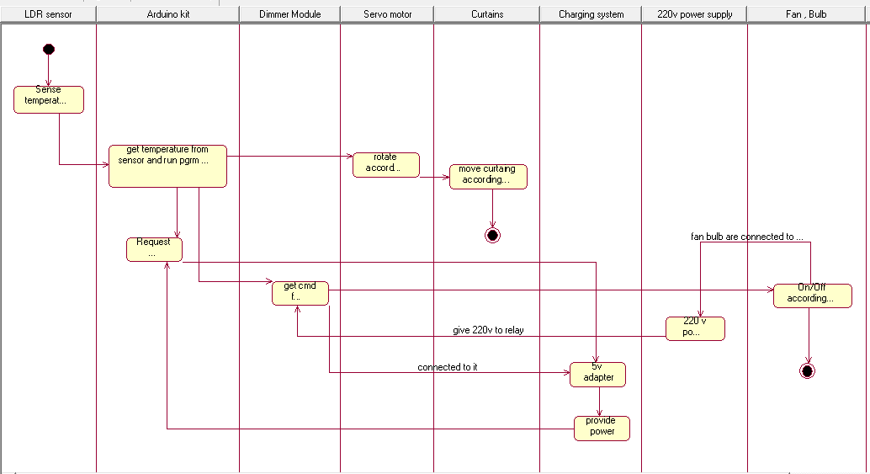

**Collaboration Diagram:**

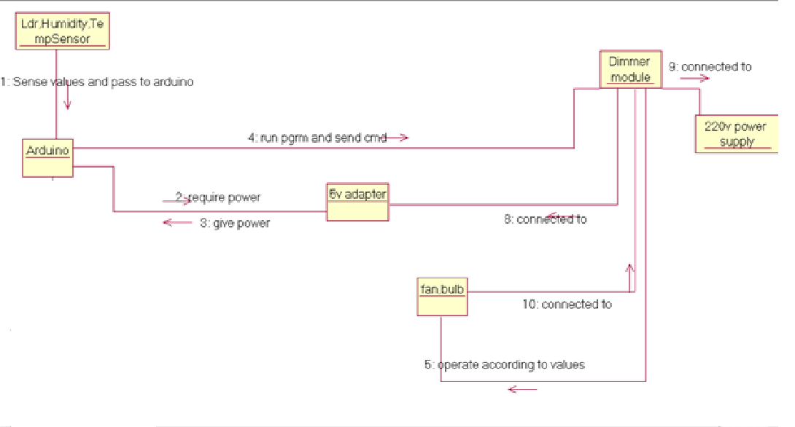

**Component Diagram:**

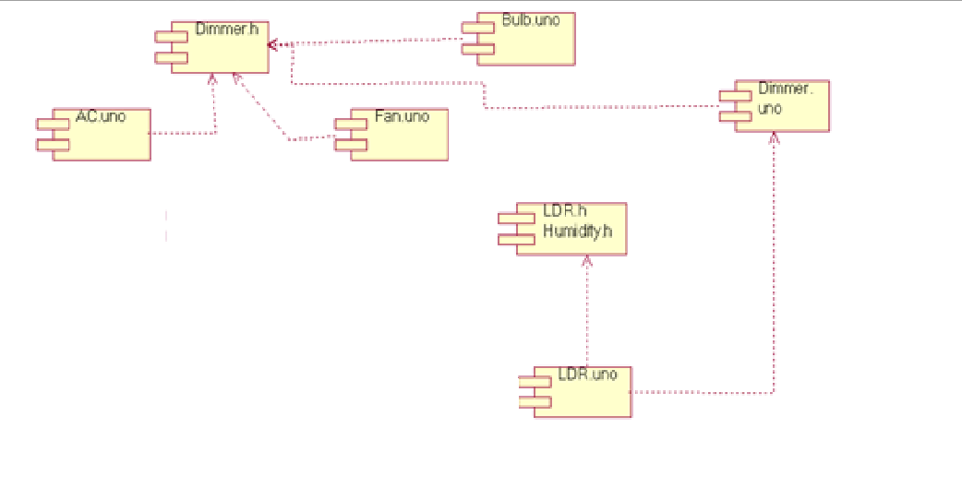

**Deployment Diagram**

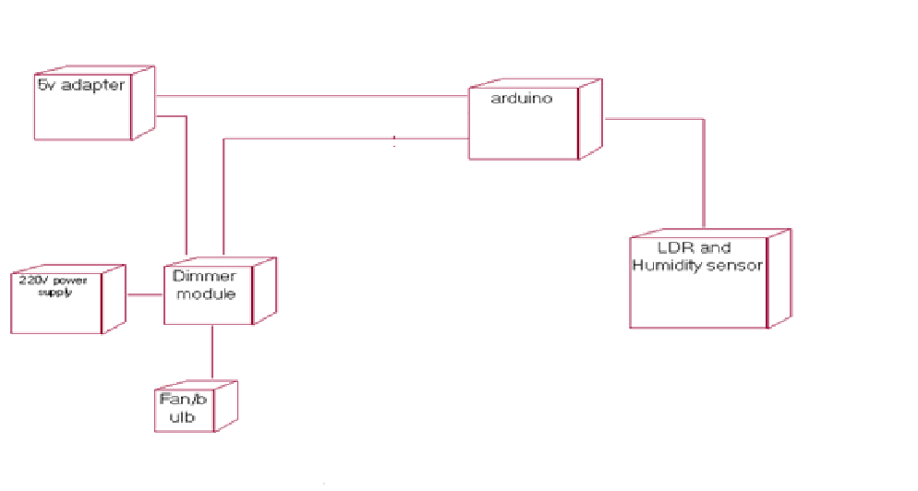

**Class Diagram:**

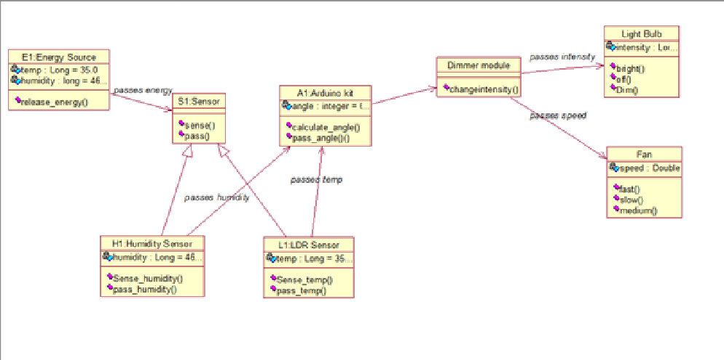

**Object Diagram:**



## Acronyms

* Out Of Sight Automation with of Conservation of energy.

# Literature Survey

“The Figure” shows Basic Architecture of Remote Home Automation.

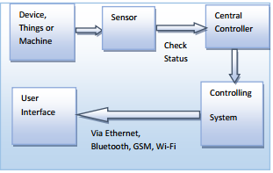

The Home automation system that uses direct connection to computer system. System consists of three main components; computer, which presents system core that controls, and monitors users’ home and hardware interface module(Arduino PCB, Cloud Database, Data-Analysis. The System is better from the scalability and flexibility point of view than the commercially available home automation systems. The User may also use the technology to login to the server web based application.

# Problem Statement

The issue of wastage of electricity is very paramount in many organisations, even when the electrical appliances are not needed but are still working and consuming huge amount of electricity and doesn’t provide any automation. Therefore we intend to make a project based on automation of electrical appliances along with automation of curtains which saves user’s time and electricity. The project involves the use of microcontroller, sensor modules and servo motor and a controller program to give commands to hardware. Our Project uses the information such as Temperature, Humidity, and Light intensity of environment and according to the information it decides that how the electricity should be provided to the appliances along with the moving of curtains. Once the project is been installed it works on its own. From this project we hope to save electricity and automate the appliances at the maximum level.

# Innovation

First ever build project that is based on the complete home automation in variability of power along with the analysis of all the data that is been captured through the controller. The project also contains direct connection of the user’s to the controller through which the user can directly control the appliances and also can analyse the working of it.

# Significance

**Automation** or automatic control, is the use of various control systems for operating equipment such as machinery, processes in factories, boilers and heat treating ovens, switching in telephone networks, steering and stabilization of ships, aircraft and other applications with minimal or reduced human intervention.

## Market Potential

The increasing cost of electricity is a major concern for household consumers. These increasing costs are influencing the households to save energy. Smart home appliances can communicate among themselves and have emerged as an effective solution to save energy. Thus, households are increasingly adopting smart home appliances to minimize their energy costs. The smart home market for home appliances is expected to grow at a high rate between 2017 and 2023 owing to the advancements in electronics and communication technologies. Factors such as rising purchasing power and changing lifestyles of people are driving the demand for smart home appliances worldwide.

## Present State

We have successfully created the complete idea that how the project is going to get implemented and what conditions are to be seen so that it would work on its full efficiency. The design of the project is been made and the implementation will start after the requirements are been satisfied.

## Results of Project implementation

Complete Home Automation project that is capable of suppling variability in power to appliances and the users can operate according to their needs, the user can also analyse the power consumption using the web access page that is linked to the cloud storage (storing all the analysed data from the sensors).

# Objective

Develop highly cost effective Automatic curtains adjustment System along with automation of electrical appliances. LDR, Humidity, Temp sensor modules and Arduino MEGA 2560 in order to rotate curtains of a window according to intensity of light, humidity, temp and also automation of electrical appliances. Easily customized as per requirements and available resources to suit the needs of different rural households.

# Methodology

1. **Who is the system for?**

Firstly you need to establish who the system will be used by – just yourself, the whole family or a client. Establishing who the system is for will enable you to get a grip and start to detail what’s required across the home. Discuss the system with your family, asking them when it comes to technology what kind of features or control you don’t want, you would like and what you must have.

1. **Decide what parts of your home you want to control**

Home Automation is about integrating many parts of your home into one solution, this can include audio and video entertainment, lighting, heating or security.

The level of control and what can be integrated is limited to your budget. Imagine home automation as a series of computers all talking to each other in a home network, every control box, keypad, TV point, remote control, heating panel, lighting solution are all a series of computers talking to each other seamlessly, now consider that this could reach numbers of up to 100 products in a medium sized system, for true reliability your budget should not be restricted to gimmicks as otherwise you may regret your choice of system.

1. **How do you want to control your home?**

In the early days of multi room and home automation, the only option was often simple hard button panels or simple remotes which offered limited control and interaction with your home.

Now it’s possible to choose which control option is best on a room by room basis. For small maybe single user rooms a simple keypad combined with a multi remote is often sufficient.

In rooms like lounges, family rooms or rooms where you are often sitting, getting up and down to use a keypad or touch screen is often not ideal, opting for a higher level of multi touch remote control gives you the same level of control but in the comfort of your sofa.

1. **Planning the stages of installation**

The success of any home automation system will come down to your homes wiring infrastructure. Get this wrong and you not only limit what’s possible but could fall down even further as new technologies develop.

We are contacted all the time by clients who followed advise from the Internet, or simply put case everywhere, wired zones in sequence and a number of other poorly led advise, to discover later that all their expectations, wants and desires were to be shattered by a poorly planned wiring attempt.

The Home Automation Company pride ourselves on delivering future proofed wiring solutions which will not only allow for numerous product options and scalability, but most importantly allow for future technologies that are years ahead but critical when technology trends change.

**5. Involve everyone in planning**

It is important from the offset that every trade is at the very least kept up to date with the proposed home automation system, so that each trade can accommodate advise, assistance and co-operation with the home automation team.

Every trade involved in a home build can and will be instrumental in the planning of a successful home automation system, from the architect & electrician to the painters and decorators. The stages involved in planning a multi room system need constant management and cross stakeholder management to ensure continuity between every aspect of the homes build and no nasty surprises around the corner.

**6. Getting the timings right**

As often a home automation can be perceived as an add on, its often left to the last minute, this can often be when projects will fall down. Contacting us early is the key to a successful and smoothly run project.

Getting in touch early can also save costs, with the majority of home automation brands, they build their own reliable devices which can control heating, lighting and other parts of your home, making sure this is planned for in the early stages prevent doubling up on unwanted equipment like thermostats, lighting modules or aerial systems.

The benefit of the home automation company is we have a vast range of products which have been tried and tested over many years to provide reliable use and scalability.

## Hardware Specification

Arduino:

|  |  |
| --- | --- |
| Microcontroller | [ATmega2560](http://www.atmel.com/Images/Atmel-2549-8-bit-AVR-Microcontroller-ATmega640-1280-1281-2560-2561_datasheet.pdf) |
| Operating Voltage | 5V |
| Input Voltage (recommended) | 7-12V |
| Input Voltage (limit) | 6-20V |
| Digital I/O Pins | 54 (of which 15 provide PWM output) |
| Analog Input Pins | 16 |
| DC Current per I/O Pin | 20 mA |
| DC Current for 3.3V Pin | 50 mA |
| Flash Memory | 256 KB of which 8 KB used by bootloader |
| SRAM | 8 KB |
| EEPROM | 4 KB |
| Clock Speed | 16 MHz |
| LED_BUILTIN | 13 |
| Length | 101.52 mm |
| Width | 53.3 mm |
| Weight | 37 g |

LDR Sensor Module:

1. Can detect ambient brightness and light intensity

2. Adjustable sensitivity (via blue digital potentiometer adjustment)

3. Operating voltage 3.3V-5V

4. Output Type

* + Analog voltage output -A0
  + Digital switching outputs (0 and 1) -D0

5. Small board PCB size: 3cm * 1.6cm

Power indicator (red) and the digital switch output indicator (green)

* Using LM393 comparator chip, stable

**Pin outs:**

* External 3.3V-5V VCC
* External GND
* DO digital output interface, a small plate (0 and 1)
* AO small board analog output interface

**3.4 Humidity Sensor module**

* Supply voltage: 3.3 ~ 5.5V DC
* Output: single-bus digital signal
* Measuring range: Humidity 20-90% RH, Temperature 0 ~ 50 ℃
* Accuracy: Humidity + -5% RH, temperature + -2 ℃
* Resolution: Humidity 1% RH, temperature 1 ℃
* Long-term stability: <± 1% RH / Year

**3.5 Dimmer**

* Works on AC power supply 230V.
* Load Capacity 12 Amp AC(Up to 2000 Watt)
* Isolated from mains power Works from any microcontroller input Serial Control (TTL). Simultaneous 3 load control with 0-100% dimming.
* Act as 3 channel solid state relay with ON/OFF and dimming.
* Optional input for Microcontroller or Bluetooth interface pin TX, RX, 5V, GND.

## Software Requirements

Arduino Idle, Cloud Storage, Python Idle

## Technologies or Tools:

1. Arduino idle for the implementation of the program that would be implemented in Arduino.
2. Python programming for the analysis of the data that is been collected from the sensor and also for storing the analysed data in the cloud storage.

# Status of Project

## Current Status of Project

For the real time analysis, we are using Python. Currently we have connected the Arduino to our pc. We have gathered the sensors data through Arduino in doc file. Now we are have data and using python library we will analyse the data. Schedule of Remaining Project. Below is tentative schedule

**Phases Completion Time**

* Study of Problem Statement 22-08-2017
* Study of Project pre-requisites 22-09-2017
* Project Setup and practice 01-10-2017
* Project design and implementation 08-01-2017
* Project merging and testing 20-02-2018
* Result and Summary 24-04-2018

# Conclusion

Based off of the technology that already exists in the market of home automation and the up-and-coming technological advances that will work to make it more accessible in the future (like IPv6 and cloud computing), it seems that a fully functional smart home is to be expected in the very near future. It will take some time for people to be comfortable leaving so much responsibility up to their home’s system, but in the long run it will be incredibly beneficial not only for comfort, but also for energy efficiency, utility cost reduction, and home safety and security. This lead to the discussion of what methodology should be employed for incorporating smart home technology into The Internet of Things. Standardized models provide easier connection with the rest of the internet whereas Proprietary models have more power within their own network. In conclusion, a smart home incorporated into the Internet of Things can work to conserve energy consumption and raise energy awareness, as well as providing comfort and efficiency to the owners.

**References**

* [**www.google.com**](http://www.google.com)
* [**www.instructables.com**](http://www.instructables.com)
* [**www.researchlabdesign.com**](http://www.researchlabdesign.com)