**Final Website**

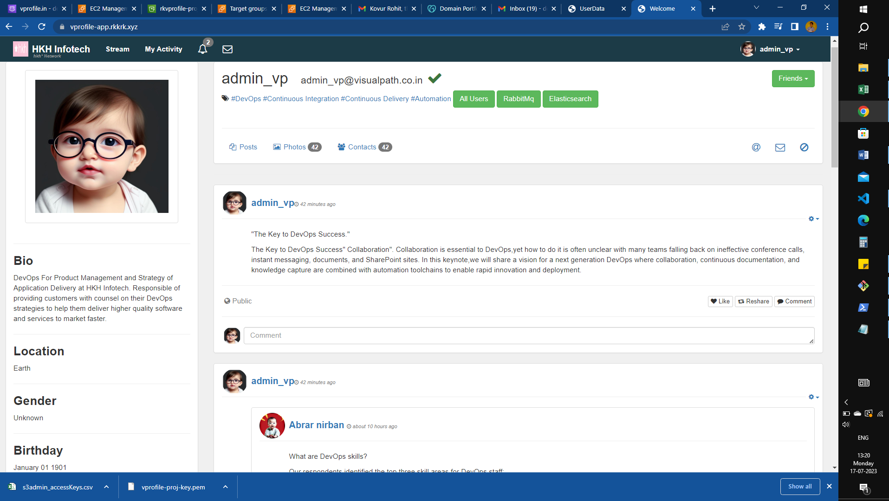

**INSTANCES LAUNCHED IN AWS:**

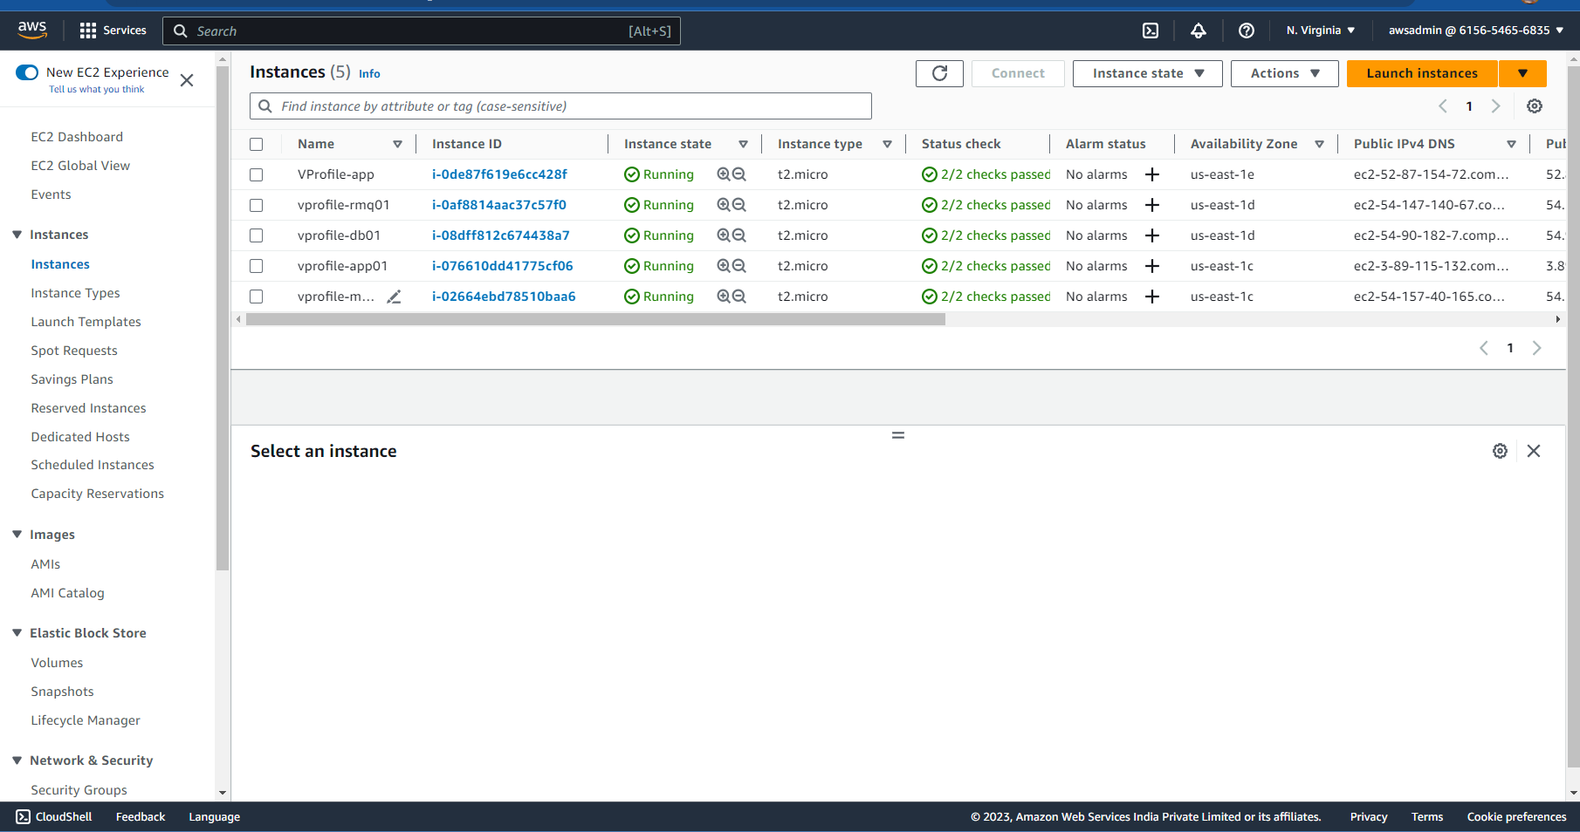

**SECURITY GROUPS:**

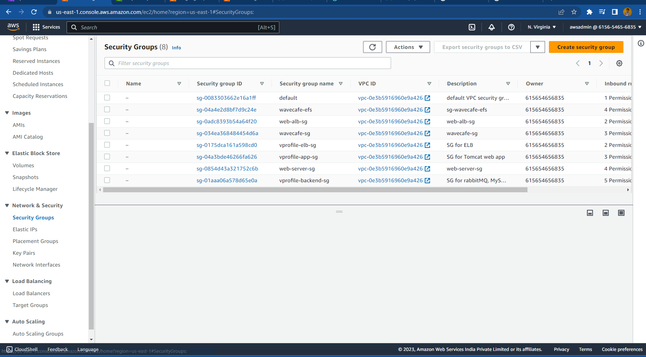

**TARGET GROUPS FOR ELB WITH HEALTHY TARGETS:**

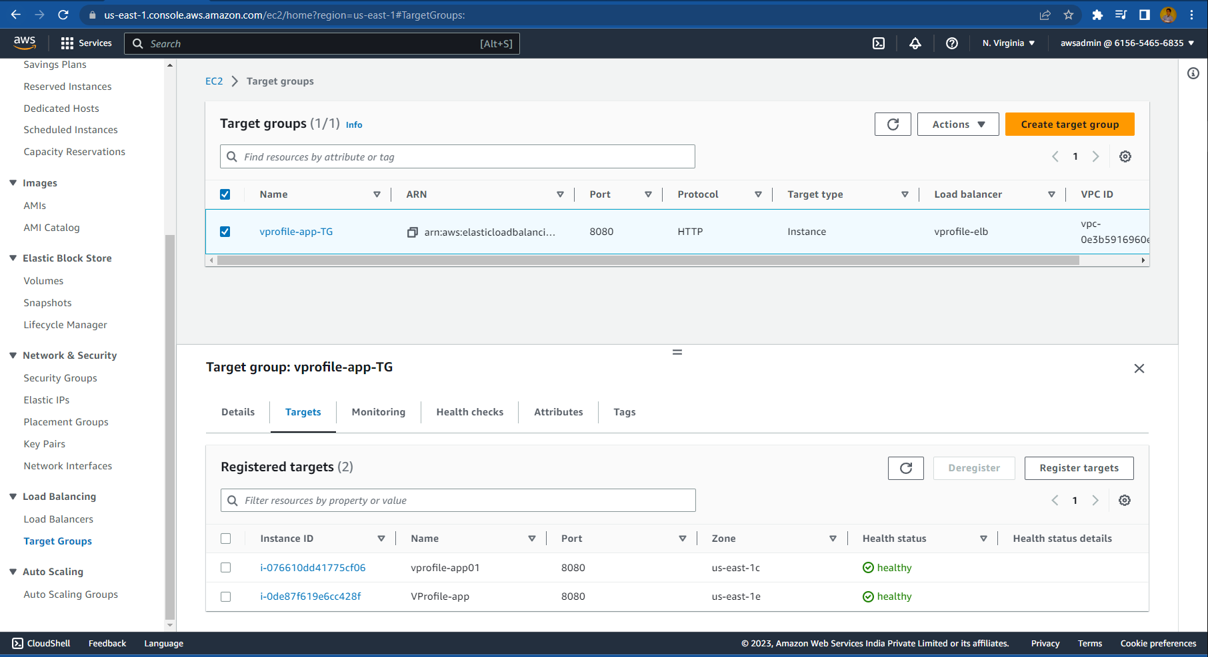

**ELB:**

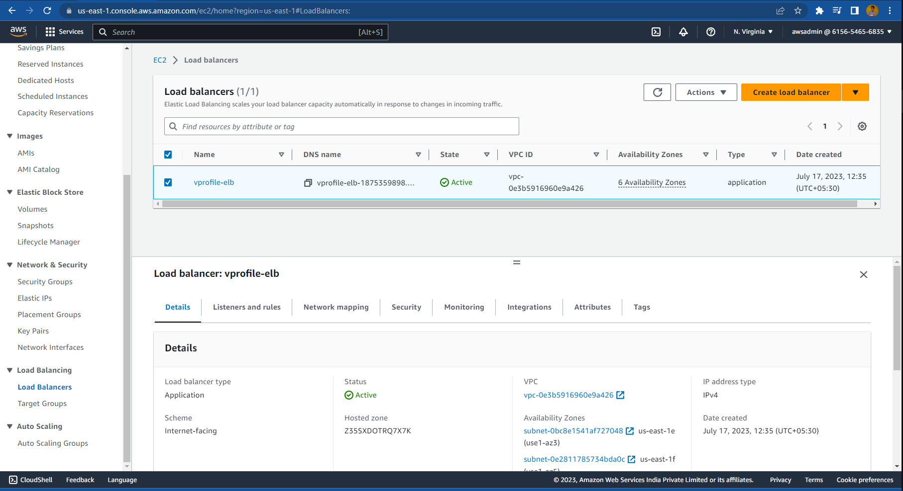

**CNAME RECORD IN DNS FOR ELB:**

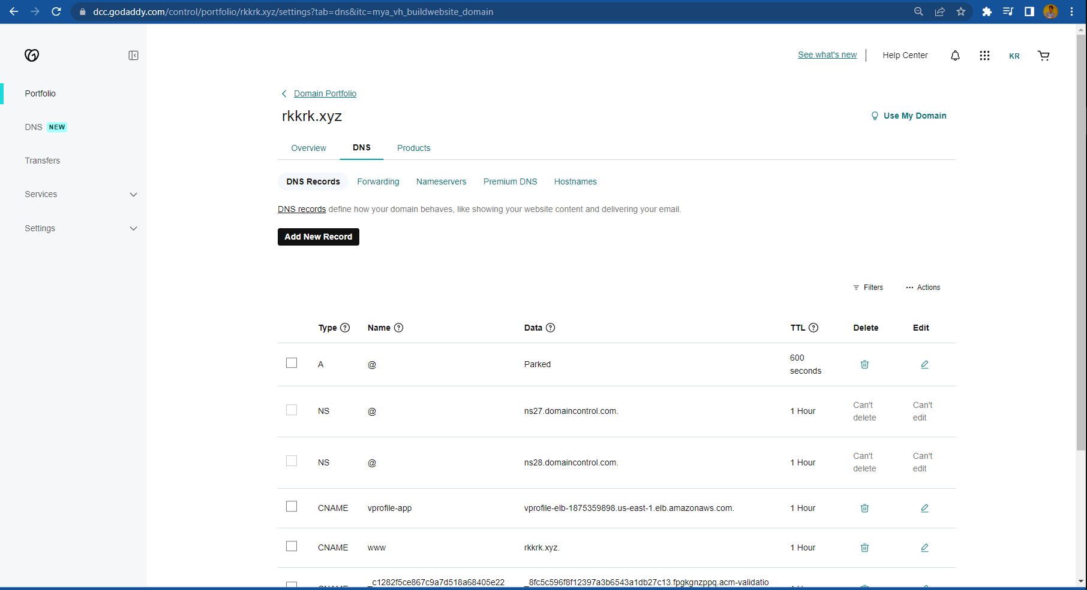

**AMI FOR AUTOSCALING:**

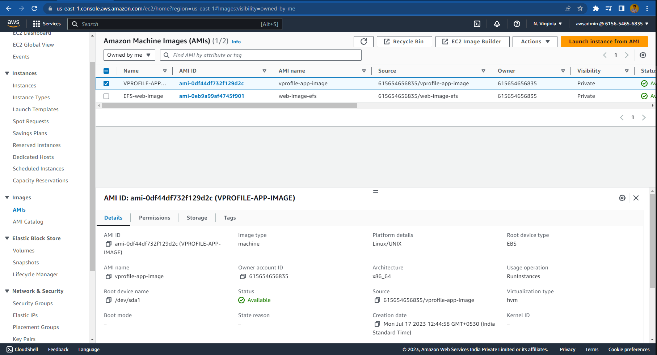

**LAUNCH CONFIGURATION FOR AUTOSCALING:**

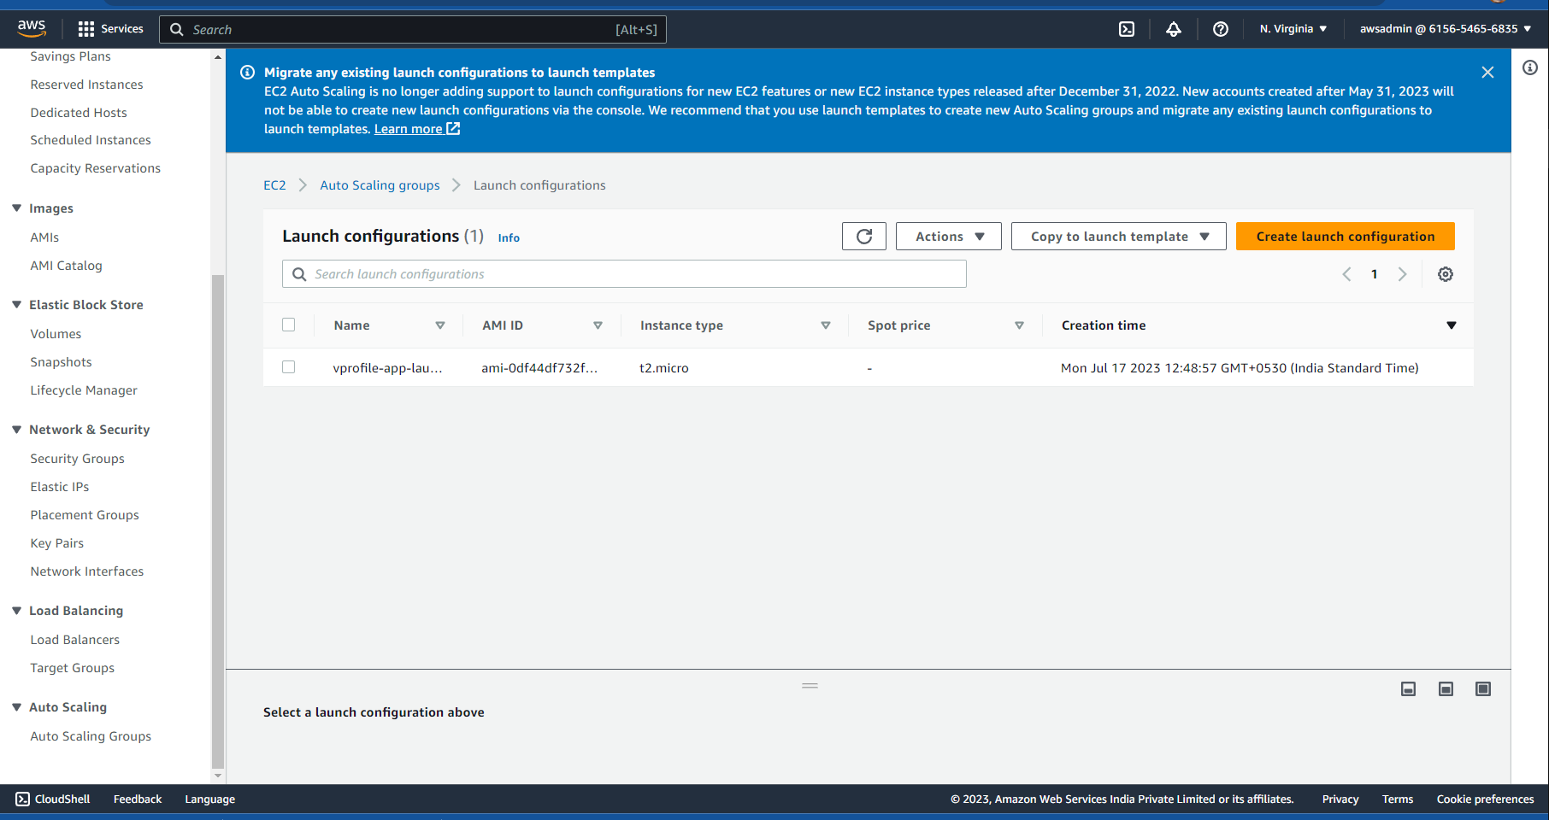

**IAM ROLE:**

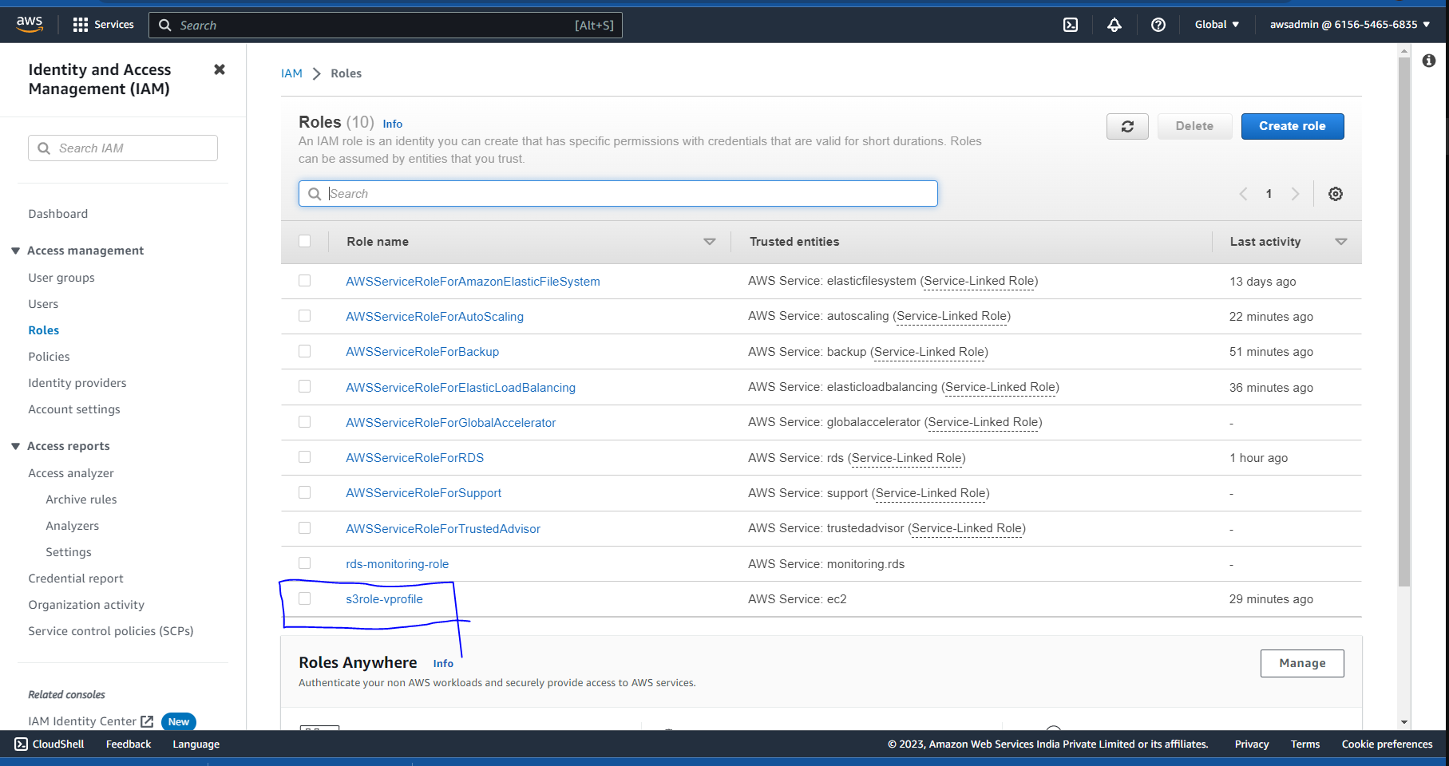

**IAM USER:**

