**Results:**

**1.Gender Analysis:**

Count of Buyers: The majority of buyers are females.

Purchasing Power: Females have a higher purchasing power compared to males.

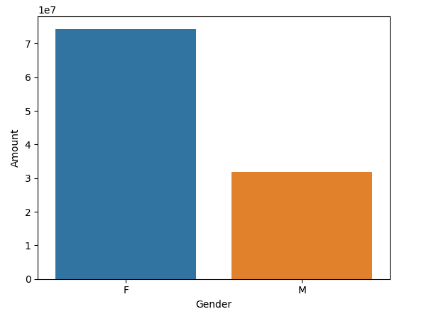

From the above graphs, we can see that most of the buyers are females, and the purchasing power of females is greater than that of males.

**2.Age Group Analysis:**

Count by Age Group: Most buyers fall within the age group of 26-35 years.

Purchasing Power by Age Group: The 26-35 age group also shows the highest purchasing power.

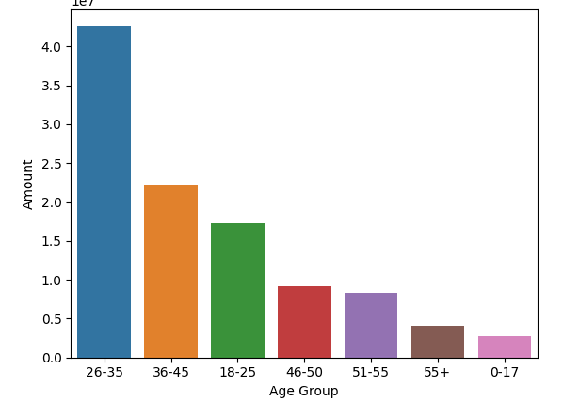

From the above graphs, we can see that most of the buyers are females aged between 26-35 years.

**3.State Analysis:**

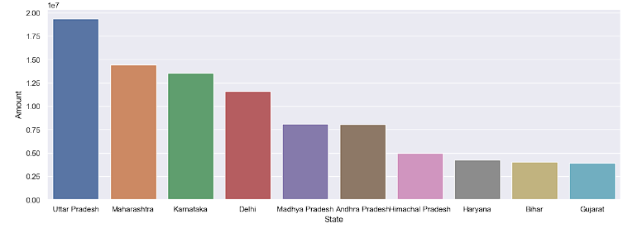

Top 10 States by Orders: Analysis of the total number of orders from the top 10 states shows where most of the sales are coming from.

**4.Sector Analysis**:

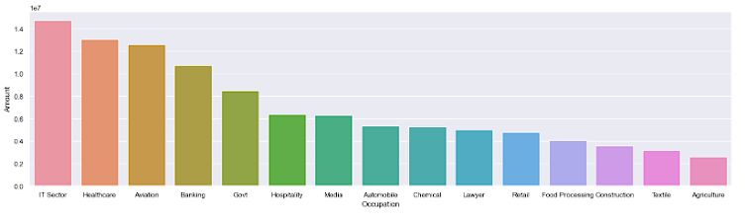

From above graphs we can see that most of the buyers are working in IT, Healthcare and Aviation sector

**5.product sold analysis:**

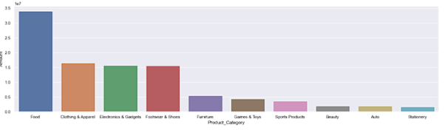

From above graphs we can see that most of the sold products are from Food, Clothing and Electronics category