**Exp-2**

**#Rohitkumar pandey 211P002**

**import matplotlib.pyplot as plt**

**from matplotlib.figure import Figure**

**from matplotlib.backends.backend_tkagg import FigureCanvasTkAgg**

**import pandas as pd**

**import numpy as np**

**from sklearn.model_selection import train_test_split**

**from sklearn.linear_model import LinearRegression**

**import tkinter as tk**

**df = pd.read_csv("placement.csv")**

**root = tk.Tk()**

**root.title("CGPA vs Package Prediction")**

**root.geometry("800x600")**

**fig = Figure(figsize=(8, 6))**

**scatter_plot = fig.add_subplot(111)**

**x = df.iloc[:, 0].values.reshape(-1, 1)**

**y = df.iloc[:, -1].values**

**x_train, x_test, y_train, y_test = train_test_split(x, y, test_size=0.2, random_state=2)**

**model = LinearRegression()**

**model.fit(x_train, y_train)**

**model.score(x_test, y_test)**

**def predict_package():**

**try:**

**cgpa = float(entry_cgpa.get())**

**predicted_package = model.predict([[cgpa]])**

**label_prediction.config(text=f"Predicted Package: {predicted_package[0]:.2f} LPA")**

**except ValueError:**

**label_prediction.config(text="Please enter a valid CGPA")**

**label_cgpa = tk.Label(root, text="Enter CGPA:")**

**label_cgpa.pack(pady=10)**

**entry_cgpa = tk.Entry(root, width=10)**

**entry_cgpa.pack()**

**button_predict = tk.Button(root, text="Predict Package", command=predict_package)**

**button_predict.pack(pady=10)**

**label_prediction = tk.Label(root, text="")**

**label_prediction.pack(pady=10)**

**scatter_plot.scatter(df['cgpa'], df['package'])**

**scatter_plot.plot(x_train, model.predict(x_train), color='red') # Use x_train and predict on it**

**scatter_plot.set_xlabel('CGPA')**

**scatter_plot.set_ylabel('Package')**

**scatter_plot.set_title('CGPA vs Package')**

**canvas = FigureCanvasTkAgg(fig, master=root)**

**canvas.draw()**

**canvas.get_tk_widget().pack(side=tk.TOP, fill=tk.BOTH, expand=1)**

**tk.mainloop()**

**#PostLab 1**

**import matplotlib.pyplot as plt**

**import pandas as pd**

**import numpy as np**

**df = pd.read_csv('./placement.csv')**

**df.head()**

**# plotting the scatter plot**

**plt.scatter(df['cgpa'],df['package'])**

**plt.xlabel('CGPA') # setting x label**

**plt.ylabel('Package(in lpa)') # setting y label**

**plt.title('By Rohitkumar Pandey')**

**plt.show()**

**from sklearn.model_selection import train_test_split**

**# Getting cgpa values as X and pacakge as Y**

**X, Y= df.iloc[:,0], df.iloc[:,1]**

**X_train,X_test,Y_train,Y_test = train_test_split(X,Y,test_size=0.2,random_state=0)**

**lr_model = LinearRegression()**

**lr_model.fit(np.array(X_train).reshape(-1,1),np.array(Y_train).reshape(-1,1))**

**Y_pred = lr_model.predict(np.array(7).reshape(-1, 1))**

**print(Y_pred)**

**class LinearRegression:**

**def __init__(self):**

**self.m = None**

**self.c = None**

**def fit(self,x_train,y_train):**

**num, den = 0,0**

**x_mean, y_mean = x_train.mean(), y_train.mean()**

**for i in range(len(x_train)):**

**num = num + ((x_train[i]-x_mean)*(y_train[i]-y_mean))**

**den = den + ((x_train[i]-x_mean)**2)**

**m = num/den**

**c = y_mean - (m*x_mean)**

**self.m = m**

**self.c = c**

**def predict(self,x_test):**

**if self.m is None or self.c is None:**

**print('Model is not trained yet, Call the fit method.')**

**return None**

**return self.m*x_test + self.c**

**import tkinter as tk**

**from matplotlib.figure import Figure**

**from matplotlib.backends.backend_tkagg import FigureCanvasTkAgg**

**root = tk.Tk()**

**root.title("Package (in LPA) Prediction")**

**root.geometry('800x400')**

**fig = Figure(figsize=(8, 6))**

**scatter_plot = fig.add_subplot(111)**

**def predict_package():**

**try:**

**cgpa = float(entry_cgpa.get())**

**predicted_package = lr_model.predict([[cgpa]])**

**label_prediction.config(text=f"Predicted Package: {predicted_package[0][0]:.2f} LPA")**

**except ValueError:**

**label_prediction.config(text="Please enter a valid CGPA")**

**label_cgpa = tk.Label(root, text="Enter CGPA:")**

**label_cgpa.pack(pady=10)**

**entry_cgpa = tk.Entry(root, width=10)**

**entry_cgpa.pack()**

**button_predict = tk.Button(root, text="Predict Package", command=predict_package)**

**button_predict.pack(pady=10)**

**label_prediction = tk.Label(root, text="")**

**label_prediction.pack(pady=10)**

**scatter_plot.scatter(df['cgpa'], df['package'])**

**scatter_plot.plot(X_train, lr_model.predict(np.array(X_train).reshape(-1,1)), color='orange')**

**scatter_plot.set_xlabel('CGPA')**

**scatter_plot.set_ylabel('Package')**

**scatter_plot.set_title('Package Prediction based on CGPA By Rohitkumar Pandey')**

**canvas = FigureCanvasTkAgg(fig, master=root)**

**canvas.draw()**

**canvas.get_tk_widget().pack(side=tk.TOP, fill=tk.BOTH, expand=1)**

**tk.mainloop()**

**# Postlab 2**

**import matplotlib.pyplot as plt**

**import pandas as pd**

**import numpy as np**

**df = pd.read_csv('./placement.csv')**

**df.head()**

**from sklearn.model_selection import train_test_split**

**# Getting cgpa values as X and pacakge as Y**

**X, Y= df.iloc[:,0], df.iloc[:,1]**

**X_train,X_test,Y_train,Y_test = train_test_split(X,Y,test_size=0.2,random_state=0)**

**from sklearn.linear_model import LinearRegression**

**lr_model = LinearRegression() # Creating the model**

**lr_model.fit(np.array(X_train).reshape(-1,1),Y_train) # Fitting the model**

**# To show the errors in prediction MAE, MSE etc**

**import tkinter as tk**

**from matplotlib.figure import Figure**

**from matplotlib.backends.backend_tkagg import FigureCanvasTkAgg**

**from sklearn.metrics import mean_squared_error, mean_absolute_error, r2_score**

**root = tk.Tk()**

**root.title("Package (in LPA) Prediction")**

**root.geometry('800x600')**

**fig = Figure(figsize=(8, 6))**

**scatter_plot = fig.add_subplot(111)**

**def predict_package():**

**try:**

**cgpa = float(entry_cgpa.get())**

**predicted_package = lr_model.predict([[cgpa]])**

**label_prediction.config(text=f"Predicted Package: {predicted_package[0]:.2f} LPA")**

**show_errors()**

**except ValueError:**

**label_prediction.config(text="Please enter a valid CGPA")**

**def show_errors():**

**y_pred = lr_model.predict(np.array(X_test).reshape(-1, 1))**

**# Calculate metrics**

**mse = mean_squared_error(Y_test, y_pred)**

**mae = mean_absolute_error(Y_test, y_pred)**

**r2 = r2_score(Y_test, y_pred)**

**rmse = np.sqrt(mse)**

**error_text = f"Regression Metrics:- \n"\**

**f"Mean Squared Error (MSE): {mse:.2f}\n" \**

**f"Mean Absolute Error (MAE): {mae:.2f}\n" \**

**f"R-squared (R2): {r2:.2f}\n" \**

**f"Root Mean Squared Error (RMSE): {rmse:.2f}"**

**label_errors.config(text=error_text)**

**label_cgpa = tk.Label(root, text="Enter CGPA:")**

**label_cgpa.pack(pady=10)**

**entry_cgpa = tk.Entry(root, width=10)**

**entry_cgpa.pack()**

**button_predict = tk.Button(root, text="Predict Package", command=predict_package)**

**button_predict.pack(pady=10)**

**label_prediction = tk.Label(root, text="")**

**label_prediction.pack(pady=10)**

**label_errors = tk.Label(root, text="")**

**label_errors.pack(pady=10)**

**scatter_plot.scatter(df['cgpa'], df['package'])**

**scatter_plot.plot(X_train, lr_model.predict(np.array(X_train).reshape(-1,1)), color='orange')**

**scatter_plot.set_xlabel('CGPA')**

**scatter_plot.set_ylabel('Package')**

**scatter_plot.set_title('Package Prediction based on CGPA By Rohitkumar Pandey')**

**canvas = FigureCanvasTkAgg(fig, master=root)**

**canvas.draw()**

**canvas.get_tk_widget().pack(side=tk.TOP, fill=tk.BOTH, expand=1)**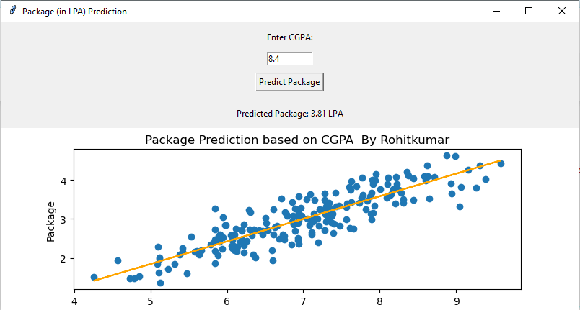

**tk.mainloop()**

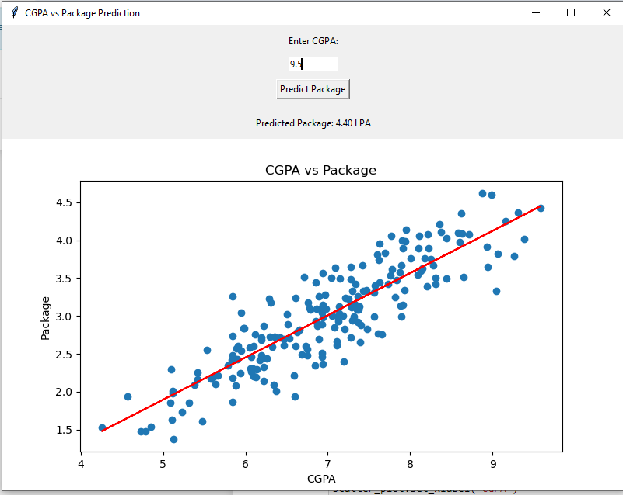

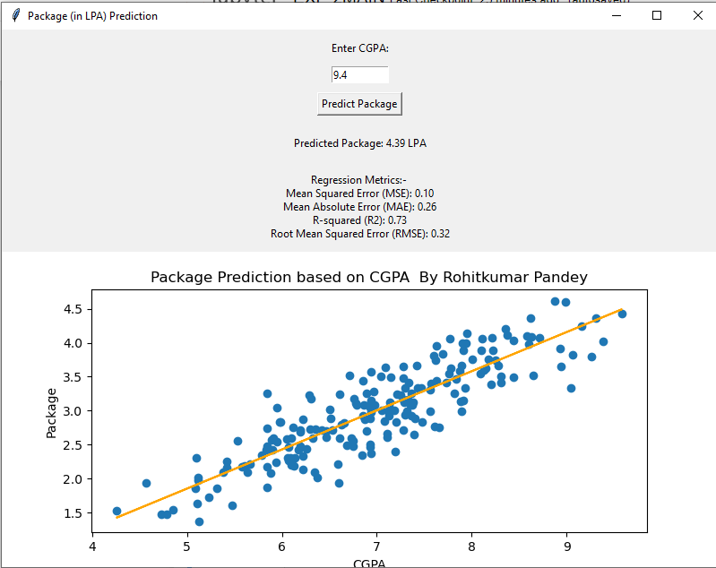

Exp-3

**import tkinter as tk**

**import pandas as pd**

**data=pd.read_csv('add.csv')**

**x=data[['x','y']]**

**y=data['sum']**

**from sklearn.model_selection import train_test_split**

**x_train,x_test,y_train,y_test=train_test_split(x,y,test_size=0.33,random_state=42)**

**from sklearn.linear_model import LinearRegression**

**model=LinearRegression()**

**model.fit(x_train,y_train)**

**def display_inputs():**

**# Retrieve inputs from the entry widgets**

**input1 = float(entry1.get())**

**input2 = float(entry2.get())**

**y_pred=model.predict([[input1,input2]])[0]**

**# Display the inputs in the label widget**

**result_label.config(text=f"Input 1: {input1}\nInput 2: {input2}\n {y_pred:.2f}")**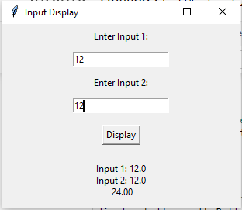

**# Create the main window**

**root = tk.Tk()**

**root.title("Input Display")**

**# Create and place the first label and entry widget**

**label1 = tk.Label(root, text="Enter Input 1:")**

**label1.pack(pady=5)**

**entry1 = tk.Entry(root)**

**entry1.pack(pady=5)**

**# Create and place the second label and entry widget**

**label2 = tk.Label(root, text="Enter Input 2:")**

**label2.pack(pady=5)**

**entry2 = tk.Entry(root)**

**entry2.pack(pady=5)**

**# Create and place the display button**

**display_button = tk.Button(root, text="Display", command=display_inputs)**

**display_button.pack(pady=10)**

**# Create and place the result label**

**result_label = tk.Label(root, text="")**

**result_label.pack(pady=10)**

**# Start the Tkinter event loop**

**root.mainloop()**

**#postlab1**

**import numpy as np**

**import tkinter as tk**

**from tkinter import ttk**

**from sklearn.datasets import load_diabetes**

**from sklearn.model_selection import train_test_split**

**from sklearn.metrics import r2_score**

**#211P002**

**data = load_diabetes()**

**X = data.data[:, :2]**

**y = data.target**

**X_train, X_test, y_train, y_test = train_test_split(X, y, test_size=0.33, random_state=42)**

**class MyLinearRegression:**

**def __init__(self):**

**self.intercept_ = None**

**self.coef_ = None**

**def fit(self, X_train, y_train):**

**X_b = np.c_[np.ones((X_train.shape[0], 1)), X_train]**

**self.coef_ = np.linalg.inv(X_b.T @ X_b) @ X_b.T @ y_train**

**self.intercept_ = self.coef_[0]**

**self.coef_ = self.coef_[1:]**

**def predict(self, X_test):**

**X_b = np.c_[np.ones((X_test.shape[0], 1)), X_test]**

**return X_b @ np.concatenate(([self.intercept_], self.coef_))**

**my_model = MyLinearRegression()**

**my_model.fit(X_train, y_train)**

**y_pred_my = my_model.predict(X_test)**

**r2_my = r2_score(y_test, y_pred_my)**

**intercept_my = my_model.intercept_**

**coefficients_my = my_model.coef_**

**class RegressionApp:**

**def __init__(self, root):**

**self.root = root**

**self.root.title("Multiple Linear Regression By 222P005")**

**self.create_widgets()**

**def create_widgets(self):**

**ttk.Label(self.root, text="Feature 1:").grid(column=0, row=0, padx=10, pady=10)**

**self.feature1_var = tk.DoubleVar()**

**self.feature1_entry = ttk.Entry(self.root, textvariable=self.feature1_var)**

**self.feature1_entry.grid(column=1, row=0, padx=10, pady=10)**

**ttk.Label(self.root, text="Feature 2:").grid(column=0, row=1, padx=10, pady=10)**

**self.feature2_var = tk.DoubleVar()**

**self.feature2_entry = ttk.Entry(self.root, textvariable=self.feature2_var)**

**self.feature2_entry.grid(column=1, row=1, padx=10, pady=10)**

**self.calc_button = ttk.Button(self.root, text="Calculate", command=self.calculate)**

**self.calc_button.grid(column=0, row=4, columnspan=2, pady=10)**

**# Result Labels**

**ttk.Label(self.root, text="Prediction:").grid(column=0, row=5, padx=10, pady=10)**

**self.result_var = tk.StringVar()**

**self.result_label = ttk.Label(self.root, textvariable=self.result_var)**

**self.result_label.grid(column=1, row=5, padx=10, pady=10)**

**# Custom Model Info**

**ttk.Label(self.root, text="R² Score:").grid(column=0, row=6, padx=10, pady=10)**

**self.r2_var = tk.StringVar(value=f"{r2_my:.4f}")**

**self.r2_label = ttk.Label(self.root, textvariable=self.r2_var)**

**self.r2_label.grid(column=1, row=6, padx=10, pady=10)**

**ttk.Label(self.root, text="Intercept:").grid(column=0, row=7, padx=10, pady=10)**

**self.intercept_var = tk.StringVar(value=f"{intercept_my:.4f}")**

**self.intercept_label = ttk.Label(self.root, textvariable=self.intercept_var)**

**self.intercept_label.grid(column=1, row=7, padx=10, pady=10)**

**ttk.Label(self.root, text="Coefficients:").grid(column=0, row=8, padx=10, pady=10)**

**self.coef_var = tk.StringVar(value=str(coefficients_my))**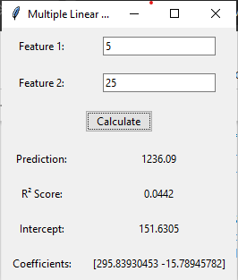

**self.coef_label = ttk.Label(self.root, textvariable=self.coef_var)**

**self.coef_label.grid(column=1, row=8, padx=10, pady=10)**

**def calculate(self):**

**feature1 = self.feature1_var.get()**

**feature2 = self.feature2_var.get()**

**features = np.array([[feature1, feature2]])**

**prediction = my_model.predict(features)[0]**

**self.result_var.set(f"{prediction:.2f}")**

**root = tk.Tk()**

**app = RegressionApp(root)**

**root.mainloop()**

**Exp4**

**import pandas as pd**

**import seaborn as sns**

**import matplotlib.pyplot as plt**

**from sklearn.model_selection import train_test_split**

**from sklearn.linear_model import LogisticRegression**

**from sklearn.metrics import confusion_matrix**

**from sklearn.metrics import accuracy_score, confusion_matrix, classification_report**

**import tkinter as tk**

**from tkinter import ttk**

**import matplotlib.pyplot as plt**

**from matplotlib.backends.backend_tkagg import FigureCanvasTkAgg**

**titanic_data = pd.read_csv('titanic.csv')**

**titanic_data.head()**

**titanic_data.isnull().sum()**

**titanic_data['age'].fillna(titanic_data['age'].mean(), inplace=True)**

**titanic_data['cabin'].fillna(titanic_data['cabin'].mode()[0], inplace=True)**

**titanic_data['embarked'].fillna(titanic_data['embarked'].mode()[0], inplace=True)**

**titanic_data['fare'].fillna(titanic_data['fare'].mean(), inplace=True)**

**titanic_data.isnull().sum()**

**sns.countplot(x='survived', data=titanic_data)**

**plt.show()**

**sns.countplot(x='survived', hue='sex', data=titanic_data)**

**plt.show()**

**sns.countplot(x='survived', hue='pclass', data=titanic_data)**

**plt.show()**

**titanic_data['age'].plot.hist()**

**titanic_data = pd.get_dummies(titanic_data, columns=['sex','embarked'])**

**titanic_data.head()**

**titanic_data.drop(['sex_female', 'embarked_C'], axis=1, inplace=True)**

**titanic_data.head()**

**X = titanic_data.drop('survived', axis=1).select_dtypes(exclude=['object'])**

**y = titanic_data['survived']**

**X_train, X_test, y_train, y_test = train_test_split(X, y, test_size=0.3, random_state=42)**

**model = LogisticRegression()**

**model.fit(X_train, y_train)**

**predictions = model.predict(X_test)**

**print("Accuracy:", accuracy_score(y_test, predictions))**

**print("\nConfusion Matrix:\n", confusion_matrix(y_test, predictions))**

**print("\nClassification Report:\n", classification_report(y_test, predictions))**

**def plot_graph():**

**hue_choice = hue_var.get()**

**sns.countplot(x='survived', hue=hue_choice, data=titanic_data)**

**plt.title(f'Survival Countplot by {hue_choice.title()}')**

**canvas = FigureCanvasTkAgg(plt.gcf(), master=root)**

**canvas.draw()**

**canvas.get_tk_widget().grid(row=2, column=0, columnspan=2)**

**root = tk.Tk()**

**root.title("Titanic Survival Visualization")**

**hue_var = tk.StringVar(value='pclass')**

**ttk.Label(root, text="Select Hue:").grid(row=0, column=0, padx=5, pady=5)**

**ttk.Radiobutton(root, text="Age", variable=hue_var, value='age').grid(row=0, column=1, sticky='w')**

**ttk.Radiobutton(root, text="Pclass", variable=hue_var, value='pclass').grid(row=1, column=1, sticky='w')**

**plot_button = ttk.Button(root, text="Plot Graph", command=plot_graph)**

**plot_button.grid(row=3, column=0, columnspan=2, pady=10)**

**root.mainloop()**

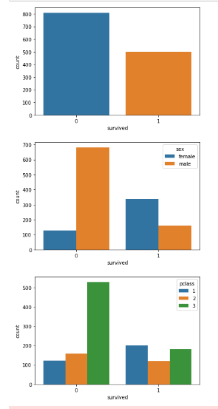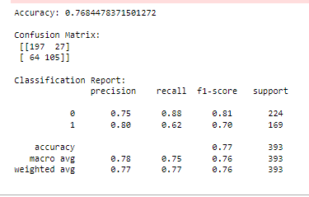

**#postlab1**

**import numpy as np**

**import matplotlib.pyplot as plt**

**from sklearn import datasets**

**from sklearn.model_selection import train_test_split**

**from sklearn.linear_model import LogisticRegression**

**from sklearn.metrics import accuracy_score**

**import tkinter as tk**

**from tkinter import \***

**from tkinter import messagebox**

**from PIL import Image, ImageTk, ImageDraw**

**import matplotlib.pyplot as plt**

**from sklearn.datasets import load_digits**

**# Load the digits dataset**

**digits = load_digits()**

**X = digits.data**

**y = digits.target**

**# Split the dataset into training and test sets**

**X_train, X_test, y_train, y_test = train_test_split(X, y, test_size=0.2, random_state=42)**

**# Create and train the logistic regression model**

**model = LogisticRegression(max_iter=10000)**

**model.fit(X_train, y_train)**

**# Predict the test set**

**y_pred = model.predict(X_test)**

**# Display accuracy**

**accuracy = accuracy_score(y_test, y_pred)**

**print(f'Accuracy: {accuracy:.4f}')**

**# Function to predict digit based on drawn image**

**def predict_digit(img):**

**# Resize image to 8x8 pixels and convert to grayscale**

**img = img.resize((8, 8), Image.Resampling.LANCZOS).convert('L') # Use LANCZOS instead of ANTIALIAS**

**img = np.array(img)**

**# Invert the image color (as the model was trained on white digits on a black background)**

**img = 16 - (img / 16)**

**img = img.reshape(1, -1)**

**# Predict the digit**

**res = model.predict(img)**

**return res[0]**

**# GUI to draw and predict digit**

**class DigitApp:**

**def __init__(self, root):**

**self.root = root**

**self.root.title("Digit Recognizer by Rohitkumar Pandey")**

**self.root.geometry("400x400")**

**self.canvas = Canvas(self.root, width=200, height=200, bg="white")**

**self.canvas.pack(pady=20)**

**self.clear_btn = Button(self.root, text="Clear", command=self.clear_canvas)**

**self.clear_btn.pack(side=LEFT, padx=20)**

**self.predict_btn = Button(self.root, text="Predict", command=self.classify_handwritten_digit)**

**self.predict_btn.pack(side=RIGHT, padx=20)**

**self.canvas.bind("<B1-Motion>", self.draw)**

**self.image = Image.new("RGB", (200, 200), (255, 255, 255))**

**self.draw_img = ImageDraw.Draw(self.image)**

**def clear_canvas(self):**

**self.canvas.delete("all")**

**self.image = Image.new("RGB", (200, 200), (255, 255, 255))**

**self.draw_img = ImageDraw.Draw(self.image)**

**def draw(self, event):**

**x, y = event.x, event.y**

**r = 8**

**self.canvas.create_oval(x - r, y - r, x + r, y + r, fill="black")**

**self.draw_img.ellipse([x - r, y - r, x + r, y + r], fill="black")**

**def classify_handwritten_digit(self):**

**digit = predict_digit(self.image)**

**messagebox.showinfo("Prediction", f"The digit is: {digit}")**

**# Create GUI window**

**root = Tk()**

**app = DigitApp(root)**

**root.mainloop()**

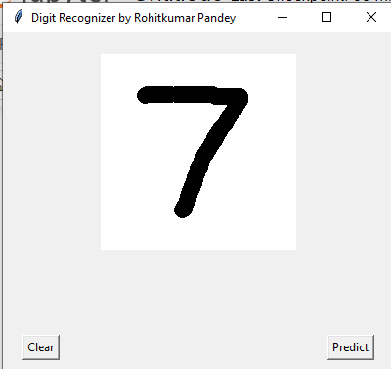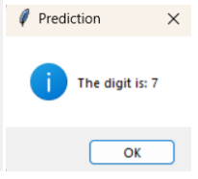

**Exp-5**

**# Importing the required libraries**

**import pandas as pd**

**import numpy as np**

**import matplotlib.pyplot as plt**

**import warnings**

**warnings.filterwarnings("ignore")**

**# Reading the csv file and putting it into 'df' object.**

**df = pd.read_csv('adult_dataset.csv')**

**df.info()**

**df.head()**

**df.isin(['?']).sum(axis=0)**

**df=df.replace('?',np.nan)**

**df=df.dropna()**

**df.isin(['?']).sum(axis=0)**

**from sklearn.preprocessing import LabelEncoder**

**le=LabelEncoder()**

**df=df.apply(le.fit_transform)**

**df.head()**

**from sklearn.model_selection import train_test_split**

**from sklearn.tree import DecisionTreeClassifier,plot_tree**

**from sklearn.metrics import accuracy_score**

**x=df.drop('income',axis=1)**

**y=df['income']**

**X_train,X_test,y_train,y_test=train_test_split(x,y,test_size=0.2,random_state=42)**

**clf=DecisionTreeClassifier(max_depth=3)**

**clf.fit(X_train,y_train)**

**y_pred=clf.predict(X_test)**

**accuracy=accuracy_score(y_test,y_pred)**

**print("Accuracy:",accuracy)**

**plt.title("Rohitkumar Pandey -- 211P002")**

**plt.figure(figsize=(10,8))**

**plot_tree(decision_tree=clf,feature_names=x.columns,class_names=['<=50k','>50k'],filled=True)**

**plt.show()**

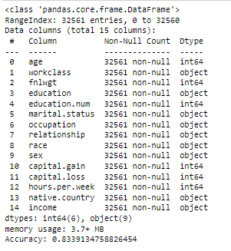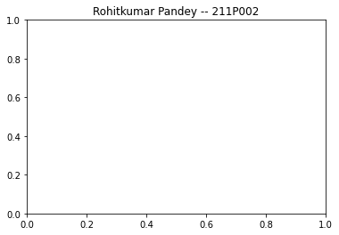

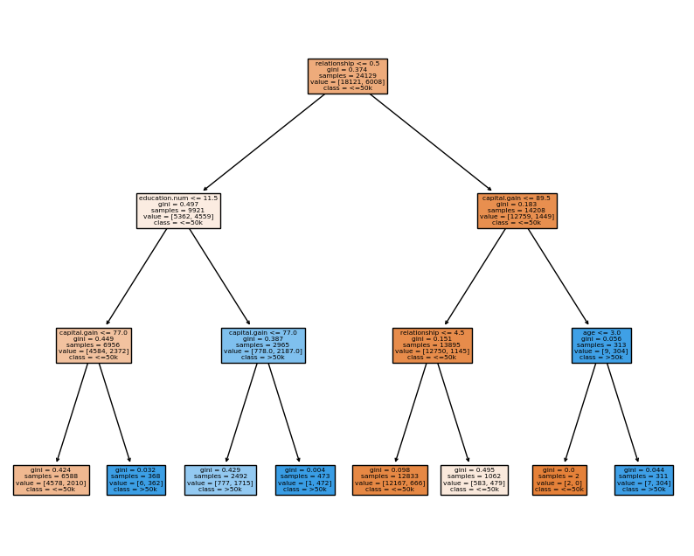

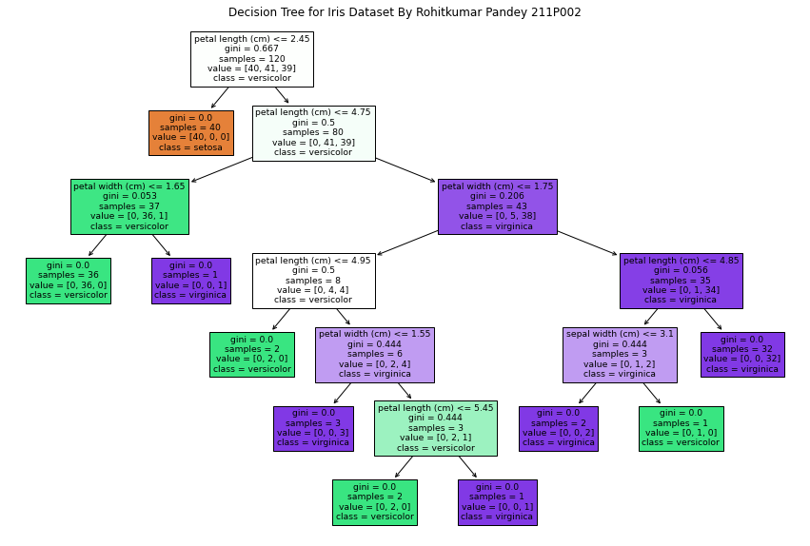

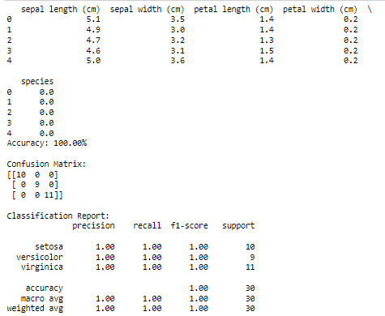

**#postlab 1**

**# Import necessary libraries**

**import numpy as np**

**import pandas as pd**

**from sklearn.datasets import load_iris**

**from sklearn.model_selection import train_test_split**

**from sklearn.tree import DecisionTreeClassifier**

**from sklearn import metrics**

**from sklearn.tree import plot_tree**

**import matplotlib.pyplot as plt**

**# Load the Iris dataset**

**iris = load_iris()**

**X = iris.data # Features (sepal length, sepal width, petal length, petalwidth)**

**y = iris.target # Labels (0: Iris-setosa, 1: Iris-versicolour, 2:Iris-virginica)**

**# Convert to a DataFrame for easy analysis (optional)**

**df = pd.DataFrame(data=np.c_[X, y], columns=iris['feature_names'] +['species'])**

**print(df.head()) # Show first few rows**

**# Split the dataset into training and test sets (80% training, 20%testing)**

**X_train, X_test, y_train, y_test = train_test_split(X, y, test_size=0.2,random_state=42)**

**# Train a Decision Tree classifier**

**clf = DecisionTreeClassifier(random_state=42)**

**clf.fit(X_train, y_train)**

**# Make predictions on the test set**

**y_pred = clf.predict(X_test)**

**# Evaluate the model**

**accuracy = metrics.accuracy_score(y_test, y_pred)**

**print(f"Accuracy: {accuracy * 100:.2f}%")**

**# Display the confusion matrix**

**confusion_matrix = metrics.confusion_matrix(y_test, y_pred)**

**print("\nConfusion Matrix:")**

**print(confusion_matrix)**

**# Display classification report (precision, recall, F1-score for each class)**

**classification_report = metrics.classification_report(y_test, y_pred,**

**target_names=iris.target_names)**

**print("\nClassification Report:")**

**print(classification_report)**

**# Visualize the Decision Tree**

**plt.figure(figsize=(15, 10))**

**plot_tree(clf, filled=True, feature_names=iris.feature_names,class_names=iris.target_names)**

**plt.title("Decision Tree for Iris Dataset By Rohitkumar Pandey 211P002")**

**plt.show()**

**# Feature importance analysis**

**feature_importances = clf.feature_importances_**

**for name, importance in zip(iris.feature_names, feature_importances):**

**print(f"{name}: {importance:.2f}")**