BUSINESS INTELLIGENCE & OPERATIONAL REPORTING
Enterprise Sales &
Operational Analytics
PROJECT DOCUMENTATION
Version 1.0 • 2024
PREPARED BY
Rohit.P.B.
Email rohitpb17@gmail.com
Phone +91-9400278146
LinkedIn linkedin.com/in/rohit-p-b-a04b87369
Medium medium.com/@rohitpb17
CONFIDENTIAL • FOR INTERNAL & PORTFOLIO USE © 2024 Rohit.P.B.

Table of Contents

1. Project Overview 3
2. Business Problem Statement 3
3. Proposed Solution 3
4. Project Objectives 3
5. Scope of the Project 4
In Scope 4
Out of Scope 4
6. Technology Stack 4
7. Initial Analysis Insights 4
8. Key Performance Indicators (KPIs) 5
9. System Architecture 5
10. Workflow Description 7
11. SQL Analytics & Reporting 7
12. Tableau Dashboard Overview 7
13. Business Benefits 8
14. Conclusion 8
15. Future Enhancements 9

1. Project Overview
This project presents an end-to-end enterprise sales analytics workflow built using Excel, Power Query, a Dockerized MySQL environment, SQL-based analytics, and Tableau dashboards.
The solution transforms raw operational sales data into actionable business intelligence through structured KPI reporting, profitability analysis, and dashboard-driven visualization, supporting data-informed decision-making across the organization.

2. Business Problem Statement
Many organizations face challenges consolidating operational sales data across multiple business regions and converting raw transactional records into actionable business insights.
Manual reporting processes commonly result in:
- Delayed visibility into key performance indicators
- Inefficient and inconsistent sales tracking
- Limited profitability analysis capability
- Difficulty identifying high-performing products and regions

Without a centralized analytics workflow, management’s ability to make timely, data-driven operational and strategic decisions is significantly constrained.

3. Proposed Solution
An end-to-end enterprise analytics workflow was designed to convert raw operational sales data into structured business intelligence reports and interactive dashboards. The solution comprises the following components:
- Data cleaning and transformation using Power Query
- KPI reporting and operational analysis in Excel
- Containerized MySQL database deployment using Docker
- SQL-based sales, profitability, and trend analysis
- Interactive Tableau dashboards for executive reporting

4. Project Objectives
- Develop an enterprise-style operational analytics workflow
- Perform sales and profitability analysis
- Implement SQL-based KPI reporting
- Create interactive Tableau dashboards
- Demonstrate end-to-end analytics integration

5. Scope of the Project

In Scope
- Cleaning and transforming operational sales data
- SQL-based analytics and KPI reporting
- Tableau dashboard visualization
- Enterprise analytics workflow integration

Out of Scope
- Real-time data streaming
- Machine learning implementation
- Automated ETL orchestration

6. Technology Stack
Category | Tools / Technologies
Data Preparation | Microsoft Excel, Power Query
Database | Docker Desktop, MySQL
Analytics | SQL, TablePlus
Visualization | Tableau
Version Control | GitHub

7. Initial Analysis Insights
- Regional sales analysis revealed varying revenue contributions across business locations.
- Monthly sales trends indicated fluctuations in operational business activity over reporting periods.
- Category profitability analysis highlighted differences in profit margin performance across product categories.
- Top-performing products contributed significantly to overall revenue generation.

8. Key Performance Indicators (KPIs)
KPI | Description
Total Revenue | Aggregate revenue generated across all transactions
Total Profit | Aggregate profit generated across all transactions
Average Profit Margin % | Mean profit margin across product categories
Regional Sales Performance | Revenue and profit performance by region
Monthly Sales Trends | Sales performance tracked over monthly periods
Category Profitability | Profit margin comparison across product categories
Top Product Revenue Contribution | Revenue share attributable to top-performing products
Payment Mode Distribution | Transaction volume by payment method

9. System Architecture
The solution follows a sequential data pipeline, moving raw operational data through transformation, storage, analysis, and visualization stages:

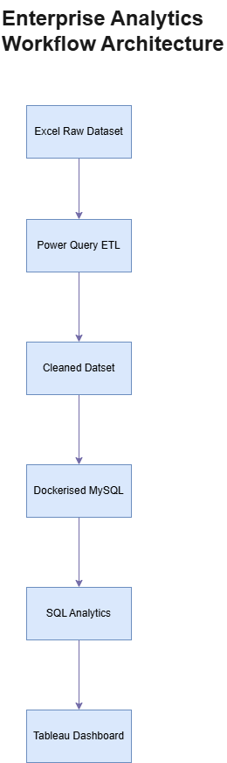
Figure 1: Enterprise Analytics Workflow Architecture

10. Workflow Description
Raw operational sales data was transformed and cleaned using Power Query in Excel. The cleaned dataset was then exported as CSV and integrated into a Dockerized MySQL database environment.
SQL queries were executed against the database to perform KPI reporting, profitability analysis, and operational sales analytics. The resulting analytical outputs were visualized using Tableau dashboards to support business intelligence reporting.

11. SQL Analytics & Reporting
The project incorporates the following SQL-based analytical reports:
- Regional Sales Analysis
- Monthly Revenue Trends
- Category Profitability Analysis
- Top Product Performance Analysis
- Payment Mode Analysis

12. Tableau Dashboard Overview
Interactive Tableau dashboards were developed to visualize:
- Regional Sales Performance
- Monthly Sales Trends
- Category Profitability
- Top Product Revenue Contribution
These dashboards support business intelligence reporting and operational KPI analysis for executive and operational stakeholders.

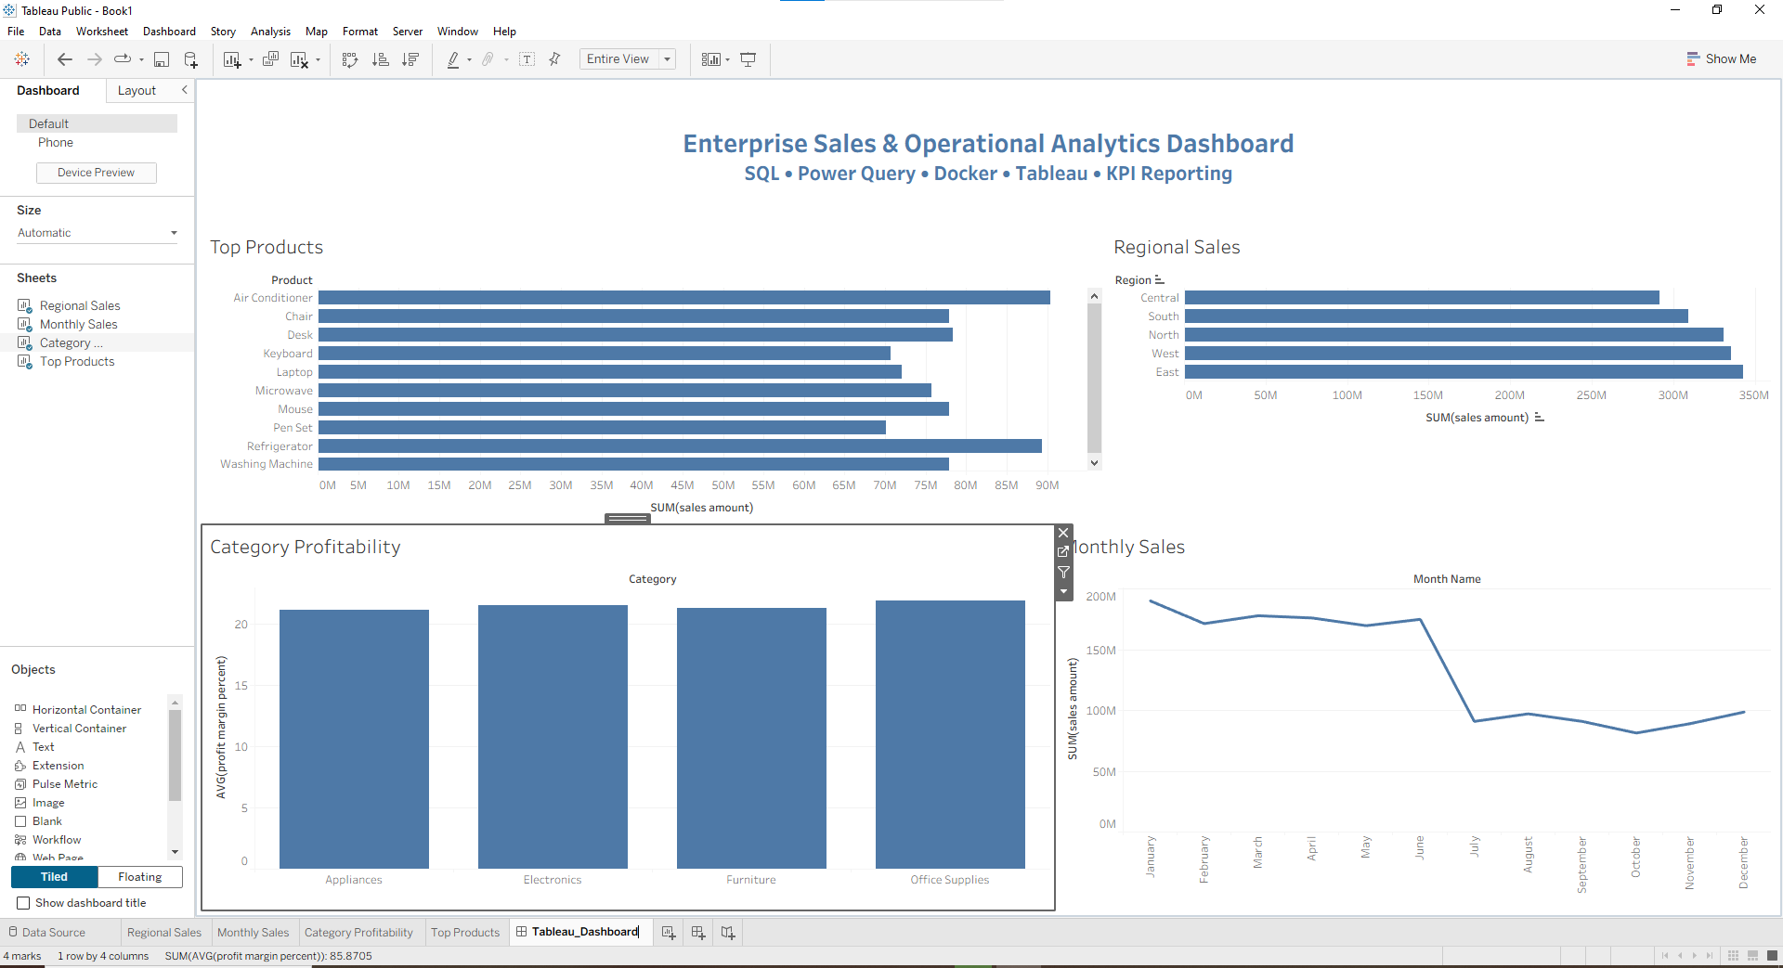

Figure 2: Enterprise Sales & Operational Analytics Dashboard

13. Business Benefits
Benefit | Impact
Improved operational visibility | Faster identification of performance trends
Faster KPI reporting workflows | Reduced time-to-insight for stakeholders
Better profitability monitoring | Clearer view of margin performance by category
Enhanced sales performance tracking | Region- and product-level performance clarity
Structured business intelligence reporting | Consistent, repeatable reporting framework
Improved decision-making support | Data-driven strategic and operational decisions

14. Conclusion
This project successfully demonstrates an end-to-end enterprise sales analytics workflow integrating Excel, Power Query, Dockerized MySQL, SQL analytics, and Tableau dashboards.
The implemented solution improves KPI visibility, operational reporting, and business intelligence analysis through a structured analytics workflow and dashboard-driven reporting, providing a scalable foundation for enterprise decision support.

15. Future Enhancements
- Power BI integration
- Automated ETL pipeline implementation
- Python-based analytics automation
- Jenkins-based workflow scheduling
- Direct MySQL to Tableau live integration
- Advanced predictive analytics implementation

