Experiment -1
AIM : Write a C++ program to find the contents and study the structure of all intermediate files created during the built-up process.
Theory: A compiler is a special program that translates a programming language's source code into machine code, bytecode or another programming language. The source code is typically written in a high-level, human-readable language such as Java or C++. A programmer writes the source code in a code editor or an integrated development environment that includes an editor, saving the source code to one or more text files. A compiler that supports the source programming language reads the files, analyses the code, and translates it into a format suitable for the target platform.
Phases of compiler design
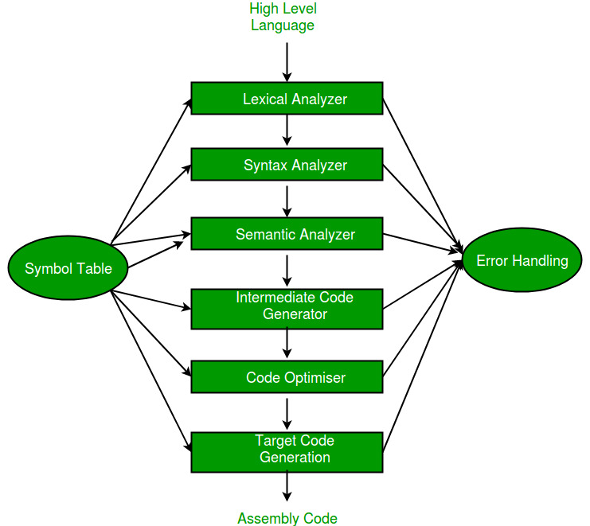
Compiler converts a C++ program into an executable. There are four phases for a C++ program to become an executable:
- Pre-processing
- Compilation
- Assembly
- Linking
By executing below command, We get the all-intermediate files in the current directory along with the executable.
Source program
Program to check if a number is palindrome or not.
#include <bits/stdc++.h>
using namespace std;

class num
{
public:
int getSum(int n)
{
int sum = 0;
while (n != 0)
{
sum = sum + n % 10;
n = n / 10;
}
return sum;
}
};

int main()
{
num g;
int n = 687;
cout << g.getSum(n);
return 0;
}

1.Pre-processing
This is the first phase through which source code is passed. This phase include:
- Removal of Comments
- Expansion of Macros
- Expansion of the included files.
- Conditional compilation
The pre-processed output is stored in the filename.i.
Command : gcc -E main_prog.cpp -o main_prog.i
Output : main_prog.i file is generated
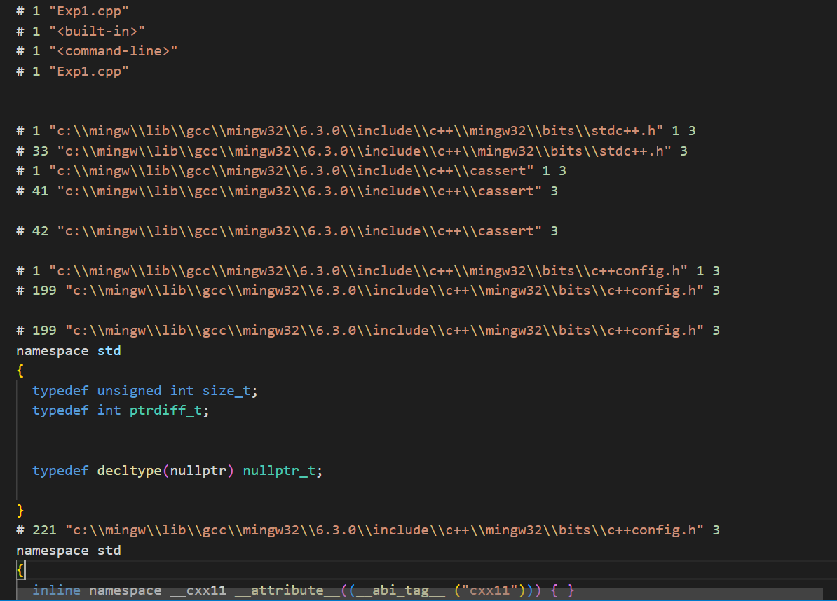

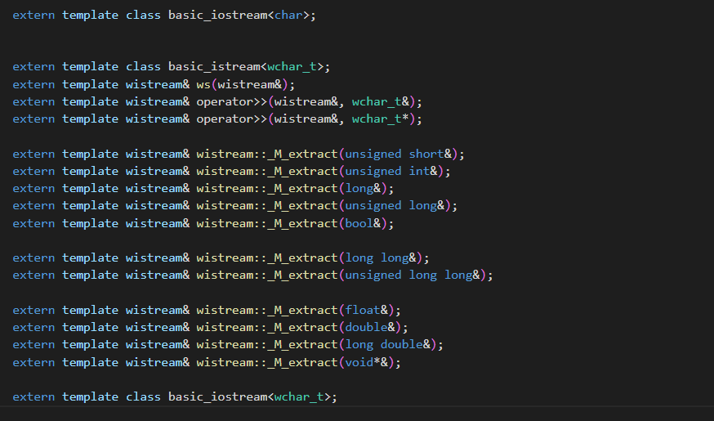
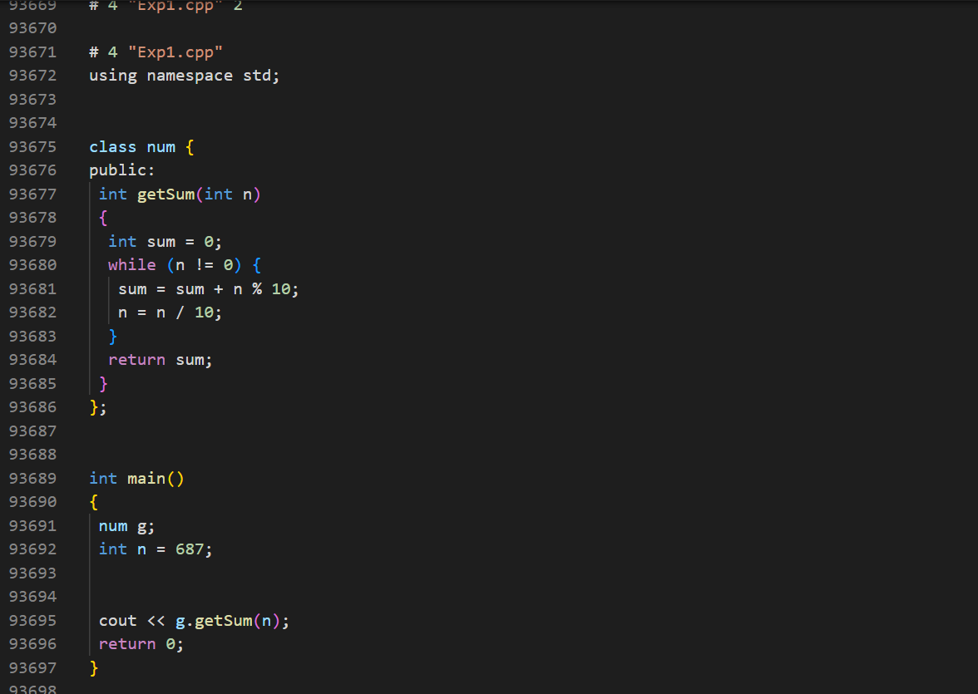

2. Compiling
The next step is to compile filename.i and produce an; intermediate compiled output file filename.s. This file is in assembly level instructions.
Command : gcc -S main_prog.cpp
Output : main_prog.s file is generated
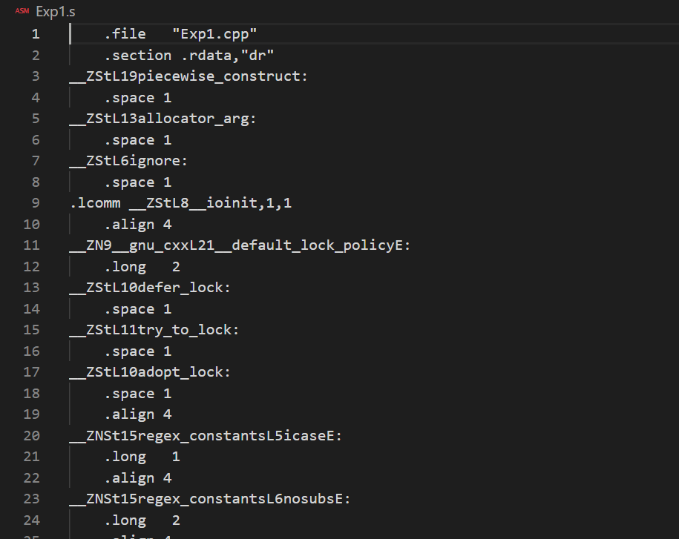

3. Assembly
In this phase the filename.s is taken as input and turned into filename.o by assembler. This file contain machine level instructions. At this phase, only existing code is converted into machine language, the function calls like printf() are not resolved.
Command: gcc -c main_prog.cpp
Output : main_prog.o generated
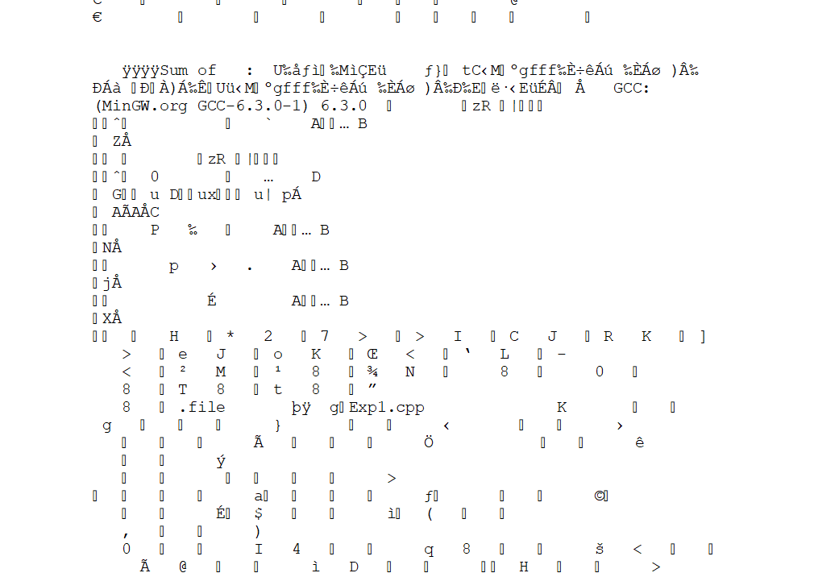
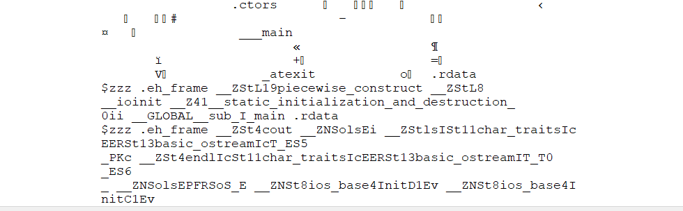

4.Executable file :
In EXE file is an executable program you can run in Microsoft Windows. Most EXE files contain either Windows applications or application installers.
Input : 595
Output:



