Experiment -3
AIM : Given an input string for a regular expression. Obtain the corresponding NFA with e-moves
Theory: ∈-NFA is similar to the NFA but have minor difference by epsilon move. This automaton replaces the transition function with the one that allows the empty string ∈ as a possible input. The transitions without consuming an input symbol are called ∈-transitions. In the state diagrams, they are usually labelled with the Greek letter ∈. ∈-transitions provide a convenient way of modelling the systems whose current states are not precisely known: i.e., if we are modelling a system and it is not clear whether the current state (after processing some input string) should be q or q’, then we can add an ∈-transition between these two states, thus putting the automaton in both states simultaneously.
Example:
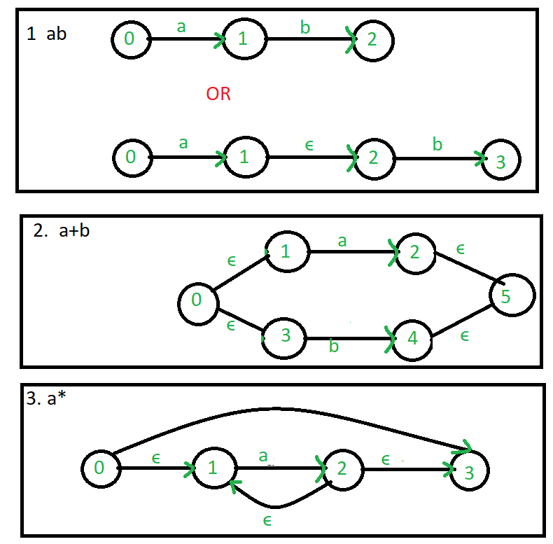

Source Program:
#include <iostream>
#include <stack>
#include <string>
#include <algorithm>
#include <vector>

using namespace std;

class node
{
public:
char input;
int to;
node *next;
};

int prec(char c)
{
if (c == '*')
{
return 3;
}
else if (c == '.')
{
return 2;
}
else if (c == '+')
{
return 1;
}
else
{
return -1;
}
}

string post(string s)
{
stack<char> st;
st.push('N');
int l = s.length();
string ns;
for (int i = 0; i < l; i++)
{
if ((s[i] >= 'a' && s[i] <= 'z') || (s[i] >= 'A' && s[i] <= 'Z'))
{
ns += s[i];
}

else if (s[i] == '(')
{
st.push('(');
}
else if (s[i] == ')')
{
while (st.top() != 'N' && st.top() != '(')
{
char c = st.top();
st.pop();
ns += c;
}
if (st.top() == '(')
{
char c = st.top();
st.pop();
}
}
else
{
while (st.top() != 'N' && prec(s[i]) <= prec(st.top()))
{
char c = st.top();
st.pop();
ns += c;
}
st.push(s[i]);
}
}
while (st.top() != 'N')
{
char c = st.top();
st.pop();
ns += c;
}
return ns;
}

void printnode(vector<node *> v)
{
cout << "___________________________________________" << endl;
cout << "| from state\t| input\t| tostates" << endl;
for (int i = 0; i < v.size(); i++)
{
cout << "| " << i << " \t|";
node *head = v[i];
cout << head->input;
bool first = true;
while (head != NULL)
{
if (first)
{
cout << " \t|";
first = false;
}
else
{
cout << " \t";
}
cout << head->to;
head = head->next;
}
cout << endl;
// cout<<"\t\t\t\t\t\t|"<<endl;
}
cout << "___________________________________________" << endl;
}

node *makenode(char in)
{
node *a = new node;
a->input = in;
a->to = -1;
a->next = NULL;
return a;
}

node *copynode(node *a)
{
node *b = new node;
b->input = -1;
b->to = -1;
b->next = NULL;
return b;
}

void andd(vector<node *> &v, vector<vector<int>> &st)
{
int x, y;
int first, last1;
y = st[st.size() - 1][0];
x = st[st.size() - 2][1];
first = st[st.size() - 2][0];
last1 = st[st.size() - 1][1];

st.pop_back();
st.pop_back();

vector<int> ptemp;
ptemp.push_back(first);
ptemp.push_back(last1);
st.push_back(ptemp);

node *last = v[y];
node *lnode = v[x];
node *temp = copynode(last);
// temp->to = -1;
while (lnode->next != NULL)
{
lnode = lnode->next;
}
lnode->next = temp;
lnode->to = y;
}

void orr(vector<node *> &v, vector<vector<int>> &st)
{
int x, y, x1, y1;
x = st[st.size() - 2][0];
y = st[st.size() - 1][0];
x1 = st[st.size() - 2][1];
y1 = st[st.size() - 1][1];
node *start = makenode('e');
node *end = makenode('e');
v.push_back(start);
int firstnode = v.size() - 1;
v.push_back(end);
int endnode = v.size() - 1;

st.pop_back();
st.pop_back();

vector<int> ptemp;
ptemp.push_back(firstnode);
ptemp.push_back(endnode);
st.push_back(ptemp);

for (int i = 0; i < v.size() - 2; i++)
{
node *h = v[i];
while (h->next != NULL)
{
if (h->to == x || h->to == y)
{
h->to = firstnode;
}
h = h->next;
}
}

node *temp = copynode(v[x]);
node *temp1 = copynode(v[y]);
node *t = v[firstnode];
while (t->next != NULL)
{
t = t->next;
}
t->to = x;
t->next = temp;
t->next->to = y;
t->next->next = temp1;

node *adlink = v[x1];
while (adlink->next != NULL)
{
adlink = adlink->next;
}

adlink->to = endnode;
adlink->next = copynode(end);

node *adlink1 = v[y1];
while (adlink1->next != NULL)
{
adlink1 = adlink1->next;
}
adlink1->to = endnode;
adlink1->next = copynode(end);
}

void closure(vector<node *> &v, vector<vector<int>> &st)
{
int x, x1;
x = st[st.size() - 1][0];
x1 = st[st.size() - 1][1];
node *s = makenode('e');
// node* e = makenode('e');
v.push_back(s);
int firstnode = v.size() - 1;
// v.push_back(e);
// int endnode = v.size() -1;
st.pop_back();
vector<int> ptemp;
ptemp.push_back(x);
ptemp.push_back(firstnode);
st.push_back(ptemp);

for (int i = 0; i < v.size() - 2; i++)
{
node *h = v[i];
while (h->next != NULL)
{
if (h->to == x)
{
h->to = firstnode;
}
h = h->next;
}
}

// node* strt = v[firstnode];
// while(strt->next!=NULL){
// strt = strt->next;
// }
// strt->to = x;
// strt->next = copynode(v[x]);
// strt->next->to = endnode;
// strt->next->next = copynode(v[endnode]);

node *t = v[x1];
while (t->next != NULL)
{
t = t->next;
}
t->to = x;
t->next = copynode(t);
t->next->to = firstnode;
t->next->next = copynode(s);
}

int main()
{
string in;
cout << "Enter a regular expression\n";
cin >> in;
string o;
vector<node *> v;
o = post(in);
cout << "\npostfix expression is " << o << endl;
vector<vector<int>> st;
int firstnode = 0;
for (int l = 0; l < o.length(); l++)
{
if (o[l] != '+' && o[l] != '*' && o[l] != '.')
{
node *temp = makenode(o[l]);
v.push_back(temp);
vector<int> ptemp;
ptemp.push_back(v.size() - 1);
ptemp.push_back(v.size() - 1);
st.push_back(ptemp);
}
else if (o[l] == '.')
{
andd(v, st);
}
else if (o[l] == '+')
{
orr(v, st);
}
else if (o[l] == '*')
{
closure(v, st);
}
}
cout << "\ntrainsition table for given regular expression is - \n";
printnode(v);
cout << endl;
cout << "starting node is ";
cout << st[st.size() - 1][0] << endl;
cout << "ending node is ";
cout << st[st.size() - 1][1] << endl;
return 0;
}

Output:
Regular expression taken as input
(a+b)*



