PRACTICAL FILE

BE (CSE) 6th Semester

COMPILER DESIGN
Submitted By
Rohit Kumar singh
Roll Number: UE203093

Submitted To
Prof. Harsh Ahlawat



Computer Science and Engineering University Institute of Engineering and
Technology
Panjab University, Chandigarh – 160014, INDIA
2022

Program 5. Recursive descent parser

AIM:
To implement a recursive descent parser.

Learning Objectives:
To be familiar with recursive descent parser.

Theory:
A recursive descent parser is a top-down parsing technique used to analyze input according to a given grammar. It uses recursive function calls to break down the input into smaller sub-problems until it determines if the input conforms to the grammar rules or not. Each nonterminal symbol in the grammar corresponds to a function, which generates a string conforming to that nonterminal. The parser starts with the nonterminal symbol corresponding to the start symbol of the grammar and recursively calls the functions for the nonterminal symbols in the production rules of the start symbol. Recursive descent parsing is easy to understand and implement, but can suffer from performance issues when parsing grammars with high ambiguity.

Program: To check for balanced parentheses. Production rule => S -> (S)S | e
#include <iostream> #include <string>
using namespace std; class Parser
{
string input; int pos; public:
Parser(string input){ this->input = input; pos = 0;
}

bool match(char c)
{
if (pos < input.length() && input[pos] == c)
{
pos++; return true;
}
return false;
}

bool S()
{
if (match('(')) {
if (!S()) {
return false;
}
if (!match(')')) { return false;
}
return S();
}
return true;
}

bool parse()

{
return S() && pos == input.length();
}
};

int main()
{
string input;
cout << "Enter a string of parentheses: "; cin >> input;

Parser parser(input); if (parser.parse())
{
cout << "Input has balanced parentheses." << endl;
}
else
{
cout << "Input does not have balanced parentheses." << endl;
}

return 0;
}

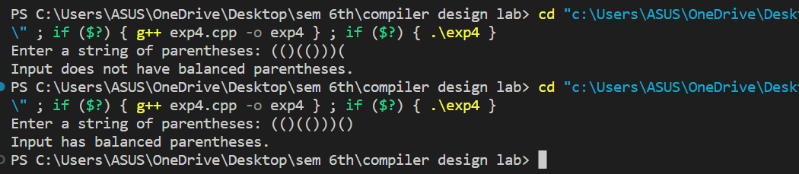
Output:

