**Practical 5**

**Aim:**

* Create a work/product breakdown structure using any software project management tool
* Draw Gantt chart using any tool

**Theory:**

**Introduction to Project Management Concepts:**

* Gantt Chart : A Gantt chart is a widely-used visual project management tool that allows project managers and teams to plan, schedule, monitor, and track project activities. It presents project tasks and their respective timelines in a bar chart format. Each task is represented as a bar, and the length of the bar indicates the task's duration. Dependencies between tasks are shown to ensure that the project progresses smoothly.
* Work Breakdown Structure (WBS) : A Work Breakdown Structure (WBS) is a hierarchical framework used to break down a project into smaller, more manageable components. It's a visual representation that organizes a project into a tree-like structure, with the main project at the top and progressively detailed sub-tasks underneath. The WBS helps project managers understand the project's scope, allocate tasks, and track progress more effectively.

**Software Project Management Tool Used : Project Libre :**

Project Libre is an open-source project management software that offers a robust set of features for planning, scheduling, and managing projects. It is a popular alternative to commercial project management tools and is known for its flexibility and accessibility. Project Libre is especially useful for software project management because it allows you to create detailed project plans, track progress, and manage resources effectively.

Key Features of Project Libre :

* Gantt Charts : Project Libre's Gantt chart feature is a powerful tool for visualizing project timelines. It allows you to create task dependencies, allocate resources, and set milestones, making it an ideal choice for software project scheduling.
* Resource Management : You can assign resources, such as team members or materials, to specific tasks. Project Libre provides resource leveling and resource allocation features, which are crucial for software projects that often involve multiple team members with various skills.
* Task Dependencies : The software allows you to define dependencies between tasks. In software development, where certain tasks must be completed before others can begin, this feature is invaluable for ensuring a logical and efficient project flow.
* Cost Tracking : Project Libre includes cost tracking capabilities, allowing you to estimate, monitor, and control project costs. This is essential for software projects where budget management is critical.
* Reporting : The tool offers various reporting and analysis features to help project managers assess project progress and make data-driven decisions. In software project management, these reports can be used to track development progress, identify issues, and make adjustments as needed.
* Import and Export : Project Libre supports importing and exporting project data in multiple formats, making it compatible with other project management tools and software commonly used in the software development field.

**Description of the Project :**

* Project Name : E - Commerce Website Development.
* Project Duration : 44 days (From 11/15/23 8:00 AM to 1/15/24 5:00 PM)
* Project Description : The "E - Commerce Website Development" project aims to create a modern, user-friendly, and feature-rich online platform. The website will serve as a digital storefront, allowing customers to browse, select, and purchase products or services seamlessly. The project encompasses various phases, including planning, design, development, testing, deployment, and ongoing maintenance.
* Resource Allocation :
* Project Manager : Alex. He serves as the project manager and oversees the entire project. He is also responsible for defining the scope of the project, project plan, payment gateway integration design, backend development, security testing, deployment and customer support system.
* Designer and tester : John. He is responsible for risk assessment, UI design, Product Catalog Design, usability and functional testing, SSL certificate implementation and server monitoring.
* Developer : Martin. He plays a crucial role in the development phase. He is responsible for requirement gathering, UX design, frontend and backend development, usability testing and in maintenance and support phase.
* Material Resources :
* Domain name : This resource is an essential component of the project and is used during deployment.
* Hosting platform : It is another crucial resource needed during the deployment phase.
* SquareSpace : SquareSpace is employed for designing website pages.
* Flaticon : Flaticon is an essential resource for designing website pages.
* Task Dependencies : The project plan incorporates task dependencies to illustrate which tasks must be completed before others can start. For example, the "Deployment" task relies on the completion of several preceding tasks to ensure a smooth launch.
* Resource Management : Resources are strategically allocated to tasks based on their specific expertise and roles in the project. This allocation ensures that the right people are assigned to the right tasks, optimizing efficiency and productivity.
* Cost Management : To manage project costs effectively, resource costs are calculated based on their hourly rates and the duration of their involvement in specific tasks. This allows for accurate budgeting and financial planning.

**OUTPUT :**

**Work Breakdown Structure(WBS) :**

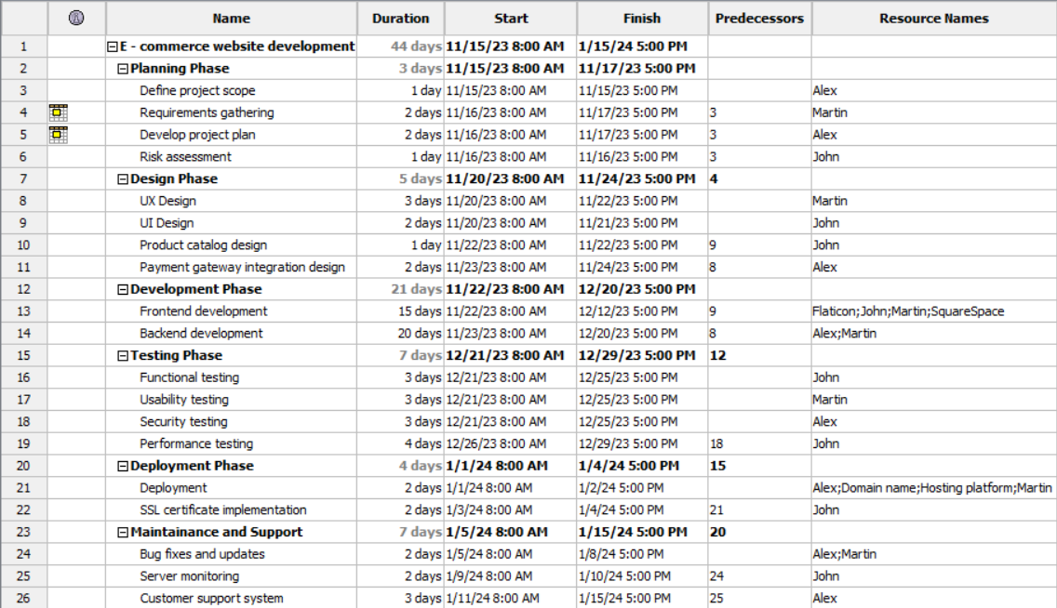

**Resources :**

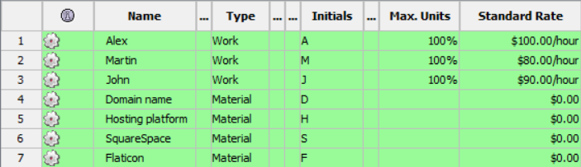

**Gantt Chart :**

