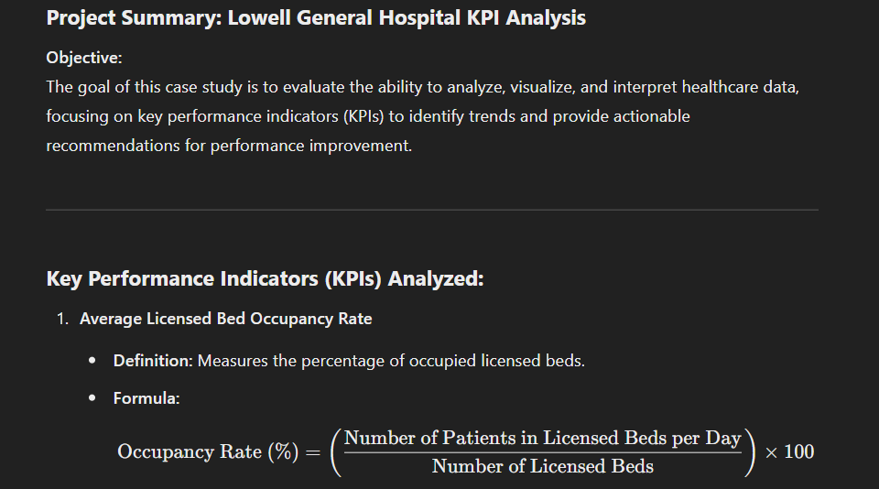

**Analysis Summary:**

1. **Introduction:**  
   A brief introduction was provided, outlining the analytical approach and the objectives of the presentation.
2. **KPI Benchmarking:**  
   Each key performance indicator (KPI) was compared against industry benchmarks to evaluate the hospital’s performance in key areas.
3. **Relationship Analysis:**  
   The relationships between the KPIs were analysed to identify correlations. For example, the analysis examined whether higher occupancy rates affected staff responsiveness or patient fall rates.
4. **Trend Identification:**  
   Trends in the data over time were identified, including seasonal or time-based patterns, and potential causes behind these trends were explored.
5. **Visual Representation:**  
   Visual aids such as graphs and charts were used to present the relationships between KPIs, making the data easier to interpret and understand.
6. **Statistical Analysis:**  
   Statistical methods were applied to quantify and assess the strength of relationships between the KPIs, providing evidence to support the findings.
7. **Recommendations:**  
   Based on the analysis, practical recommendations were provided for the nursing staff and leadership team to improve patient care and operational performance.