1.



2.

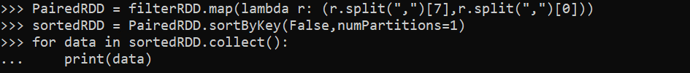

3.





4.

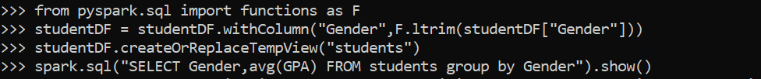

5.



6.

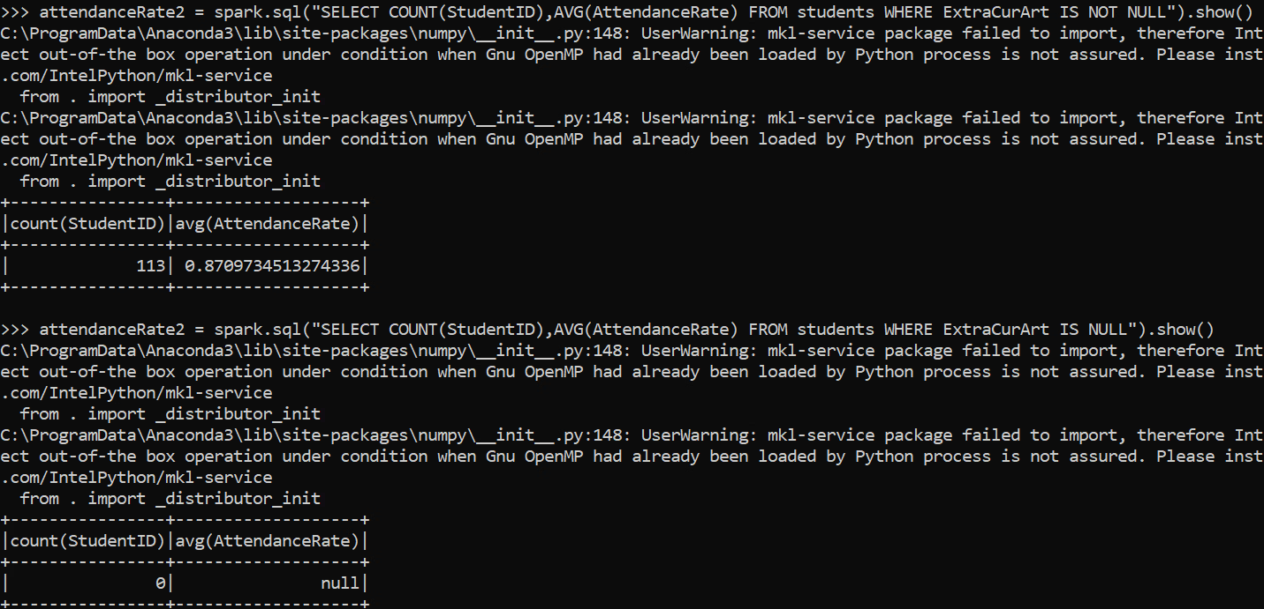

7.

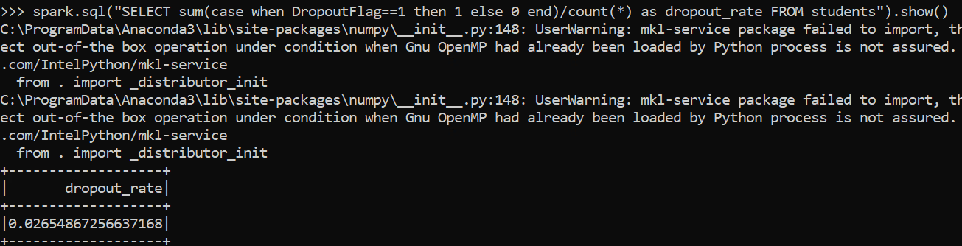

8.

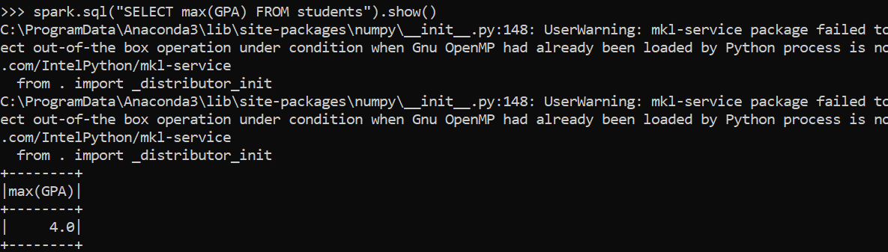

9.

10.

11.

12.

13.

14.

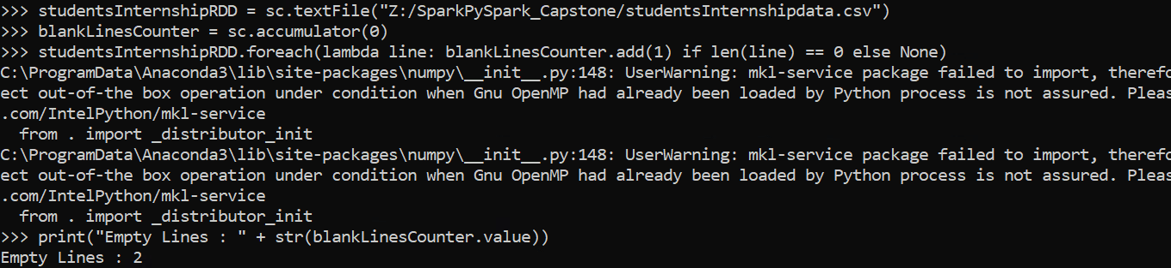

15.

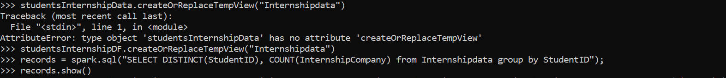

16.



17.



