Q.1



Q.2

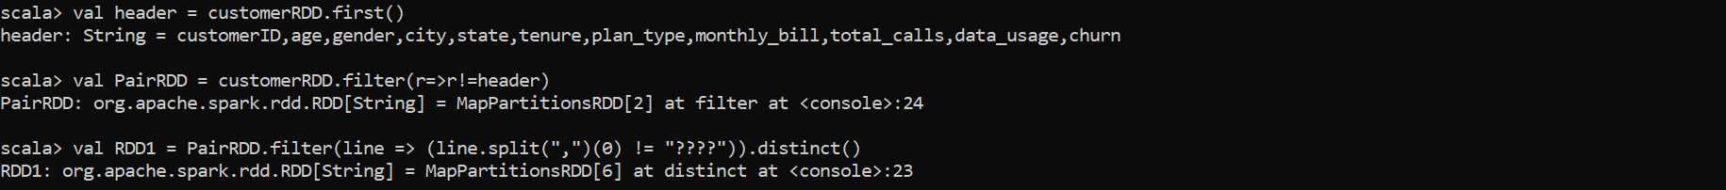

Q.3

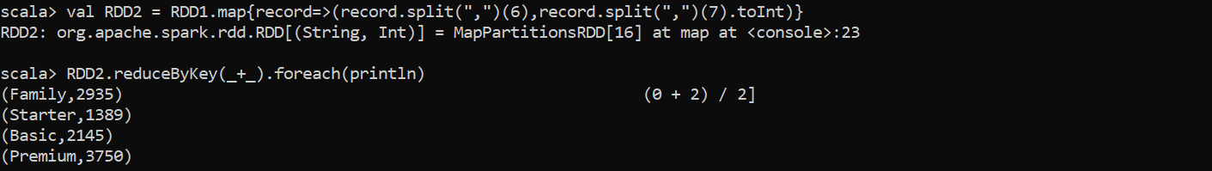

Q.4



Q.5

Q.6



Q.7

Q.8

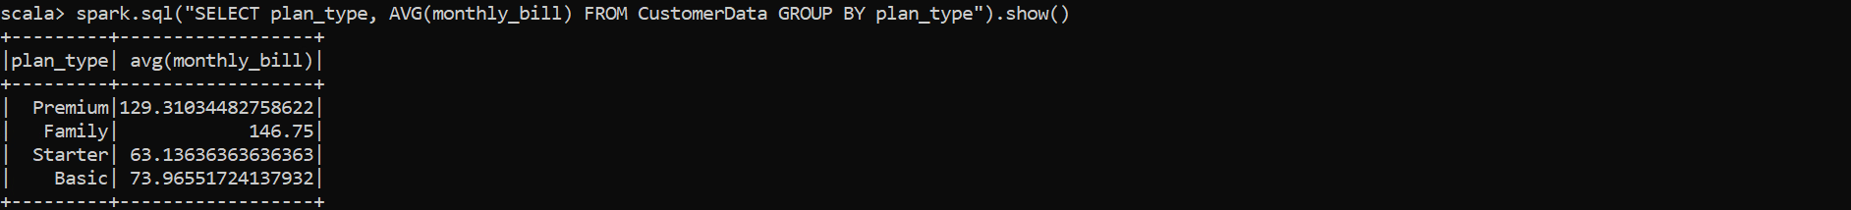

Q.9

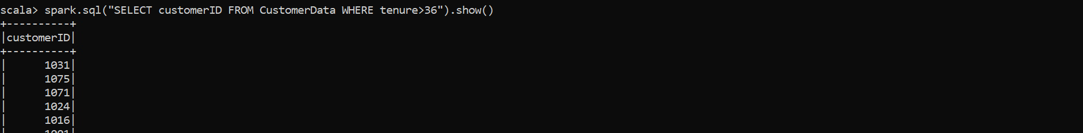

Q.10



Q.11

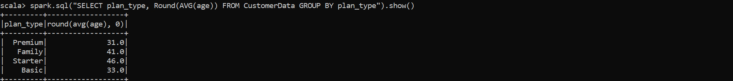

Q.12



Q.13

Q.14

Q.15

Q.16

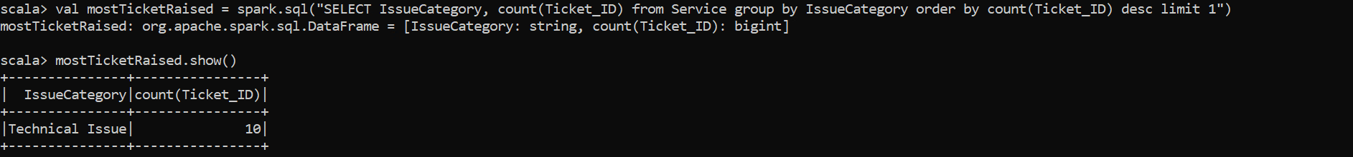

Q.17

