**Name : Kadam Rohit Roll no: 218**

**Experiement no: 11 Write a PHP program to perform search operation on the student records using AJAX.**

**Code:**

**Index.html**

<!DOCTYPE html>

<html lang="en">

<head>

<meta charset="UTF-8">

<meta name="viewport" content="width=device-width, initial-scale=1.0">

<title>PR11</title>

</head>

<body>

<div class="container" style="border: 1px solid">

<label for="rollno">Roll no:</label>

<input type="number" name="rollno" id="rollno">

<br>

<button id="btn">Search</button>

</div>

<div style="border: 1px blue solid;">

<p id="Responce"></p>

</div>

<script> let btn = document.getElementById("btn"); btn.addEventListener('click', function() {

// var rollno = document.getElementById("rollno"); const rollno= document.getElementById("rollno").value; console.log("search entered");

let xhr = new XMLHttpRequest(); xhr.open("POST", "search.php", true);

xhr.setRequestHeader("Content-Type", "application/x-www-formurlencoded");

xhr.onreadystatechange = function() { if (this.readyState == 4 && this.status == 200) { document.getElementById("Responce").innerHTML = this.responseText

} } console.log(rollno) xhr.send("rollno="+encodeURIComponent(rollno));

})

</script>

</body>

</html>

**Search.php**

<?php

$con = mysqli_connect("localhost", "root", "", "student"); if (!isset($con)) { echo "Error:" . mysqli_error($con);

}

?> <?php if($_SERVER["REQUEST_METHOD"]=="POST"){

$rollno=intval($_POST["rollno"]);

$query="SELECT rollno,name,class,prnno FROM student where rollno=".$rollno."";

$result= mysqli_query($con,$query);

echo "<table border='1' cellpadding='5'>

<tr>

<th>Roll no</th>

<th>Name</th>

<th>class</th>

<th>PRN no</th>

</tr>";

if (mysqli_num_rows($result) > 0) { // output data of each row while ($row = mysqli_fetch_assoc($result)) { echo "<tr>

<td>" . $row['rollno'] . "</td>

<td>" . $row['name'] . "</td>

<td>" . $row['class'] . "</td>

<td>" . $row['prnno'] . "</td>

</tr>

"; } } else { echo "0 results";

}

} echo"</table>";

mysqli_close($con);

?>

**Output:**

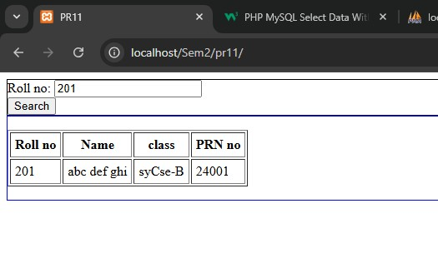

**Name :Sarvesh Padole Roll no: 233**

**Experiement no: 12. Write a PHP program to sort the student records which are stored in the database using ascending/descending order.**

**Index.html**

<!DOCTYPE html>

<html lang="en">

<head>

<meta charset="UTF-8">

<meta name="viewport" content="width=device-width, initial-scale=1.0">

<title>PR12</title>

</head>

<body>

<div class="container" style="border: 1px solid">

<label for="order">select a order:</label>

<br>

<select name="order" id="order" title="slect order">slect

<option value="ascending">ascending</option>

<option value="decending">decending</option>

</select>

<br>

<button id="btn">Select</button>

</div>

<div style="border: 1px blue solid;">

<p id="Responce"></p>

</div>

<script> let btn = document.getElementById("btn"); btn.addEventListener('click', function() { let a =document.getElementById("order").value;

let xhr = new XMLHttpRequest(); xhr.open("POST", "search.php", true); xhr.setRequestHeader("Content-Type", "application/x-www-formurlencoded");

xhr.onreadystatechange = function() { if (this.readyState == 4 && this.status == 200) { document.getElementById("Responce").innerHTML = this.responseText

}

}

xhr.send("order="+encodeURIComponent(a));

})

</script>

</body>

</html>

**Search.php**

<?php

$con = mysqli_connect("localhost", "root", "", "student"); if (!isset($con)) { echo "Error:" . mysqli_error($con);

}

?>

<?php if($_SERVER["REQUEST_METHOD"]=="POST"){ if($_POST["order"]=="ascending"){

$query= "SELECT * FROM student ORDER by rollno ASC";} else{

$query = "SELECT * FROM student ORDER by rollno DESC";

}

}

$result= mysqli_query($con,$query);

echo "<table border='1' cellpadding='5'>

<tr>

<th>Roll no</th>

<th>Name</th>

<th>class</th>

<th>PRN no</th>

</tr>"; if (mysqli_num_rows($result) > 0) { // output data of each row while ($row = mysqli_fetch_assoc($result)) { echo "<tr>

<td>" . $row['rollno'] . "</td>

<td>" . $row['name'] . "</td>

<td>" . $row['class'] . "</td>

<td>" . $row['prnno'] . "</td>

</tr>

"; } } else {

echo "0 results";

}

echo"</table>";

mysqli_close($con);

?>

**Output:**

**Ascending Descending**

