Optimization of an Angle of Attack Sensor for Fighter Aircraft
Fluid Mechanics
Final Project Report
Sai Rohit Kalahasti

Acknowledgements Page
Outside References: Thank you to Dr. Peggy Menzies for providing the initial design and a physical example that we could use for dimensioning the original model. Additionally, this project relied heavily on instruction in Autodesk CFD and Inventor provided by Dr. Rita Schnipke.
Contributions of Team Members:
Sam Carr – Co-designed the final model and contributed to the CFD analysis. Wrote the conclusion/recommendations and discussion sections and contributed to the methods and results sections.
Q Han – Used Inventor to model existing design and co-designed final model. Wrote the abstract and introduction sections and contributed to the recommendations and conclusion section.
Jeff Jernigan – Ran CFD analysis for the existing design and contributed to the modeling of the final design. Wrote the methods section and contributed to the results.
Neal Rose – Ran CFD analysis for compressible and incompressible tests of final design. Determined the mesh characteristics to successfully run the models in CFD. Wrote the results section and contributed to the methods.

Abstract
The goal of this project is to improve upon the existing angle of attack sensor made by Dr. Peggy Menzies and her team using the knowledge learned in Fluid Mechanics I & II. The area of design our improvement largely focuses on is to reduce the drag caused by the angle of attack sensor. After going through some intermediate ideas for improvement, the team ultimately decided to modify the original angle of attack indicator through the addition of ‘ribs’ on the surface. We then modeled this idea in Autodesk Inventor. Through the use of hand calculations and CFD results, the existing angle of attack sensor is compared to our new design to discuss whether it made any improvements in both incompressible and compressible flow conditions across varying angles of attack. With proper parameters, which will be discussed later, CFD analyses were performed to attain results that we could compare with the original design. The results were admittedly unsatisfactory. The new model was not able to measure the angle of attack accurately as well as the design showed an increase in drag in both incompressible and compressible flow. However, one improvement our design made was that the flow around the sensor stayed attached longer so that the wake area was smaller than the existing design. Beside the attachment of the wake, the new design has not made improvements; therefore, some recommendations for future testing have been made. Recommendations for improvement will be discussed later in this report.

Introduction

Project Description: Purpose and objective of the project
The purpose of this project is to redesign and improve the angle of attack sensor developed by Dr. Peggy Menzies so that it can accurately measure the angle of attack on a high performance fighter aircraft. The objectives of our redesign are to reduce the drag force of the sensor while still retaining or possibly improving the indicated angle of attack accuracy.

Design Criteria
- Must have lower drag than the existing angle of attack sensor
- Must comply with the FAA rules and regulations
- Must be located on a part of the aircraft that protrudes through the boundary layer
- Must be located on a part of the aircraft where the free stream airflow is constant
- Must accurately sense the correct angle of attack to within .05 degrees
- Must be shaped in such a way that icing does not present a problem
- Must be located on a part of the aircraft such that it does not break off during flight
- Cannot interfere with radar system
- Must not decrease performance envelope of the aircraft
- Must be resistant to corrosion, salinity, and adverse weather conditions
- Must not leave notable radar signature

Existing Design and Dimensions
Pictured below are the dimensions of the existing design.
Figure 1-4. Existing Design Dimensions.
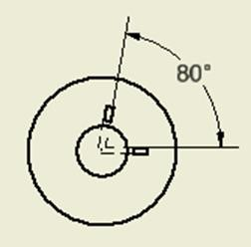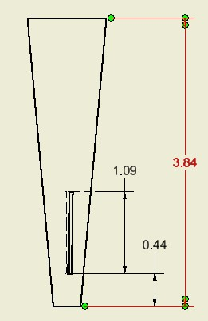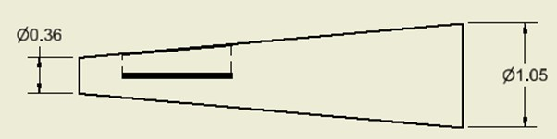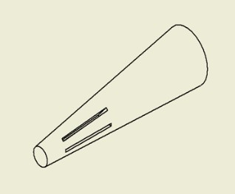

Expectations for the Project
Through this project, the team hopes to increase our understanding of key aspects of basic and advanced fluid mechanics, such as Bernoulli’s Law, the different types of drags, and shocks in compressible flow. We hope to apply the knowledge learned in Fluid Mechanics I and II in a real world scenario in order to design an angle of attack sensor for a fighter jet. We hope to practice the design process that is used in the real world through software such as Autodesk Inventor and Computational Fluid Dynamics (CFD). We want to work our way towards a functional design until we can attain a well refined design. Because one semester is a very short time (compared to the time and effort put into real world designs) we may not come as close to the successful results of the existing design. In fact, we know that we will fail at some point during the process, but still we want to try our best and learn from our mistakes. We want to improve and refine our design with our best abilities until it reaches or exceeds the design criteria. The team hopes to gain hands-on experience and to decrease the gap between the theories that we’ve learned in the classroom and real world applications in the industry.

Assumptions and Limitations
- CFD: Computational Fluid Dynamics software is a very strong tool to have available. Within the process of running CFD, it solves the mathematical equations that govern much of fluid dynamics – the Navier-Stokes equations. In a sense, CFD is an extension of hand calculations. However, it still contains minor errors. These minor errors, sometimes, could cause large discrepancies in results. This is why one must understand fluid dynamics so that the outcome of running CFD makes sense. However, CFD is still used due to its consistency; it is not always realistically accurate but still does work in a way that allows for consistent, comparable results. The biggest problem we faced throughout the project was that the computational power of the computers we had was limited so that it took a lot of time to run and get results from CFD.
- Hand Calculations: One of the biggest limitations of the hand calculations is that we have to make a list of assumptions to solve the given problem (i.e. no heat transfer, incompressible or compressible, etc.), which of course limits the results. However, this gives us an estimate of what the realistic results should be.
- Experiment: As Dr. Peggy Menzies said, she and her team did extensive testing before producing her company’s design. Building a prototype of the sensor and going through real world experimentation would without doubt require a large sum of money. Unfortunately, we could not do physical testing and could only model our results using computation fluid dynamics. Again, this is due to the money and time it takes to go through a real word experiment.

Methods
Of our design criteria, the only three we could directly improve (because of our limitations) were the drag forces on the indicator, the accuracy of the angle of attack reading, and the susceptibility to icing due to the indicator’s geometry.

Hand Calculations
It was first necessary to determine the baseline values for the existing design. To do this, hand calculations were performed to provide an approximate value that could be used to compare the CFD results to. For drag, the assumption that the original angle of attack indicator could be modeled as a trapezoid was made.
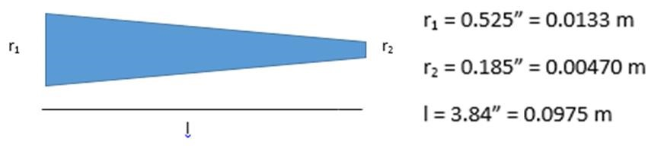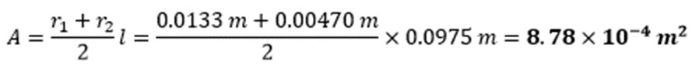

We estimated our coefficient of drag by assuming the cone behaved as a cylinder when the flow is perpendicular. This way our 𝐶_{𝐷} = 1.2 (Figure 1.54, Anderson 77). This way, the drag at 100 m/s (incompressible flow) was estimated to be:
To predict the angle of attack, we used the difference in pressure due to the free stream flow. The equation for the pressure coefficient on the surface of a cylinder as a function of the angle from the front is 𝐶_{𝑝} = 1 − 4 sin² 𝜃, where 𝜃 is the angle from the horizontal, measured clockwise (Anderson, 257). Although our indicator is not a true cylinder, we made the assumption that the flow behaves in the same way since the cone shape is similar to a cylinder. (See Figure 5).
Figure 5. Anderson, Page 259.
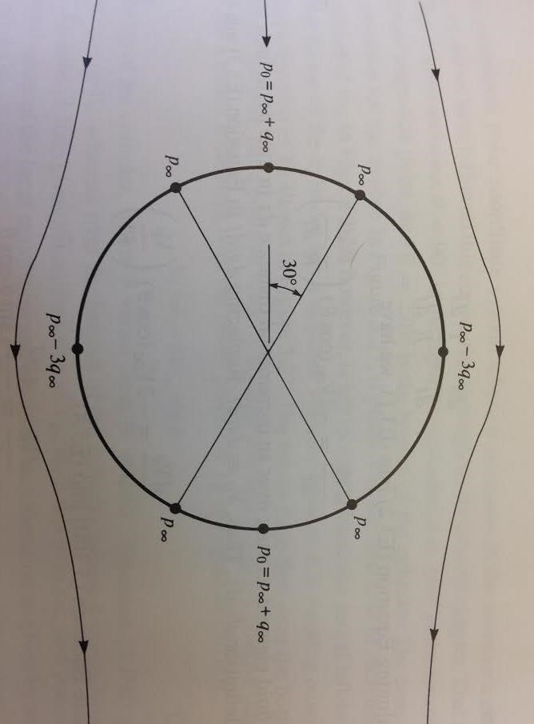
From this we knew that the pressure was at a maximum at the front of the indicator, and decreased on either side, being the lowest at both the top and bottom. If we could find the pressure at two points on either side of the horizontal, at zero angle of attack they would be the same. However, any change in the angle of attack would create a different pressure reading for the two points, because now they are different 𝜃′𝑠 and thus have different pressures.
Figure 6. Angle of Attack from Pressures.
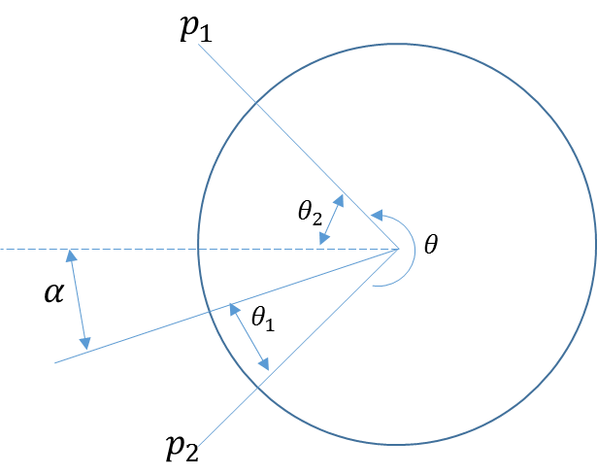
From geometry manipulation, we can come up with an expression for the angle of attack as a function of the different pressures.
𝜃₁ + 𝜃₂ = 𝜃 = 80°. (This value was set in the initial design, and is symmetric about the horizontal axis as shown above.)
𝑝₁ sin(𝜃₁) = 𝑝₂ sin(𝜃₂)
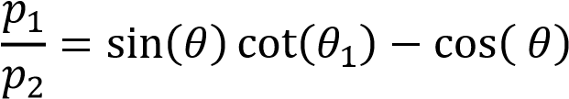
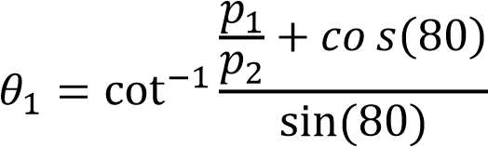
Finally,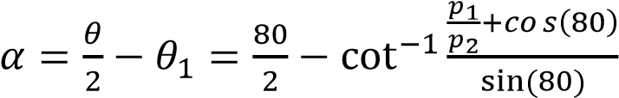

Steps for CFD Setup
To set up a simulation in CFD, we need to focus on three parameters for the scenario: materials, boundary conditions, and meshing. In CFD, we set a box around the angle of attack indicator to use as air. We then chose to use aluminum for our angle of attack indicator. We then need to set up a few different boundary conditions to create the flow field around the angle of attack indicator. We first want to define the velocities to be tested. Specifically, we tested a total of six different velocity scenarios, as described below:
- Normal Velocity of 100 m/s to simulate incompressible flow at a 0 degree angle of attack.
- Component Velocity of 99.619 m/s towards the angle of attack indicator and 8.716 m/s directed upwards to simulate incompressible flow at a 5 degree angle of attack.
- Component Velocity of 98.481 m/s towards the angle of attack indicator and 17.365 m/s directed upwards to simulate incompressible flow at a 10 degree angle of attack.
- Normal Velocity of 400 m/s to simulate compressible flow at a 0 degree angle of attack.
- Component Velocity of 398.48 m/s towards the angle of attack indicator and 34.862 m/s directed upwards to simulate compressible flow at a 5 degree angle of attack.
- Component Velocity of 393.923 m/s towards the angle of attack indicator and 69.459 m/s directed upwards to simulate compressible flow at a 10 degree angle of attack.
The boundary conditions are described below depending on the type of flow.
Incompressible:
Upwind (Front) Face: Velocity (normal for 0 AoA, components for non-zero AoA).
Downwind (Rear) Face: Zero pressure.
Open Air Sides: Slip/symmetry condition. Aircraft Side: Unassigned.
Compressible:
Upwind (Front) Face: Velocity (normal for 0 AoA, components for non-zero AoA) with zero pressure.
Downwind (Rear) Face: Unknown.
Open Air Sides: Velocity components (same components as for front face). Aircraft Side: Unassigned.
The next step was to mesh the model. This was done by using an automatic mesh and refining and spreading the changes on the model. For the existing design, we were able to use a fairly fine mesh and still run the tests to obtain data. However, when we put the model of our final design into CFD, the software was unable to mesh the design within a reasonable amount of time without making the mesh coarser. By reducing the mesh size to 740,000 elements (a reduction of almost three orders of magnitude) and uniformly spreading the changes, we were able to get our model to run on the available computers. For consistency, the tests for the existing design were repeated so that they had similar mesh characteristics.
Finally, the solver was used to run the CFD program. For the incompressible tests, incompressible physics were selected with heat transfer turned off. For the compressible tests, the physics were turned to compressible and a temperature of 300 Kelvin was used.

Problems Encountered with CFD Setup
The biggest problem we encountered with CFD was our incredibly high element count. Prior to any meshing corrections, we had an element count on the order of 170 million. The computational power needed for these kind of computations far exceeded what was available to us, so we had to make our mesh very coarse (740K elements). While this does cause a lot of errors in the analytic results that CFD gives us, we were at least able to get a rough simulation finished to get an idea of how our design would interact with a flow field.

Design Methodology and Analysis Steps
From our initial baseline values for the original design, it was clear that drag was our main factor that must be addressed. To reduce the drag, we initially had three separate design modifications. The first was to make our indicator a diamond shape, similar to a diamond airfoil used for supersonic flight. The second was to decrease the overall size of our indicator, and the third was to change the surface of the indicator to reduce the drag, not necessarily the shape.
The diamond shaped AoA indicator would be ideal since it would be on an aircraft that would routinely fly in supersonic conditions. However, we worried about what affect aerobatic forces would have on the indicator. We were concerned it would act as a wing, and although this would have decreased drag from a blunt object, it might cause yielding in certain flight conditions because it would create excessive lift. We decided to stick with a cone shaped object, since we felt the sturdy base was more statically stable. The reason we opted not to change the overall size of the indicator was because we wanted to make sure that the indicator extended beyond the boundary layer on the side of the aircraft. Our overall objective is to have an accurate angle of attack reading, and risking the accuracy for the minimal reduction in drag was not worth it. We concluded our best course of action was to change the surface of the indicator while keeping the same dimensions. This would allow for it to extend out of the boundary layer while reducing the drag and still allowing for an accurate angle of attack reading.
Because the original indicator is essentially a cone (a blunt object), we applied our knowledge learned through our Fluids I and II classes. We learned that with blunt objects, increasing the surface roughness keeps the boundary layer attached to the object for longer, decreasing the wake drag behind the object and therefore decreasing the overall drag. A golf ball’s dimples are used in this manner to decrease drag in flight, so we decided to design our surface with this same concept in mind.
As a proof of concept before modeling this design, a rudimentary estimate of the drag for a dimpled surface was found by increasing the surface roughness of the material in CFD. The added roughness did actually improve the drag forces involved and provided the justification to continue with our design.

Final Design
While keeping the same dimensions of the original indicator, we decided to increase the surface roughness by adding small ridges that ran the length of the indicator and circled it entirely. We knew we wanted ridges, but we didn’t know how many. So we looked to our inspiration for guidance. We counted the average number of dimples around the surface of an average golf ball at the center, which was 28. We assumed that a golf ball was about the size of our indicator, so that the aerodynamic properties and efficiency would be approximately the same. We took our existing dimensions for the AoA indicator, and made calculations so that 14 ridge and trough pairs surrounded the surface.

Drafting the final Design in Inventor
For our initial attempt to create the ridges in Inventor, we started off with a 2 dimensional work plane, and used the “pattern” feature to revolve a ridge and trough pair around the center point of a circle. We did this for the larger face (the base) of the indicator in another work plane offset the length of the indicator. The size of the ridges for the larger face was just scaled by the ratio of the diameters of the two faces. We tried to loft the two sketches together to form the body of the indicator, but did not succeed.
Our second attempt involved making a ridge and trough pair and connecting it to a center point of the circle, making a wedge shape. This was done for the larger face as well, and the two faces were connected with an axis line equal to the length of the indicator. The “loft” feature was used to fill between the two faces. The pattern feature was then used to create a circular pattern revolving around the line. The reason we did this is because we wanted to have as few components as possible that were rotated so that discontinuities would be minimized. Next we used the “stitch” feature to connect the different elements of the pattern.
Figure 7 shows an example of a ridge and trough pair that was connected to make a wedge.
7.
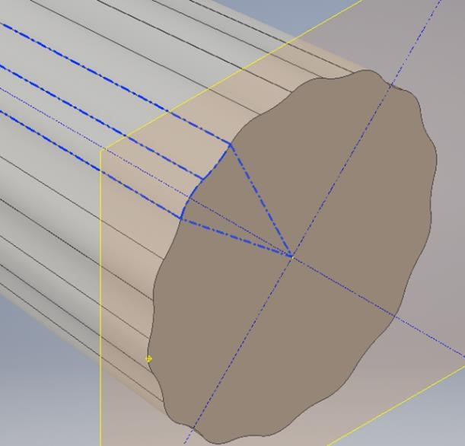
What we did not account for was that our numbers were not exact when we made the calculations for the 14 ridge and trough pairs, and thus small ridges between adjacent wedges formed. We knew this would create meshing problems for us in the CFD software, so we went in and applied the “fillet” feature for each connection between wedges to smooth out the discontinuities. After the basic ribbed cone shape was complete, we added the pressure slots using work planes, using the same method we used to make the initial indictor drawing. A picture of the final design is shown below in Figure 8.
Figure 8.
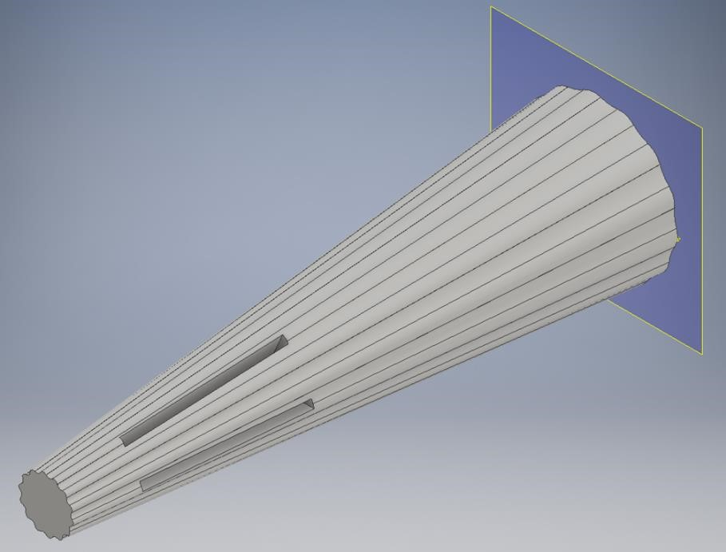

Results and Discussion

Analysis of Existing Design
Since our primary concern was to improve the drag performance of the existing design, certain data had to be collected to provide a frame of reference for the analysis of our final design. With CFD software, the model can be ran for both compressible and incompressible conditions with free stream velocities of 400 m/s and 100 m/s, respectively. The shear and pressure wall forces along the axis of the airflow were summed to get the drag force. The table below shows the drag forces for the existing design.
Table 1. Existing design quantitative data.
Flow Type | Free Stream Velocity (m/s) | Drag (N)
Incompressible | 100 | 15.045
Compressible | 400 | 786.56
Because the design is actively used by the United States Air Force, we assume that the angles of attack measured by it are accurate to within 0.05 degrees. Therefore, the analysis of the angle attack accuracy for the final design will be based off of the error between the measured value and the true value.
The following figures show the velocity profiles for the existing design.
Figure 9. Incompressible Velocity Profile.
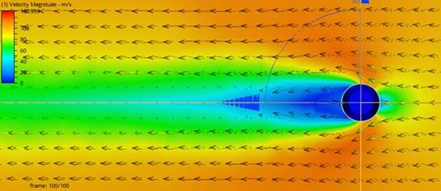
10. Compressible Velocity Profile.
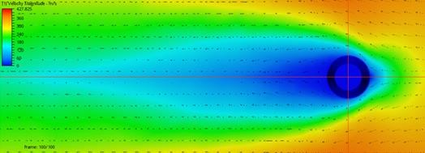

Analysis of Intermediate Designs
Most of our designs were scrapped prior to testing in CFD, so our primary intermediate design was the original design with an increased roughness factor. We ran two tests on the original design: one with the material as aluminum and another with the same material, but an increased roughness factor. We ran the same scenario for each test: a 0 degree angle of attack with a free stream velocity of 100 m/s. Using the analytic results for wall forces in CFD, we found that the drag was reduced. We used this intermediate process as a proof of concept for our ribbed design, which gave us the go-ahead to start modeling our angle of attack indicator in CFD.

Analysis Results of Final Design
As described in the methods, the final analysis of our design was conducted by using computational fluid dynamics to test the sensor’s performance at both incompressible and compressible conditions through a variety of angles of attack. For the incompressible testing, a free stream velocity of 100 m/s was used and was varied for angles of attack of 0, 5, and 10 degrees. The same angles were used for the compressible flow testing but with a free stream velocity of 400 m/s. Since our goals were to lower drag and accurately measure angle of attack, the CFD results we collected were based around these parameters. To calculate drag, the wall forces experienced along the axis of the airflow were added together. The two wall forces used for this calculation were the shear force and pressure force. The angle of attack was found using the procedure described in the methods section.
The following table shows the drag forces and indicated angles of attack for both incompressible flow and compressible flow across multiple angles of attack.
Table 2. Quantitative Results for Final Design.
 | Angle of Attack (°) | Indicated Angle of Attack (°) | %Error | Drag (N)
Compressible Flow | 0 | -0.78 | Undef. | 834.22
Compressible Flow | 5 | 1.56 | 68.8% | 1055.99
Compressible Flow | 10 | 2.48 | 75.2% | 1047.06
Incompressible Flow | 0 | 7.76 | Undef. | 17.8
Incompressible Flow | 5 | 10.4 | 108.0% | 17.6
Incompressible Flow | 10 | 6.75 | 32.5% | 17.3
The following figures were captured in CFD and show the static pressure distribution for both incompressible and compressible flow.
Figure 11. Incompressible Static Pressure Distribution.
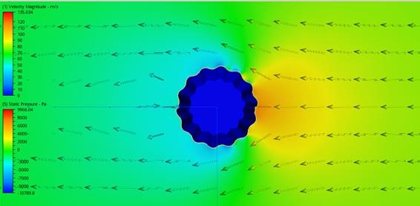
The above image shows the static pressure distribution proximal to the center of the slits in the sensor for incompressible flow (V = 100 m/s). It is noteworthy that the bottom of each ridge on the leading edge has a higher static pressure due to the airflow being funneled in and causing a stagnation zone. In contrast, the tops of the ridges show areas of low pressure where the velocity along the profile would be increasing. The next plot shows the distribution of the static pressure along the leading edge of the sensor for incompressible conditions with a 5 degree angle of attack.
12. Incompressible Leading Edge Pressure Distribution at 5 degree AoA.
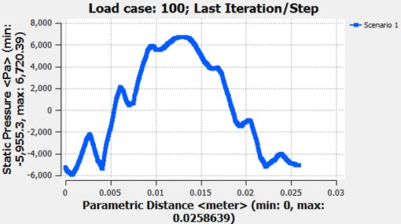
Here we can clearly see the effect the ridges have on static pressure. The local peaks that occur are located at the bottom of the ridges where stagnation of the flow occurs. The local dips in pressure are the tops of the ridges where pressure drops due to an increase in surface velocity. With the five degree angle of attack, it is also clear to see the difference in static pressure between the upper leading edge and lower leading edge based off of whichever side is more into the relative airflow than the other.
The next figures detail the static pressure distributions for compressible flow.
Figure 13. Compressible Static Pressure Distribution.
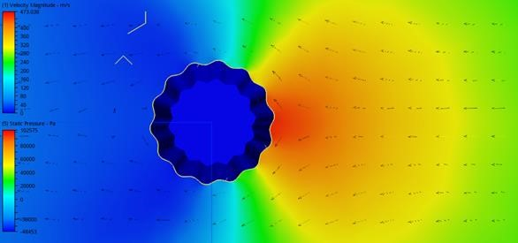
The effects of compressibility are very clear here. The most immediately noteworthy aspect is the presence of shocks being emitted from the top of each ridge on the leading edge. Additionally, due to the blunt nature of our design, there is also a detached shock observable upwind of the sensor where the green changes to yellow on the diagram. As expected, the pressure is significantly higher for compressible flow than incompressible (around two orders of magnitude). The following plot shows the leading edge profile of the static pressure for compressible flow with an angle of attack of five degrees.
Figure 14. Compressible Leading Edge Pressure Distribution at 5 Degree AoA.
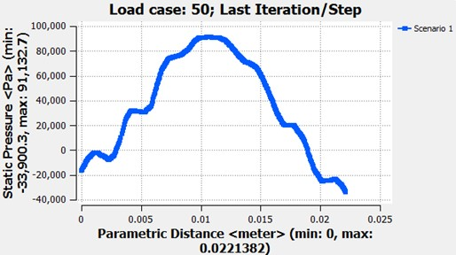
As before, the effects of the ridges are clearly visible, but are less pronounced.
The following figures show the velocity profiles of the sensor for both cases.
Figure 15. Incompressible Velocity Profile.
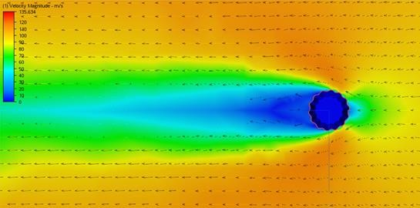
16. Compressible Velocity Profile.
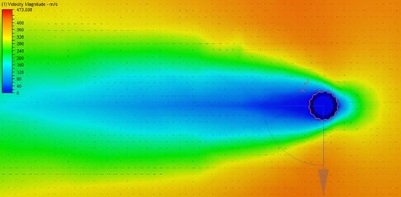

Comparisons
The following table shows a comparison of the drag forces between the existing and final designs. The drag forces listed for the final design are the average drag forces between the three angles of attack.
Table 3. Drag Comparison.
Flow Type | Average Drag of Our Design (N) | Average Drag of  Original Design (N) | % Increase in Drag
Incompressible | 17.57 | 15.04 | 16.82%
Compressible | 979.09 | 786.56 | 24.48%
While our design did have an average increase in drag of 20%, we see that the flow around the angle of attack indicator stayed attached. CFD showed no signs of turbulent flow behind the angle of attack indicator, which could be seen in the original design. Either the flow was carried around the angle of attack indicator and continued directly past, or the flow was directed towards the tip of the AoA indicator.
Figure 17.
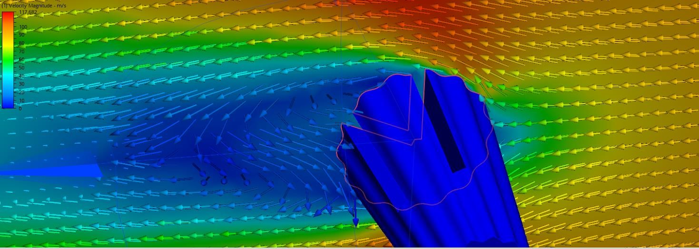
The velocity profiles can be seen by comparing Figures 9 and 15 for incompressible flow and 10 and 16 for compressible flow.

Recommendations and Conclusions
One of the biggest problems we faced as a design team was the incredibly high computational power that was needed to produce a fine mesh over our model. Because of this, we had to make our CFD mesh very coarse which limited the accuracy of our results. We believe that one of the primary causes of this was the inaccuracy in our inventor model. We had rounding errors that produced very small surfaces that created a huge number of elements in CFD. Without any meshing corrections, we originally were running CFD with an element count on the order of 170 million. For every 5 elements, CFD creates one node to use for calculations. This means that originally, our CFD program was trying to recreate 34 million calculations, something far outside the scope of one single computer in a reasonable amount of time. To fix this problem, we would recommend creating a 2n-sided symmetric polygon in inventor. To create the peaks and troughs, we can then extend arcs inwards and outwards on adjacent sides of the polygon. This should provide a fix for most discontinuities in the surface, and any remaining repairs can be made by filleting the edges between sides of the now ‘ribbed’ surface.
Another slight adjustment we would like to make would be to design the ribs such that we have quad-symmetry. That is to say that we could draw vertical and horizontal axes and the angle of attack indicator would be symmetric across both axes. This would allow us to place the pressure slits on similar regions about the angle of attack indicator (i.e put both slits equidistant from the center on the top of a ridge). Because the airflow is funneled into the troughs around the angle of attack indicator, we will have maximum static pressure in the bottom of the ridges regardless of our actual angle of attack. This property of our geometry forces us to place the pressure slits on the top of the ridges, symmetric about the horizontal axis.
The primary design change recommendation comes to the amount of ‘ribs’ as well as how
deep each ‘rib’ is. As we increase the amount of ribs, we increase roughness, but it becomes increasingly hard to machine. We can also change the deepness of each ‘rib’, but as we make these ribs deeper, we are increasing the parasitic drag on our angle of attack indicator. Thus, we find that we need to optimize both the amount of ribs as well as the deepness of each rib. Somewhere between the original design and the design that we created is an optimal balance between a decrease in wake drag and a slight increase in parasitic drag.

References
Anderson, John D. Fundamentals of Aerodynamics. 5th ed. New York: McGraw-Hill, 2011. Print.

