# 

**AIM: - Use your SWOT info to come up with Strategic**

**Solutions to Cash in your strengths, minimize your weaknesses, negate the threats**

**& optimize your opportunities**

**Objective:- 1) Students should be made aware of their goal, Strength and weakness**

**2) Students should have self-confidence, etiquettes and nonverbal skills.**

**Activity:-**

1. **STRENGTH:**

* **Problem solving, Quickly learning new programming languages and technologies.**
* **Time Management.**
* **I have developed skills in python programming.**
* 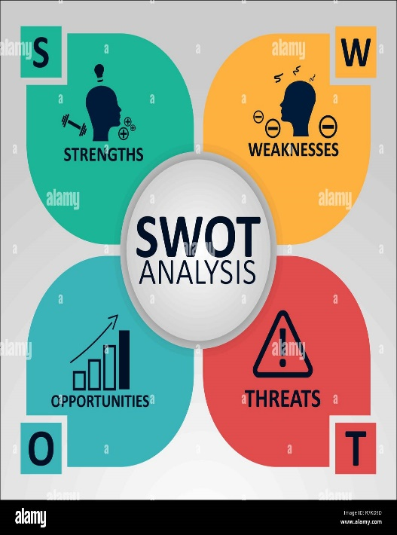**I learned basics of JAVA, C, C++.**

1. **WEAKNESS:**

* **Lack of focus.**
* **Low confidence.**
* **Weak communication skills.**
* **Insufficient experience in a particular field.**
* **Struggling with particular subject or topics.**
* **Difficulty understanding others, or remembering details.**

1. **OPPURTUNITY:**

* **Launching startup.**
* **Developing algorithms.**
* **Getting higher packages.**
* **Creating interactive games for various platforms.**

1. **THREATS:**

* **Miscommunication.**



* **Problems with communication tools.**
* **Losing opportunities due to low confidence.**
* **Due to lack of focus, increasing in the stressed levels.**