AI ASSISTED CODING
ASSIGNMENT - 2.1
ROLL NO. 2303A510J0

Lab 2: Exploring Additional AI Coding Tools beyond Copilot – Gemini (Colab) and Cursor AI

Task 1: Statistical Summary for Survey Data
Prompt:
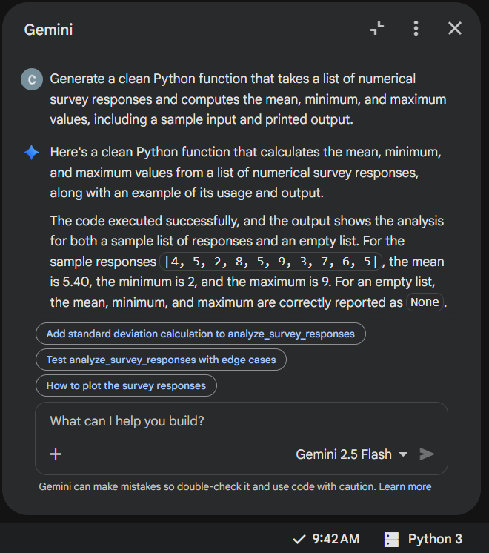

Code:
import statistics

def analyze_survey_responses(responses):
"""
Computes the mean, minimum, and maximum of a list of numerical survey responses.

Args:
responses (list): A list of numerical survey responses.

Returns:
dict: A dictionary containing the mean, minimum, and maximum values.
Returns None for min/max if the list is empty, and handles mean accordingly.
"""
if not responses:
return {"mean": None, "min": None, "max": None}

mean_value = statistics.mean(responses)
min_value = min(responses)
max_value = max(responses)

return {"mean": mean_value, "min": min_value, "max": max_value}

# Sample Input
sample_responses = [4, 5, 2, 8, 5, 9, 3, 7, 6, 5]

# Compute and Print Output
analysis_results = analyze_survey_responses(sample_responses)
print("Survey Analysis Results:")
print(f" Responses: {sample_responses}")
print(f" Mean: {analysis_results['mean']:.2f}")
print(f" Minimum: {analysis_results['min']}")
print(f" Maximum: {analysis_results['max']}")

Output:
Explanation:
Google Gemini generated a modular Python function using built-in functions such as sum(), min(), and max().
The logic calculates the mean by dividing the total sum of elements by the number of elements.
The function-based approach improves reusability and clarity.

Task 2: Armstrong Number – AI Comparison

Github copilot:

Prompt:

# Write a Python function to check if a number is an Armstrong number.
# Use an efficient approach and keep the code concise.

Code:

# Write a Python function to check if a number is an Armstrong number.
# Use an efficient approach and keep the code concise.
def is_armstrong_number(num):
# Convert the number to string to easily iterate over digits
digits = str(num)
num_digits = len(digits)

# Calculate the sum of each digit raised to the power of num_digits
armstrong_sum = sum(int(digit) ** num_digits for digit in digits)

# Check if the calculated sum is equal to the original number
return armstrong_sum == num
# Example usage:
print(is_armstrong_number(153)) # True
print(is_armstrong_number(123)) # False
print(is_armstrong_number(9474)) # True

Output:
PS C:\Users\rohit\OneDrive\Documents\SRU\ai_code\lab_2.1> & C:/Users/rohit/AppData/Local/Programs/Python/Python314/python.exe c:/Users/rohit/OneDrive/Documents/SRU/ai_code/lab_2.1/assignment_2_git_copilot.py
True
False
True

Gemini:
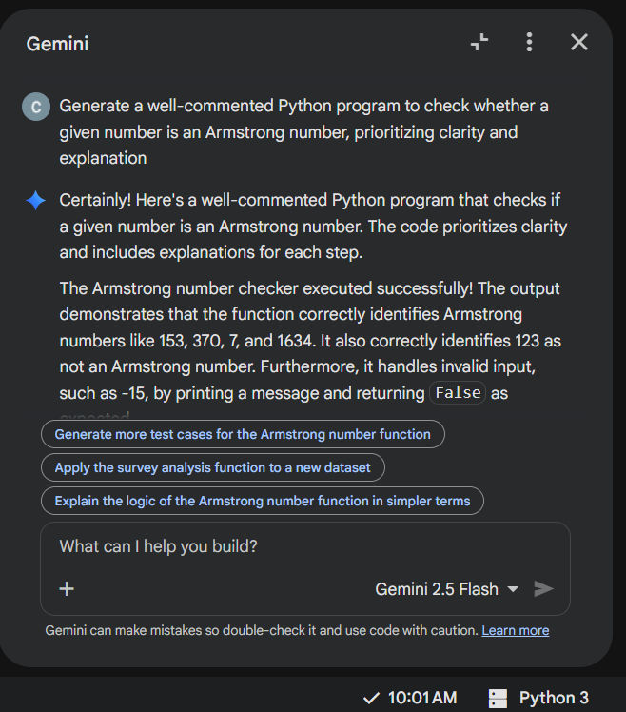
Code:
# Function to check if a number is an Armstrong number
def is_armstrong_number(number):
"""
Checks if a given positive integer is an Armstrong number.

An Armstrong number (also known as a narcissistic number, pluperfect digital invariant,
or plus perfect number) is a number that is the sum of its own digits each raised
to the power of the number of digits.

For example, 153 is an Armstrong number because 1^3 + 5^3 + 3^3 = 1 + 125 + 27 = 153.

Args:
number (int): The integer to be checked.

Returns:
bool: True if the number is an Armstrong number, False otherwise.
"""
# Ensure the input is a positive integer
if not isinstance(number, int) or number < 0:
print("Please enter a positive integer.")
return False

# Convert the number to a string to easily get its digits and count them
num_str = str(number)
num_digits = len(num_str)

# Initialize the sum of powers of digits
sum_of_powers = 0

# Iterate through each digit of the number
for digit_char in num_str:
# Convert the character digit back to an integer
digit = int(digit_char)
# Add the digit raised to the power of the number of digits to the sum
sum_of_powers += digit ** num_digits

# Compare the original number with the calculated sum
# If they are equal, it's an Armstrong number
return number == sum_of_powers

# --- Sample Usage and Output ---

# Test with an Armstrong number
num1 = 153
print(f"Is {num1} an Armstrong number? {is_armstrong_number(num1)}")

# Test with another Armstrong number
num2 = 370
print(f"Is {num2} an Armstrong number? {is_armstrong_number(num2)}")

# Test with a non-Armstrong number
num3 = 123
print(f"Is {num3} an Armstrong number? {is_armstrong_number(num3)}")

# Test with a single-digit number (all are Armstrong numbers)
num4 = 7
print(f"Is {num4} an Armstrong number? {is_armstrong_number(num4)}")

# Test with a larger Armstrong number
num5 = 1634
print(f"Is {num5} an Armstrong number? {is_armstrong_number(num5)}")

# Test with an invalid input
num6 = -15
print(f"Is {num6} an Armstrong number? {is_armstrong_number(num6)}")

Output:
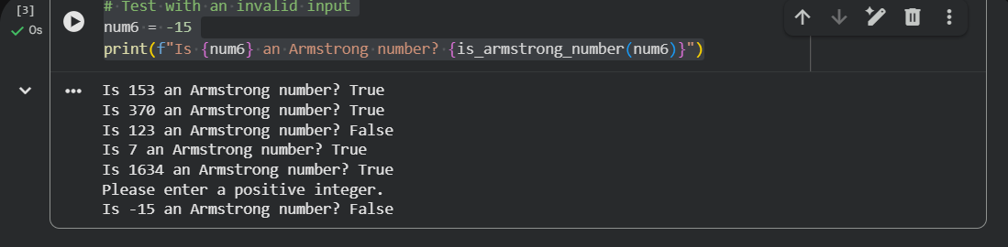

Comparison

Criteria | GitHub Copilot | Google Gemini
Output | Produces correct Boolean outputs (True / False) for valid Armstrong and non-Armstrong numbers. Example outputs are directly printed for test cases. | Produces correct Boolean outputs and also prints descriptive messages using formatted strings, making outputs more user-friendly and informative.
Logic Style | Uses a compact and efficient approach with generator expressions and built-in sum() for digit power calculation. Focuses on brevity and performance. | Uses a step-by-step procedural approach with explicit loops and intermediate variables, emphasizing understandability and correctness.
Clarity & Documentation | Minimal comments, intended for developers who already understand the logic. Code is concise but less explanatory. | Highly documented with docstrings, inline comments, examples, and input validation, making it suitable for beginners and academic purposes.

Conclusion:
Both GitHub Copilot and Google Gemini generate logically correct Armstrong number programs.
Copilot prioritizes concise and efficient code suitable for experienced developers, while Gemini focuses on clarity, documentation, and educational value.

Task 3: Leap Year Validation Using Cursor AI

Prompt:
Generate a minimal Python function to determine whether a given year is a leap year using standard rules, and include a simple function call to verify the logic with a sample test case.
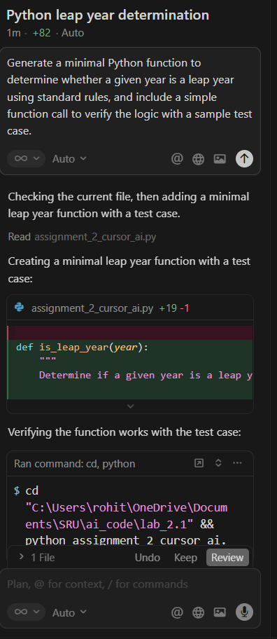
Code:
def is_leap_year(year):
"""
Determine if a given year is a leap year using standard rules.

Rules:
- Divisible by 400: leap year
- Divisible by 100 but not 400: NOT a leap year
- Divisible by 4 but not 100: leap year
- Otherwise: NOT a leap year
"""
return (year % 4 == 0 and year % 100 != 0) or (year % 400 == 0)

# Test case
if __name__ == "__main__":
test_year = 2024
result = is_leap_year(test_year)
print(f"{test_year} is a leap year: {result}")

Output:
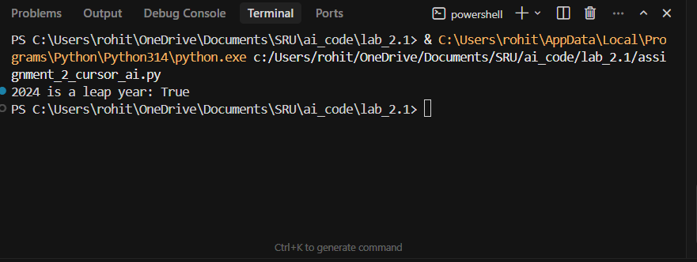

Explanation:
The function is_leap_year determines whether a given year is a leap year by applying standard calendar rules.
It returns True if the year is divisible by 4 but not by 100, or if it is divisible by 400.
A test case is included to validate the function by checking the year 2024 and printing the result.
This approach ensures correctness, simplicity, and reusability of the leap year validation logic.

Refactoring the code:
Prompt:
Extend the leap year validation logic into a complete, user-friendly Python program that accepts year input, validates it, handles invalid cases, and prints descriptive output messages.

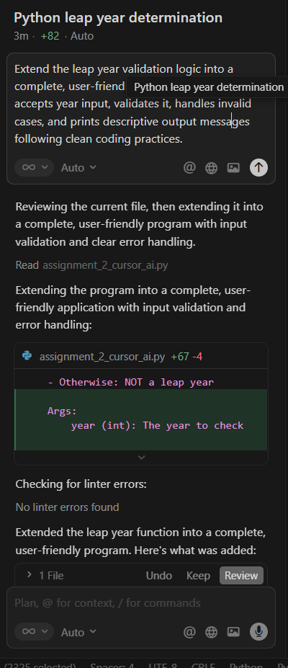
Code:
def is_leap_year(year):
"""
Determine if a given year is a leap year using standard rules.

Rules:
- Divisible by 400: leap year
- Divisible by 100 but not 400: NOT a leap year
- Divisible by 4 but not 100: leap year
- Otherwise: NOT a leap year

Args:
year (int): The year to check

Returns:
bool: True if the year is a leap year, False otherwise
"""
return (year % 4 == 0 and year % 100 != 0) or (year % 400 == 0)

def get_year_input():
"""
Get and validate year input from the user.

Returns:
int: A valid year entered by the user

Raises:
ValueError: If the input cannot be converted to an integer
"""
while True:
try:
user_input = input("Enter a year: ").strip()

if not user_input:
print("Error: Input cannot be empty. Please try again.")
continue

year = int(user_input)

if year <= 0:
print("Error: Year must be a positive integer (greater than 0). Please try again.")
continue

return year

except ValueError:
print("Error: Invalid input. Please enter a valid integer (e.g., 2024).")
except KeyboardInterrupt:
print("\n\nProgram interrupted by user.")
raise
except Exception as e:
print(f"Error: An unexpected error occurred: {e}. Please try again.")

def main():
"""
Main function to run the leap year validation program.
"""
print("=" * 50)
print("Leap Year Validator")
print("=" * 50)
print()

try:
year = get_year_input()

if is_leap_year(year):
print(f"\n✓ {year} is a leap year.")
print(f" (It has 366 days with February 29th)")
else:
print(f"\n✗ {year} is not a leap year.")
print(f" (It has 365 days)")

except KeyboardInterrupt:
print("\n\nProgram terminated.")
except Exception as e:
print(f"\nError: An unexpected error occurred: {e}")

if __name__ == "__main__":
main()

Output:
PS C:\Users\rohit\OneDrive\Documents\SRU\ai_code\lab_2.1> & C:\Users\rohit\AppData\Local\Programs\Python\Python314\python.exe c:/Users/rohit/OneDrive/Documents/SRU/ai_code/lab_2.1/assignment_2_cursor_ai.py
==================================================
Leap Year Validator
==================================================
Enter a year: 2023
✗ 2023 is not a leap year.
(It has 365 days)
PS C:\Users\rohit\OneDrive\Documents\SRU\ai_code\lab_2.1> & C:\Users\rohit\AppData\Local\Programs\Python\Python314\python.exe c:/Users/rohit/OneDrive/Documents/SRU/ai_code/lab_2.1/assignment_2_cursor_ai.py
==================================================
Leap Year Validator
==================================================
Enter a year: 2024
✓ 2024 is a leap year.
(It has 366 days with February 29th)
PS C:\Users\rohit\OneDrive\Documents\SRU\ai_code\lab_2.1>

Explanation:
This program extends the leap year logic into a complete user-interactive application by separating validation, computation, and execution into modular functions.
It improves robustness and usability by handling invalid inputs, providing descriptive output messages, and ensuring clean program flow using structured error handling.

Comparison:
The first implementation focuses on a minimal, function-based approach suitable for backend validation and logical correctness testing.
In contrast, the second implementation expands the logic into a full user-interactive program with input validation, error handling, and descriptive outputs, making it more robust and suitable for real-world applications.

Task 4: Student Logic + AI Refactoring (Odd/Even Sum)
Student code:
# Student code
numbers = (1, 2, 3, 4, 5, 6)
even_sum = 0
odd_sum = 0

for num in numbers:
if num % 2 == 0:
even_sum += num
else:
odd_sum += num

print("Sum of even numbers:", even_sum)
print("Sum of odd numbers:", odd_sum)

Output:
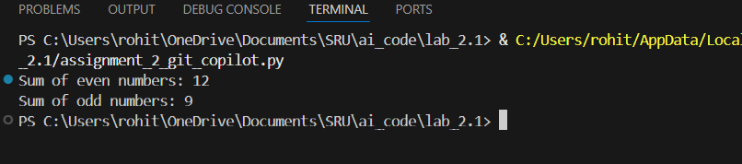
Explanation:
This code calculates the sum of even and odd numbers in a tuple by iterating through each element and checking its parity using the modulo operator.
Separate variables even_sum and odd_sum are updated accordingly, and the results are printed, demonstrating clear but verbose manual logic.

Refactoring using AI (Gemini colab):
Prompt:
Refactor the following Python code to improve readability, conciseness, and Pythonic style while preserving its functionality. Please provide the refactored code in a new code cell below the original code

Code:
# Refactored Code (Pythonic and Concise)

numbers = (1, 2, 3, 4, 5, 6)

# Calculate sum of even numbers using a generator expression
even_sum_refactored = sum(num for num in numbers if num % 2 == 0)

# Calculate sum of odd numbers using a generator expression
odd_sum_refactored = sum(num for num in numbers if num % 2 != 0)

print("Refactored - Sum of even numbers:", even_sum_refactored)
print("Refactored - Sum of odd numbers:", odd_sum_refactored)

Output:

Explanation:
The AI-refactored code replaces explicit loops and conditional statements with Pythonic generator expressions and the built-in sum() function.
This makes the code more concise and readable while preserving the original logic, improving maintainability and following Python best practices.

Comparison:
The original code uses manual iteration and conditionals, which is easy to understand but verbose.
The refactored version achieves the same result in fewer lines, with improved clarity and Pythonic style, making it more elegant and efficient for real-world use.

