AI ASSISTED CODING
ASSIGNMENT - 3.1
ROLL NO. 2303A510J0

Question 1: Zero-Shot Prompting (Palindrome Number Program

Prompt:
Write a Python function that checks whether a given number is a palindrome.
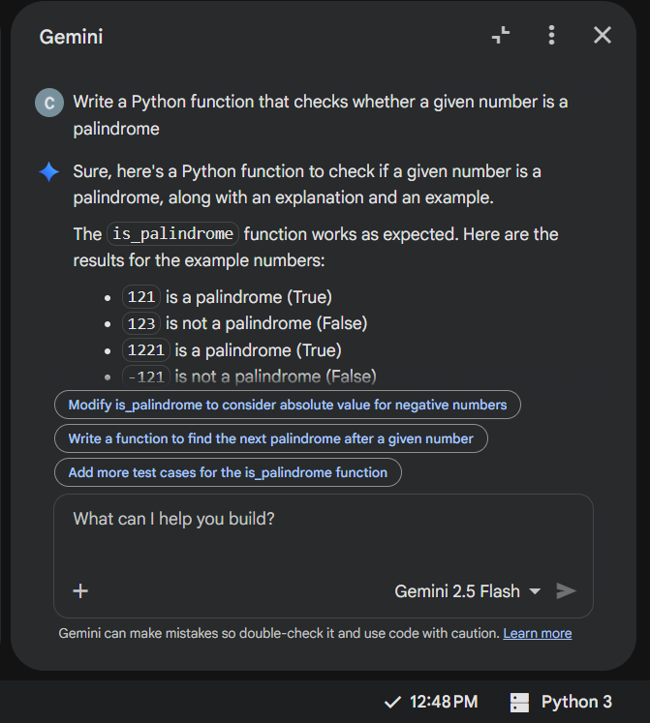

Code:
def is_palindrome(number):
"""
Checks if a given number is a palindrome.

Args:
number (int): The integer to check.

Returns:
bool: True if the number is a palindrome, False otherwise.
"""
# Convert the number to a string
num_str = str(number)

# Compare the string with its reverse
return num_str == num_str[::-1]

# Example usage:
print(f"Is 121 a palindrome? {is_palindrome(121)}")
print(f"Is 123 a palindrome? {is_palindrome(123)}")
print(f"Is 1221 a palindrome? {is_palindrome(1221)}")
print(f"Is -121 a palindrome? {is_palindrome(-121)}")
Output:
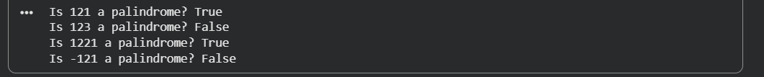
Explanation:
Code uses type casting and then reverse the string to compare and check for palindrome

Analysis (Errors & Edge Cases)
Aspect | Observation
Logic | Correct for positive integers
Negative numbers | -121 → False (acceptable, but not explicitly handled)
Input validation | Missing (floats, strings not handled)
Efficiency | Efficient for small numbers
Conclusion:
Zero-shot prompting produces short and correct code, but lacks validation and explicit constraints.

Question 2: One-Shot Prompting (Factorial Calculation)
Prompt:
Write a Python function to calculate the factorial of a number.
Example: Input: 5 gives Output: 120

Code:
def factorial(n):
"""
Calculates the factorial of a non-negative integer.

Args:
n (int): The non-negative integer to calculate the factorial for.

Returns:
int: The factorial of n.

Raises:
ValueError: If n is a negative integer.
"""
if not isinstance(n, int) or n < 0:
raise ValueError("Factorial is defined only for non-negative integers.")

if n == 0:
return 1

result = 1
for i in range(1, n + 1):
result *= i
return result

# Example usage:
print(f"Factorial of 0: {factorial(0)}")
print(f"Factorial of 1: {factorial(1)}")
print(f"Factorial of 5: {factorial(5)}")
print(f"Factorial of 7: {factorial(7)}")

# Example with a negative number (will raise an error)
try:
print(f"Factorial of -3: {factorial(-3)}")
except ValueError as e:
print(f"Error: {e}")

Output:

Explanation:
This function calculates the factorial of a number using an iterative approach.
It first validates the input, ensuring that n is a non-negative integer; otherwise, it raises a ValueError.
If n is 0, it returns 1 (by definition of factorial).
For positive integers, it multiplies numbers from 1 to n and returns the final result.

Comparison: Zero-Shot vs One-Shot
Feature | Zero-Shot | One-Shot
Input validation | No | Yes
Clarity | Medium | High
Edge cases | Missing | Handled
Readability | Basic | Improved
Conclusion:
Providing one example improves correctness, validation, and clarity.

Question 3: Few-Shot Prompting (Armstrong Number Check)
Prompt:
Write a Python function to check whether a number is an Armstrong number.
Use these examples as guidance:
• 153 → Armstrong Number
• 370 → Armstrong Number
• 123 → Not an Armstrong Number
The function should validate input (non-negative integers only) and, after implementation, test the function with boundary values (0, 1) and invalid inputs (negative numbers, non-integers), displaying the results.
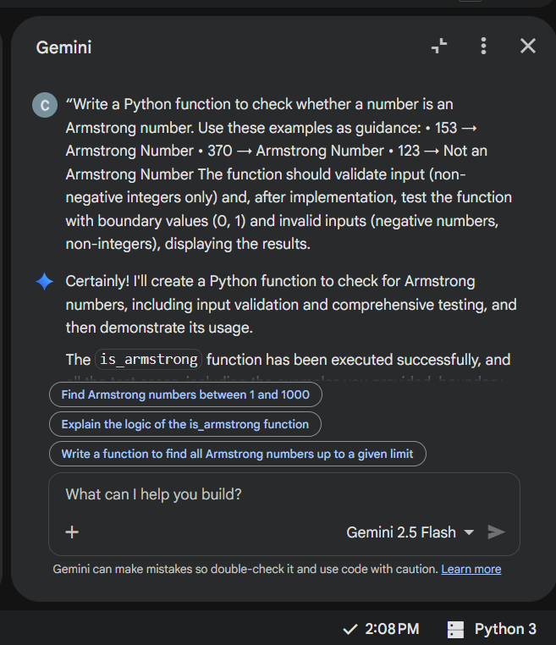

Code:
def is_armstrong(number):
"""
Checks if a given number is an Armstrong number.

An Armstrong number is a number that is the sum of its own digits each raised
to the power of the number of digits.

Args:
number (int): The integer to check.

Returns:
bool: True if the number is an Armstrong number, False otherwise.

Raises:
ValueError: If the input is not a non-negative integer.
"""
if not isinstance(number, int) or number < 0:
raise ValueError("Input must be a non-negative integer.")

# Special case for 0 and single-digit numbers
if number < 10:
return True

num_str = str(number)
num_digits = len(num_str)
armstrong_sum = 0

for digit_char in num_str:
digit = int(digit_char)
armstrong_sum += digit ** num_digits

return armstrong_sum == number

# Test cases provided by the user
print(f"Is 153 an Armstrong number? {is_armstrong(153)}") # Expected: True
print(f"Is 370 an Armstrong number? {is_armstrong(370)}") # Expected: True
print(f"Is 123 an Armstrong number? {is_armstrong(123)}") # Expected: False

# Test with boundary values
print(f"Is 0 an Armstrong number? {is_armstrong(0)}") # Expected: True
print(f"Is 1 an Armstrong number? {is_armstrong(1)}") # Expected: True
print(f"Is 9 an Armstrong number? {is_armstrong(9)}") # Expected: True
print(f"Is 10 an Armstrong number? {is_armstrong(10)}") # Expected: False

# Test with other known Armstrong numbers
print(f"Is 371 an Armstrong number? {is_armstrong(371)}") # Expected: True
print(f"Is 407 an Armstrong number? {is_armstrong(407)}") # Expected: True

# Test with invalid inputs
print("\nTesting with invalid inputs:")
try:
print(f"Is -153 an Armstrong number? {is_armstrong(-153)}")
except ValueError as e:
print(f"Error for -153: {e}")

try:
print(f"Is 12.5 an Armstrong number? {is_armstrong(12.5)}")
except ValueError as e:
print(f"Error for 12.5: {e}")

try:
print(f"Is 'abc' an Armstrong number? {is_armstrong('abc')}")
except ValueError as e:
print(f"Error for 'abc': {e}")

Output:
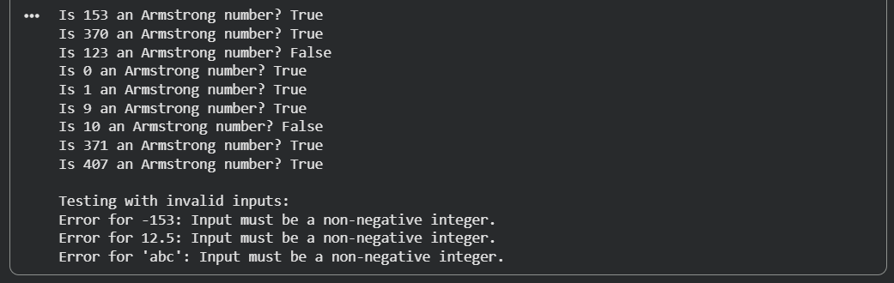
Explanation:
The function checks whether a number is an Armstrong number after validating that the input is a non-negative integer.
It extracts each digit, raises it to the power of the total number of digits, and sums the results.
If this sum equals the original number, the function returns True; otherwise, it returns False.

Analysis: Effect of Multiple Examples

Providing multiple examples helps the AI correctly understand the Armstrong number formula.
It improves code accuracy, ensures proper digit-based computation, and leads to a clear and reliable implementation.

Question 4: Context-Managed Prompting (Optimized Number
Classification)

Prompt:
Write an optimized Python program that classifies a given number as Prime, Composite, or Neither.
The program must validate input, handle numbers less than or equal to 1 correctly, and use an efficient prime-checking approach (checking divisibility only up to √n).
After implementation, test the program with valid inputs, boundary values, and invalid inputs, and display the results clearly.
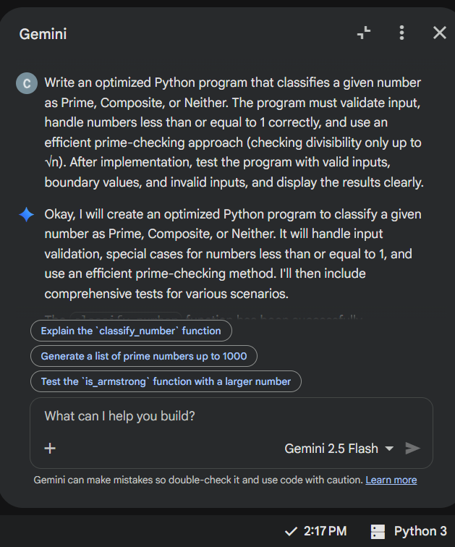

Code:
import math

def classify_number(number):
"""
Classifies a given number as Prime, Composite, or Neither.

Args:
number (int): The integer to classify.

Returns:
str: 'Prime', 'Composite', or 'Neither' based on the classification.

Raises:
ValueError: If the input is not an integer.
"""
if not isinstance(number, int):
raise ValueError("Input must be an integer.")

if number <= 1:
return "Neither"
elif number == 2:
return "Prime"
elif number % 2 == 0:
return "Composite"

# Check for divisibility from 3 up to sqrt(number) with a step of 2
# (only odd numbers need to be checked after 2)
for i in range(3, int(math.sqrt(number)) + 1, 2):
if number % i == 0:
return "Composite"
return "Prime"
# Test cases for classify_number function
print("--- Valid Inputs ---")
print(f"2 is: {classify_number(2)}") # Expected: Prime
print(f"7 is: {classify_number(7)}") # Expected: Prime
print(f"10 is: {classify_number(10)}") # Expected: Composite
print(f"17 is: {classify_number(17)}") # Expected: Prime
print(f"25 is: {classify_number(25)}") # Expected: Composite
print(f"101 is: {classify_number(101)}") # Expected: Prime
print(f"999 is: {classify_number(999)}") # Expected: Composite

print("\n--- Boundary Values ---")
print(f"0 is: {classify_number(0)}") # Expected: Neither
print(f"1 is: {classify_number(1)}") # Expected: Neither
print(f"-5 is: {classify_number(-5)}") # Expected: Neither
print(f"-1 is: {classify_number(-1)}") # Expected: Neither

print("\n--- Invalid Inputs ---")
try:
print(f"1.5 is: {classify_number(1.5)}")
except ValueError as e:
print(f"Error for 1.5: {e}")

try:
print(f"'abc' is: {classify_number('abc')}")
except ValueError as e:
print(f"Error for 'abc': {e}")

try:
print(f"None is: {classify_number(None)}")
except ValueError as e:
print(f"Error for None: {e}")

Output:
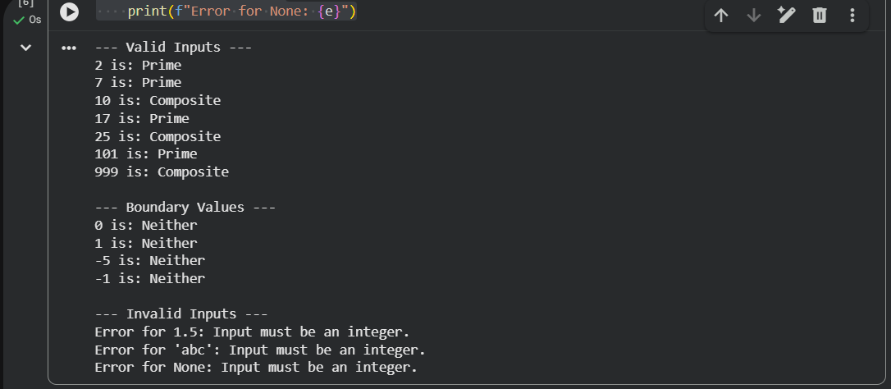

Explanation:
The function first validates that the input is an integer.
Numbers less than or equal to 1 are classified as Neither, while 2 is directly classified as Prime.
Even numbers greater than 2 are marked Composite.
For other numbers, divisibility is checked only up to √n and only for odd numbers, making the algorithm efficient.
If no divisor is found, the number is classified as Prime.

Comparison with Earlier Prompting Strategies
Compared to zero-shot and few-shot prompting, context-managed prompting produces more optimized and structured output.
Earlier strategies often lacked efficiency or complete validation, whereas this approach ensures correct classification, input validation, and better performance.
Overall, context-managed prompting results in more reliable and production-quality code.

Question 5: Zero-Shot Prompting (Perfect Number Check)

Prompt:
Write a Python function that checks whether a given number is a perfect number.
The function should return True if the number is perfect and False otherwise.
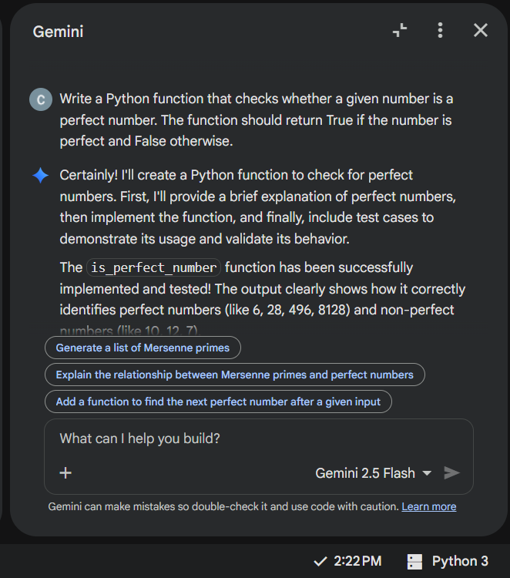
Code:
def is_perfect_number(number):
"""
Checks if a given number is a perfect number.

A perfect number is a positive integer that is equal to the sum of its
proper positive divisors (divisors excluding the number itself).

Args:
number (int): The integer to check.

Returns:
bool: True if the number is a perfect number, False otherwise.

Raises:
ValueError: If the input is not a positive integer.
"""
if not isinstance(number, int) or number <= 0:
raise ValueError("Input must be a positive integer.")

if number == 1:
return False # 1 has no proper divisors, sum is 0, not 1

sum_of_divisors = 1 # Start with 1, as 1 is always a divisor
for i in range(2, int(number**0.5) + 1):
if number % i == 0:
sum_of_divisors += i
if i * i != number:
sum_of_divisors += number // i

return sum_of_divisors == number

# Example usage and test cases
print("--- Perfect Number Checks ---")
print(f"Is 6 a perfect number? {is_perfect_number(6)}") # Expected: True (1 + 2 + 3 = 6)
print(f"Is 28 a perfect number? {is_perfect_number(28)}") # Expected: True (1 + 2 + 4 + 7 + 14 = 28)
print(f"Is 496 a perfect number? {is_perfect_number(496)}") # Expected: True
print(f"Is 8128 a perfect number? {is_perfect_number(8128)}") # Expected: True

print("\n--- Non-Perfect Number Checks ---")
print(f"Is 10 a perfect number? {is_perfect_number(10)}") # Expected: False (1 + 2 + 5 = 8)
print(f"Is 12 a perfect number? {is_perfect_number(12)}") # Expected: False (1 + 2 + 3 + 4 + 6 = 16)
print(f"Is 7 a perfect number? {is_perfect_number(7)}") # Expected: False (1)

print("\n--- Boundary and Invalid Inputs ---")
print(f"Is 1 a perfect number? {is_perfect_number(1)}") # Expected: False (as per definition)

try:
print(f"Is 0 a perfect number? {is_perfect_number(0)}")
except ValueError as e:
print(f"Error for 0: {e}")

try:
print(f"Is -5 a perfect number? {is_perfect_number(-5)}")
except ValueError as e:
print(f"Error for -5: {e}")

try:
print(f"Is 12.5 a perfect number? {is_perfect_number(12.5)}")
except ValueError as e:
print(f"Error for 12.5: {e}")

try:
print(f"Is 'abc' a perfect number? {is_perfect_number('abc')}")
except ValueError as e:
print(f"Error for 'abc': {e}")

Output:
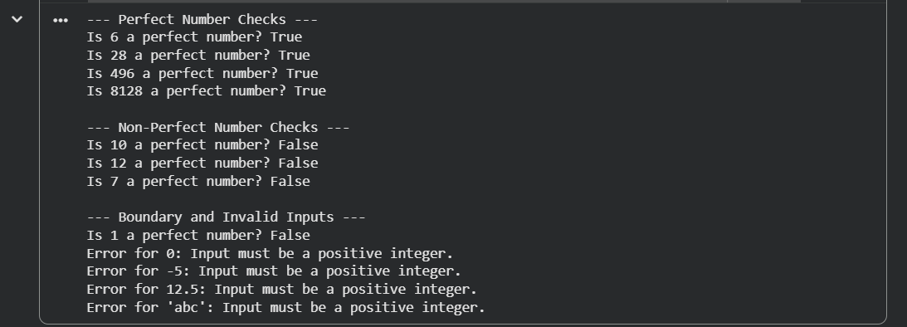
Explanation:
The function first checks whether the input is a positive integer, raising an error for invalid inputs.
It returns False for 1 since it is not a perfect number.
The function then calculates the sum of all proper divisors by checking divisors only up to √n, adding both the divisor and its pair when found.
Finally, it compares the sum of divisors with the original number to determine if it is perfect.

Missing Conditions or Inefficiencies in the Logic
- The code efficiently reduces time complexity by checking divisors only up to √n.
- However, it does not stop early if the divisor sum exceeds the number, which could improve performance.
- Large input values may still be computationally expensive due to iteration.
- Apart from minor optimization opportunities, the logic correctly handles all required conditions.

Question 6: Few-Shot Prompting (Even or Odd Classification with Validation)

Prompt:
Write a Python program to determine whether a given number is Even or Odd.
Use the following examples as guidance:
• Input: 8 → Output: Even
• Input: 15 → Output: Odd
• Input: 0 → Output: Even
The program should validate input and handle negative numbers and non-integer inputs appropriately.
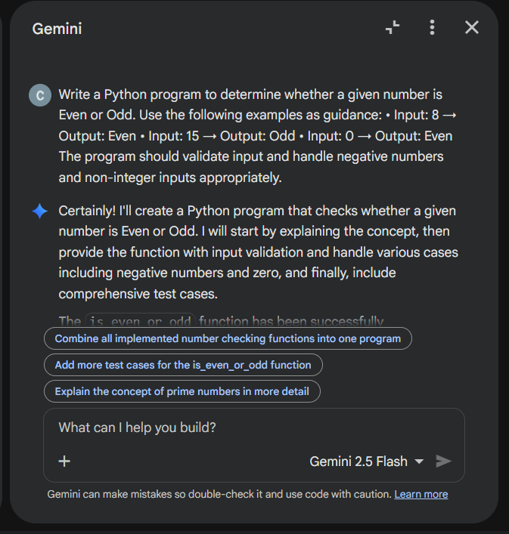
Code:
def is_even_or_odd(number):
"""
Determines if a given number is Even or Odd.

Args:
number (int): The integer to check.

Returns:
str: 'Even' if the number is even, 'Odd' if the number is odd.

Raises:
ValueError: If the input is not an integer.
"""
if not isinstance(number, int):
raise ValueError("Input must be an integer.")

if number % 2 == 0:
return "Even"
else:
return "Odd"
# Example usage and test cases
print("--- Even/Odd Number Checks ---")
print(f"8 is: {is_even_or_odd(8)}") # Expected: Even
print(f"15 is: {is_even_or_odd(15)}") # Expected: Odd
print(f"0 is: {is_even_or_odd(0)}") # Expected: Even
print(f"-2 is: {is_even_or_odd(-2)}") # Expected: Even
print(f"-7 is: {is_even_or_odd(-7)}") # Expected: Odd
print(f"100 is: {is_even_or_odd(100)}") # Expected: Even
print(f"99 is: {is_even_or_odd(99)}") # Expected: Odd

print("\n--- Invalid Inputs ---")
try:
print(f"1.5 is: {is_even_or_odd(1.5)}")
except ValueError as e:
print(f"Error for 1.5: {e}")

try:
print(f"'abc' is: {is_even_or_odd('abc')}")
except ValueError as e:
print(f"Error for 'abc': {e}")

try:
print(f"None is: {is_even_or_odd(None)}")
except ValueError as e:
print(f"Error for None: {e}")

Output:
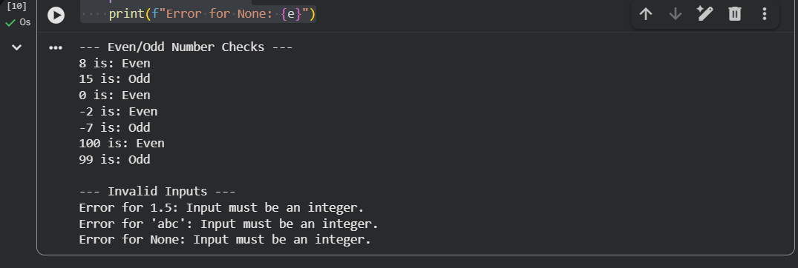
Explanation:
The program first checks whether the input is an integer to ensure valid input.
It then uses the modulo operator to determine if the number is divisible by 2.
If divisible, the number is classified as Even; otherwise, it is classified as Odd.
Invalid inputs are handled gracefully using input validation.

Analysis: Effect of Examples
Providing multiple examples helps the AI clearly understand the expected behavior for different cases.
It improves input handling, ensures correct classification of 0 and negative numbers, and enhances output clarity.

Conclusion from this assignment:

Prompt design directly impacts the accuracy and quality of AI-generated code.
Zero-shot prompting gives basic solutions but may lack validation or optimization.
One-shot and few-shot prompting improve correctness, readability, and handling of edge cases.
Context-managed prompting produces optimized, reliable, and fully validated programs.
Well-structured prompts lead to more efficient, robust, and production-ready code.

