AI ASSISTED CODING
ASSIGNMENT - 1
ROLL NO. 2303A510J0

Task 0: Install and configure GitHub Copilot in VS Code
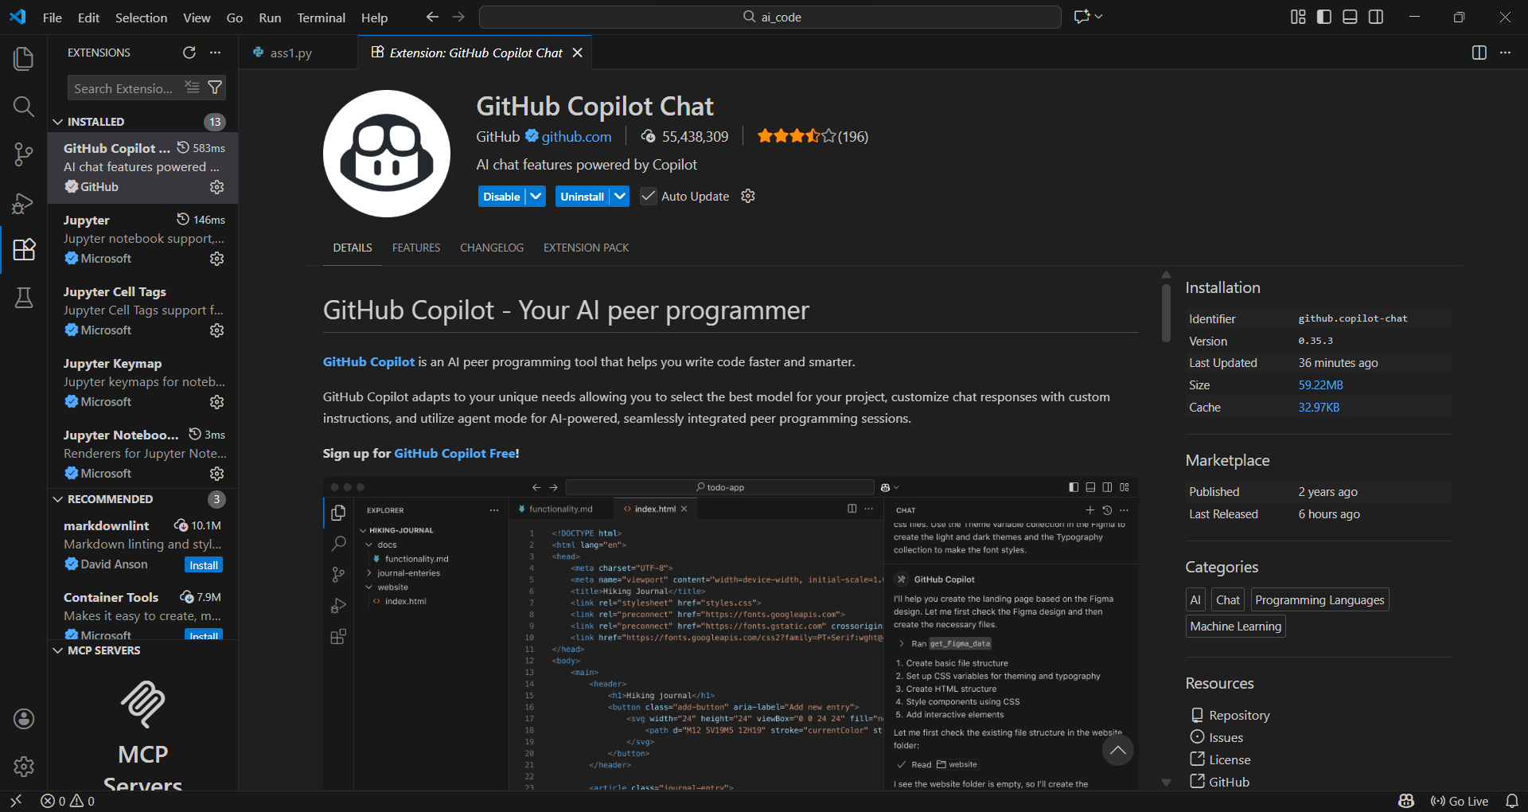

Task 1: AI-Generated Logic Without Modularization (Fibonacci Sequence Without Functions)

# Write a Python program to print Fibonacci sequence up to n terms
# Take user input
# Do not use any user-defined functions

n = int(input("Enter the number of terms: "))

# Initialize first two terms
a, b = 0, 1

# Print the first term if n is greater than 0
if n > 0:
print(a, end=" ")

# Print the second term if n is greater than 1
if n > 1:
print(b, end=" ")

# Generate and print the remaining terms
for i in range(2, n):
c = a + b
print(c, end=" ")
a = b
b = c

Output:
PS C:\Users\rohit\OneDrive\Documents\SRU\ai_code> & C:/Users/rohit/AppData/Local/Programs/Python/Python314/python.exe c:/Users/rohit/OneDrive/Documents/SRU/ai_code/lab1_7_1/ass1.py
Enter the number of terms: 5
0 1 1 2 3

Explanation:
The program directly implements Fibonacci logic in the main block.
It uses variables a and b to store previous values.
No functions are used, making it procedural.
GitHub Copilot generated the logic based on comments.

Task 2: AI Code Optimization & Cleanup (Improving Efficiency)
# Optimize this Fibonacci code
# Simplify variable usage
# Improve readability
n = int(input("Enter number of terms: "))

prev, curr = 0, 1

for _ in range(n):
print(prev, end=" ")
prev, curr = curr, prev + curr
print()

Output:
PS C:\Users\rohit\OneDrive\Documents\SRU\ai_code> & C:/Users/rohit/AppData/Local/Programs/Python/Python314/python.exe c:/Users/rohit/OneDrive/Documents/SRU/ai_code/lab1_7_1/ass1.py
Enter number of terms: 5
0 1 1 2 3

Explanation:
Reduced number of variables.
Cleaner tuple assignment.
More readable and concise.
Better performance due to fewer operations.

Task 3: Modular Design Using AI Assistance (Fibonacci Using Functions)

# Write a Python function to generate Fibonacci sequence up to n
# Use meaningful comments
def fibonacci_sequence(n):
"""Generate Fibonacci sequence up to n terms."""
sequence = []
a, b = 0, 1
for _ in range(n):
sequence.append(a)
a, b = b, a + b
return sequence

# Take user input
n = int(input("Enter the number of terms: "))
# Generate and print the Fibonacci sequence
fib_sequence = fibonacci_sequence(n)
print(*fib_sequence)

Output:
PS C:\Users\rohit\OneDrive\Documents\SRU\ai_code> & C:/Users/rohit/AppData/Local/Programs/Python/Python314/python.exe c:/Users/rohit/OneDrive/Documents/SRU/ai_code/lab1_7_1/ass1.py
Enter the number of terms: 10
0 1 1 2 3 5 8 13 21 34

Explanation:
Fibonacci logic is encapsulated in a function.
Improves reusability and clarity.
Easy to maintain and test.
Copilot generated comments and clean structure.

Task 4: Comparative Analysis – Procedural vs Modular Fibonacci Code

Feature | Without Functions | With Functions
Code clarity | Moderate | High
Reusability | No | Yes
Debugging | Difficult | Easy
Readability | Average | Better
Large systems | Not suitable | Suitable

Analysis:
- Modular code is preferred in real-world applications.
- Functions allow reuse and easier debugging.
- Procedural code is suitable only for small scripts.

Task 5: AI-Generated Iterative vs Recursive Fibonacci Approaches (Different Algorithmic Approaches for Fibonacci Series)
# Write an iterative Fibonacci program in Python
def fibonacci_iterative(n):
a, b = 0, 1
for _ in range(n):
print(a, end=" ")
a, b = b, a + b
n = int(input("Enter number of terms: "))
fibonacci_iterative(n)

Output:
PS C:\Users\rohit\OneDrive\Documents\SRU\ai_code> & C:/Users/rohit/AppData/Local/Programs/Python/Python314/python.exe c:/Users/rohit/OneDrive/Documents/SRU/ai_code/lab1_7_1/ass1.py
Enter number of terms: 10
0 1 1 2 3 5 8 13 21 34

# Write a recursive Fibonacci program in Python
def fibonacci_recursive(n):
if n <= 0:
return []
elif n == 1:
return [0]
elif n == 2:
return [0, 1]
else:
seq = fibonacci_recursive(n - 1)
seq.append(seq[-1] + seq[-2])
return seq

n = int(input("Enter number of terms: "))
fib_sequence = fibonacci_recursive(n)
print(*fib_sequence)

Output:
PS C:\Users\rohit\OneDrive\Documents\SRU\ai_code> & C:/Users/rohit/AppData/Local/Programs/Python/Python314/python.exe c:/Users/rohit/OneDrive/Documents/SRU/ai_code/lab1_7_1/ass1.py
Enter number of terms: 6
0 1 1 2 3 5

Execution Flow Explanation
- Iterative: Uses a loop and updates values step-by-step.
- Recursive: Calls itself repeatedly until base condition is met.

Comparison
Aspect | Iterative | Recursive
Time Complexity | O(n) | O(2ⁿ)
Space Complexity | O(1) | O(n)
Performance | Fast | Slow
Large n | Recommended | Avoided

Why recursion should be avoided
- High memory usage due to stack calls.
- Poor performance for large inputs.

