MAJOR PROJECT STAGE - 1 (IT705PC)
On
MindMorph: Emotion Adaptive AI Interaction System

Submitted in partial fulfillment of the requirements for the award of the Degree of
Bachelor of Technology (B. Tech)

in
INFORMATION TECHNOLOY

By

A Dharani Priya Reddy 22AG1A1202
Rohit Kumar Patil 22AG1A1255
A Abhinay 22AG1A1201

Under the Esteemed Guidance of

Krishna Teja

Assistant Professor


Department of Information Technology
ACE ENGINEERING COLLEGE
An Autonomous Institution
All the courses are Accredited by NBA and NAAC with A Grade

(Affiliated to Jawaharlal Nehru Technological University, Hyderabad, Telangana)
Ankushapur, Ghatkesar, Medchal, Hyderabad - 501 301

Nov-2025


ACE
Engineering College
An Autonomous Institution

All the courses are Accredited by NBA and NAAC with A Grade (Affiliated to Jawaharlal Nehru Technological University, Hyderabad, Telangana)
Website: www.aceec.ac.in E-mail: info@aceec.ac.in

CERTIFICATE

This is to certify that the Major Project Stage-1 work entitled “MindMorph: Emotion Adaptive AI Interaction System” is being submitted by:

A Dharani Priya Reddy 22AG1A1202
Rohit Kumar Patil 22AG1A1255
A Abhinay 22AG1A1201

in partial fulfillment for the award of Degree of BACHELOR OF TECHNOLOGY in INFORMATION TECHNOLOGY to the Jawaharlal Nehru Technological University, Hyderabad during the academic year 2025 - 26 is a record of bonafide work carried out by them under our guidance and supervision.

The results embodied in this report have not been submitted by the student to any other University or Institution for the award of any degree or diploma.

Internal Guide Head of the Department
Krishna Teja Prof. K. JAYA BHARATHI
Assistant Professor Professor and Head
Dept. of IT Dept. of IT

ACKNOWLEDGEMENT
We would like to express my gratitude to all the people behind the screen who have helped me transform an idea into a real time application.

We would like to express my heart-felt gratitude to my parents without whom I would not have been privileged to achieve and fulfill my dreams.

A special thanks to our Secretary, Prof. Y. V. GOPALA KRISHNA MURTHY for having founded such an esteemed institution. I am also grateful to our beloved principal, Dr. N. SUDHAKAR REDDY for permitting us to carry out this project.

We profoundly thank Prof. K. JAYA BHARATHI, Head of the Department of Information Technology who has been an excellent guide and also a great source of inspiration to my work.

We are very thankful to our internal guide KRISHNA TEJA, Assistant Professor who has been given continuous support for the completion of our project work.

The satisfaction and euphoria that accompany the successful completion of the task would be great, but incomplete without the mention of the people who made it possible, whose constant guidance and encouragement crown all the efforts with success. In this context, we would like to thank all the other staff members, both teaching and non-teaching, who have extended their timely help and eased my task.

A Dharani Priya Reddy 22AG1A1202
Rohit Kumar Patil 22AG1A1255
A Abhinay 22AG1A1201

DECLARATION

We hereby declare that major project stage-1 entitled “MindMorph: Emotion Adaptive AI Interaction System” which is being submitted in the partial fulfillment of the requirements for the award of degree of Bachelor of Technology in Information Technology. This dissertation is our original work and the project has not formed the basis for the award of any degree, associate ship, fellowship or any other similar titles and no part of it has been published or sent for the publication at the time of submission.

A Dharani Priya Reddy (22AG1A1202)
Rohit Kumar Patil (22AG1A1255)
A Abhinay (22AG1A1201)

Table of Contents
Contents Page No.
Chapter 1: Introduction 1-3
1.1. Motivation 1
1.2. Overview of existing system 1
1.3. Overview of proposed system 2
1.4. Problem Statement 2
1.5. System Features 3
Chapter 2: Literature Survey 4-6
Chapter 3: System Requirements 7-10
3.1. Operating environments 7
3.2. Functional requirements 8
3.3. Non-Functional requirements 9
3.4. System Analysis 10
Chapter 4: System Design 11-12
4.1. System Architecture 11
4.2. Data Flow Diagram Level-0 12
4.3. Data Flow Diagram Level-1 12
Chapter 5: System Modeling 13-18
5.1. UML Diagrams 13
5.2. Database Modeling 18
Chapter 6: Conclusion 19
Chapter 7: References 20
7.1. Reference Websites 20

ABSTRACT

MindMorph is an intelligent web platform that dynamically adapts digital content based on the user’s emotional state, aiming to enhance mental well-being and user experience. It integrates real-time facial emotion recognition, voice-tone analysis, and user interaction patterns to detect emotions such as happiness, sadness, anger, surprise, or neutrality. Based on the detected emotion, the system updates the user interface by changing background colors, displaying mood-aligned quotes, and suggesting music or media. A fusion-logic engine ensures accurate emotion classification by combining facial and voice signals. Additionally, the platform provides an emotion dashboard to track mood trends and patterns over time. MindMorph leverages AI and machine learning techniques to create a personalized, adaptive, and interactive environment that responds to the user’s emotional context in real time. This project demonstrates the potential of emotion-aware systems in digital interfaces, promoting relaxation, motivation, and focus.

List of Figures
Sno. Contents Page No.
- System Architecture 11
- Data Flow Diagram Level – 0 12
- Data Flow Diagram Level – 1 12
- Use Case Diagram 13
- Class Diagram 14
- Sequence Diagram 15
- Activity Diagram 16
- Deployment Diagram 17
- Entity-Relationship Diagram 18

List of Abbreviations
Sno. Contents Page No.
1 AI - Artificial Intelligence 2
2 ML - Machine Learning 2
3 FER - Facial Emotion Recognition 3
4 SER - Speech Emotion Recognition 3
5 UI - User Interface 4
6 NLP - Natural Language Processing 4
7 GPT - Generative Pre-trained Transformer 5
8 API - Application Programming Interface 6
9 HTTPS - Hyper Text Transfer Protocol Secure 7
10 CNN - Convolutional Neural Network 8

Chapter 1
Introduction

  - Motivation

• Emotion-Blind Technology: Most digital systems today do not understand human emotions, leading to robotic and impersonal interactions that fail to connect with the user’s real emotional state.

• Rise in Mental Fatigue: Increasing screen time, online communication, and AI usage have created emotional strain, making emotionally intelligent systems more essential than ever.

• Human-Centric Design Need: Modern users expect technology to be empathetic, personalized, and responsive to mood changes—not just logically correct.

• Better Digital Well-being: Emotion-aware systems can help reduce stress, improve comfort, and create safer online spaces by adapting tone, visuals, and responses based on the user's mood.

• Next-Generation Interfaces: The shift toward adaptive UI/UX demands systems that respond dynamically to emotions, offering a futuristic and more natural human–AI interaction.

  - Overview of Existing System
These points explain why current AI or UI systems fail to provide emotionally adaptive experiences.

• Static Interactions: Current AI systems (like Siri, Alexa, ChatGPT UI) respond with the same tone regardless of the user’s emotion or context.

• Text-Only Understanding: Most assistants rely only on text input, ignoring facial expressions, voice tone, or emotional cues.

• No Real-Time Sensing: Traditional interfaces cannot analyze camera or microphone data to detect emotion in real time.

• No Emotion Fusion: Existing systems cannot combine facial + speech emotion signals to improve accuracy.
• Lack of Adaptive UI: The interface theme, visuals, and tone remain unchanged, making the experience emotionally flat.
• Generic Responses: AI tools provide helpful responses, but they lack emotional depth and personalization, making conversations less human-like.

  - Overview of Proposed System
These points introduce the innovative MindMorph Emotion-Adaptive AI System.
• Multimodal Emotion Detection: MindMorph uses DeepFace for facial expression analysis and SER models for speech emotion classification.
• Fusion-Based Emotion Output: A custom Fusion Engine integrates face and voice emotions to produce a precise dominant emotion.
• Emotion-Adaptive UI: The system dynamically adjusts the interface theme, colors, animations, aura effects, and emotion orb based on detected emotions.
• GPT-Powered Emotional Responses: Uses GPT to generate empathetic, personalized, and mood-aware conversations.
• Mood-Based Content Suggestions: Integrates Spotify and Unsplash APIs to offer music and visual recommendations aligned with the user’s emotional state.
• Emotion History & Analytics: Logs emotional patterns over time to provide insights and improve personalization.
• Modern Architecture: Built with Next.js, Tailwind CSS, Flask/Node backend, and Firebase for storage and secure user sessions.

  - Problem Statement
The problem is that current AI interfaces lack emotional intelligence and fail to adapt to the user’s emotional state.
• Emotion Unawareness: Most systems do not recognize user emotions, leading to disconnected conversations and poor engagement.

• Monotone Interaction: AI responses do not change tone, empathy level, or mood, making them feel robotic.

• No Multimodal Sensing: Existing solutions cannot combine face + voice cues to understand user sentiment accurately.

• Non-Adaptive UI: Interfaces do not change based on mood, which reduces user comfort and experience quality.

• Lack of Personalization: Users do not receive responses, visuals, or content tailored to their emotions.

• Poor Emotional Support: Without emotional insight, systems cannot provide stress relief, mood support, or empathetic AI interaction.

  - System Features
These are the key features that define the capabilities of the MindMorph project.

• Facial Emotion Recognition: Uses DeepFace to classify real-time facial expressions into core emotion categories.

• Speech Emotion Recognition: Uses a CNN-LSTM–based model to detect emotions from audio and voice tone.

• Multimodal Fusion Engine: Combines facial and audio results to produce a more reliable emotion outcome.

• Adaptive Aura & Emotion Orb: Visual components that change color, intensity, and flow based on the detected emotion.

• GPT Emotional Response Generator: Creates empathic, mood-aware responses customized to the user’s emotional state.

• Mood-Based Content Engine: Suggests music, images, and textual content based on detected emotions through Spotify and Unsplash APIs.

• Emotion History Tracking: Stores previous detected emotions and interactions in Firestore/MongoDB for personal analytics.

• Responsive Modern Dashboard: Built using Next.js and Tailwind CSS, offering a futuristic, smooth, and highly interactive user experience.

Chapter 2
Literature Survey

- Title: A Survey of Deep-Learning-Based Multimodal Emotion Recognition
Published By: MDPI
Year: 2023

Authors: W. Lian, Z. Ma, Y. Zheng, J. Zhang, Y. Yan

Outcomes:

- Multimodal Advantage: The study confirms that combining facial expressions, speech
tone, and other signals significantly improves emotion recognition accuracy compared
to single-modality systems.

- Higher Robustness: Fusion-based systems are more resilient to noise, lighting
variations, or missing data from one modality, making them better suited for real-world conditions.

- Deep Learning Impact: CNN, LSTM, and hybrid architectures outperform traditional
machine-learning methods for emotion detection.

- Growing Demand: The paper highlights increasing global demand for emotionally
intelligent systems in healthcare, education, and human–AI interaction platforms.
Observations:
This paper directly justifies the multimodal foundation of MindMorph. It proves that emotion fusion (Face + Speech) is essential for accuracy, motivating our Fusion Engine architecture. It also confirms the practical value of emotionally aware AI, supporting the relevance of our system.

- Title: Real-Time Speech Emotion Recognition Using CNN–LSTM Models
Published By: Springer
Year: 2024

Authors: C. Barhoumi, M. Nassar, M. Bouhlel

Outcomes:

- High-Accuracy SER: The CNN–LSTM model achieved strong performance
Using MFCC and spectrogram features, demonstrating reliability even in noisy environments.

- Temporal Understanding: LSTM layers capture emotional transitions over
time, improving classification stability.

- Dataset Validation: Models were tested on major SER datasets (RAVDESS,
TESS, EmoDB), confirming real-world applicability.

- Real-Time Capability: The paper proves that real-time SER is feasible with
optimized models, opening the door for live emotional sensing.

Observations:

This research influenced the audio-processing module of MindMorph. It validates
the use of CNN–LSTM pipelines for speech emotion detection and supports our goal
of real-time microphone-based emotion recognition.

- Title: Affective Computing and Emotion-Aware User Interfaces
Published By: ACM
Year: 2023
Authors: A. Alipour, K. Kargar, H. Alipour, Y. Shang

Outcomes:
- Emotion-Driven UI Adaptation: The paper demonstrates that adapting interface
themes and visuals based on user emotion significantly improves user satisfaction and usability.

- Design Framework: Introduces affective UI principles that map emotional states (e.g .stress, happiness, sadness) to specific UI changes such as color, brightness, and animations.

- User Engagement: Emotion-aware systems increase engagement, reduce cognitive load, and create a more personalized UI experience.

- Interaction Quality: Emotion-adaptive interfaces improve communication clarity in human–AI systems, making interactions feel more natural.

Observations:
This study directly supports MindMorph’s adaptive UI module. It justifies our approach of using emotion-controlled themes, aura animations, and the emotion orb. The research confirms that emotional personalization enhances user comfort and interaction quality.

Chapter 3
System Requirements

  - Operating Environments
The operating environment defines where the MindMorph system runs, both during development and during real-time user interactions. The project uses a hybrid architecture that distributes the workload across client, cloud, and backend environments.

    - Client-Side Environment (User's Device)

- Description: This is the environment where the user directly interacts with the system. It includes personal devices such as laptops, smartphones, or tablets equipped with a camera and microphone
- Components: The main MindMorph Emotion-Adaptive Interface built using Next.js/React. It handles UI rendering, captures camera and audio input, displays adaptive visuals, and processes lightweight client-side logic.
- Requirement: The interface must be fully responsive and function smoothly on all modern browsers (Chrome, Edge, Firefox). The device must support camera/microphone permissions and real-time rendering without delays.

    - Cloud Service Environment (Data & Intelligence)

- Description: These are the cloud-hosted intelligent services that power emotion analysis, AI responses, and media retrieval. They handle storage, session history, and API-based emotional content generation.
- Components: Firebase Firestore for storage, Firebase Authentication for login, GPT API for emotion-aware responses, and Spotify/Unsplash APIs for mood-based content suggestions.
- Requirement: All communication must occur over secure HTTPS channels to ensure safe transmission of user audio, video frames, and session data. Cloud responses must be fast for seamless user experience.

3.1.3. Server-Side Environment (Deployment Blueprint)

- Description: This is the dedicated server environment where the core ML models run. It hosts the emotion detection pipeline and manages backend communication.

- Components: Python/Flask or Node.js backend, DeepFace model for facial emotion recognition, SER model for speech emotion analysis, and a custom Fusion Engine for multimodal combination.

- Requirement: The server must securely host Python/ML models and efficiently process face/audio inputs. It should allow integration of future modules like advanced emotion models or additional sensor inputs.

  - Functional Requirements
Functional requirements define what MindMorph must accomplish to meet user and system needs.

3.2.1 Multimodal Emotion Detection

- Requirement: The system must accurately detect the user’s emotional state using both facial expressions and speech tone.

- Detail: The camera captures facial features for DeepFace, while the microphone captures voice data for SER. The outputs are combined for final emotion classification.

3.2.2 Fusion-Based Emotion Classification

- Requirement: The system must integrate outputs from face and speech models to produce a single, reliable emotion.

- Detail: The Fusion Engine determines the dominant emotion based on confidence scores, ensuring higher accuracy than single-model prediction.

- Detail: This AI-generated text must be derived from the prediction data and be grounded in current, real-world information (e.g., linking the high Geopolitical Score to current events).

3.2.3 Emotion-Adaptive UI Changes

- Requirement: The system must dynamically update the interface based on the detected emotion.

- Detail: The UI adjusts color themes, animations, aura effects, and the emotion orb visuals in real time to reflect user mood.

  - Non-Functional Requirements
Non-functional requirements describe how well the system must perform. These ensure reliability, security, and a great user experience.

3.3.1 Performance (Speed)

• Requirement: Emotion detection and response rendering must occur within 1–2 seconds for a smooth experience.

• Detail: Client-side preprocessing and optimized model inference ensure minimal lag during camera/mic processing.

3.3.2 Reliability and Fault Tolerance

• Requirement: MindMorph must handle inconsistent audio, low-light video, or API delays gracefully.

• Detail: Fallback prompts, retry mechanisms, and confidence scoring ensure stability even in imperfect conditions.

3.3.3 Security

• Requirement: User information, camera data, and audio input must be securely handled.

• Detail: Firebase Authentication, HTTPS communication, and strict access permissions protect user sessions and logs.

  - System Analysis
System analysis involves examining the project structure to ensure it is logical and feasible.

3.4.1 Feasibility:
The system is feasible because all major technologies — DeepFace, SER models, GPT API, Spotify/Unsplash APIs, Firebase, and React — are freely available and integrate efficiently. The modular design enables easy upgrading of models and frontend components.
3.4.2 Module Relationships:
MindMorph uses a modular architecture where the Emotion Detection Module feeds the Fusion Engine, which then drives the UI Adaptation and GPT Response modules. This separation ensures future scalability — models or UI components can be replaced without affecting the rest of the system.
3.4.3 Data Flow Verification:
The system follows a structured data pipeline:
User Input → Emotion Detection → Fusion Engine → GPT Response Generation → UI Adaptation → Emotion Logging.
This flow ensures consistent emotional context handling and maintains a clean interaction history for improved personalization.
Chapter 4
System Design

  - System Architecture

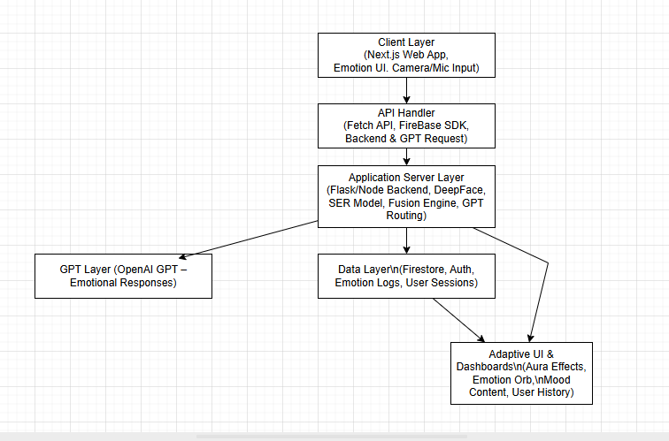

  - Data Flow Diagram Level – 0

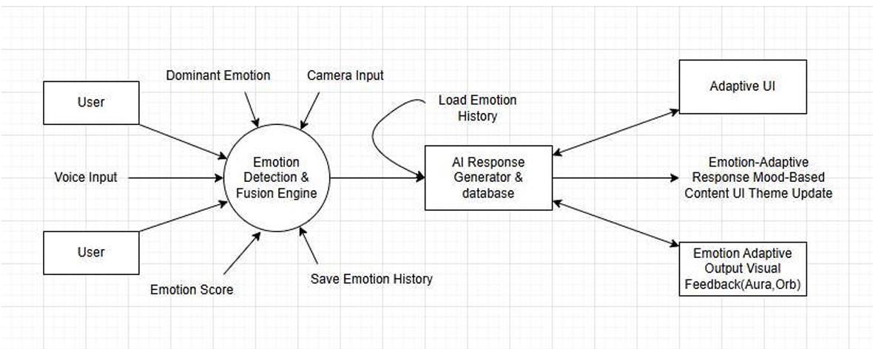

  - Data Flow Diagram Level – 1

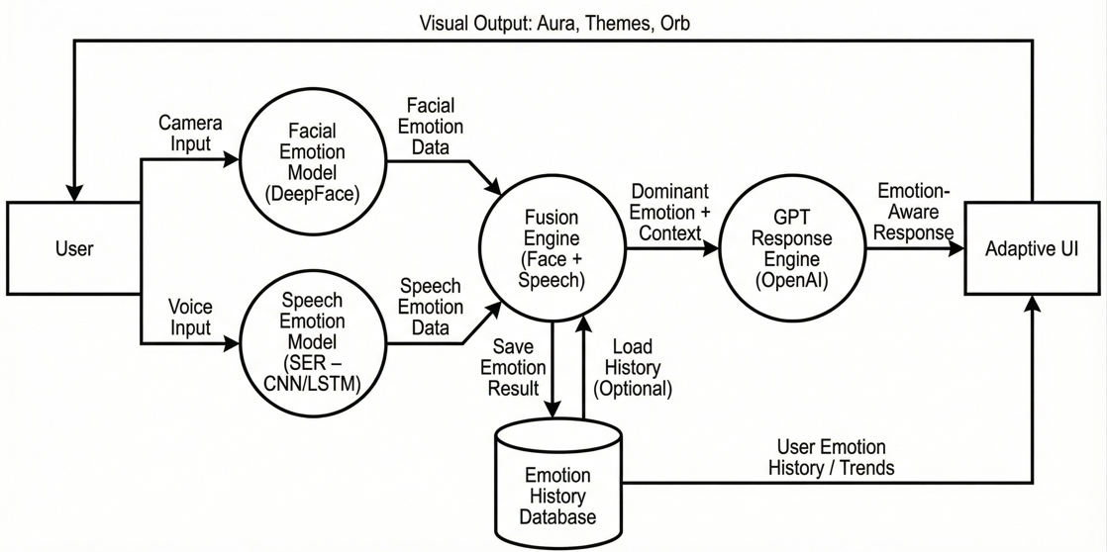

Chapter 5
System Modeling

  - UML Diagrams

5.1.1 Use Case Diagram

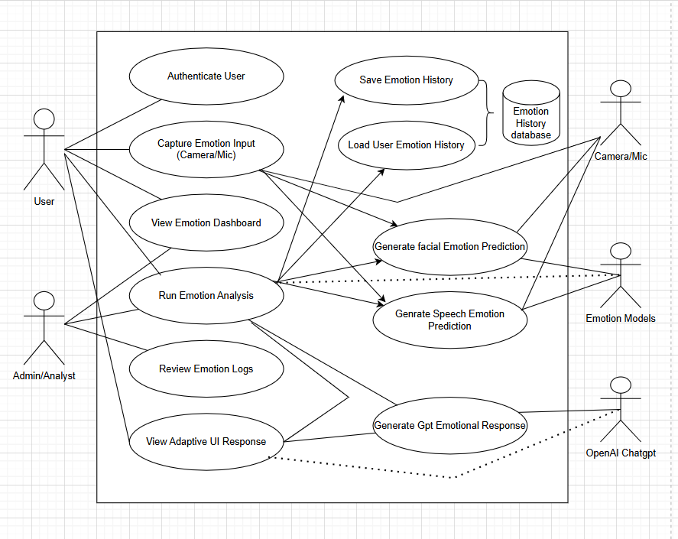

    - Class Diagram

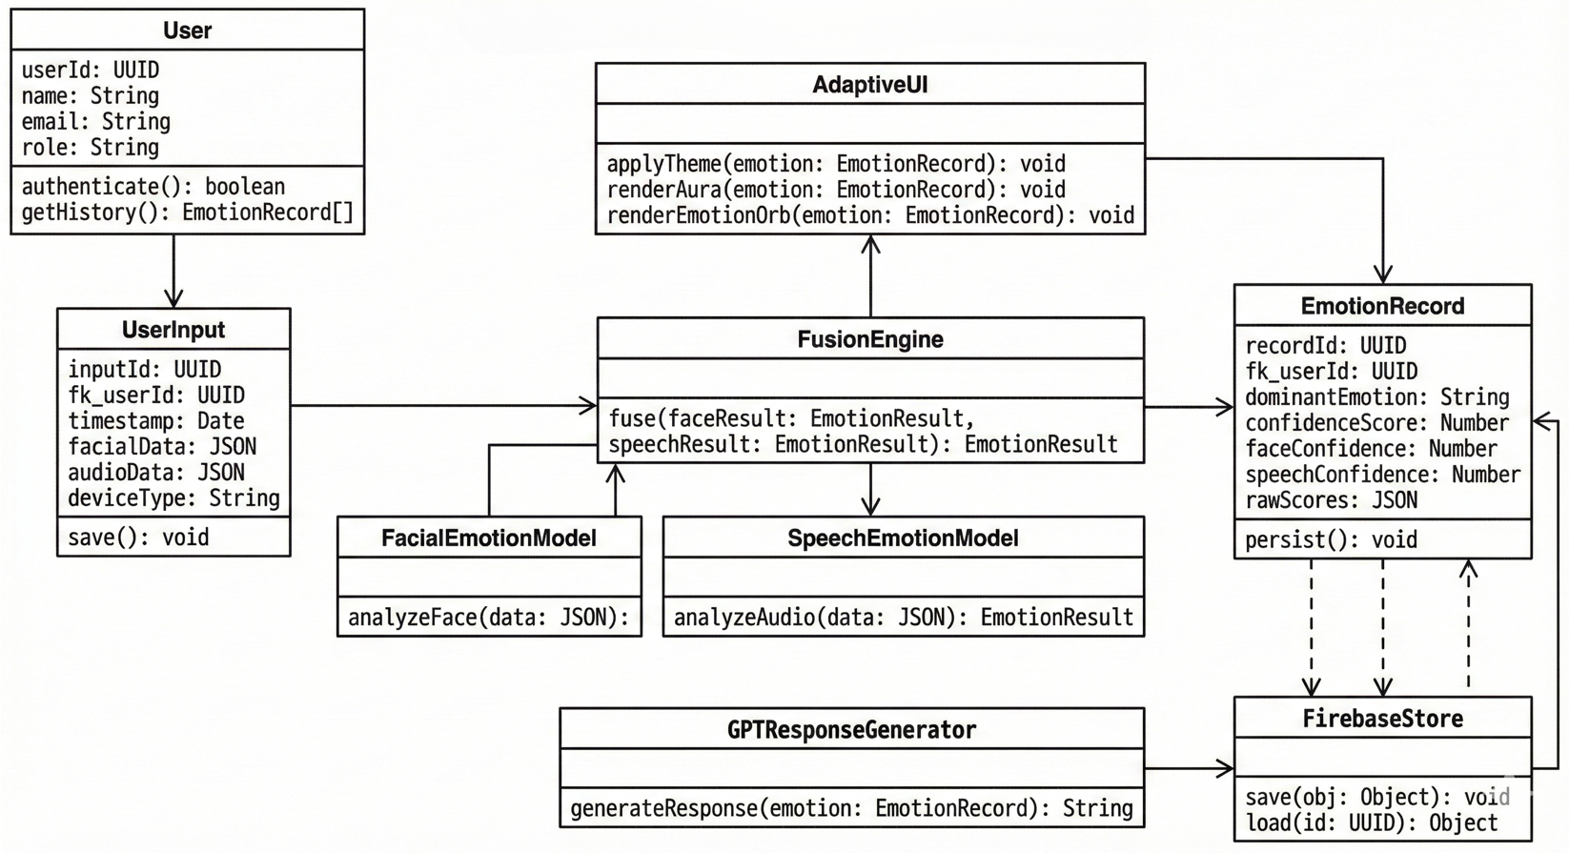

    - Sequence Diagram

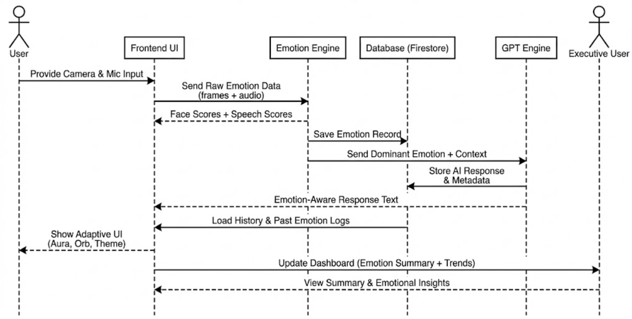

    - Activity Diagram

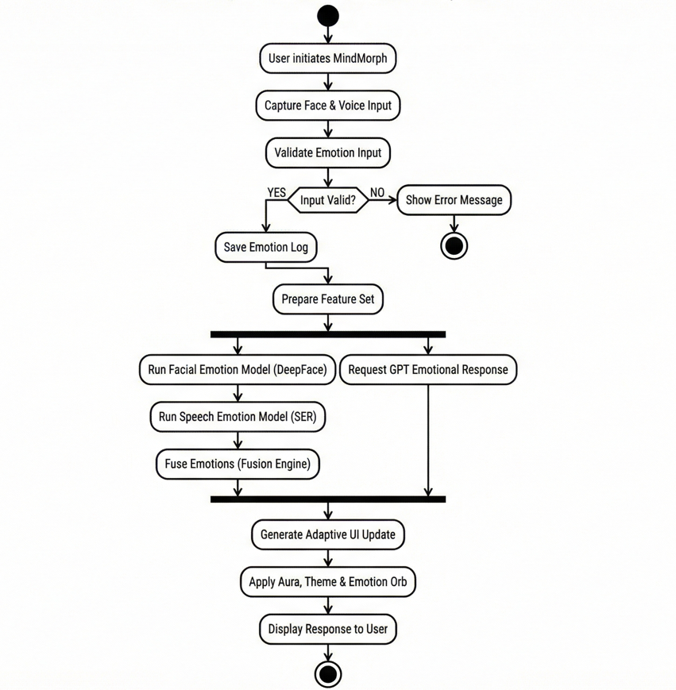

  - .5 Deployment Diagram

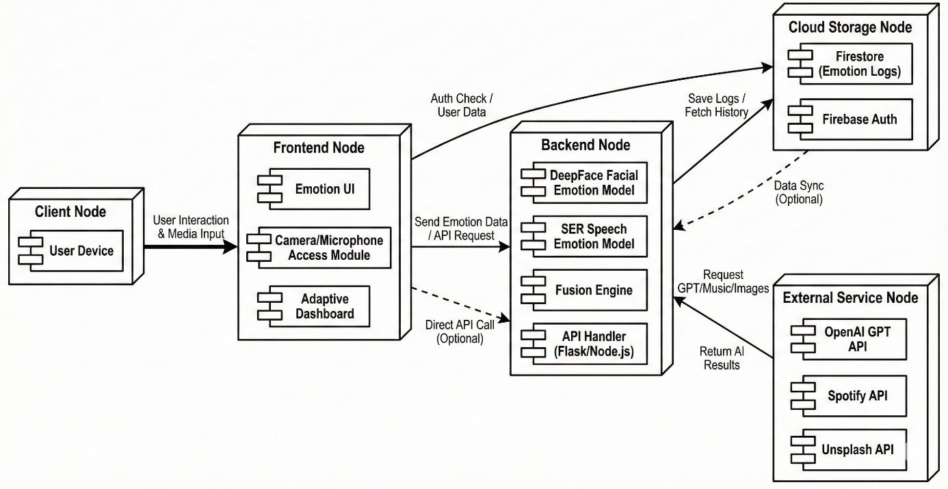

  - Database Modeling

    - Entity-Relationship Diagram

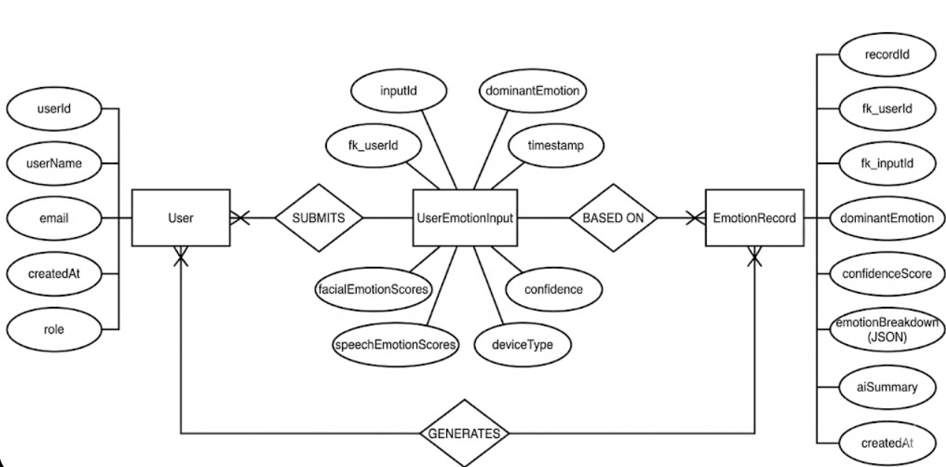

Chapter 6
Conclusion

MindMorph, the Emotion-Adaptive AI Interaction System, successfully demonstrates that emotionally intelligent technology is essential for the next generation of human–computer interaction. The project’s effectiveness lies in moving digital communication away from cold, generic responses and toward empathetic, human-centered engagement. We developed a complete system that uses multimodal Machine Learning models—facial emotion recognition and speech emotion detection—to accurately identify the user’s emotional state in real time. More importantly, the system enhances this emotional understanding through a Fusion Engine and transforms it into actionable, meaningful interaction using GPT-based emotional responses.The introduction of adaptive UI elements, such as mood-based themes, aura animations, and the emotion orb, provides a dynamic, intuitive experience that adjusts instantly to the user’s mood. By integrating external APIs like Spotify and Unsplash, the system enriches emotional support with relevant music and visuals, creating a calming and personalized environment. This blend of real-time sensing, ML-driven insights, and generative AI ensures that users receive responses that feel natural, empathetic, and contextually appropriate.Ultimately, MindMorph sets a strong foundation for emotionally aware digital systems, showing how AI can move beyond logic and begin to understand humans on a deeper level. The project proves that emotional intelligence in technology is not just possible but necessary for improving mental well-being, enhancing digital communication, and building the future of adaptive, user-centered interaction.
Chapter 7
References
7.1 Reference Websites:
DeepFace Library: Used for real-time facial emotion recognition and feature extraction.
Website: https://github.com/serengil/deepface
Speech Emotion Recognition (SER): Used for extracting MFCC features and classifying emotion from voice signals.
Website: https://librosa.org/doc/latest/
OpenAI GPT API: Used to generate emotion-aware conversational responses and adapt tone based on detected mood.
Website: https://platform.openai.com/docs
Next.js: Framework used to build the MindMorph frontend, enabling fast rendering and seamless UI updates.
Website: https://nextjs.org/docs
React: JavaScript library used for creating dynamic and responsive user interfaces.
Website: https://react.dev/learn
JavaScript: Core scripting language used in the frontend for UI logic, camera/mic access, and API integration.
Website: https://www.geeksforgeeks.org/javascript/javascript-tutorial/
Tailwind CSS: Utility-first CSS framework used for adaptive UI styling, animations, and responsive layouts.
Website: https://tailwindcss.com/docs

