AICTE Activity Point Program Report

***Submitted in***

***partial fulfilment for the award of the degree***

***Of***

## Bachelor of Technology

**in Computer Science & Engineering**



### Submitted By:

**Name: Sarthak Bakre University Roll No: 01UG19020040**

**Semester/Branch: 8th (CSE)**

**SUBMITTED TO:**

**Department of Computer Science and Engineering O P JINDAL UNIVERSITY**

**Raigarh (Chhattisgarh)**

# CERTIFICATE

This is to certify that, the report entitled “AICTE Activity Point Program Report”- submitted by Sarthak Bakre(01UG19020040) in partial fulfilment of the requirements for the award of Degree of **Bachelor of Technology in Computer Science & Engineering** of **OP Jindal University,** Raigarh, for the session of 2022-23, is a bonafide record of activities carried out under my supervision.

## Prof. Princy Diwan

**OP Jindal University Raigarh, Chhattisgarh**

**STUDENT DECLARATION**

I hereby declare that the report entitled “**AICTE Activity Point Program Report”** submitted for the partial fulfilment of the B. Tech Degree is a record of my own activities performed during my entire B.Tech program.

## Sarthak Bakre

**(01UG19020040)**

**Acknowledgement**

First and foremost, I wish to express my sincere thanks and gratitude to my esteemed Mentor **"Prof. Princy Diwan",**for giving me the opportunity to do these activities. It would never be possible for me to take this work to this level without his limitless support and encouragement.

I am obliged to staff members of the University and other members who directly or indirectly helped me to perform the activities. I am grateful for their cooperation during the period of my work.

Lastly, I think almighty, my parents, and friends for their constant encouragement without which this assignment would not be possible.

**Sarthak Bakre**

**(01UG19020040)**

**Contents**

|  |  |
| --- | --- |
| **Description** | **Date** |
| Awareness on cleanliness | 19-04-2023 |
| Awareness on importance of education | 19-04-2023 |
| Awareness on  Energy Conservation | 21-04-  2023 |
| Awareness on Voters  Awareness | 21-04-  2023 |
| Distribution of  food to blind children | 16-05-  2023 |

**1.) CREATED AWARENESS ABOUT CLEANLINESS AMONG GOVT SCHOOL**

On 19/04/23, the National Service Scheme (NSS) organised a program at our college, led by Dr. Aarti Vaish. As part of this initiative, a group of students from our batch visited the government school in Tumidih with the aim of creating awareness among children. Our main focus was to encourage them to keep their surroundings clean, prioritise their studies, and strive for lofty goals. During the visit, we engaged in a clean-up activity, wearing gloves and using poly bags to tidy up the school premises. Additionally, we imparted knowledge to the children about maintaining cleanliness in their surroundings, emphasising the importance of safeguarding both the environment and their health.

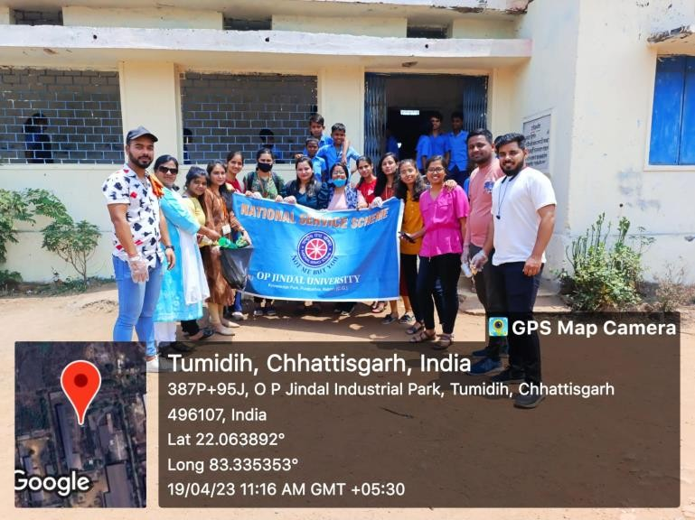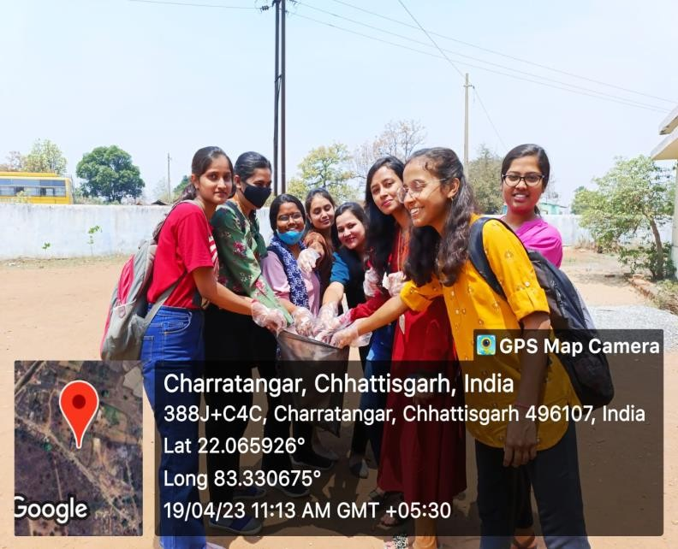

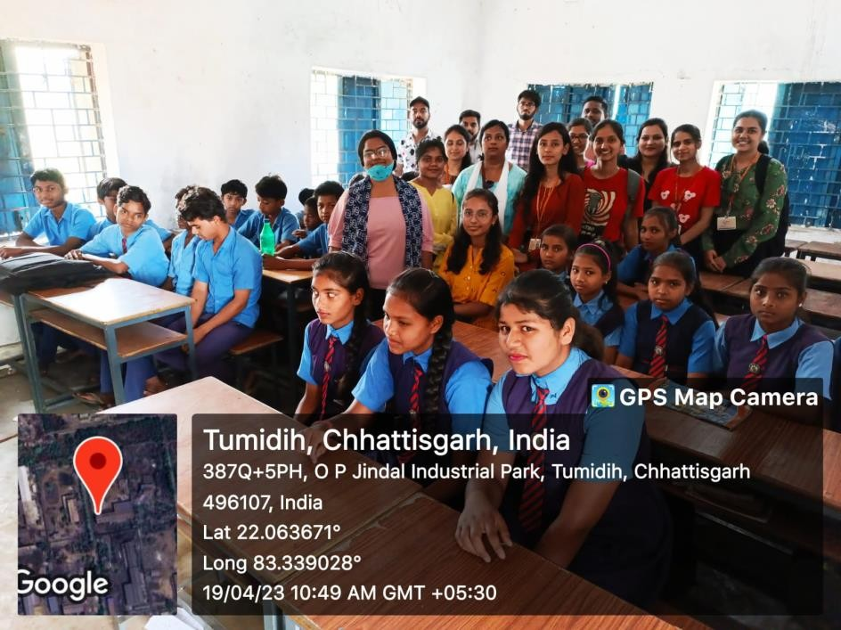

**2.) AWARENESS ABOUT IMPORTANCE OF EDUCATION**

On 19/04/23, the National Service Scheme (NSS) organised a program at our college, led by Dr. Aarti Vaish. As part of this initiative, a group of students from our batch visited the government school in Tumidih with the aim of creating awareness among children. Our main focus was to encourage them to prioritise their studies, and strive for lofty goals. During the visit, we encouraged students to focus on their goals and achievements for a bright future.

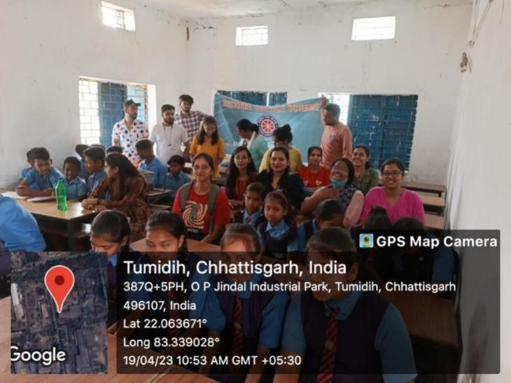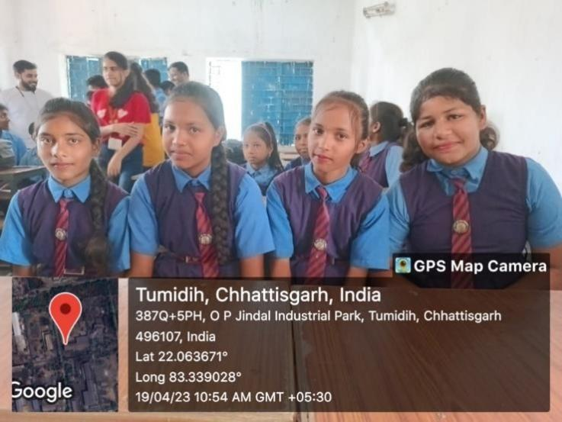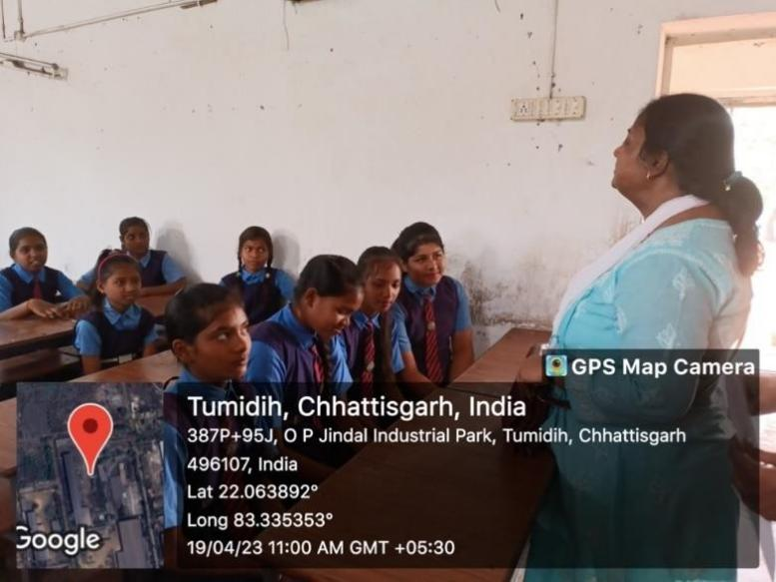

**3.) DISTRIBUTES DAL AND FOOD PACKETS TO BLIND CHILDRENS**

The NSS organised a visit to a government school, where a distribution drive was conducted. During the visit, 5 kg of dal (lentils) along with packets of chocolates and chips were distributed to the students. The NSS volunteers actively participated in this initiative, aiming to bring smiles to the faces of the young learners. This event aimed to provide essential food items and small treats to the children, promoting their well-being and creating a joyful atmosphere. Through such acts of kindness, the NSS seeks to make a positive impact on the lives of students and foster a spirit of compassion and solidarity in the community.

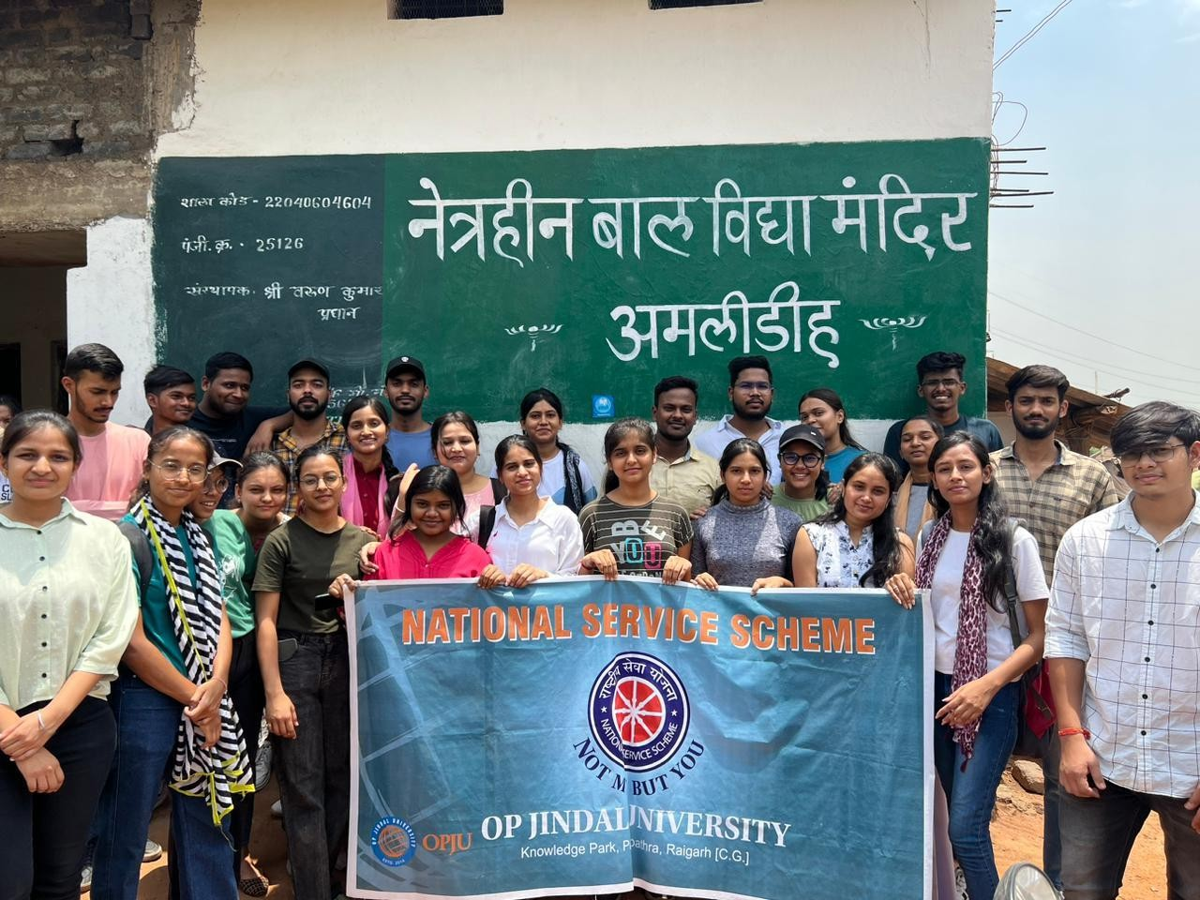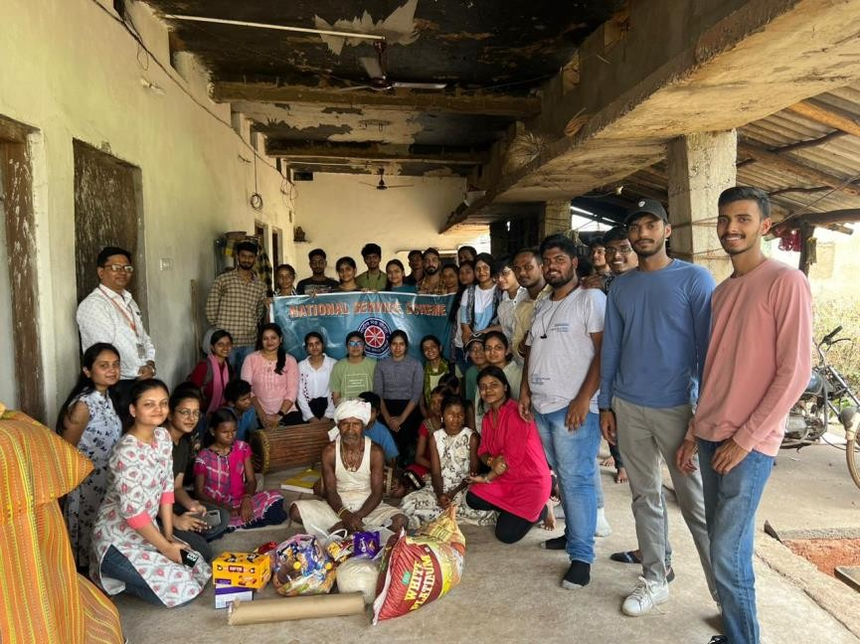

1. **) AWARENESS PROGRAMME ON VOTERS AWARENESS**

On 21/04/23, we visited Samaruma Village, to create awareness about the importance of voting.To motivate them to right to vote.To Create Awareness among the Communities to request every one above 18 years of age to make their voter id and vote. Explain them the function of EVM of machine . Made the People aware for voting by Door to Door Campaign and Explaining them about the how to use EVM machine.

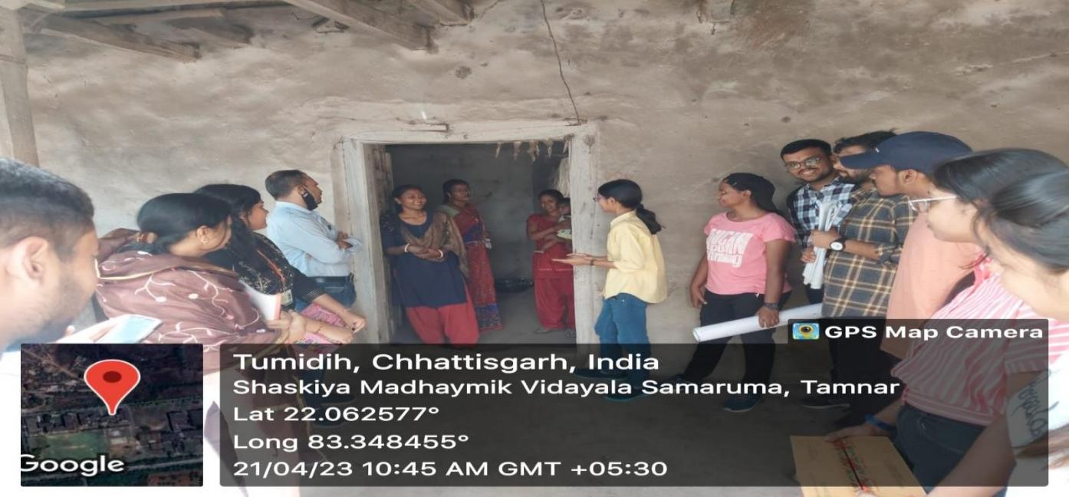

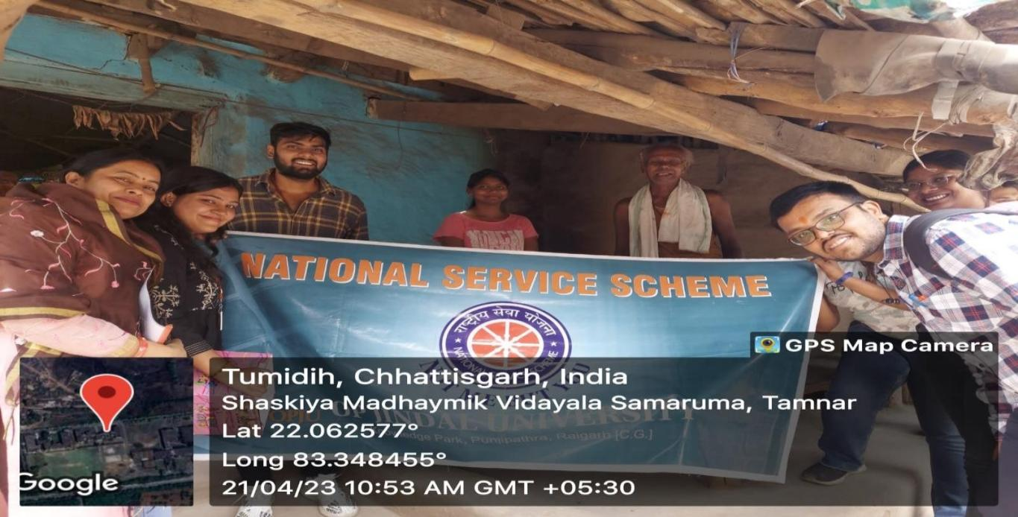

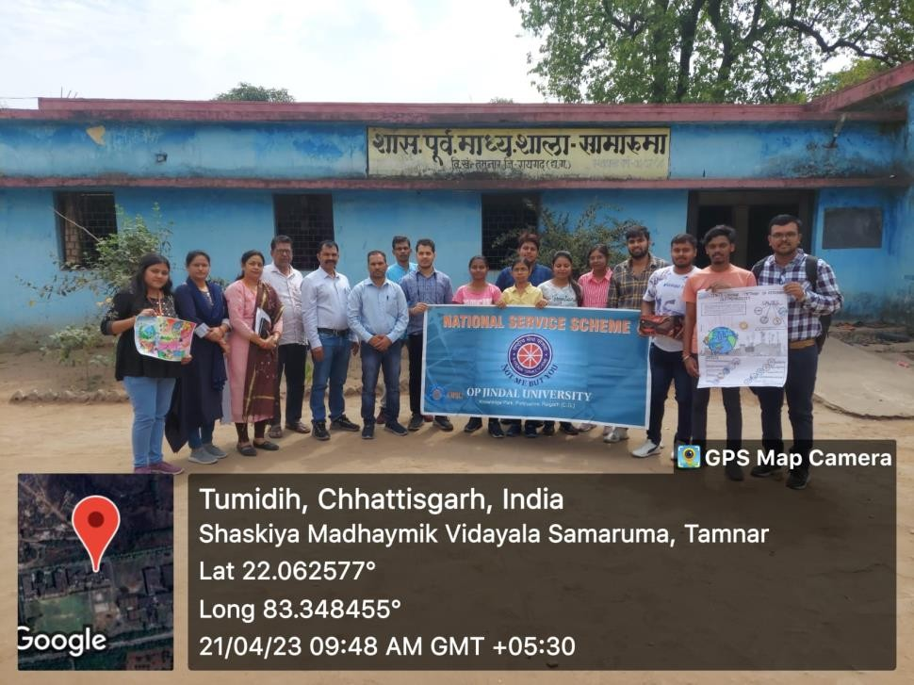

1. **) Awareness campaign on Energy Conservation**

On 21/04/23, we visited Samaruma Village, to create awareness about energy conversation. To promote the Necessity of Energy Conservation among the people.To Create Awareness among the Communities about Modern Day Technologies which are Beneficial for the conservation of Energy. Made the People aware about need of Energy Conservation and its impact in the Coming future. Also, Explained about the modern techniques of energy conservation such as Use of LEDs and Solar Powered Devices by Door to Door Campaign through the means of posters.

