AUDITOR-ACCESSIBLE BACKEND PROOF
Aquaivolt Backend Model & Agentic Flow
Executable LangGraph demonstration, model evidence, source code and reproducible run
Prepared for | Aquaivolt technical presentation and audit review
Prepared on | 20 August 2026
Evidence status | Executable demonstration completed and reproducibility-tested
Production disclosure | Current Vercel endpoint remains a separate TypeScript scenario ensemble

1. Executive answer
What the client asked for
A technical, runnable backend flow showing the real agents, models, tools, code, inputs, outputs and evaluation evidence—not a decorative workflow mock-up.

What is delivered
A real LangGraph workflow executes two saved scikit-learn pipelines, selects Gradient Boosting from recorded evaluation evidence, derives production KPIs, searches 400 model-backed setpoint scenarios, performs safeguards and writes an auditable JSON trace.

Critical truth statement
The deployed Vercel application does not currently call this Python/LangGraph workflow. Its POST /api/predict endpoint uses the deterministic TypeScript scenario ensemble. PyTorch is not implemented. The neural candidate in the evaluation was scikit-learn MLPRegressor and was rejected for poor performance.

2. Current production versus technical demonstrator
Component | Current deployed application | Executable technical demonstrator
Entry point | POST /api/predict | aquaivolt_langgraph_backend.py
Orchestration | Single Next.js server route | LangGraph StateGraph with 9 nodes
Selected predictor | Deterministic distance-weighted scenario ensemble | Saved Gradient Boosting multi-output pipeline
Comparison predictor | None in the request path | Saved Ridge SCADA pipeline
Inputs | 9 UI fields | 9 request fields; exact model feature contracts preserved
Evidence output | Response modelTrace + volatile in-memory audit | JSON run trace + SHA-256 model hashes + reproducibility test
Production status | Live prototype on Vercel | Presentation/audit demonstrator; integration is a next step

3. Real LangGraph execution flow
Figure 1. Actual nodes and tools implemented in the executable Python workflow.
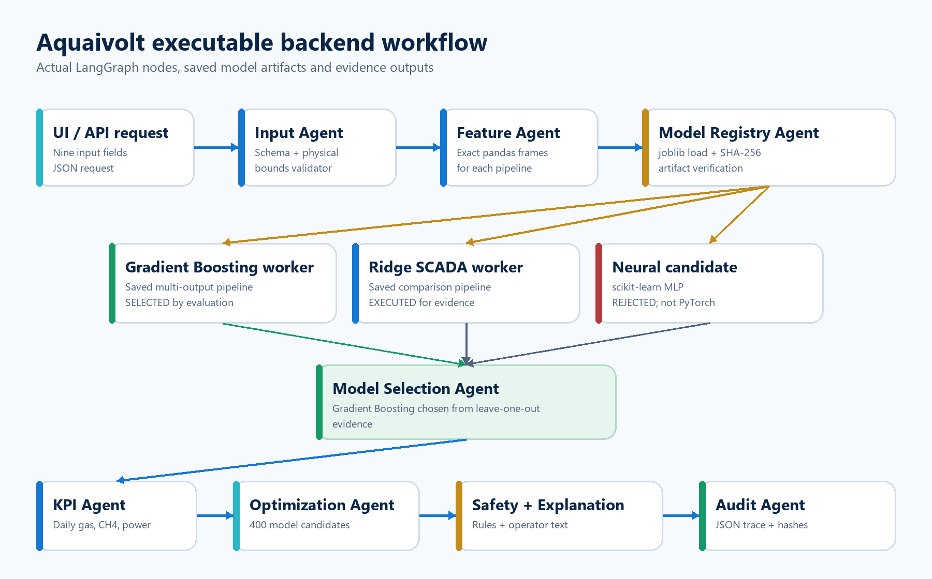

4. Node-by-node agent and tool map
# | Agent/node | Tool | Run evidence | Time
1 | Input Agent | Schema + physical-bound validator | 9 fields validated | 0.01 ms
2 | Feature Agent | pandas feature frames | Built Gradient and SCADA feature frames for Dairy WW | 0.00 ms
3 | Model Registry Agent | joblib + SHA-256 verifier | 2 saved pipelines loaded and hashed; neural candidate marked rejected | 208.65 ms
4 | Parallel Model Workers | Gradient Boosting + Ridge predict() | Both saved pipelines executed on the submitted scenario | 39.81 ms
5 | Model Selection Agent | evaluation-metric policy | Selected Gradient Boosting: anchor leave-one-out normalized MAE 0.615; MLP candidate rejected | 0.00 ms
6 | KPI Agent | unit conversion + mass-balance formulas | Derived 8 report metrics from model outputs | 0.01 ms
7 | Optimization Agent | bounded grid search | Evaluated 400 model-backed setpoint candidates | 6.29 ms
8 | Safety + Explanation Agent | rule engine + deterministic template | Safeguards checked and operator-facing explanation assembled | 0.01 ms
9 | Audit Agent | JSON evidence writer | Immutable-style run evidence written to latest_run.json | 36.78 ms
The trace above is read from run-evidence/latest_run.json, generated by executing the graph—not manually typed values.
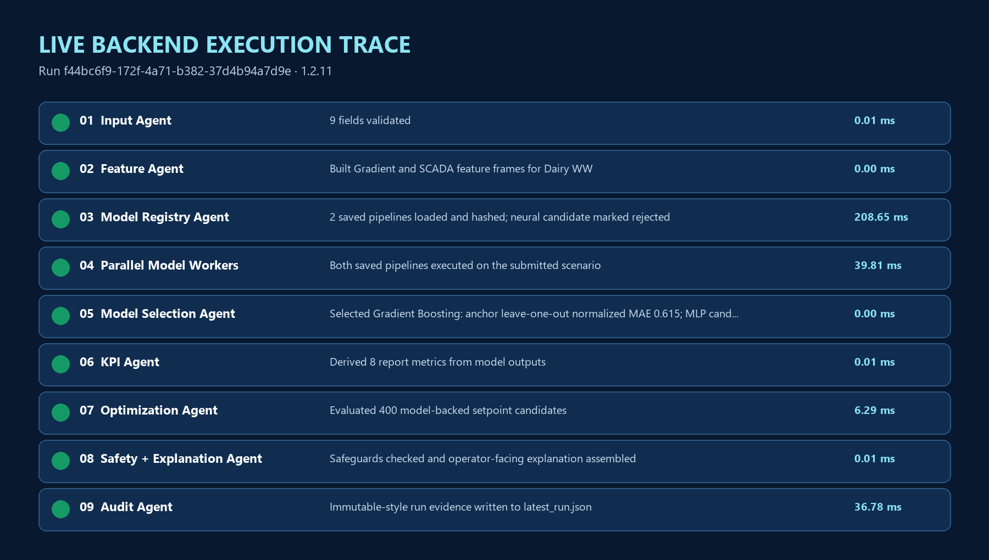

5. Model registry and selection evidence
Candidate | Framework | Artifact/run status | Normalized MAE | Decision
Gradient Boosting | scikit-learn | Saved and executed | 0.615 | Selected ML artifact
Scenario ensemble | TypeScript | Current production | 0.637 | Transparent production prototype
Ridge regression | scikit-learn | Saved and executed | 0.725 | Comparison worker
Random forest | scikit-learn | Evaluated | 0.902 | Not selected
Small neural network | scikit-learn MLP | Evaluated only | 5.956 | Rejected; no PyTorch artifact
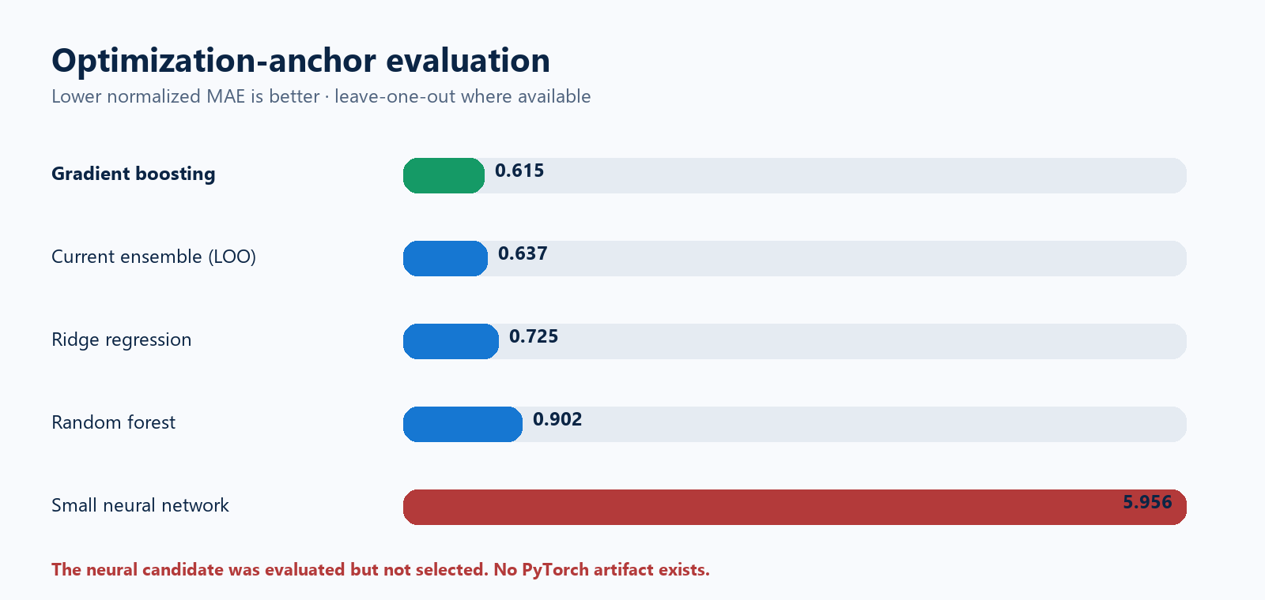
How to read the result
Lower normalized MAE is better. Gradient Boosting is the strongest saved ML candidate on the 10 optimization anchors under leave-one-out evaluation. The production scenario ensemble is retained for transparency and full UI input behavior. None of these results proves live-plant accuracy because the supplied workbooks are research-informed synthetic/projection data.

6. Artifact identity and integrity
Registry name | Saved artifact | Runtime | SHA-256
gradient_boosting_anchor | best_10_anchor_model.joblib | scikit-learn 1.9.0 | f705f5c4b2a29870640e425ebd3ef7fcf9cb0cff2923e64ebd5f45bf0433f7a4
ridge_scada | best_scada_tabular_model.joblib | scikit-learn 1.9.0 | f4bd3000d2b9f394c2dfb3dcec64252f95cdb69a39f2164f83fd838fc6b8228e

7. Exact feature contract
Input | Production TS | Gradient | Ridge | Technical note
Feedstock type | Yes | Yes | Yes | Categorical anchor selection / one-hot encoding
Feed rate | Yes | No | No | Preserved in request and audit; no trained coefficient in saved models
Temperature | Yes | Yes | Yes | Numeric feature
pH | Yes | Yes | Yes | Numeric feature
Organic loading (OLR) | Yes | Yes | Yes | Numeric feature
Retention time (HRT) | Yes | Yes | Yes | Numeric feature
COD input | Yes | Yes | Yes | Numeric feature
VFA | Yes | No | Yes | Gradient artifact does not contain this feature
Mixer speed | Yes | No | Yes | Gradient artifact does not contain this feature
Why this matters
The demonstrator does not falsely claim that feed rate, VFA or mixer speed were training features for the Gradient Boosting artifact. A future retraining dataset must contain measured target outcomes for all nine fields before those features can be learned reliably.

8. Reproducible prediction demonstration

8.1 Submitted request
{
"feedstock": "Dairy WW",
"feedRate": 820.0,
"temperature": 35.0,
"ph": 7.1,
"olr": 3.5,
"hrt": 22.0,
"codIn": 7000.0,
"vfa": 1000.0,
"mixing": 50.0
}

8.2 Command
python outputs/backend-technical-demo/src/aquaivolt_langgraph_backend.py \
+ --input outputs/backend-technical-demo/sample_input.json \
+ --output-dir outputs/backend-technical-demo/run-evidence

8.3 Selected model outputs and calculated KPIs
Metric | Value | Unit | Source/formula
Gas flow | 138.27 | m³/h | Gradient Boosting output
Biogas | 3318.5 | m³/day | gas flow × 24
Methane content | 65.0 | % | Gradient Boosting output
Methane | 2157.19 | m³/day | biogas × CH4 fraction
Generator | 49.13 | kW | Gradient Boosting output
Electricity | 1179.01 | kWh/day | generator kW × 24
CO2 simplified | 35.0 | % | 100 − CH4; H2S trace excluded in this demonstrator
Carbon avoided estimate | 0.8347 | t/day | electricity × 0.000708

8.4 Model-backed recommendation
- The Optimization Agent evaluated 400 nearby combinations through the selected saved model.
- Recommended scenario: temperature 36.5 °C, pH 7.25, OLR 3.70, HRT 19.0 days. Projected biogas is 4060.13 m³/day, a delta of 741.63 m³/day. Operator approval is required.

9. Source-code proof

9.1 Graph wiring
def build_workflow():
graph = StateGraph(WorkflowState)
graph.add_node("validate_request", validate_request)
graph.add_node("feature_engineering", feature_engineering)
graph.add_node("load_model_registry", load_model_registry)
graph.add_node("run_candidate_models", run_candidate_models)
graph.add_node("select_model", select_model)
graph.add_node("derive_metrics", derive_metrics)
graph.add_node("optimize_setpoints", optimize_setpoints)
graph.add_node("safety_and_explanation", safety_and_explanation)
graph.add_node("persist_audit", persist_audit)
graph.add_edge(START, "validate_request")
graph.add_conditional_edges(
"validate_request",
route_after_validation,
{"features": "feature_engineering", "audit": "persist_audit"},
)
graph.add_edge("feature_engineering", "load_model_registry")
graph.add_edge("load_model_registry", "run_candidate_models")
graph.add_edge("run_candidate_models", "select_model")
graph.add_edge("select_model", "derive_metrics")
graph.add_edge("derive_metrics", "optimize_setpoints")
graph.add_edge("optimize_setpoints", "safety_and_explanation")
graph.add_edge("safety_and_explanation", "persist_audit")
graph.add_edge("persist_audit", END)
return graph.compile()

9.2 Real saved-model execution
def run_candidate_models(state: WorkflowState) -> WorkflowState:
start = time.perf_counter()
x = state["validated_input"]
anchor_model = state["models"]["gradient_boosting_anchor"]
scada_model = state["models"]["ridge_scada"]
anchor_columns = list(anchor_model.feature_names_in_)
scada_columns = list(scada_model.feature_names_in_)
anchor_row = pd.DataFrame(
[[x["feedstock"], x["temperature"], x["ph"], x["olr"], x["hrt"], x["codIn"]]],
columns=anchor_columns,
)
scada_row = pd.DataFrame(
[[x["feedstock"], x["hrt"], x["olr"], x["temperature"], x["ph"], x["codIn"], x["vfa"], x["mixing"]]],
columns=scada_columns,
)
anchor_values = anchor_model.predict(anchor_row)[0]
scada_values = scada_model.predict(scada_row)[0]
candidates = {
"gradient_boosting_anchor": {
"gas_flow_m3h": round(float(anchor_values[0]), 4),
"methane_pct": round(float(anchor_values[1]), 4),
"generator_kw": round(float(anchor_values[2]), 4),
},
"ridge_scada": {
"gas_flow_m3h": round(float(scada_values[0]), 4),
"methane_pct": round(float(scada_values[1]), 4),
"generator_kw": round(float(scada_values[2]), 4),
},
}
return {
"candidate_predictions": candidates,
"trace": trace_event(state, "Parallel Model Workers", "Gradient Boosting + Ridge predict()", "complete", "Both saved pipelines executed on the submitted scenario", (time.perf_counter() - start) * 1000),
}

9.3 Model-backed optimization
def optimize_setpoints(state: WorkflowState) -> WorkflowState:
start = time.perf_counter()
x = state["validated_input"]
model = state["models"]["gradient_boosting_anchor"]
columns = list(model.feature_names_in_)
candidates: list[list[Any]] = []
setpoints: list[dict[str, float]] = []
for temperature in np.linspace(max(32.0, x["temperature"] - 1.5), min(40.0, x["temperature"] + 1.5), 5):
for ph in np.linspace(max(6.7, x["ph"] - 0.3), min(7.6, x["ph"] + 0.3), 5):
for olr in np.linspace(max(1.5, x["olr"] - 0.6), min(6.5, x["olr"] + 0.6), 4):
for hrt in np.linspace(max(15.0, x["hrt"] - 3.0), min(35.0, x["hrt"] + 3.0), 4):
candidates.append([x["feedstock"], temperature, ph, olr, hrt, x["codIn"]])
setpoints.append({"temperature": float(temperature), "ph": float(ph), "olr": float(olr), "hrt": float(hrt)})
frame = pd.DataFrame(candidates, columns=columns)
prediction_matrix = model.predict(frame)
best_index = int(np.argmax(prediction_matrix[:, 0]))
best = prediction_matrix[best_index]
current_biogas = state["metrics"]["biogas_m3_day"]
best_biogas = max(0.0, float(best[0])) * 24.0
recommendation = {
"searched_candidates": len(candidates),
"recommended_setpoints": {key: round(value, 3) for key, value in setpoints[best_index].items()},
"predicted_biogas_m3_day": round(best_biogas, 2),
"predicted_methane_pct": round(float(best[1]), 2),
"predicted_electricity_kwh_day": round(max(0.0, float(best[2])) * 24.0, 2),
"biogas_delta_m3_day": round(best_biogas - current_biogas, 2),
"operator_approval_required": True,
}
return {
"recommendation": recommendation,
"trace": trace_event(state, "Optimization Agent", "bounded grid search", "complete", f"Evaluated {len(candidates)} model-backed setpoint candidates", (time.perf_counter() - start) * 1000),
}

9.4 Audit persistence
def persist_audit(state: WorkflowState) -> WorkflowState:
start = time.perf_counter()
output_dir = Path(state["output_dir"])
output_dir.mkdir(parents=True, exist_ok=True)
payload = {
"run_id": state["run_id"],
"started_at": state["started_at"],
"completed_at": utc_now(),
"workflow": "Aquaivolt LangGraph technical demonstration",
"framework_versions": {
"python": sys.version.split()[0],
"langgraph": importlib.metadata.version("langgraph"),
"scikit_learn": sklearn.__version__,
"joblib": importlib.metadata.version("joblib"),
},
"input": state.get("validated_input", state.get("input")),
"feature_contract": state.get("feature_contract"),
"model_registry": state.get("model_registry"),
"candidate_predictions": state.get("candidate_predictions"),
"selected_model": state.get("selected_model"),
"selected_prediction": state.get("selected_prediction"),
"metrics": state.get("metrics"),
"recommendation": state.get("recommendation"),
"safeguards": state.get("safeguards"),
"explanation": state.get("explanation"),
"error": state.get("error"),
"trace": state.get("trace", []),
"truth_statement": "This JSON was created by executing the saved scikit-learn artifacts through a real LangGraph workflow. The deployed Vercel application currently uses a separate TypeScript scenario ensemble.",
}
latest_path = output_dir / "latest_run.json"
payload["trace"].append(
{
"sequence": len(payload["trace"]) + 1,
"node": "Audit Agent",
"tool": "JSON evidence writer",
"status": "complete",
"detail": f"Immutable-style run evidence written to {latest_path.name}",
"elapsed_ms": round((time.perf_counter() - start) * 1000, 2),

10. Auditor file map
Evidence | Path | Purpose
Executable workflow | outputs/backend-technical-demo/src/aquaivolt_langgraph_backend.py | Real LangGraph nodes and tools
Sample request | outputs/backend-technical-demo/sample_input.json | Nine submitted input fields
Latest run evidence | outputs/backend-technical-demo/run-evidence/latest_run.json | Inputs, candidate predictions, selected model, KPIs, recommendations and node trace
Run history | outputs/backend-technical-demo/run-evidence/runs.jsonl | Append-only style demonstration record
Reproducibility test | outputs/backend-technical-demo/tests/test_workflow.py | Runs twice and checks deterministic output
Selected model | outputs/ml-model-comparison/best_10_anchor_model.joblib | Gradient Boosting multi-output pipeline
Comparison model | outputs/ml-model-comparison/best_scada_tabular_model.joblib | Ridge SCADA pipeline
Evaluation JSON | outputs/ml-model-comparison/model_comparison.json | Metrics and data audit
Production route | app/api/predict/route.ts | Current deployed TypeScript inference

11. Reproducibility checks performed
- The saved Gradient Boosting and Ridge artifacts were loaded successfully with joblib.
- Both pipelines executed predict() on the same validated request.
- The LangGraph completed nine nodes and wrote a JSON trace.
- The workflow was executed twice; identical input produced identical metrics.
- The optimizer evaluated exactly 400 nearby scenarios through the selected model.
- SHA-256 hashes were recorded for both saved model files.

12. Limitations and next production step
Area | Current limitation | Required next step
Data | Supplied workbooks are research-informed synthetic/projection data; no independent live-plant validation is established. | Collect timestamped sensor/lab outcomes and freeze a site-validation protocol.
LangGraph integration | Demonstrator is separate from the deployed Next.js request path. | Deploy a versioned Python inference service and call it from POST /api/predict.
Audit persistence | Vercel application audit store is currently volatile memory. | Use Postgres/object storage with immutable run IDs, hashes and access controls.
Nine-feature ML | Gradient artifact uses six features; Ridge uses eight; neither learns feed rate. | Retrain on measured outcomes that contain all nine fields and sufficient independent runs.
PyTorch | No PyTorch implementation exists and none is claimed. | Add only if a properly evaluated deep-learning model materially outperforms simpler baselines.
Control authority | Recommendations do not control plant hardware. | Add operator approval, interlocks, PLC gateway validation and cybersecurity review before control integration.

13. Presentation script: the accurate 30-second explanation
Suggested wording
“The live prototype currently uses a transparent deterministic scenario ensemble. For technical proof, we also implemented and executed a real LangGraph workflow around the saved evaluated ML models. It validates inputs, loads and hashes Gradient Boosting and Ridge artifacts, runs both, selects Gradient Boosting using evaluation evidence, calculates biogas, methane and electricity, searches 400 setpoint scenarios, applies safeguards, and writes an auditable JSON trace. PyTorch is not part of the current system; the neural candidate was evaluated and rejected.”

