Maharashtra State Board of Technical Education,Mumbai
Sir. Dr.M.S.Gosavi Polytechnic Institute Nashik Road
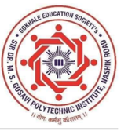
Certificate

This is to certify that following students of THIRD SEMISTER Diploma Engineering Program in Computer Engineering have successfully completed the Micro-Project entitled “Blood Bank Management System” under my supervision, in the partial fulfillment of Course OOP (313304) for Academic Year 2026-27 as per prescribed in the MSBTE “K Scheme” curriculum.
SR. No | Roll no. | Name of Student | Enrollment No. | Seat No.
03 | 12 | PRAVIN CHETAN PATIL | 25612590013 | 531262

Date:
Place: Nashik

Subject incharge Head of Department Principal
Seal Of Institute

