Create a s3 general purpose bucket

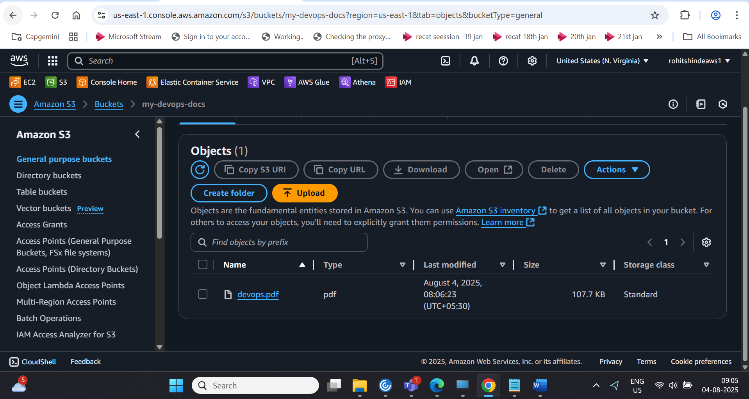

Create a knowledge base with amazon bedrock

Choose LLM models from the list /request access

Test the knowledge base with open search

Result -

