**Answer Sheet - SQL**

Name : Rohit Kumar Magotra

Batch No. :

Phone No. : 8492863337

Email : rohitmagotra77@gmail.com

**Major Question 1**

1. List the salary of all the employees.

select ename , salary from employee

Insert Image-

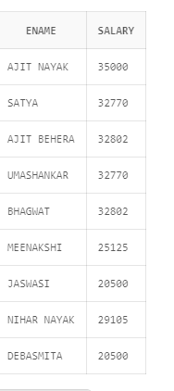

1. Display the names of all employees with any “A” at any place of the name.

select ename from employee

where ename like '%A%';

Insert Image –

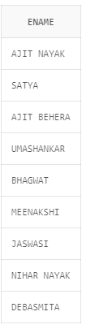

1. Show all employees who were hired in the first half of the month (Before the 16th of the month).

SELECT column1column2 FROM Table1 WHERE DAY(hired_date) <= 16;

Insert Image – not able to insert image and get the output as none of the table consists of a column name hired date but the code would look something like this

1. Display the name of all female employees.

select ename ,sex from employee

where sex='F';

Insert Image –

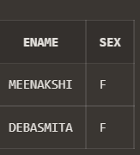

1. Display the employee who is paid most in the company.

SELECT ename, salary

FROM employee

WHERE salary = (SELECT MAX(salary) FROM employee);

Insert Image –

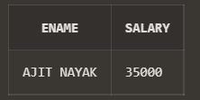

**Major Question 2**

1. Display employee name, address, department no and department name.

SELECT e.ename, e.address, d.dnumber, d.dname

FROM employee e

INNER JOIN department d

ON e.dno = d.dnumber;

Insert Image –

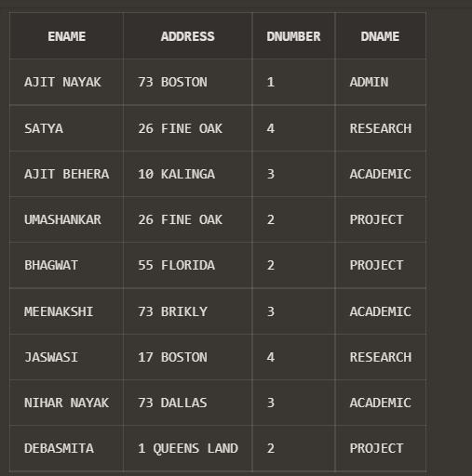

1. Display all the employees who are *not in* ACADEMIC department

SELECT e.ename, e.address, d.dnumber, d.dname

FROM employee e

INNER JOIN department d

ON e.dno = d.dnumber

where d.dname<> 'ACADEMIC';

Insert Image –

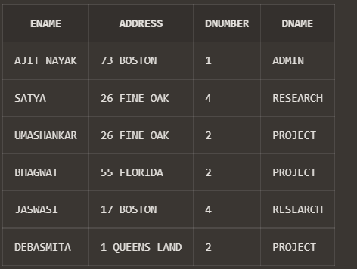

1. Display SATYAS’ project location.

SELECT e.ename ,p.plocation

FROM employee e

INNER JOIN project p

ON e.dno = p.dnum

WHERE e.ename = 'SATYA';

Insert Image –

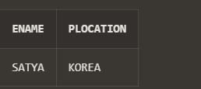

1. Find the total working hours of *each* female employee.

SELECT e.ename, SUM(w.hours) AS TOTAL

FROM employee e

INNER JOIN works_on w

ON e.esrno = w.esrno

WHERE e.sex = 'F'

GROUP BY e.ename;

Insert Image –

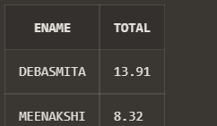

1. Display the details of the people whose projects are located at SOUTH AFRICA.

SELECT e.ename, e.address, e.sex,e.bdate, p.pname, p.plocation

FROM employee e

INNER JOIN project p

ON e.dno = p.dnum

WHERE p.plocation = 'SOUTH AFRICA'

Insert Image –

