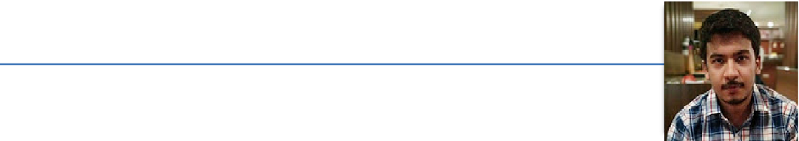ROHIT SEN

House-19A, Road-3, Zone-9, Birsanagar, Jamshedpur, Jharkhand-831019 | +918092368015 |+918789155510 [rhtsn12@gmail.com](mailto:rhtsn12@gmail.com%20) | linkedin.com/in/rohit-sen-335467133

**OBJECTIVE**

To obtain a full-time position as a Software Engineer or Technology Analyst in a reputed firm to start my career.

**EDUCATION**

|  |  |  |  |
| --- | --- | --- | --- |
| B. Tech | SRM Institute of | 2020 | 78% |
|  | Science and |  |  |
|  | Technology, Tamil |  |  |
|  | Nadu |  |  |
|  |  |  |  |
| ISC | Hill Top School, | 2016 | 89.2% |
|  | Jamshedpur |  |  |
|  |  |  |  |
| ICSE | Hill Top School, | 2014 | 89% |
|  | Jamshedpur |  |  |
|  |  |  |  |

**EXPERIENCE**



**ELECTRICAL SYSTEM OFFICER** | 4ZERACING|[www.4zeracing.com](http://www.4zeracing.com/)

2016 – Current

“4ze” stands for “For Zero Emission”. Official formula one

electric team of SRM Institute of Science and Technology.



**TEAM HEAD** | THEPROJECTTEAM|[www.theprojectteamsrm.com](http://www.theprojectteamsrm.com/)

2017 – 2018

Team under the ECE Dept. which build projects, conducts workshops, organizes both profitable and non-profitable events and fests, etc.



**CAPTAIN AND MENTOR |** MYCAPTAIN (THE CLIMBER) |IoT and RACE Car [www.mycaptain.in/workshop/racecartech#2](http://www.mycaptain.in/workshop/racecartech#2)

2018 – Current

The Climber is an Education Start-up that helps students discover and pursue their Passions through MyCaptain and large city-wide Youth fests, summits and boot camps.

**CERTIFICATIONS**

* Event Coordinator and organizer | Tech fest – Arduino Day 2017.
* Event Coordinator and organizer | Tech fest – Arduino Day 2018.
* Runner up 2019 Formula Green held at Buddh Circuit Delhi | 2019.

**INDUSTRIAL TRAINING**

* TATA MOTORS, Jamshedpur Plant, Jamshedpur, Jharkhand 2018.
* BSNL, Jamshedpur, Jharkhand 2017.

**PROJECTS**

* Detection of Lung tissue disorders through crackles and wheezes| 2019
* Ultrasonic mapping and ranging | 2016
* Bluetooth voice control Home Automation | 2017
* Home automation using Raspberry Pi | 2018
* ZEV 3.0 Electric Car Controls | Formula student electric car | 2019
* Water Treatment Plant Monitoring through Industrial Grade Sensors | 2019
* Battery Monitoring System | 2019

**SOFTWARE AND COMPUTER LANGUAGES**

|  |  |
| --- | --- |
| Eagle | LabVIEW |
|  |  |
| C | VHDL |
|  |  |
| Arduino IDE | Proteus/Multisim |
|  |  |
| Atmel Studio | Pspice |
|  |  |
| Java | MATLAB & Simulink |
|  |  |

**PERSONAL DETAILS**

|  |  |
| --- | --- |
| Nationality | Indian |
|  |  |
| Date of Birth | 10TH December 1997 |
|  |  |
| Place of Birth | Jharkhand |
|  |  |
| Gender | Male |
|  |  |
| Languages Known | English, Hindi, Bengali, Japanese |
|  |  |
|  |  |