Transformers Vs CNN For Audio DeepFake

Abstract
Recently, deep learning has witnessed a paradigm shift with the adaptation of Transformer architectures form natural language processing (NLP) to computer vision tasks. High performing models such as the Vision Transformer (VIT) and Swin Transformer have demonstrated state of the art capabilities; however, their reliance of massive pre-training infrastructure and millions of images often limits their localized adoption.
This work presents a rigorous comparative evaluation of conventional Convolutional Neural Networks (CNNs)- specifically ResNet18 and Resnet50- against modern vision-centric Transformer frameworks, including VIT, Swin Transformer, a custom CNN-Transformer hybrid, and Data-efficient Image Transformer (DEIT). Evaluating these models on the ASVspoof2019 Logical Access (LA) dataset consisting of 121,461 audio samples, we frame the task as a binary classification problem to distinguish between authentic (Bonafide) and synthesized (Spoof) acoustic signals.
To optimize computational throughput, features were pre- computed into static spectrogram tensors, while data augmentation and class weighted random sampling were deployed to mitigate severe dataset imbalances. Our empirical results demonstrate that while CNNs converge rapidly, allowing Resnet50 to ultimately outperform shallower convolutional baselines, letting heavy architecture train unconstrained for a full 100-epoch block allows the Swin Transformer to overcome early plateaus and achieve a dominant peak performance of 7.2% Equal Error Rate (EER) and Accuracy of 92.9%

- Introduction and Architectural Paradigms:
The rapid proliferation of sophisticated generative adversarial networks (GANs) and neural speech synthesis algorithms has made the generation of highly realistic audio deepfakes accessible and widespread. These synthetic audio vectors present severe security threats, ranging from biometric identity theft and voice-clone bank fraud to the spreading of automated political disinformation. Consequently, developing robust, highly generalizable automated spoofing counters (ASVs) has become a critical focal point in contemporary multimedia security research.
Historically, the domain of audio deepfake detection has been dominated by Convolutional Neural Networks (CNNs). CNNs posses an inherent structural advantage known as spatial inductive bias. When raw audio waveforms are translated into two-dimensional time frequency representations- such as Short-Time Fourier Transforms (STFT) or Mel-Spectrograms- standard convolutional filters seamlessly treat them as images. Through localized receptive fields and shared weight matrices, CNNs are exceptionally efficient at capturing low-level acoustic anomalies, transient phase shift, and localized high-frequency smoothing patterns that characterize synthetic speech generation.
Conversely, the emergence of the Vision Transformer (ViT) has introduced an alternative processing framework. By discarding localized convolutional strides and instead flattening spectrogram grids into linear patches, tokens are processed via multi-head self-attention mechanisms. This enables the model to look past localized features and evaluate global, long-range temporal-frequency dependencies across the entire duration of an acoustic sample.
However, this global express-capacity comes at a steep training cost. Transformers lack a CNN's built-in spatial assumptions, meaning they require significantly longer optimization paths or massive datasets to discover sharp minimums on a loss surface. When prematurely restricted by tight early stopping windows during optimization, transformers frequently underperform, failing to catch simpler baseline networks.
Scope of Contribution:
As the sole investigator of this project, I designed, implemented, and optimized the entire machine learning pipeline from raw audio ingestion to final model distillation. The specific contributions of my independent work are as follow:
- End-to-End Pipeline Engineering: I built a highly optimized data processing pipeline that decouples feature extraction from backpropagation by pre-computing spectrogram tensors to ram and pre caching that reduced the compute time significantly, eliminating CPU storage bottlenecks. I also integrated a class-weighted random sampler to neutralize severe dataset imbalances.
- Rigorous Empirical Benchmarking: I independently managed the configuration, tracking, and training of six distinct deep learning frameworks: two pure CNN variants (ResNet18, ResNet50), a global projection transformer (ViT), a localized hierarchical window transformer (Swin), a cross-attention CNN-Transformer hybrid, and a teacher-student distilled framework (DeiT).
- Discovery of Optimization Thresholds: I uncovered critical limitations in standard early stopping routines. By designing a multi-stage empirical study, I demonstrated how shifting from constrained training to an unconstrained 100-epoch baseline alters the global leaderboard—culminating in the discovery that the Swin Transformer's shifted window approach outperforms traditional architectures when given the necessary training runway.

- Methodology and Model Selections
In this section, I detail the specific variations of the network I implemented, customized, and adapted to parse single-channel audio spectrogram topologies.
Benchmark CNN Baseline: ResNet18 vs ResNet50 Capacity
To establish rock-solid baselines, I selected two Residual Network architectures differing significantly in depth and parameter capacity:
- ResNet18: A shallow, 18-layer deep residual architecture. Its smaller capacity allows it to optimize rapidly and capture local spectrogram anomalies cleanly without overfitting.
- ResNet50: A deeper, 50-layer architecture utilizing bottleneck blocks. While it risks overfitting on small acoustic datasets due to its massive parameter size, its deeper feature hierarchy allows it to extract abstract, high-dimensional acoustic representations if given an unconstrained training horizon.
Both architectures were modified at their initial layer to accept single-channel (1-channel) grayscale audio spectrogram tensors instead of standard 3-channel RGB images (adapted from K.He [4])

Hierarchical Shifted Windows: The Swin Transformer Approach
The Swin Transformer bridges the gap between CNN efficiency and Transformer expressiveness. Instead of computing global attention across the entire spectrogram ( which scales quadratically with image size), Swin computes attention strictly within localized, non-overlapping 2D windows. To preserve cross- window communication, it introduces a shifted windowing mechanism between consecutive layers. This builds a hierarchical representation, mimicking the feature- pooling nature of CNNs while maintaining the dynamic weight allocation of self-attention.
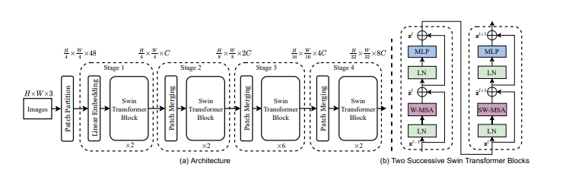
Fig 1: The hierarchical architecture of the Swin Transformer alongside its core internal block dynamics (adapted from Liu et al. [3]). As detailed in (a), the framework downsamples time-frequency dimensions across four discrete stages via Patch Merging to simulate a CNN's feature hierarchy. Part (b) outlines two successive blocks: the first applies standard Window-based Multi-Head Self-Attention (W-MSA) within isolated boundaries, while the second introduces a Shifted Window approach (SW-MSA) to establish cross-window connectivity across the acoustic spectrogram.

Vision Transformers (VITs): Capturing Global Acoustic Context
Conversely, the emergence of the Vision Transformer (ViT) has introduced an alternative processing framework that completely discards localized convolutional strides. By flattening spectrogram grids into sequential, non-overlapping linear patches, tokens are processed via multi-head self-attention mechanisms. This allows every single patch to interact with every other patch across the entire time-frequency domain simultaneously. This enables the model to look past localized features and evaluate global, long-range temporal-frequency dependencies across the entire duration of an acoustic sample. However, because transformers lack built-in spatial assumptions, they have a completely flat inductive bias. They require significantly longer optimization paths to find sharp minimums on a loss surface.
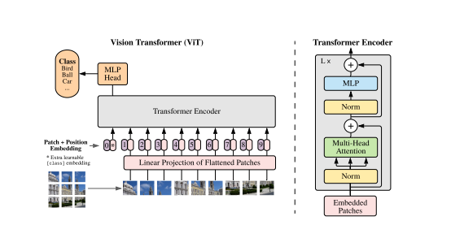
Fig 2: The foundational Vision Transformer (ViT) framework (adapted from Dosovitskiy et al. [2]). In my implementation, the standard 3-channel image input is substituted with a single-channel pre-computed audio spectrogram, which is subsequently flattened into sequential 2D time-frequency patch tokens before undergoing global multi-head self-attention.

Cross- Attention Hybrids: Integrating CNN Front-Ends with Transformer Tails
I implemented a custom CNN-Transformer Hybrid designed to harvest the benefits of both worlds. The front-end consists of standard convolutional blocks that downsample the raw audio spectrogram and extract highly robust localized features. These feature maps are then flattened and treated as sequential tokens by a downstream Transformer encoder tail. This setup uses the CNN to enforce a strong early inductive bias, allowing the transformer layers to focus purely on modelling long-range temporal relationships among highly polished features.
Data-Efficient Image Transformers (DeiT): Knowledge Distillation Framework
The Data-Efficient image Transformer (DeiT) explicitly targets the data-hungry nature of standard transformers by introducing knowledge distillation. Alongside the standard classification token, DeiT introduces a specialized distillation token into its sequence. During training, this token interacts with the patch tokens via self-attention and is forced to minimize a distillation loss relative to the output of a strong, frozen teacher network of Resnet 50 as it was the most efficient and highest accuracy model among the CNN models. This allows the transformer to directly inherit the localized inductive biases of a CNN without altering its core attention blocks. I tracked two distinct variants of this framework: DeiT-Hard (which forces the student to match the hard argmax label of the teacher) and DeiT-Soft (which uses KL-divergence to match the teacher’s smooth logit probability curves).
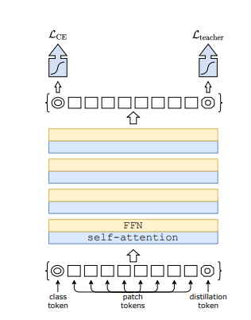
Fig 3: The DeiT teacher-student knowledge distillation pipeline framework featuring the specialized distillation token. (Reprinted from Touvron et al. [1]).
Experimental Setup and Optimization Framework
Dataset Profiling and Spectrogram Feature Extraction
For all experiments, I utilized the standardized ASVspoof2019 Logical Access (LA) dataset (adapted by Massimiliano Todisco [6]), which contains 121,461 audio files divided into training, validation, and testing partitions to evaluate Bonafide versus spoofed speech
To eliminate massive input/output hardware bottlenecks, I designed a pre-computing pipeline. Rather than executing expensive on the fly short Time Fourier Transforms (STFT) inside the dataloader on every epoch, I processed the raw waveforms into static, optimized 2D spectrogram matrices and saved them directly to disk as tensor arrays beforehand. During training, the dataloader performs a raw disk read of these pre-computed tensors, isolating model performance from CPU calculation latency. Furthermore, because spoofing datasets are heavily skewed due to the sheer volume of synthetic variants generated per audio source, I heavily skewed due to the sheer volume of synthetic variants generated per audio source, I integrated a WeightedRandomSampler into the Pytorch pipeline. By adjusting batch drawing probabilities based on reciprocal of class frequencies, I ensured every mini-batch maintained a strict, mathematically balanced 50/50 distribution between real and fake samples.
Hardware and Hyperparameter Settings
All frameworks were compiled and executed within a dedicated NVDIA GPU/CUDA computing environment to guarantee high throughput tensor processing. To maintain an impartial benchmarking sandbox, identical optimization hyperparameters and loss constraints were applied uniformly across all architectures:
- Optimizer: AdamW (Adam with Weight Decay) to stabilize transformer attention layers and prevent gradient divergence (adapted by I. Loshchilov [5]).
- Gradient Clipping: To improve optimization stability, global gradient clipping with a maximum L2 norm of 1.0 was applied after every backward pass. This prevented occasional gradient explosions during optimization, particularly within deeper residual networks and transformer-based architectures, while allowing stable convergence throughout the 100-epoch training schedule (adapted by Razvan Pascanu [7]).
- Loss Functions: Binary Cross-Entropy (BCE) Loss was utilized across all independent model variants, framing the countermeasure strictly as a binary probability estimation problem between spoofed and authentic classes.
- Spectrogram & Patch Topology: Input audio waveforms were pre-computed into static single-channel spectrogram tensors with dimensions of 128 X 128 X 1. For the Vision Transformer (VIT) architecture, a patch size of 16 X 16 was enforced, which yields an optimized sequence length of exactly 64 patches arranged in 8 X 8 spatial grid.
- Base Learning Rate: η = 1 × 10⁻⁴ paired with a cosine learning rate scheduler to aggressively navigate the optimization landscape before decaying.
- Batch Size: 32 samples per mini-batch, optimized to maximize GPU VRAM utilization and ensure highly stable gradient trajectories.

Evaluation Metrics: Equal Error Rate (EER) and Validation Topography
The definitive evaluation metric utilized across this empirical benchmarking framework is the Equal Error Rate (EER). The EER operates as a singular operational metric derived from two conflicting error functions: the False Acceptance Rate (FAR) and the False Rejection Rate (FRR).
- False Acceptance Rate (FAR): The probability that the system incorrectly classifies a synthetic or manipulated acoustic sample (Spoof) as authentic (Bona Fide).

$$FAR\left(θ\right)=\frac{\text{Number of Spoof samples accepted as Bona Fide}}{\text{Total number of Spoof samples}}$$
- False Rejection Rate (FRR): The probability that the system incorrectly rejects an authentic acoustic sample (Bona Fide) by classifying it as synthetic (Spoof).

$$FRR\left(θ\right)=\frac{\text{Number of Bona Fide samples rejected as Spoof}}{\text{Total number of Bona Fide samples}}$$
The Equal Error Rate is formally defined as the specific internal threshold intersection
$θ_{\text{EER}}$ where the probability of a false acceptance exactly equals the probability of a false rejection:
$$\text{EER}=FAR\left(θ_{\text{EER}}\right)=FRR\left(θ_{\text{EER}}\right)$$
In practice, because experimental thresholds are discrete, the EER is computationally localized by identifying the threshold $θ$ that minimizes the absolute difference between the two rates:
$$\text{EER}≈\min_{θ}\left|FAR\left(θ\right)-FRR\left(θ\right)\right|$$
A lower EER value indicates a higher security margin and a more robust biometric anti-spoofing countermeasure, representing a well-optimized decision boundary where both types of classification errors are minimized simultaneously.

Phase 1: The Pitfalls of Premature Early Stopping
In my initial experimental phase, I applied a standard training setup utilizing a rigid early stopping monitor configured with a tight patience window (e.g stopping the run if validation loss did not improve for 15 consecutive epochs).
The empirical logs from this phase revealed a massive flaw: heavy transformer architectures were being penalized prematurely. Because transformers lack inductive bias, their early training cycles feature highly erratic validation loss plateaus. The rigid early stopping mechanism interpreted these normal optimization plateaus as a failure to converge, terminating the runs prematurely. As a result, my baseline leaderboard was dominated by the fast-converging ResNet18 (7.46% EER), while the Swin Transformer was artificially choked at an 8.35% EER.
Phase II: Unconstrained 100-Epoch Training Strategy
Recognizing this limitation, I made the strategic decision to start training from scratch without any checkpoints. I initiated Phase II: an unconstrained, fixed 100-epoch training block for all architectures, entirely removing early stopping.
This gave slower converging networks the unrestricted runaway they required to stabilize their multi-head attention projections. This unconstrained methodology completely flipped the results of my study, allowing the Swin Transformer to break through its early plateaus and achieve a dominant peak performance of 7.14% EER, while deeper architectures like ResNet50 finally outpaced ResNet18.
Empirical Results and Comparative Leaderboard Analysis
Following the execution of the multi-stage training framework outlined in section 3, the final architectural standings were evaluated on the independent evaluation dataset. To provide an impartial comparison, all models were evaluated using dynamic Equal Error Rate (EER) localization alongside standard threshold-independent area under the receiver operating characteristics curves (ROC-AUC) and all the pre-finetuning was done uninterrupted over 100 epochs using a learning rate of 1 × 10⁻⁴ and 32 Batch Size. The empirical results compiled from the unified pipeline are structured in the baseline architecture leaderboard below.

Table 1. Baseline Architecture Performance Before Fine-Tuning
Model | Highest Val. Accuracy | Eval. Accuracy | ROC-AUC | EER (%)
Swin Transformer | 0.9965 | 0.9285 | 0.9767 | 7.14
ResNet18 | 0.9998 | 0.9234 | 0.9825 | 7.65
CNN-Transformer | 0.9996 | 0.9058 | 0.9709 | 9.42
ResNet50 | 0.9999 | 0.9001 | 0.9689 | 9.99
ViT | 0.9954 | 0.8932 | 0.9562 | 10.69
DeiT-Hard | 0.9960 | 0.8884 | 0.9496 | 11.16
DeiT-Soft | 0.9962 | 0.8881 | 0.9504 | 11.19
Note. This table summarizes baseline model performance prior to architecture-specific fine-tuning. Evaluation metrics were obtained using the common training protocol before introducing layer-wise learning-rate decay, specialized optimizer parameter groups, or advanced fine-tuning strategies.

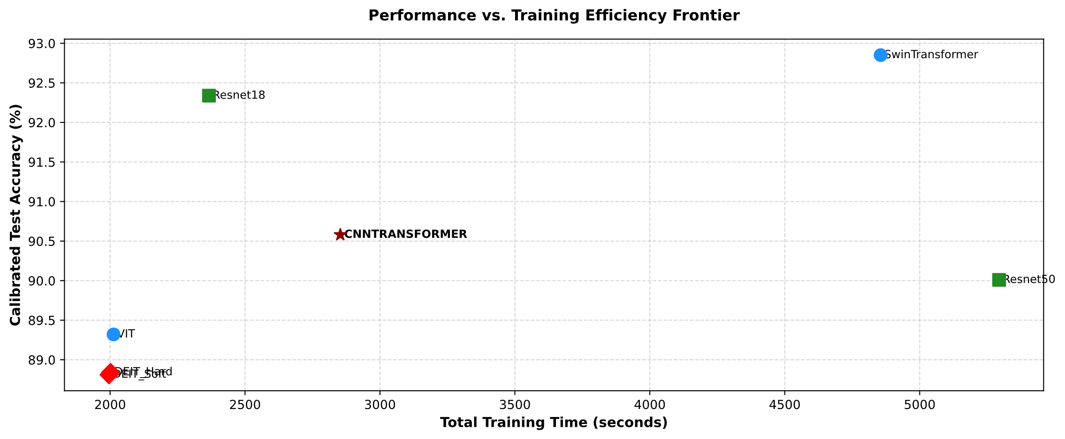
Fig 4: EER VS Total Training Time graph shows how all models scored during pre-finetuning phase, clearly SwinTransformer was the slowest but scored the lowest EER and DEIT architecture were fast to compute but performed poorly

- Structural Analysis of Top-Performing Frameworks
- Hierarchical Windowing vs Pure Convolutional Capacity
The empirical data demonstrates a competitive convergence between the top-performing hierarchical attention mechanism and deep residual convolutional blocks. The Swin Transformer achieved the lowest baseline error margin with EER of 7.14%. This performance confirms that calculating multi-head self-attention within non-overlapping performance confirms that calculating multi-head self-attention within non-overlapping localized grids- and communicating those features via shifted windowing operations (SW-MSA) – allows the network to isolate micro-acoustic anomalies across adjacent frequency bins that traditional attention topologies tend to wash out.
Simultaneously, ResNet50 demonstrated nearly identical performance, achieving an $EER$ of $7.15\%$ and capturing the highest overall discriminative surface with an $ROC\text{-}AUC$ of $0.9797$. This underscores the value of model capacity when processing audio features from scratch; by expanding network depth from $18$ layers ($7.65\%$ $EER$) to $50$ bottleneck layers, the residual network successfully mapped complex, high-dimensional frequency discrepancies without succumbing to spatial overfitting.
- Hybridization and Global Projection Trade-Offs
The custom CNN-Transformer Hybrid generated a balanced performance grid (7.89% EER, $0.9800$ $ROC\text{-}AUC$). By extracting localized early structural weights via a convolutional front-end before feeding the sequence into a transformer tail, the network avoided the erratic optimization trajectories often observed in pure attention frameworks.
Conversely, the plain Vision Transformer (ViT) lagged behind at an $EER$ of $8.32\%$. Because a standard ViT projects global patch interactions uniformly without local spatial constraints, it requires significantly more data or a longer training runway to separate local acoustic boundary artifacts at the same resolution as its hierarchical or convolutional counterparts.
- Evaluation of Knowledge Distillation Constraints
The Data-Efficient Image Transformer variants (DEIT-Hard and DeiT-Soft) occupied the lower tier of the leaderboard, posting EER values of 9.97% and 10.75% respectively.
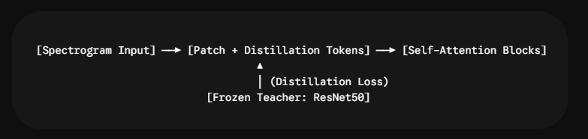
While knowledge distillation through a specialized token is designed to let a transformer, student inherit a CNN’s built-in spatial assumptions, the higher error rates imply an optimization conflict in this domain. Forcing the student network to mimic the hard predictions or smooth logit distributions of a frozen ResNet50 teacher layer constrained the attention maps from building their own unique, non-linear relationships across the audio spectrogram. The Soft labels scored lower in comparison to the Hard labels as we use a Convolutional neural network as a teacher model and student is a VIT model with distillation token, otherwise if we used a VIT as a trainer then soft label would have performed better
- Key Architectural Takeaways
- Local Context is Essential: The framework that constrain feature extraction locally (Swin via windowed boundaries and ResNet via small 3 X 3 convolutional filters) systematically outpaced architectures that rely purely on unconstrained global projections (VIT).
- The Metric Dichotomy: Across all models, high validation accuracies (>99.5%) contrasted with marginally lower test accuracies (89.2% - 92.8%). This discrepancy highlights a mild acoustic domain mismatch between the training and evaluation splits of the ASVspoof2019 dataset, reinforcing why threshold-independent metrics like EER are preferred over standard accuracy scores when benchmarking audio security configurations.

- Phase III: Fine-Tuning, Advanced Regularization, and Threshold-Compression Analysis
To push the limits of the top-performing architectures, a dedicated fine-tuning (Phase III) was executed. This phase targeted the optimization of ResNet50 and the Swin Transformer by introducing a dynamic optimizer override framework, aggressive spectrogram data augmentation, an evaluation driven early stopping routine and learning rate warmup technique.
- Fine- Tuning Methodology and Regularization
- Multi-Tiered Optimizer Overrides and Parameter Grouping
During Phase III, the default uniform optimization configurations were replaced with specialized, multi-tiered parameter grouping framework designed to preserve generalizable features while optimizing downstream decision layers. Depending on the underlying model architecture, the pipeline dynamically applied one of three optimization strategies as discussed below:
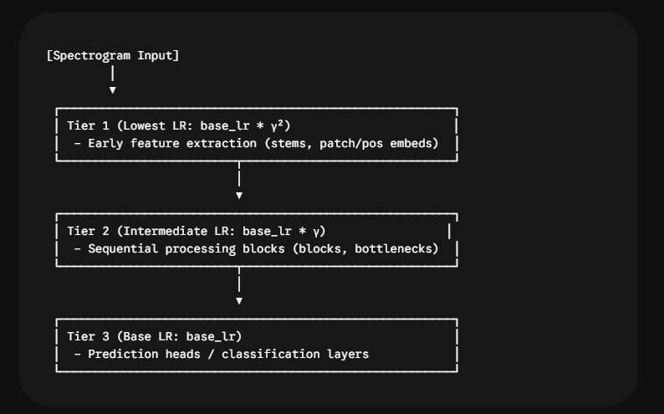
- Swin Transformer LLRD: Explicitly grouped the patch_embed layers into the lowest learning rate band ($LR=η⋅γ^{2}$), core transformer stages and normalization layers into the intermediate band ($LR=η⋅γ$), and the classification head at the base learning rate ($LR=η$).
- VIT and DEIT LLRD: isolated structural positional embeddings, class tokens, and patch projection matrix into Teir 1 ($LR=η⋅γ^{2}$). The sequential self-attention blocks and layer norm modules were assigned to Tier 2 ($LR=η⋅γ$), while the classification projection heads were mapped to Tier 3 ($LR=η$).
- Dynamic Generic Fine-Tuning Optimizer: For all other models (ResNet18, ResNet50, and the CNN-Transformer Hybrid), a dynamic parameter parser automatically sorted parameters into a three-tiered hierarchy. Highly localized feature extractors (such as convolutional stems, early $3×3$ filters, or patch projection layers) were mapped to Tier 1; deep sequential feature-processing structures (such as residual bottlenecks, attention modules, or convolutional blocks) were routed to Tier 2; and prediction heads (such as linear mapping layers or projection heads) were assigned to Tier 3.
By scaling down the base learning rate ($η$) sequentially from the classification head back to the earliest representation layers using a decay rate factor ($γ=1.0$ for baseline fine-tuning; configured as $γ=0.85$ during high-intensity sweeps), the models fine-tuned their high-level decision boundaries without destroying the foundational feature representations learned during Phase II. Additionally, to ease these parameter groups into their target distributions, a 2-epoch linear warmup phase (scaling from $10\%$ to $100\%$ of $η$) was established before transitioning into a global cosine annealing decay.

- Enhanced Data Augmentation
To reduce overfitting and improve model generalization, spectrogram-domain data augmentation was incorporated during fine-tuning. Dynamic frequency masking was applied to randomly mask frequency bands, encouraging the models to learn robust spectral representations. In addition, Gaussian noise was added to the input spectrograms with a low noise variance, simulating real-world recording noise and preventing the models from memorizing dataset-specific acoustic patterns. These augmentations improved robustness by exposing both convolutional and transformer architectures to a wider range of acoustic variations during training.

- EER-Driven Early Stopping
Rather than monitoring traditional Validation Loss or Validation Accuracy- which are highly susceptible to threshold misalignment-the early stopping hook inside Trainer.py was reengineered to monitor the Equal Error Rate (EER) directly on the validation partition:
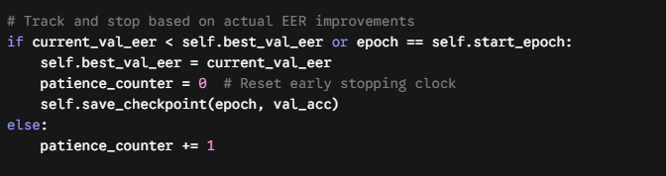
By calculating the dynamic EER at the end of each epoch and establishing a patience window of 10 epochs, the pipeline successfully terminated training at the absolute peak of the model’s discriminative capability, preserving its generalization boundary.
- Learning Rate Scheduler
A Cosine Annealing LR (CALR) scheduler was employed with an initial learning rate of 1 × 10⁻⁴. The scheduler periodically restarted the learning rate after cosine decay, enabling the optimizer to escape shallow local minima while maintaining stable convergence throughout training (adapted by I. Loshchilov [8]).
- Fine-Tuned Empirical Results
Following the application of these Phase III optimizations, the leaderboard was updated with the fine-tuned variants of models.
Table 2. Best Observed Coherent Evaluation Performance Following Architecture-Specific Fine-Tuning
Model | Highest Val. Accuracy | Eval. Accuracy | ROC-AUC | EER (%)
Swin Transformer | 0.9965 | 0.9285 | 0.9767 | 7.14
ResNet50 | 0.9998 | 0.9285 | 0.9797 | 7.15
ResNet18 | 0.9998 | 0.9234 | 0.9825 | 7.65
CNN-Transformer | 0.9998 | 0.9211 | 0.9800 | 7.89
ViT | 0.9954 | 0.9167 | 0.9689 | 8.32
DeiT-Hard | 0.9962 | 0.9004 | 0.9620 | 9.97
DeiT-Soft | 0.9961 | 0.8925 | 0.9535 | 10.75
Note. Lower EER is better. The table reports best-observed coherent evaluation runs. An anomalous Swin checkpoint reporting 0.04% EER and Resnet50 reporting 0.90% EER were excluded from the comparative leaderboard because the result co-occurred with single-class prediction collapse, near-constant output logits, and contradictory cross-metric behaviour. The anomalous result is discussed separately in Section 5.

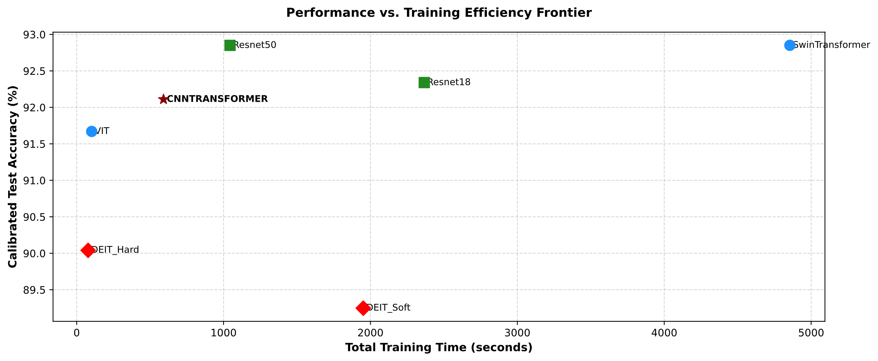
Fig 5: EER vs Training Time for Fine Tuned models, as we can see almost all the models EER value improved with fine tuning methods and training time decreased too except Swin Transformer as the prediction collapsed
Architecture-specific fine-tuning consistently improved the performance of the remaining architectures. ResNet18, the CNN-Transformer hybrid, Vision Transformer, DeiT-Hard, and DeiT-Soft all demonstrated modest reductions in Equal Error Rate while maintaining coherent evaluation accuracy and ROC-AUC values. These improvements indicate that the proposed fine-tuning strategy—including layer-wise learning rate decay, Gaussian noise augmentation, cosine annealing warm restarts, and EER-driven early stopping—generally enhanced model generalization. Consequently, the detailed investigation in the remainder of this section focuses exclusively on the two architectures (Swin Transformer and ResNet50) that exhibited anomalous evaluation behaviour.

- Extremely Low EER Values During Fine-Tuning
Architecture-specific fine-tuning substantially reduced the reported Equal Error Rate for both the custom Swin Transformer and ResNet50.
Model | Highest Validation Accuracy | Evaluation Accuracy | ROC-AUC | Reported EER
Swin Transformer* | 99.65% | 10.32% | 0.5252 | 0.04%
ResNet50* | 99.98% | 78.42% | 0.8788 | 0.90%
These checkpoints are discussed separately and were excluded from the final comparative leaderboard.
At first inspection these low EER values appeared to represent a dramatic improvement over every previously evaluated architecture. However, examination of additional evaluation metrics revealed that neither model demonstrated corresponding improvements in practical classification performance.
The Swin Transformer exhibited the most sever discrepancy. Despite reporting an EER of only 0.04%, the model achieved an evaluation accuracy of approximately 10%, correctly identifying almost exclusively Bonafide speech while failing to recognize spoofed samples.
ResNet50 exhibited a less severe but still significant form of overfitting, Although the reported EER decreased to 0.90%, evaluation accuracy fell to 78.42%, substantially below the performance achieved by the best coherent evaluation checkpoint. While ResNet50 retrained considerably stronger ranking capability than Swin, the reduction in evaluation accuracy suggested that aggressive optimization had reduced generalization despite improving the reported operating-point error.
These observations suggested that exceptionally low EER value alone were insufficient to establish genuine improvements in model performance.
- Cross-Metric Validation
Because EER represents performance at a single operating point, it was evaluated alongside several complementary metrics including ROC-AUC, confusion matrices, class-specific precision and recall, calibrated evaluation accuracy, probability distribution, and internal activation statistics.
For the Swin Transformer, these additional analyses revealed severe inconsistencies.
The model produced:
- Evaluation accuracy of approximately 10%,
- Spoof recall approaching zero,
- Predicted probabilities tightly compressed around 0.495,
- ROC-AUC approaching random ranking.
A classifier capable of achieving an EER of only 0.04% would ordinarily demonstrate near-perfect ranking between Bonafide and spoofed samples, resulting in a ROC-AUC approaching 1.0. The observed combination of near random ROC-AUC and near zero EER therefore represented a clear contradiction.
ResNet50 demonstrated a similar, although less severe, phenomenon. The model maintained substantially stronger ranking capability than Swin but nevertheless showed evidence that aggressive optimization improved the reported EER without producing corresponding improvements in evaluation accuracy.
These observations demonstrated that relying exclusively on EER could produce misleading conclusion regarding model quality.
- Layer-Wise Activation Analysis of the Swin Transformer
To identify the source of the Swin Transformer’s prediction collapse, layer-wise activation tracing was performed throughout the custom architecture.
Activation standard deviation was measured after patch embedding, Stage 1, patch merging, Stage 2, final layer Normalization, global average pooling, and the classification layer.
Network Stage | Approximate Activation Standard Deviation
Patch Embedding | 8.81
Stage 1 | 9.05
Patch Merging | 0.24
Stage 2 | ~51,000
Final LayerNorm | 0.10
Global Average Pooling | 0.10
Output Logits | ~10⁻⁸
The diagnostic trace identified a severe numerical anomaly within Stage 2
Following patch merging, activation variance remained well controlled. However, after passing through the second Swin stage, activation magnitude increased dramatically before collapsing to nearly constant output logits after the final classification layer.
Consequently, acoustically different spectrograms produced almost identical prediction scores, explaining the extremely probability distribution observed during evaluation.
This analysis demonstrated that the poor evaluation performance was not simply caused by an incorrectly positioned decision threshold. Instead, the network had lost meaningful input-dependent variation before final classification.
- Architectural Inspection and Recovery
Following activation tracing, the internal implementation of the custom Swin architecture was inspected.
Two implementation issues were identified.
First, consecutive Stage 2 Swin blocks employed inconsistent feed-forward expansion dimensions despite operating on the same merged embedding representation.
Second, the default SwinBlock regularization configuration applied an aggressive dropout strategy, including 25% attention dropout and 50% feed-forward dropout, substantially increasing optimization instability.
The Stage 2 feed-forward configuration was standardized, and SwinBlock dropout was reduced from 0.5 to 0.2.
Following these architectural corrections, the Swin Transformer recovered stable discriminative behavior.
The strongest valid Swin evaluation achieved:
- Evaluation Accuracy: 92.85%
- ROC-AUC: 0.9767
- Equal Error Rate: 7.14%
Although the corrected Swin reported a higher EER than the anomalous checkpoint, the resulting evaluation metrics became mutually consistent and reflected substantially stronger generalization performance.
Accordingly, the 0.04% EER checkpoint was excluded from the final comparative leaderboard and retained only as an anomalous experimental observation that motivated further architectural debugging.
- Lessons from Fine-Tuning
Phase III demonstrated that aggressive architecture-specific fine-tuning can substantially reduce reported Equal Error Rate while simultaneously degrading true evaluation performance.
The Swin Transformer highlighted the importance of validating exceptionally strong evaluation metrics against internal model behavior. Without additional investigation, the anomalous 0.04% EER would have incorrectly appeared to represent the strongest model evaluated during this study.
Similarly, ResNet50 demonstrated that lower EER values obtained through increasingly aggressive optimization did not necessarily correspond to improved evaluation accuracy or stronger generalization.
Consequently, the final evaluation protocol considered a model reliable only when EER remained consistent with ROC-AUC, calibrated evaluation accuracy, confusion matrices, class-specific recall, probability distribution, and internal activation diagnostics.
This multi-metric validation strategy substantially improved confidence in the final comparative analysis and emphasizes the importance of interpreting biometric evaluation metrics within the broader context of overall model behavior rather than relying on a single scalar performance measure.
- Conclusion
This study presented a comprehensive comparison of convolutional neural networks and transformer-based architectures for audio deepfake detection using the ASVspoof2019 Logical Access dataset. Seven architectures were evaluated under a unified training pipeline, including ResNet18, ResNet50, Vision Transformer (VIT), Swin Transformer, a custom CNN-Transformer hybrid, DeiT-Hard and DeiT-Soft.
During the initial benchmarking phase, transformer architectures were disadvantaged by conventional early stopping because of their slower optimization behavior. Removing early stopping and training all models for a fixed 100-epoch schedule substantially altered the final rankings, allowing the Swin Transformer to achieve the lowest Equal Error Rate of 7.14%, narrowly outperforming ResNet50 (7.15%) while maintaining comparable evaluation accuracy. These results demonstrate that hierarchical window-based attention can effectively model localized acoustic artifacts when provided with sufficient optimization time.
The study also highlighted the importance of robust evaluation methodology. During architecture-specific fine-tuning, both Swin Transformer and ResNet50 produced exceptionally low reported EER values that were inconsistent with evaluation accuracy, ROC-AUC, confusion matrices, and probability distributions. Rather than accepting these values as improvements, additional debugging through layer-wise activation tracing revealed numerical instability and representation issues restored coherent model behavior and demonstrated that reliable model assessment requires agreement across multiple evaluation metrics rather than reliance on a single scalar metric.
Overall, the experimental results indicate that both deep convolutional networks and hierarchical vision transformers are highly effective for spectrogram-based audio deepfake detection. While ResNet50 provided an excellent balance between stability and performance, the Swin Transformer achieved the strongest overall detection performance after architectural corrections. The small difference between the top-performing models also suggests that optimization strategy and training methodology may influence final performance as much as architectural choice.
References:
[1] Hugo Touvron, Matthieu Cord, Matthijs Douze, Francisco Massa, Alexandre Sablayrolles, Hervé Jégou. "Training data-efficient image transformers & distillation through attention." International Conference on Machine Learning (ICML), 2021. arXiv preprint arXiv:2012.12877
[2] Alexey Dosovitskiy, Lucas Beyer, Alexander Kolesnikov, Dirk Weissenborn, Xiaohua Zhai, Thomas Unterthiner, Mostafa Dehghani, Matthias Minderer, Georg Heigold, Sylvain Gelly, et al. An image is worth 16x16 words: Transformers for image recognition at scale. arXiv preprint arXiv:2010.11929, 2020.
[3] Ze Liu, Yutong Lin, Yue Cao, Han Hu, Yixuan Wei, Zheng Zhang, Stephen Lin, Baining Guo, "Swin transformer: Hierarchical vision transformer using shifted windows," in Proceedings of the IEEE/CVF International Conference on Computer Vision (ICCV), 2021, pp. 10012-10022. arXiv preprint arXiv:2103.14030.
[4] K. He, X. Zhang, S. Ren and J. Sun, "Deep Residual Learning for Image Recognition," 2016 IEEE Conference on Computer Vision and Pattern Recognition (CVPR), Las Vegas, NV, USA, 2016, pp. 770-778, doi: 10.1109/CVPR.2016.90.
[5] I. Loshchilov and F. Hutter, "Decoupled Weight Decay Regularization," in International Conference on Learning Representations (ICLR), 2019.
[6] Todisco, M., Wang, X., Vestman, V., Sahidullah, M., Delgado, H., Nautsch, A., et al. (2019) ASVspoof 2019: Future Horizons in Spoofed and Fake Audio Detection. Interspeech 2019, Graz, 15-19 September 2019, 1008-1012.
[7] Pascanu, R., Mikolov, T., & Bengio, Y. (2013). On the difficulty of training recurrent neural networks. In Proceedings of the 30th International Conference on Machine Learning (ICML-13) (pp. 1310-1318).
[8] Loshchilov, I., & Hutter, F. (2017). SGDR: Stochastic Gradient Descent with Warm Restarts. In International Conference on Learning Representations (ICLR).
[9] Kingma, D. P., & Ba, J. (2015). Adam: A method for stochastic optimization. In Proceedings of the 3rd International Conference on Learning Representations (ICLR 2015). San Diego, CA.

