Laravel Food Project

- Implementing Laravel in Project:

To implement the project in laravel first we need to install laravel in a project. The following steps will show we the way to implement food project. To create a laravel project we need to go to MAMP->htdocs. we can go to the destination through wer terminal. Then we need to enter the following command:

composer create-project --prefer-dist laravel/laravel food (here food is the project name)

After we have entered this code in wer terminal wer laravel project food is created.

Then we need to see if wer project is installed properly or not. So, to know if it is installed or not we need to run the project. To run the project we need to enter the following command:

php artisan serve

Running the above command will run wer project in a server. Then the following screen will be displayed in the browser.

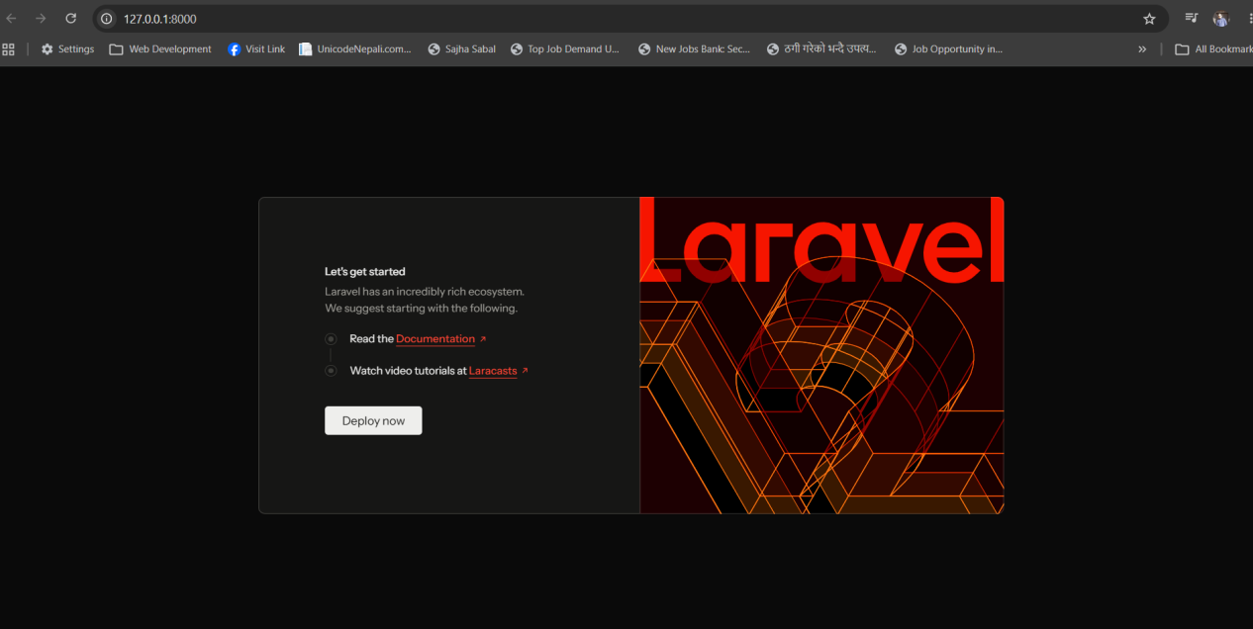

- Create Database and Configuration

To create a database first we need to go to the phpmyadmin. In our project we are using mamp. So, to go to php myadmin we need to open MAMP and click on Open WebStart Page as shown below:
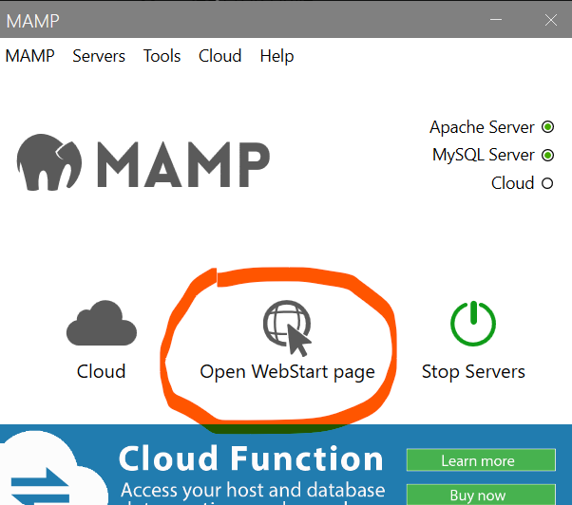

After clicking it mamp localhost server is opened and below we can find phpMyAdmin link where we need to click it.
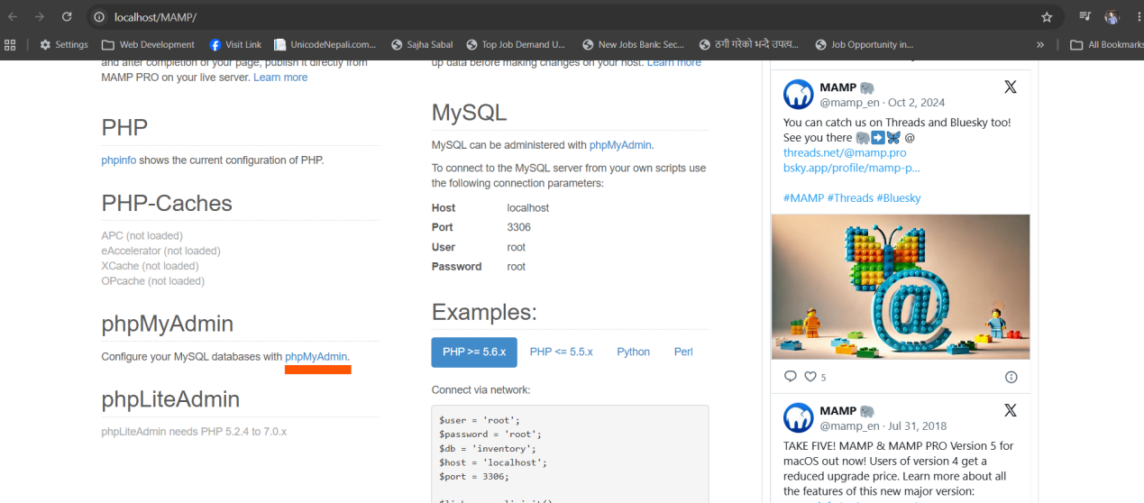

Clicking it will redirect we to the phpmyadmin page.
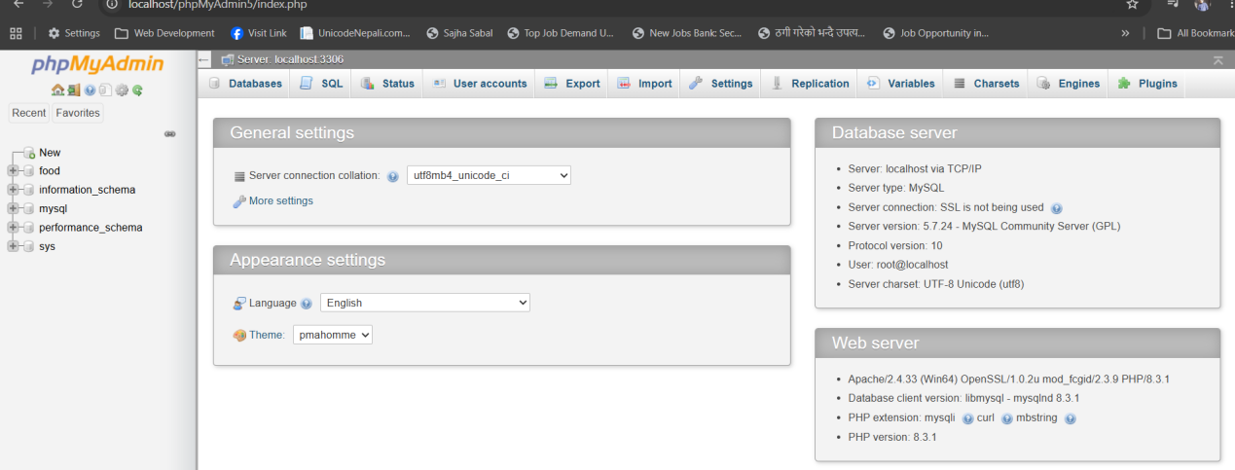
Then go to the database tab and provide database name and click on the create button.
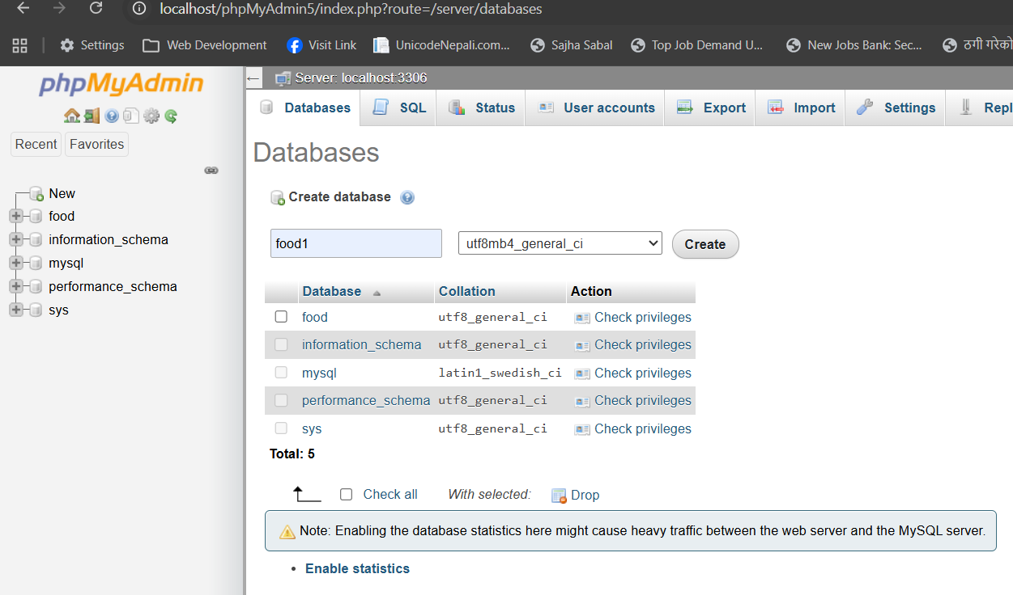

After creating the database go to wer project and go to .env file. Here, we go to the DB section where we need to set it as shown below:
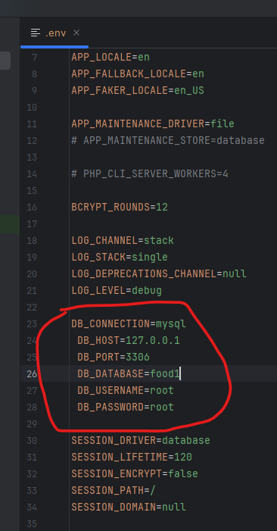

- Install Laravel Breeze

To install Laravel Breeze in wer project first we need to enter thr following command:
composer require laravel/breeze --dev

The above command will install the laravel breeze package in wer system. After that we need to enter another command which will prompt we for wer preferred frontend stock and testing framework:
php artisan breeze: install

Entering this command will ask we to select the breeze stack from the given options as shown in the following picture:
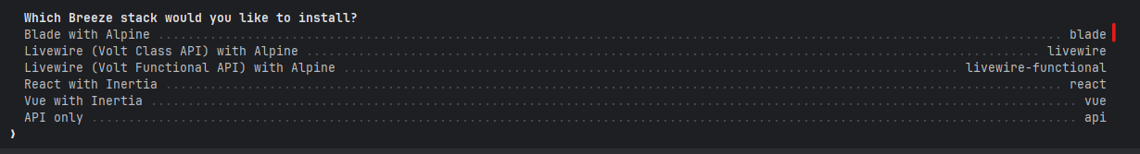

Here I have selected the blade with alpine option. So I will type blade and hit enter. Then it will ask we to select the dark mode support. If we like to have dark mode type ‘yes’, if not type ‘no’ and hit enter.

Here, I will type yes and hit enter. Then it will ask we to choose the testing framework we prefer as shown in the following figure:
Here I will type 1 and hit enter. After the installation is completed wer breeze is installed.

Now we need to migrate the default table to the database. Before doing that we need to do as following:
database->migrations->create_users_table
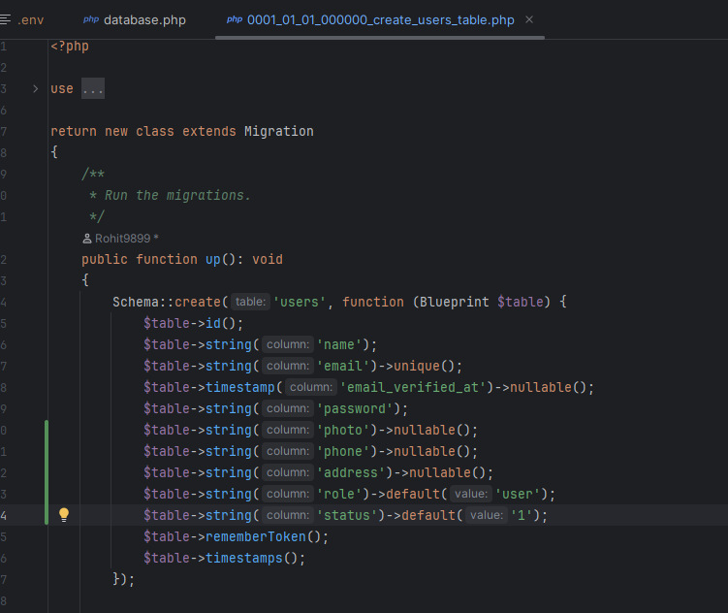

After doing as above now we need to migrate the table to the database. To migrate we need to use the following command:
php artisan migrate

Then wer database is populated with the table as shown in the following:
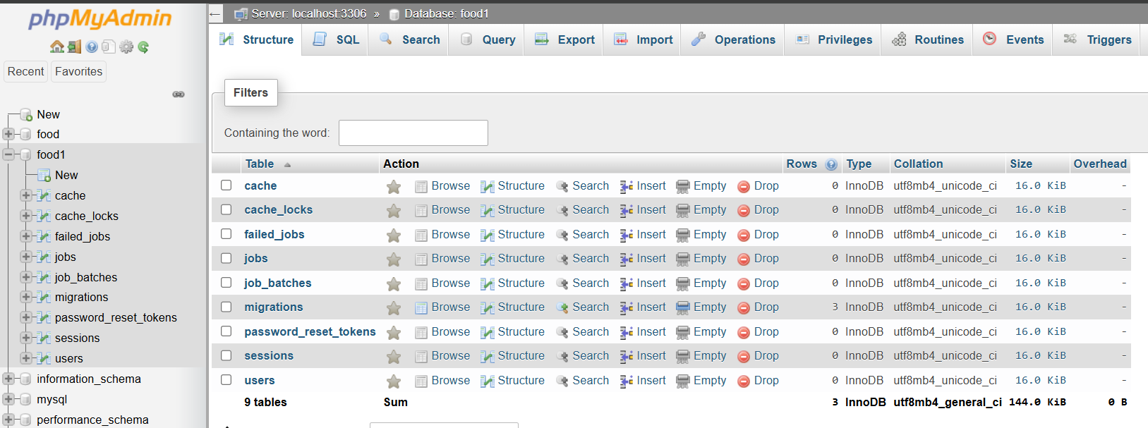

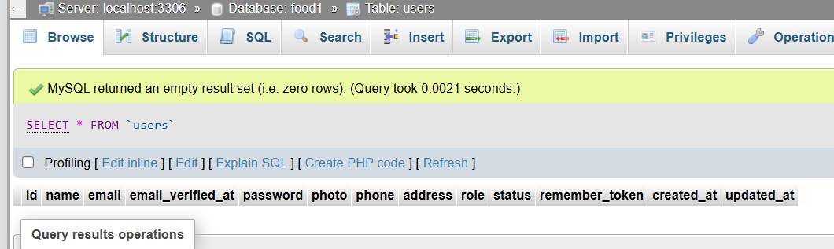

Now when we refresh wer server we will see it as follow:
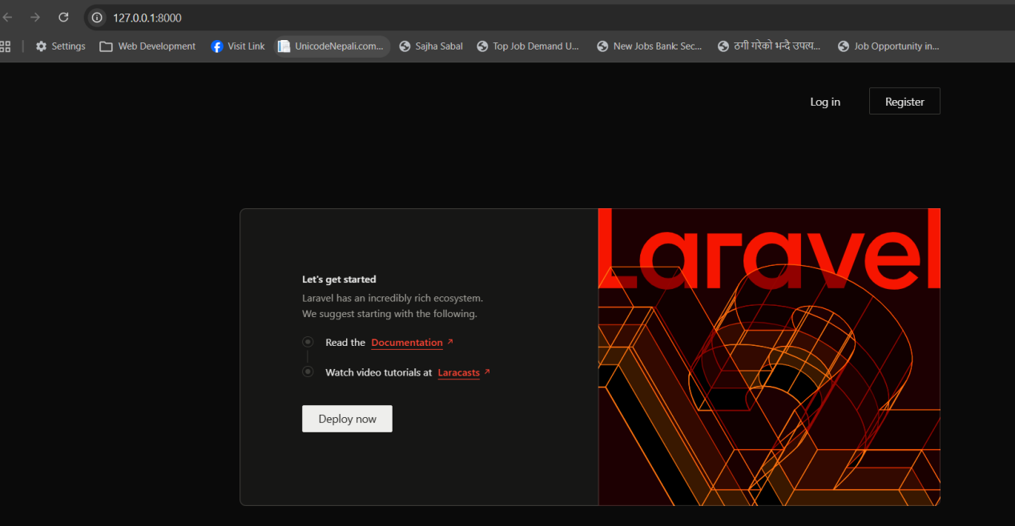

Also breeze will install all the necessary authentication files that are needed in the project. Now when we click on register we can register user and the data will be saved in the database as shown below:

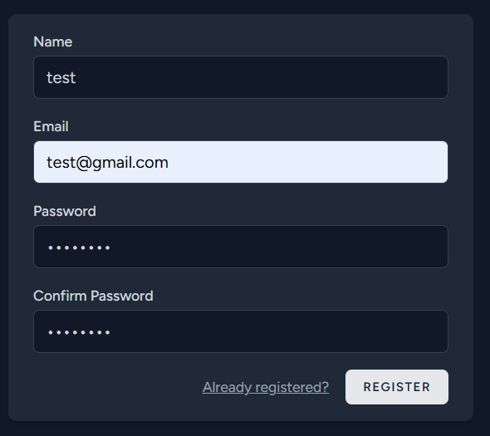

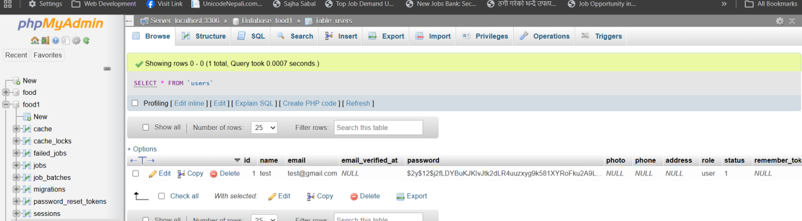

- Laravel Breeze Verify Email System

Now we will create a verify email system in our project . To do this first we need to go to the mailtrap.io and login. Go to Email Sandbox->Start Testing->My Sandbox. The following page will be displayed:
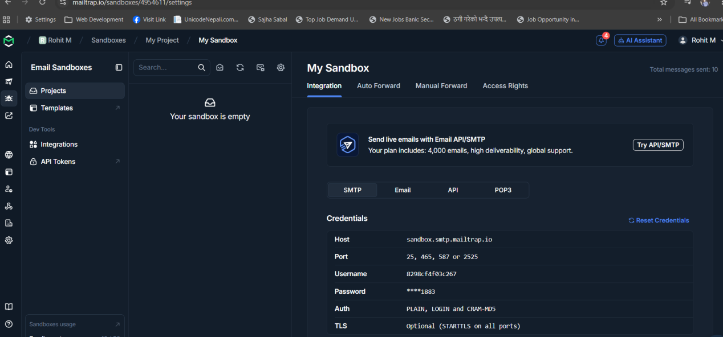

Go to the SMTP tab and under cUrl dropdown choose PHP: Laravel 9+
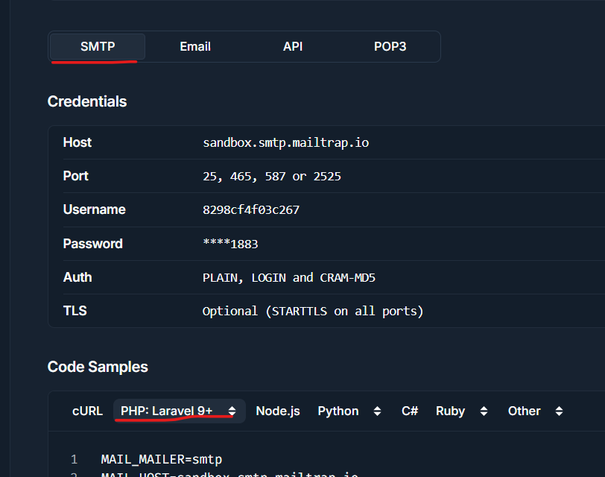

Now we need to copy the code that is shown when we select the laravel 9+ option and accordingly need to enter the data as shown in .env file as shown below:

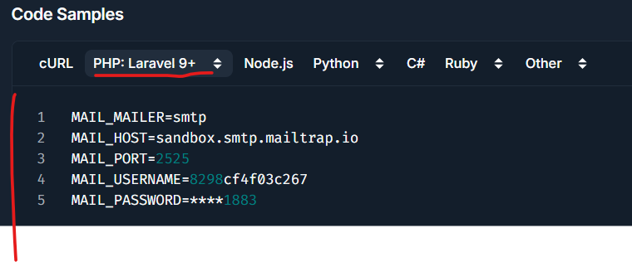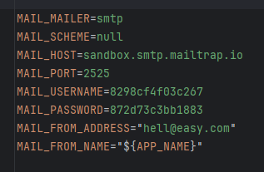

After setting up the smtp now we need to go to the app->Models->User.php. Here, we need to add the following functionality
use Illuminate\Contracts\Auth\MustVerifyEmail;
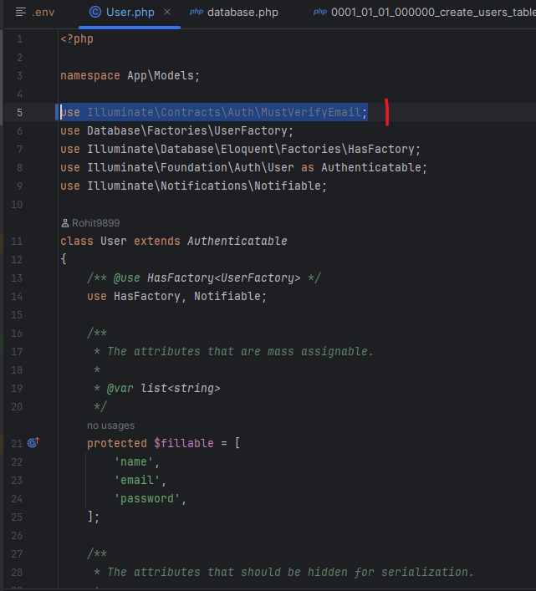

To use this functionality we need to add the code as shown in the below picture:
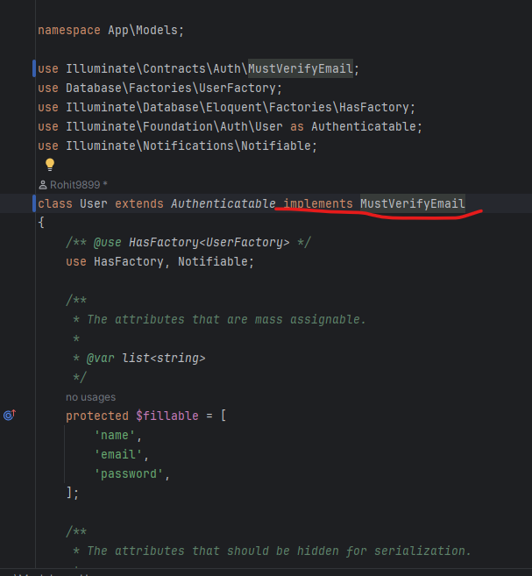

Then below go to the following code
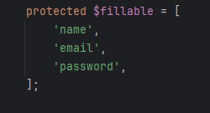

And change it as
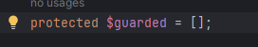

After changing this go to wer server and click on register and register wer user as shown below:

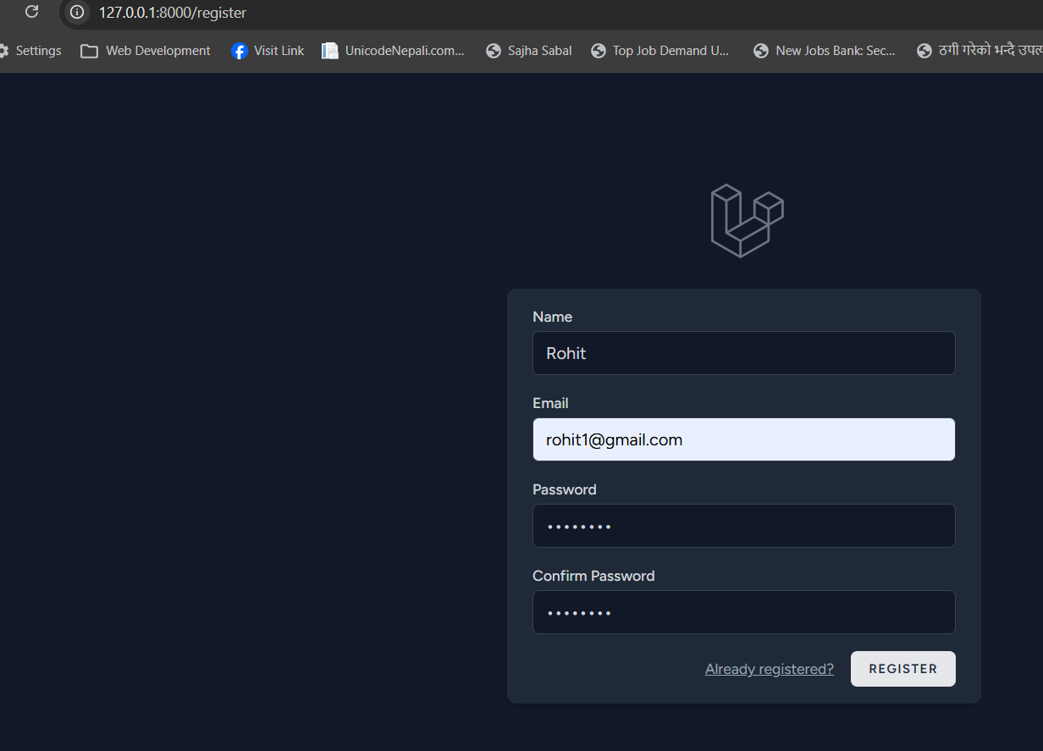

After that it will send we the verification message in wer mailtrap and when we click on it we will see the result as shown below:
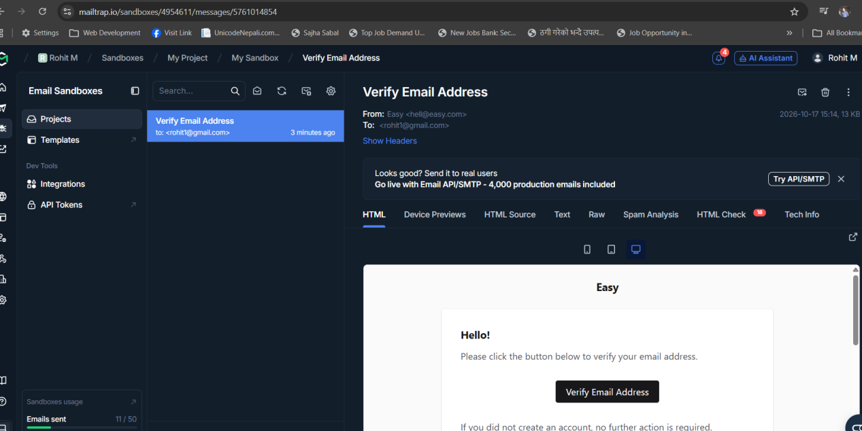

When we click on verify email address option wer email will be verified and the email verified field will shown in the database.
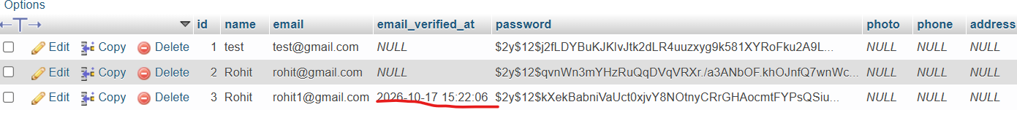

- Laravel Breeze reset Password System

First we need to go to the login page and click on the forgot password link.
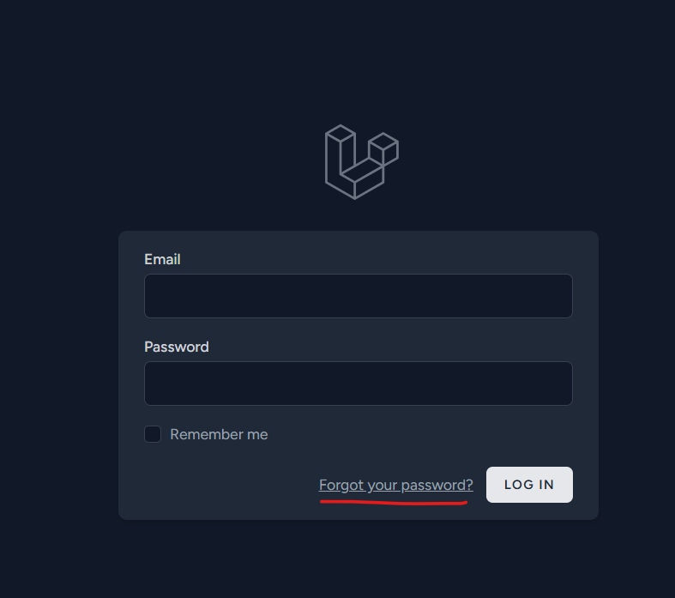

Then we will be redirected to the forgot password page. Here, enter the email that we want to reset the password and click on the email password reset link button.

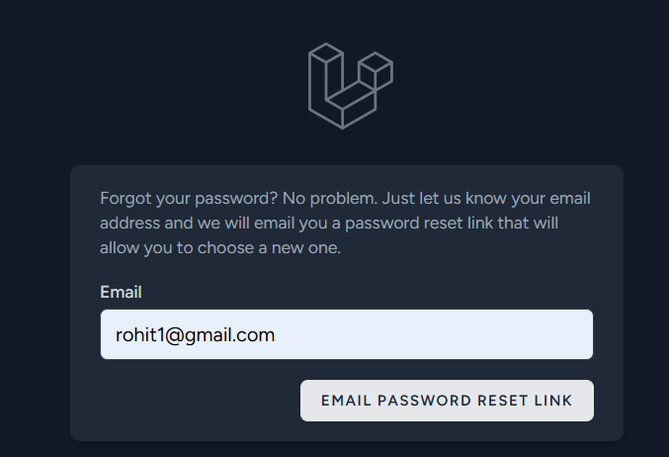

After that we will receive a mail in wer mail as shown and when clicked on reset password it will redirect we to the reset password page.
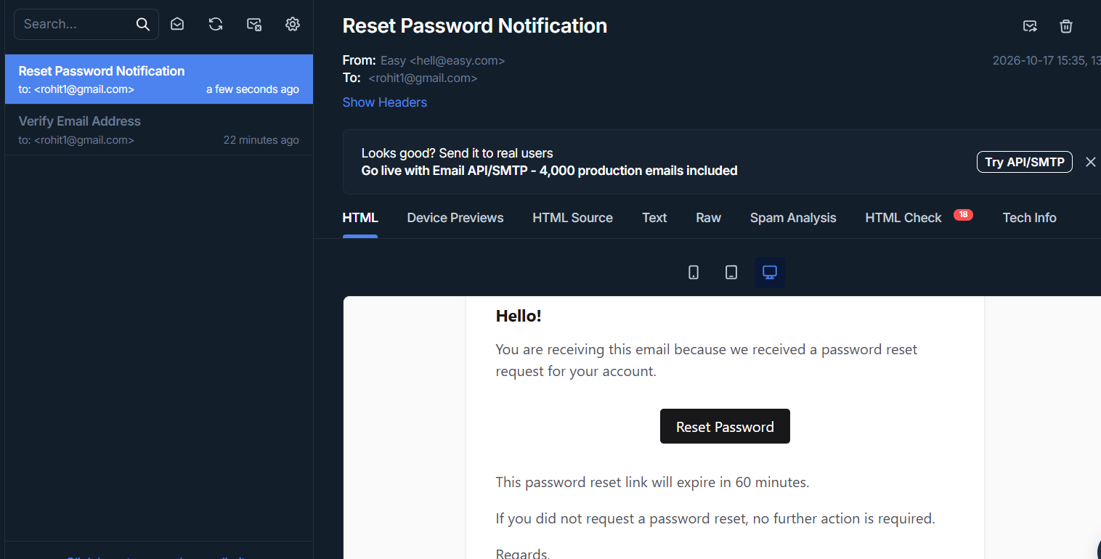

Then in the reset password email we will be asked to enter the password and confirm password as shown below and click on reset button.

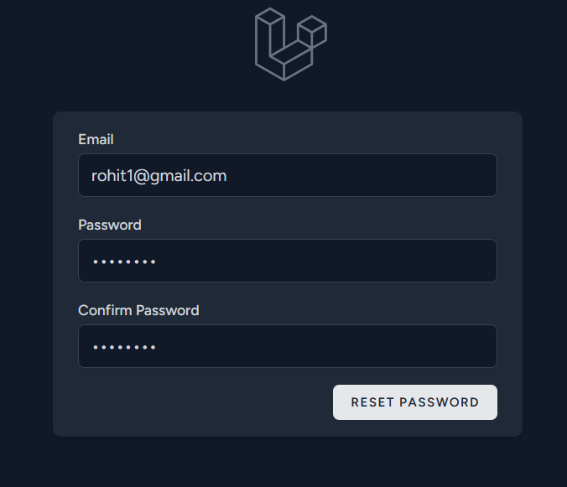

Note:After we click on forget password button in wer email we will also see the data in password_reset_tokens table in the database.

- Laravel Multi Auth with Breeze Part 1

Here we need to make the admin authentication. To do that first we need to enter the following command:
php artisan make:model Admin -m

The above command will create an admin model and a database migration file for the admins table.

After that go to the admins migration (database->migrations->create_admins_table.php) and add fields as shown below:

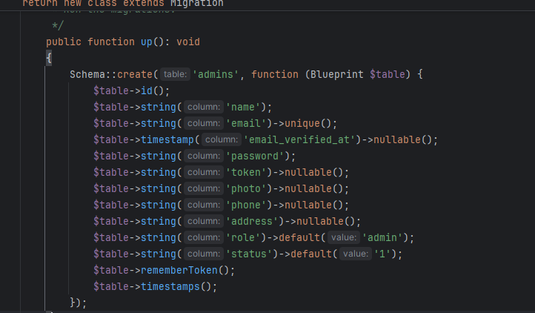

After that go to the Admin Models (app->models->Admin.php) and add code as shown below:
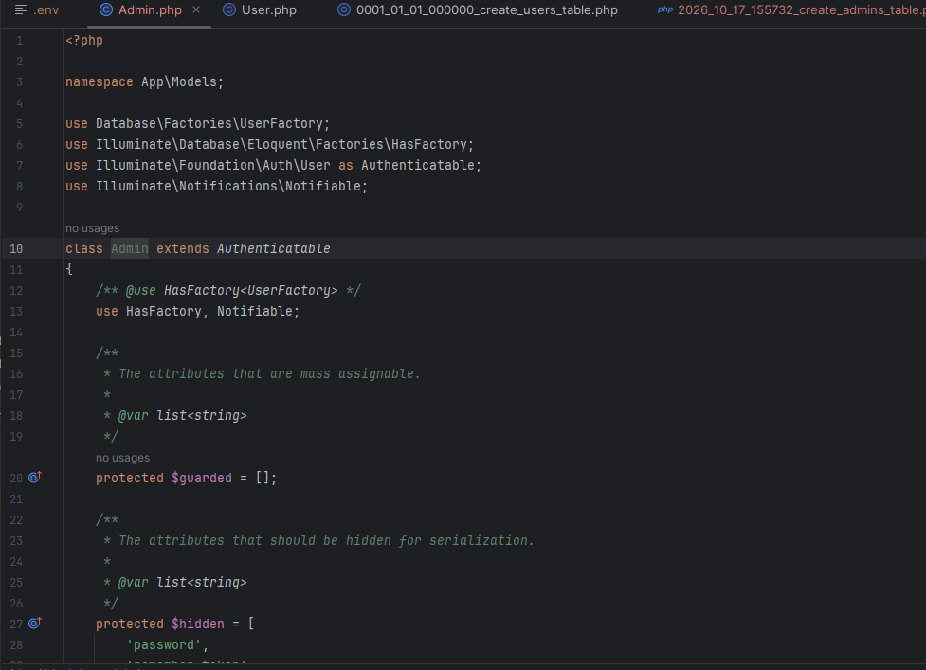

After that we need to migrate the admins table to the database. To do that we need to use the command:
php artisan migrate

After we run the above command the table can be seen in wer database.

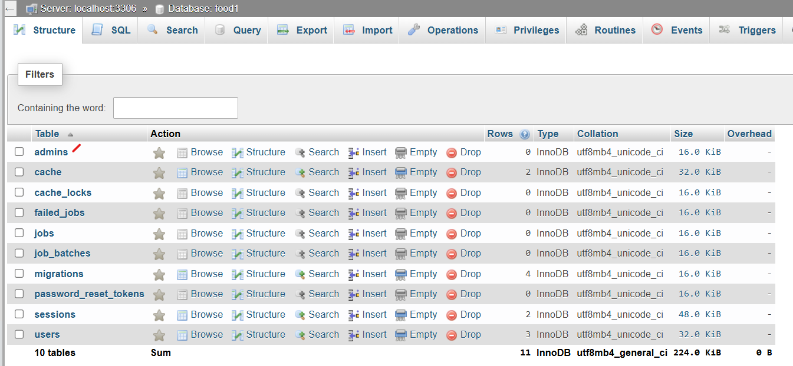

After the table is created there are no data. So, here we will add our demo data. To insert the demo data we can use the folliowing command:

php artisan make:seeder AdminSeeder (AdminSeeder is the seeder file name)

Then go to wer AdminSeeder file (database->seeders->AdminSeeder.php) and add code as shown:
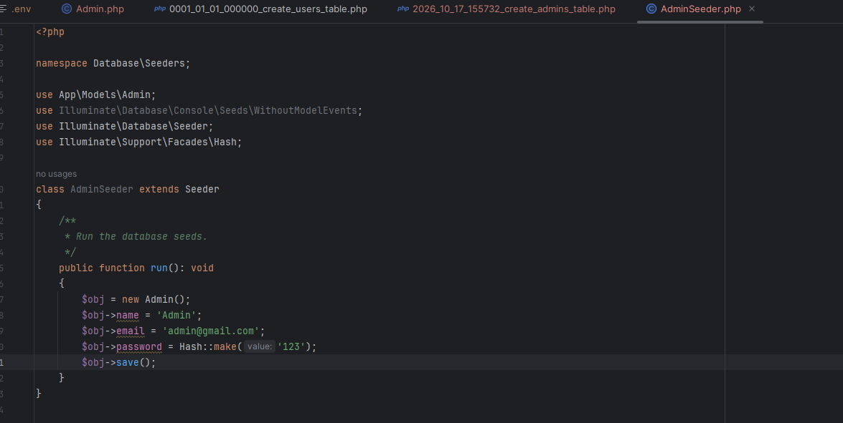

Then we need to go to DatabaseSeeder.php (database->seeders->DatabaseSeeder.php) and following code:
$this->call([AdminSeeder::class])
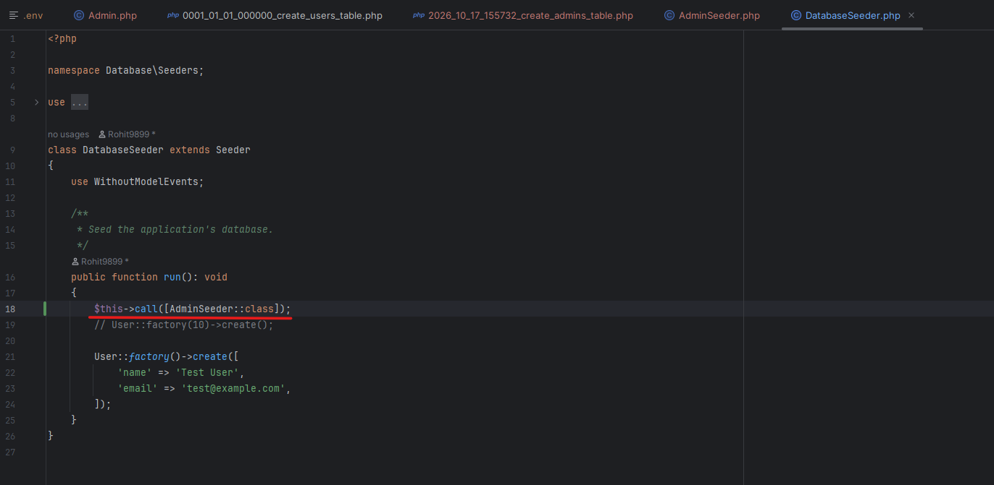

After this we need to go to the terminal and insert the following command:

php artisan db:seed

Doing this will add data in wer table as shown below:
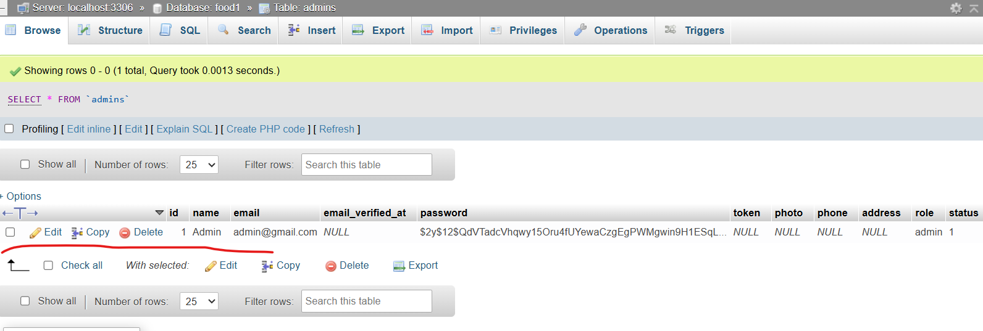

- Laravel Multi Auth with Breeze Part 2 (admin side)

What is a controller?
Controller is used to handle the logic of wer application. It receives requests from users, processes the required data, interacts with models or databases, and returns a response or view.

First we need to create a controller. Here, we will create the Admin Controller with the following command:
php artisan make:controller AdminController

This will create the controller named AdminController(app->http->controllers->AdminController.php)
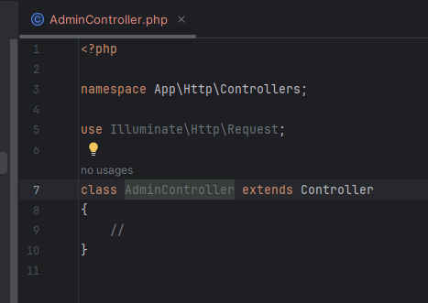

After creating the admin controller now we need to go the Admin Model. In the Admin model we need to assign the following:

Protected $guard = ‘admin’;
<?php

namespace App\Models;

use Database\Factories\UserFactory;
use Illuminate\Database\Eloquent\Factories\HasFactory;
use Illuminate\Foundation\Auth\User as Authenticatable;
use Illuminate\Notifications\Notifiable;

class Admin extends Authenticatable
{
/** @use HasFactory<UserFactory> */
use HasFactory, Notifiable;

/**
* The attributes that are mass assignable.
*
* @var list<string>
*/
protected $guard = 'admin';
protected $guarded = [];

/**
* The attributes that should be hidden for serialization.
*
* @var list<string>
*/
protected $hidden = [
'password',
'remember_token',
];

/**
* Get the attributes that should be cast.
*
* @return array<string, string>
*/
protected function casts(): array
{
return [
'email_verified_at' => 'datetime',
'password' => 'hashed',
];
}
}

Then we need to go the auth.php(config->auth.php) file. Here we need to go to the Authentication Guards section where we need to add the following code and is also shown in the picture.
'admin' => [
'driver' => 'session',
'provider' => 'admins',
],
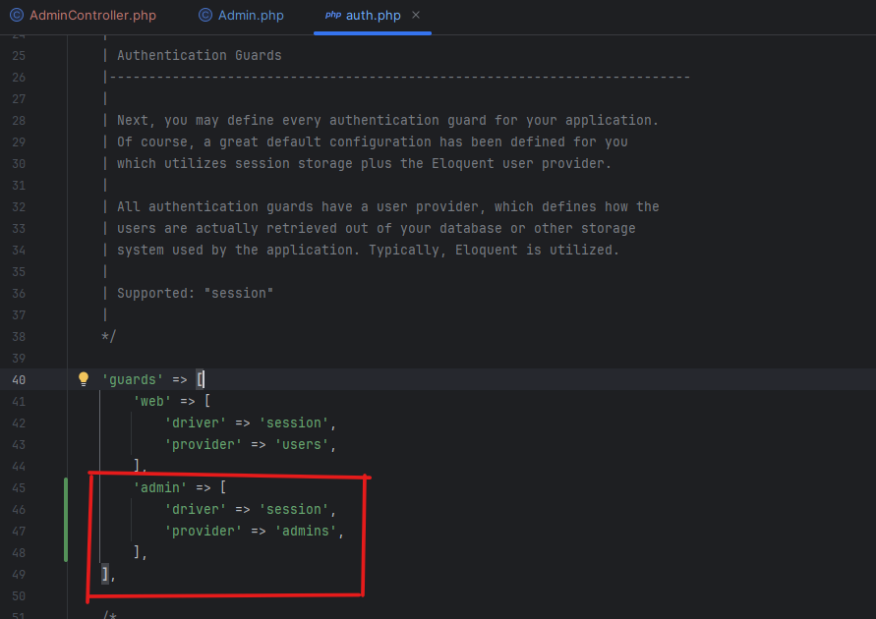

After that we need to go to the provider section and add the following code as shown in the following picture.
'admins' => [
'driver' => 'eloquent',
'model' => env('AUTH_MODEL', App\Models\Admin::class),
],
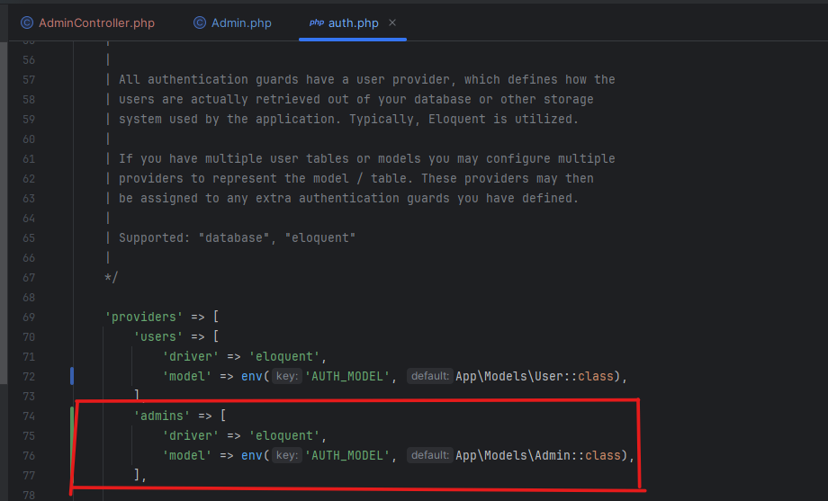

After adding both the guard and provider as done above we need to go to the web.php(routes->web.php) to assign routes. Now , at the top we need to add the following code so that wer web.php will support AdminController.
use App\Http\Controller\AdminController;
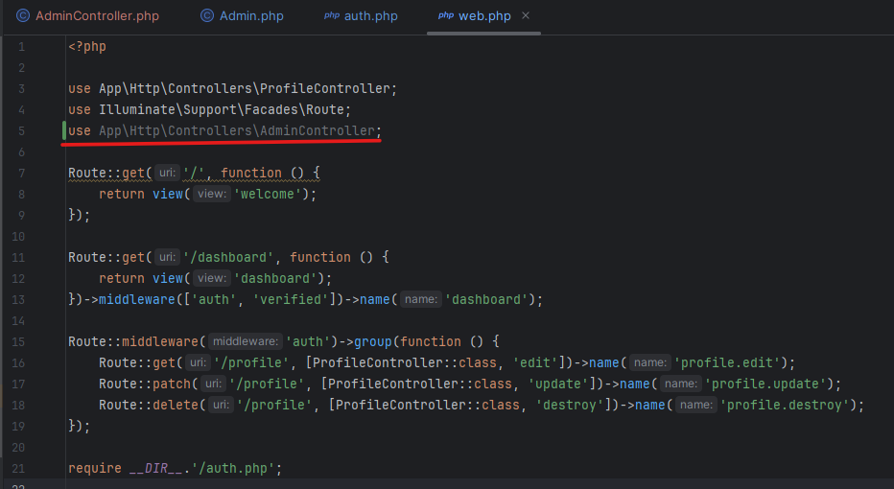

Now we need to add the route as mentioned below in yoour web.php file.

Route::get('/admin/login', [AdminController::class, 'AdminLogin'])->name('admin.login');

After we have defined the route go to the AdminController and create a public funtion name Admin Login:
public function AdminLogin(){
return view('admin.login');
}
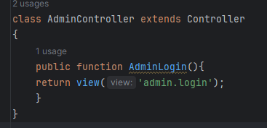

Now we need to create the view. To create the view ‘admin.login’ we need to go to the views. (resources->views). Inside the views we need to create a new folder admin and inside which we need to create a new file as login.(resources->views->admin->login)

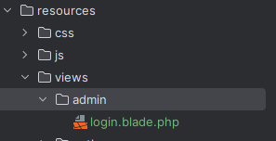

Now create a simple html structure for the admin login as shown below:
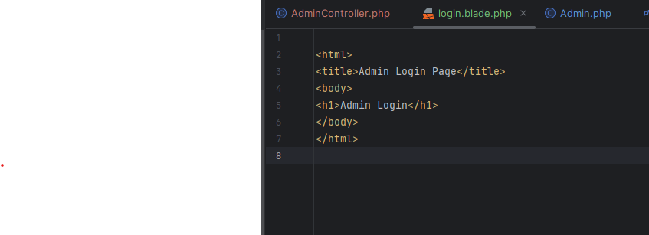

After this clear the cache and go to wer project. In the project go to the url and type /admin/login and we will be redirected to admin login page.
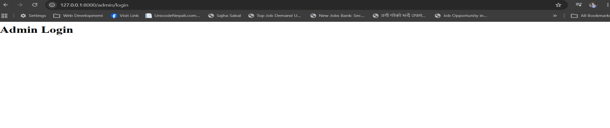
we should do similar for dashboard for now.

- Laravel Multi Auth with Breeze Part 3 (admin side)

Now we have to design the admin login form so that the admin can login. To do that first we need to go to the bootstrap. From there we need to copy the bootstrap CDN and paste it under the title tag as shown below:

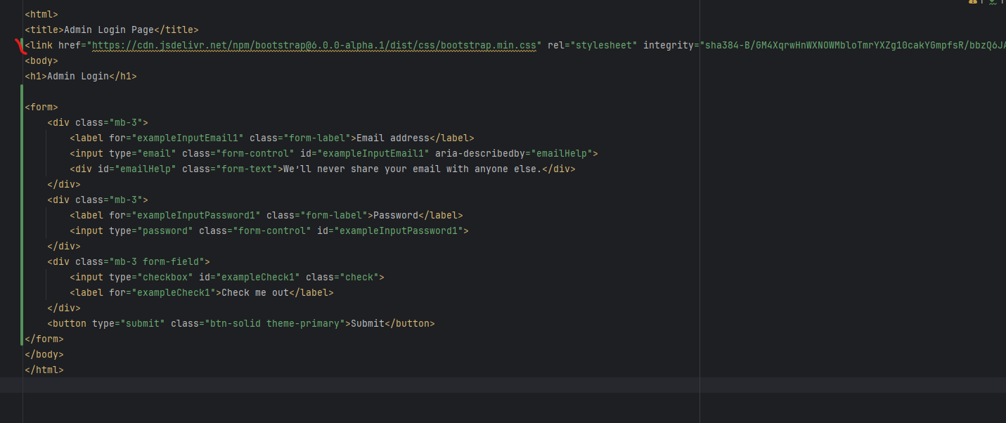

Copy the form design code from the form control and paste it under the body section.

<form>
<div class="mb-3">
<label for="exampleInputEmail1" class="form-label">Email address</label>
<input type="email" class="form-control" id="exampleInputEmail1" aria-describedby="emailHelp">
<div id="emailHelp" class="form-text">We’ll never share wer email with anyone else.</div>
</div>
<div class="mb-3">
<label for="exampleInputPassword1" class="form-label">Password</label>
<input type="password" class="form-control" id="exampleInputPassword1">
</div>
<div class="mb-3 form-field">
<input type="checkbox" id="exampleCheck1" class="check">
<label for="exampleCheck1">Check me out</label>
</div>
<button type="submit" class="btn-solid theme-primary">Submit</button>
</form>

The above code will generate the following form:
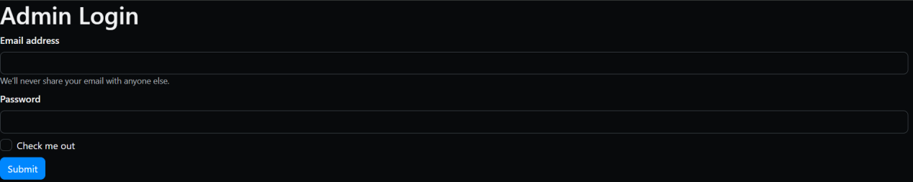

Now to show any error or validation problem we need to add the following code in login.blade.php file above the form tag and below the h1 tag.

@if($errors->any())
@foreach($errors->all() as $error)
<li>{{$error}}</li>
@endforeach
@endif
@if(Session::has('error'))
<li>{{Session::get('error')}}</li>
@endif
@if(Session::has('success'))
<li>{{Session::get('success')}}</li>
@endif

Now we need to match the email and password provided by the user in the database. To do that we need to add these code inside the form tag as shown below:
<form action="{{route('admin.login_submit')}}" method="post">
@csrf
Note: @csrf should be mentioned under the form tag.

After adding the above code now we need to check if the name inside input tag is matched with the field in the database. If there is no name in input tag or is mismatched then we need to add or fix the name.
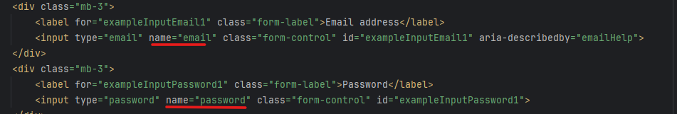

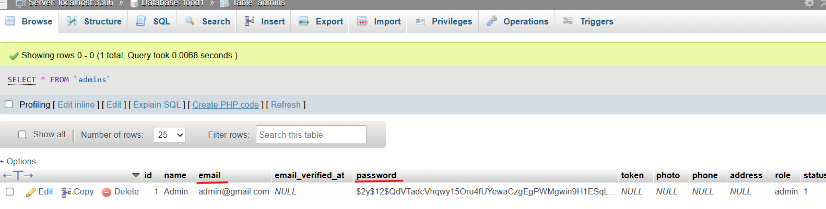
After this now we need to create a route for wer route that we have mentioned(‘admin.login_submit’) in wer login form. To do that we need to go to the web.php and add the following code.

Route::post('/admin/login_submit',[AdminController::class,'AdminLoginSubmit'])->name('admin.login_submit');
Note: As the form is post method we have used post in the route instead of get.

After that we need to create a function for AdminLoginSubmit in Admin controller.
public function AdminLoginSubmit(Request $request){
}

- Multi Auth with Breeze Pt4

Now we need to make the fileds in Admin Login Page required. That means it cannot be left empty. To do this we need to use the following code in wer Admin Controller under AdminLoginSubmit function.
$request->validate([
'email'=>'required|email',
'password'=>'required',
]);

After this we will create a variable and store all the input data submitted by the user. That means when user enters the email and password then it will store it in a variable. Here, we will use the following code:
$check = $request->all()
After this we will create another variable that will store the data from check.
$data = [
'email' => $check['email'],
'password' => $check['password'],
];

Now, we need to check if the data that is entered is admin or not. To do that first we need to add the following code at top as shwon below:
use Illuminate\Support\Facades\Auth;
use Illuminate\Support\Facades\Hash;
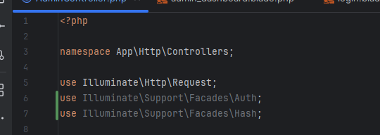

Now go to the AdminLoginSubmit function and add the following code:
if(Auth::guard('admin')->attempt($data)){
return redirect()->route('admin.dashboard')->with('success','Login successfully');
} else{
return redirect()->route('admin.login')->with('error','Invalid Email or Password');
}
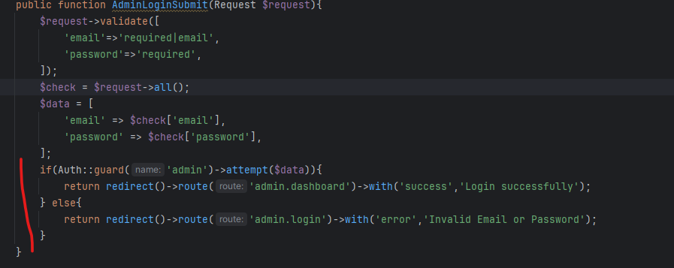

The above code will check if the user entered is admin or not. If it is admin then it will redirect we to admin dashboard along with successful message. If it is not admin then it will redirect we to admin login page with error message.

Now when we enter the wrong email and password we will not be able to go to the dashboard else we can login to the dashboard.

Now we will add a code for the login successful message once the admin is logged in using the following code.
@if(Session::has('error'))
<li>{{Session::get('error')}}</li>
@endif
@if(Session::has('success'))
<li>{{Session::get('success')}}</li>
@endif
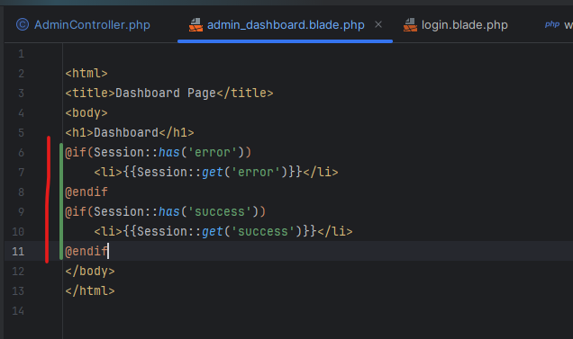

Also add a code for logout as shown below:

<a href="#">Loggout</a>

- Laravel Multi Auth with Breeze Part 5:

Now we need to create logout functionality. To do that first we need to go to the admin_dashboard page. Then inside the <a href> we need to add route code as shown below:

<a href="{{route('admin.logout')}}">Loggout</a>
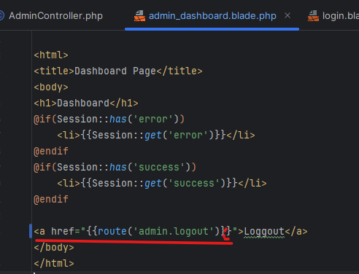

Now we need to go to the web.php and add the route as shown below:
Route::get('/admin/logout', [AdminController::class, 'AdminLogout'])->name('admin.logout');
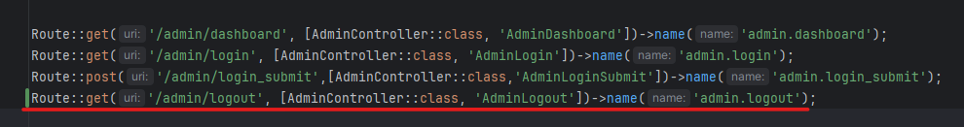

After we have created the route now we need to create AdminLogout function in AdminController. we need to enter the following code in wer function.
public function AdminLogout(){
Auth::guard('admin')->logout();
return redirect()->route('admin.login')->with('success','Logout successfully');
}
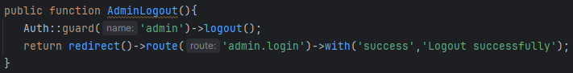

After that clear wer cache and reload wer logged in dashboard page. Then click on logout link and it will reirect it to admin login page with success message as shown below:

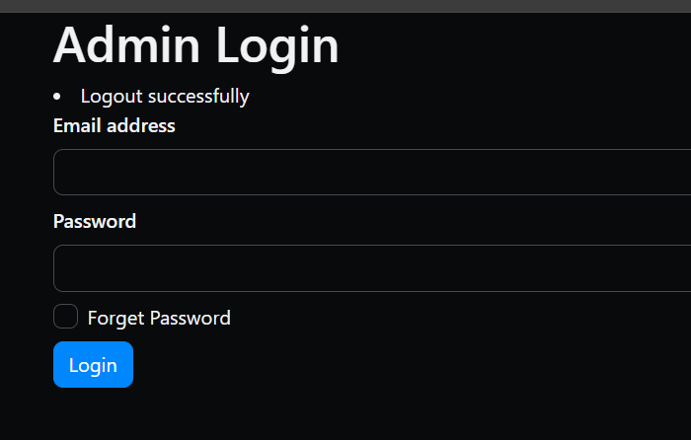

- Laravel Multi Auth with Breeze Part 6:

Here we will make the functionality in a way that only logged in admin are able to login and redirected to admin dashboard. To do that we need to do as mentioned below.

First we need to create a middleware for the Admin. To do that we need to add the following command in the terminal:
php artisan make:middleware Admin

The above code will create a middleware named ‘Admin’(http\middleware\Admin.php)

After we have created the middleware we need to register the middleware. To register middleware we need to go to Bootstrap\app.php. Now we need register wer middleware inside withMiddleware function as shown below:

$middleware->alias(['admin' => App\Http\Middleware\Admin::class]);
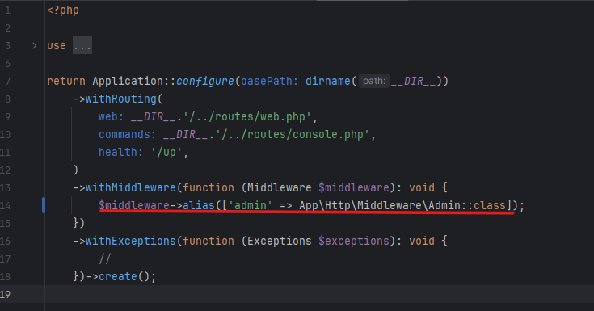
After this go to the Admin middleware and write the following code on top as shown below:
use Illuminate\Support\Facades\Auth;
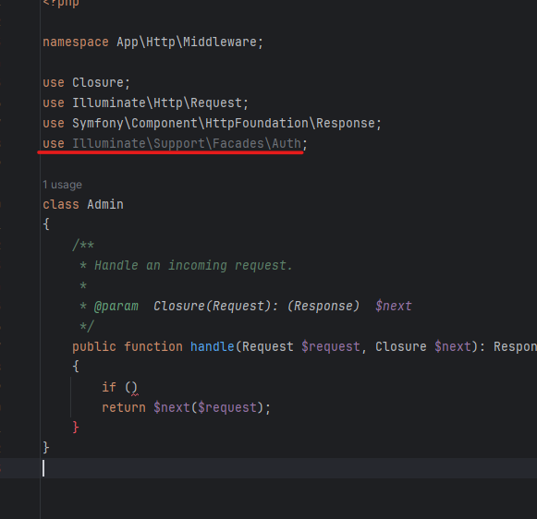

Then inside handle function we need to create ‘if’ function with the following functionality as shown below:
if (!Auth::guard('admin')->check()) {
return redirect()->route('admin.login')->with('error', 'we are not permitted to access this page.');
}
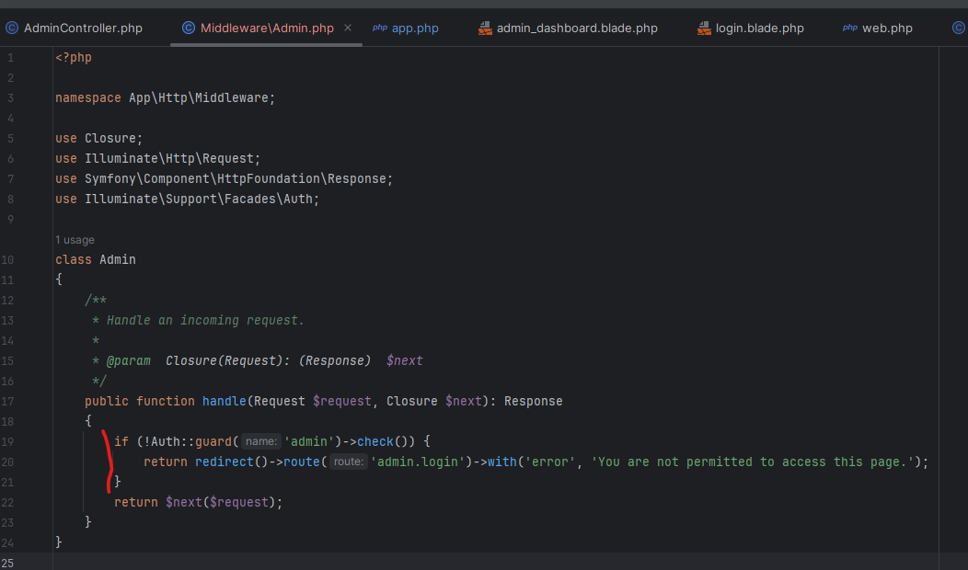
After this go to the web.php and add a route for middleware as shown below:
Route::middleware('admin')->group(function () {});
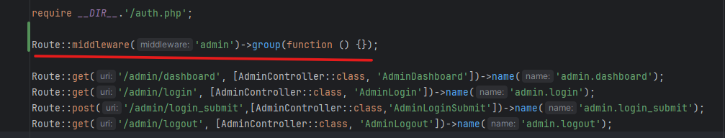

Now inside this function copy the dashboard route and paste it as shown below:
Route::middleware('admin')->group(function () {
Route::get('/admin/dashboard', [AdminController::class, 'AdminDashboard'])->name('admin.dashboard');
});

After this when wer admin user is not registered then we are not allowed to visit admin dashboard through the url. we are only allowed to enter if wer admin user is verified.

¥¥¥¥¥¥¥¥¥¥¥¥¥¥¥¥¥¥¥¥¥¥¥¥¥¥¥¥¥¥¥¥¥¥¥¥¥¥¥¥¥¥¥¥¥¥¥¥¥¥¥¥¥¥¥¥¥¥¥¥¥¥¥¥¥¥¥¥¥¥¥¥¥¥

- Multi Auth Forget Password for Admin Part 1:

Noe we need to create a custom design for the forget password page. To do this first we need to go to the login page and there we need to add ‘a href’ as shown below:

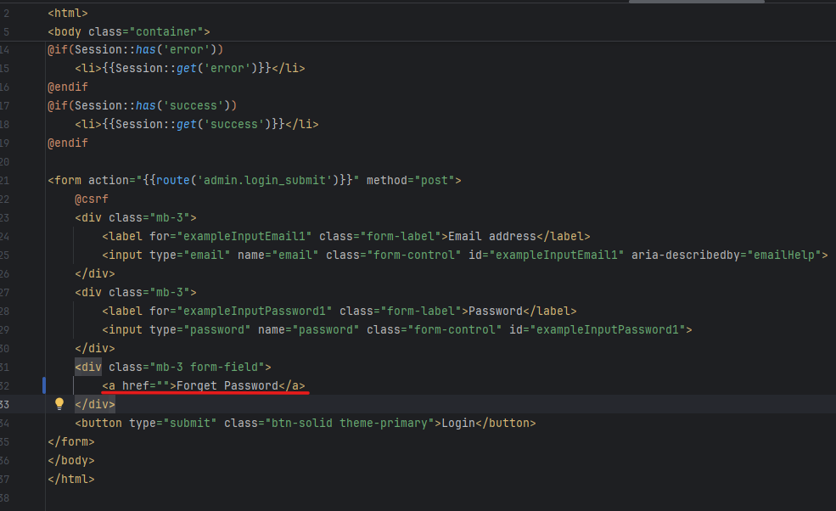

Note: Here we have removed the input field for forget password and added ‘a href’.

Now inside the href we need to specify route as {{route(‘admin.forget_passsword’)}} as shown below:

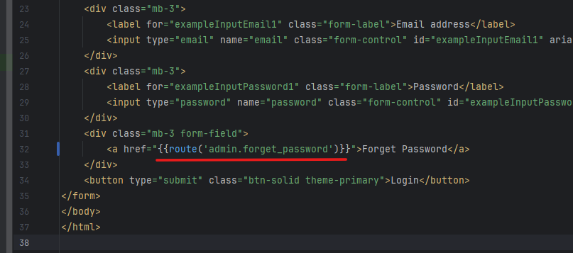

After we have given the route as above we need to specify route in the web.php. we need to specify the route as follow:
Route::get('/admin/forget_password', [AdminController::class, Admin'ForgetPassword'])->name('admin.forget_password');

After that we need to go to the Admin Controller and create the function AdminForgetPassword and should include the following:
public function AdminForgetPassword(){
return view('admin.forget_password');
}
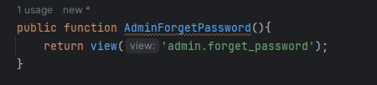

Now we need to create a file named ‘forget_password’ (resources->views->admin)

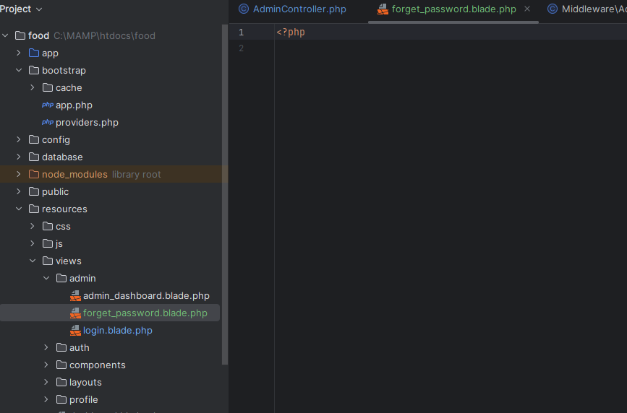

Enter the following code in the forget _password page.
<html>
<title>Forget Passsword Page</title>
<link href="https://cdn.jsdelivr.net/npm/bootstrap@6.0.0-alpha.1/dist/css/bootstrap.min.css" rel="stylesheet" integrity="sha384-B/GM4XqrwHnWXNOWMbloTmrYXZg10cakYGmpfsR/bbzQ6JAJI4ihuyADKLnBgrCe" crossorigin="anonymous">
<body class="container">
<h1>Forget Password</h1>

@if($errors->any())
@foreach($errors->all() as $error)
<li>{{$error}}</li>
@endforeach
@endif

@if(Session::has('error'))
<li>{{Session::get('error')}}</li>
@endif
@if(Session::has('success'))
<li>{{Session::get('success')}}</li>
@endif

<form action="{{route('admin.login_submit')}}" method="post">
@csrf
<div class="mb-3">
<label for="exampleInputEmail1" class="form-label">Email address</label>
<input type="email" name="email" class="form-control" id="exampleInputEmail1" aria-describedby="emailHelp">
</div>

<button type="submit" class="btn-solid theme-primary">Email Password Reset Link</button>
</form>
</body>
</html>

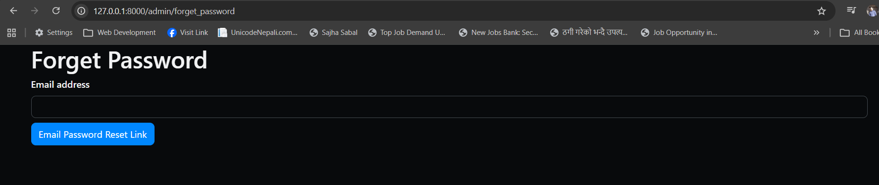

Now we need to allow only the email that is in the database should be sent the email to reset password. To do that first we need to add route in the s form action as shown below:

{{route('admin.password_submit')}}
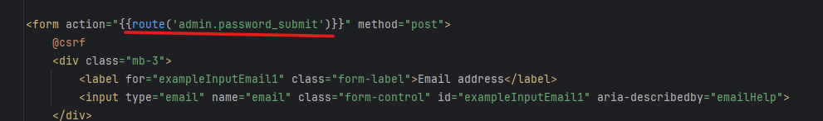

Now we need to create the route in web.php as shown below:

Route::post('/admin/password_submit',[AdminController::class,'AdminPasswordSubmit'])->name('admin.password_submit');
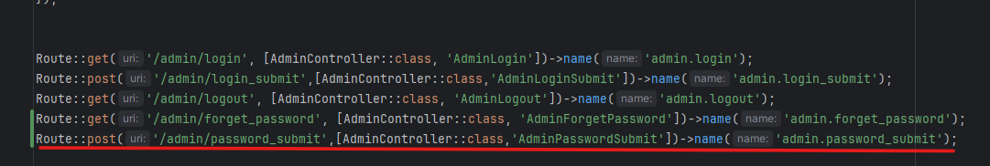

- Multi Auth Forget Password for Admin Part 2

Now we need to create email functionality so that when the user enters the email that they want to reset the password for they will get an email. To do that we need to first run the following command to setup

php artisan make:mail Websitemail

This will create a mailable class named Websitemail, which we can use to prepare and send emails from our laravel applicarion. It is located inside app->Mail->Websitemail.php.

Now we need to create two public variables inside class Websitemail as shown below:

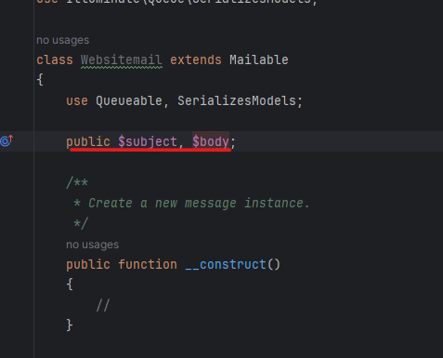

Now we will pass these two variables in our function_construct.
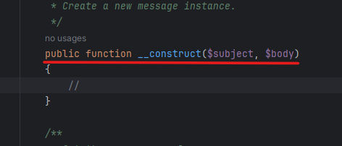

Now we need to access it, to do that we need to do as follow:
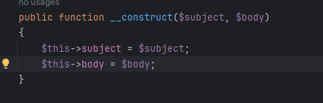

Now inside function envelope we need to pass the subject as shown below:

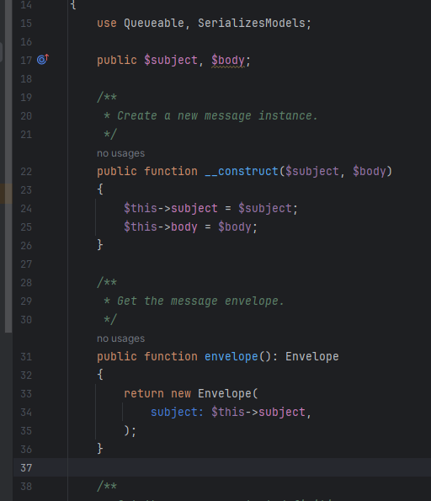

Now inside function content change the view ‘view.name’ to ‘email’.
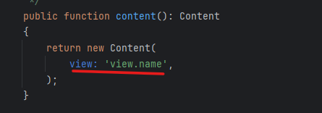

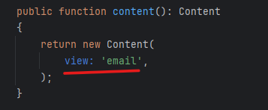

Then create a file ‘email’ inside views. Here we will pass the body from websiteemail file as shown below:

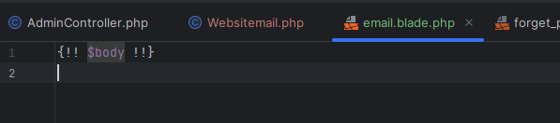

Now go to the ‘AdminController’. Here we should load the ‘email’ file as shown below:
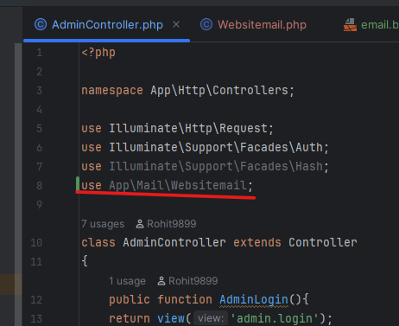

Now go to the function AdminPasswordSubmit of AdminController and type the following:

public function AdminPasswordSubmit(Request $request){
$request->validate([
'email'=>'required|email',
]);
}
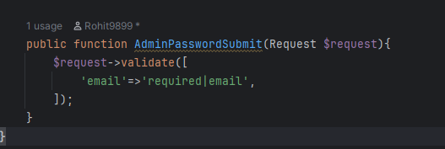

Now we need to access the admin table from the database. To do that we need to add the following line as shown below in AdminController.

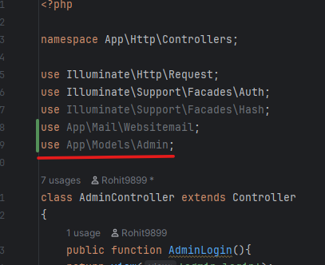

Now we need to create a variable in which it will check if the email entered is valid or not inside the function AdminPasswordSubmit as shown below:

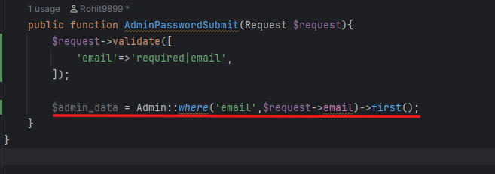

Note: first() retrieves the first matched data from the database.

Now we need to create the if function so that it will tell we what to do if the email is not found.
if(!$admin_data){
return redirect()->back()->with('error','Invalid Email');
}
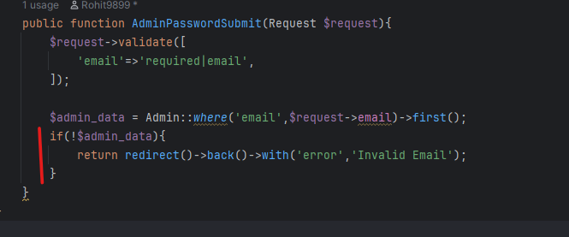

Now we need to generate a hashed value to use as a reset token. To do that we need to type the following code:

$token = hash('sha256',time());

After that we need to assign the above generated token to the token property of the Admin model. To do that we need to enter as shown below:

$admin_data->token = $token;

Then we need to update the token to do that we need to use the following code:

$admin_data-> update;

Now we need to create a complete URL that admin can click to reset their password. To do that we need to enter the following code:

$reset_link = url('admin/reset-password/'.$token.'/'.$request->email);

Now we need to create a subject containing the subject for the email that the admin will receive. We need to enter the code shown below:

$subject = “Reset Password”

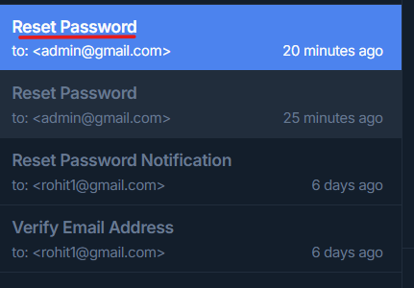

We can see the admin will receive the mail with the subject as we mentioned. In above scenario we have used “Reset Password” in the $subject variable. So, we receive Reset Password.

After this we need to create a body with message and link so that when we open the email it will tell us what to display. To do that we need to enter the following code:

$message = "Please Click on below link to reset wer password<br>";
$message .= "<a href='".$reset_link." '> <button>Reset Password</button></a>";

The above code will give we the following output as shown in the following picture.
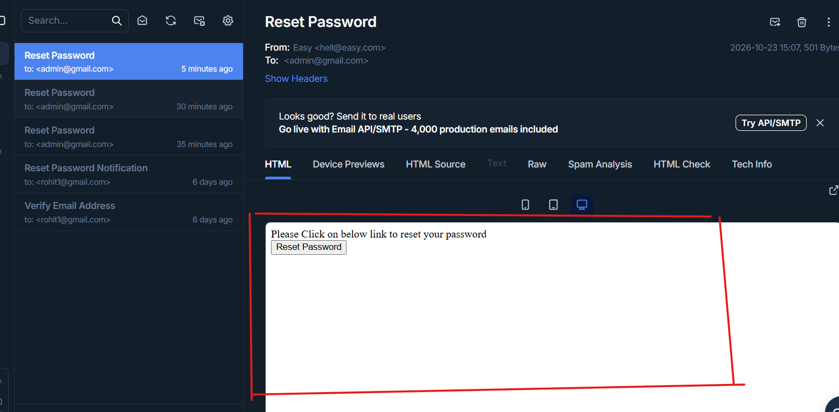

Then we need to enter the code which will send the email to the email address entered by the user. To do that we need to enter the following code:

Mail::to($request->email)->send(new Websitemail($subject,$message))

The above code will send an email to the requested email with subject and message.

Then we need to redirect to the forget_password page after the email is send to the email with success message. To to that we need to add the following code:

Mail::to($request->email)->send(new Websitemail($subject,$message))

After this steps are done we will receive the mail to wer email. And when we click on the reset password button or link we will be redirected to the reset-password page with the token and requested email as shown below:

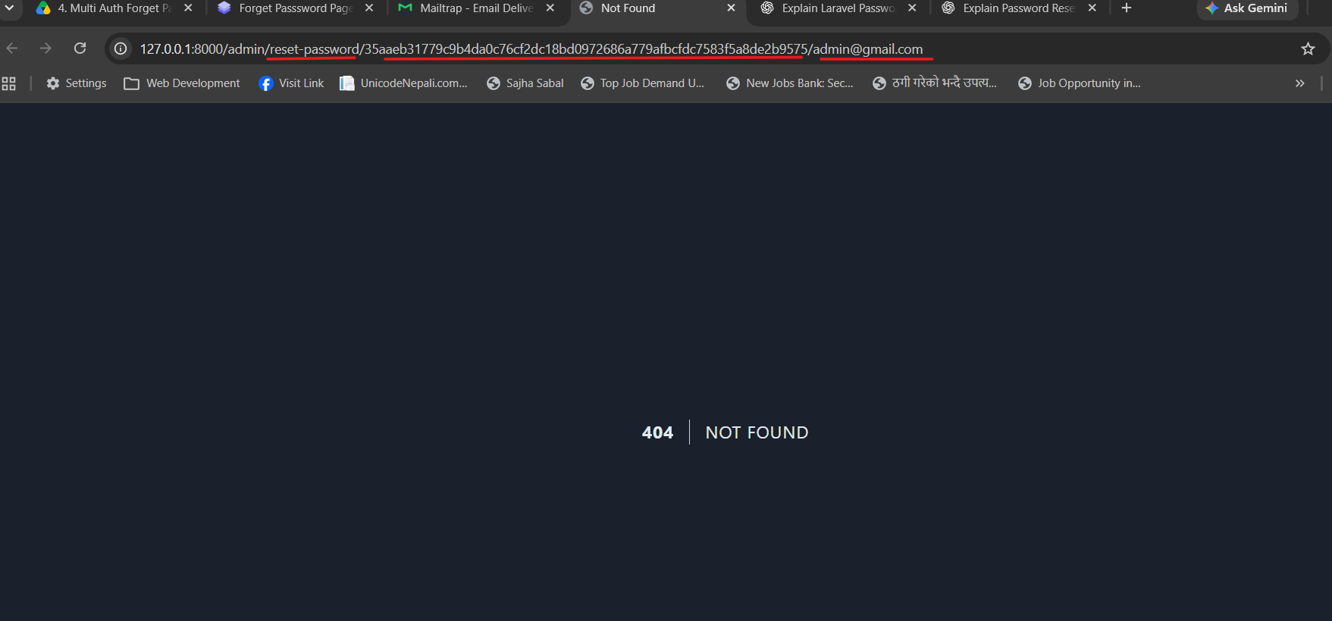

- Multi Auth Forget Password for Admin Part 3

Now we need to create a route for the admin/reset-password page. To do that go to the web.php and create a route as shown below:

Route::get('/admin/reset-password/{token}/{email}', [AdminController::class, 'AdminResetPassword']);

Note: Here we have not specified name and have passed parameters ‘token’ and ‘email’ as we have defined it as URL.

Now we need to create a function for the AdminResetPassword in the Admin Controller. We should also pass the parameter in the function as shown below as it is through URL and and we need to have email and token.
public function AdminResetPassword($token,$email){

}

Now inside the function we need to create a variable named $admin_data in which we need to store the data that user has entered is matched with the data in database. In this case we check if the token and email that is trying to reset password matches the data in database. To do that we need to enter the following code:

$admin_data= Admin::where('token',$token)->where('email',$email)->first();

Now we need to create a if function which will tell what to do if $admin_data is matched and what not to do if not.

if(!$admin_data){
return redirect()->route('admin.login')->with('error','Invalid Email or Token');
}
return view('admin.reset_password',compact('token','email'));
}

The above code will redirect we to the Admin Login Page with error message if email or token is not matched with the database else it will redirect we to the reset_password page.

Now we need to create a new file reset_password inside resources->views->admin. Here we need to enter the following in the file.

<html>
<title>Reset Password Page</title>
<link href="https://cdn.jsdelivr.net/npm/bootstrap@6.0.0-alpha.1/dist/css/bootstrap.min.css" rel="stylesheet" integrity="sha384-B/GM4XqrwHnWXNOWMbloTmrYXZg10cakYGmpfsR/bbzQ6JAJI4ihuyADKLnBgrCe" crossorigin="anonymous">
<body class="container">
<h1>Reset Password</h1>

@if($errors->any())
@foreach($errors->all() as $error)
<li>{{$error}}</li>
@endforeach
@endif

@if(Session::has('error'))
<li>{{Session::get('error')}}</li>
@endif
@if(Session::has('success'))
<li>{{Session::get('success')}}</li>
@endif

<form action="{{route('admin.login_submit')}}" method="post">
@csrf
<input type="hidden" name="token" value="{{$token}}">
<input type="hidden" name="email" value="{{$email}}">
<div class="mb-3">
<label for="exampleInputEmail1" class="form-label">New Password</label>
<input type="password" name="password" class="form-control" id="exampleInputEmail1" aria-describedby="emailHelp">
</div>
<div class="mb-3">
<label for="exampleInputPassword1" class="form-label">Confirm New Password</label>
<input type="password" name="password_confirmation" class="form-control" id="exampleInputPassword1">
</div>
<div class="mb-3 form-field">

</div>
<button type="submit" class="btn-solid theme-primary">Submit</button>
</form>
</body>
</html>

Now when we click on the reset password link or button in the emal we will be redirected to the following reset_password page.
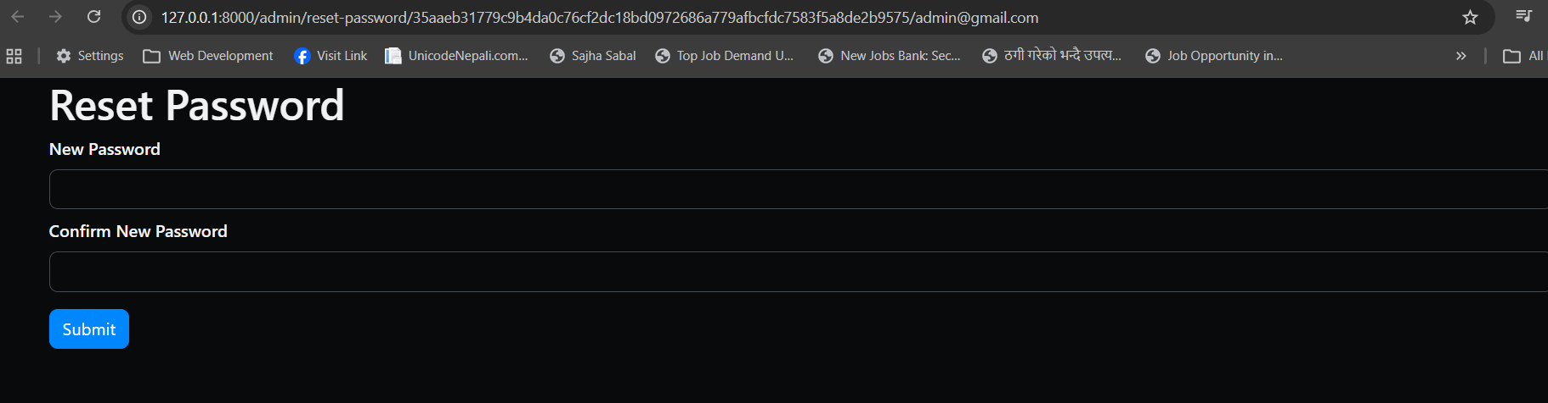

- Multi Auth Forget Password for Admin Part 4

Now we need to go to the reset_password page. Inside the form action enter the route ‘admin.reset_password_submit’ and also enter the route inside web.php.

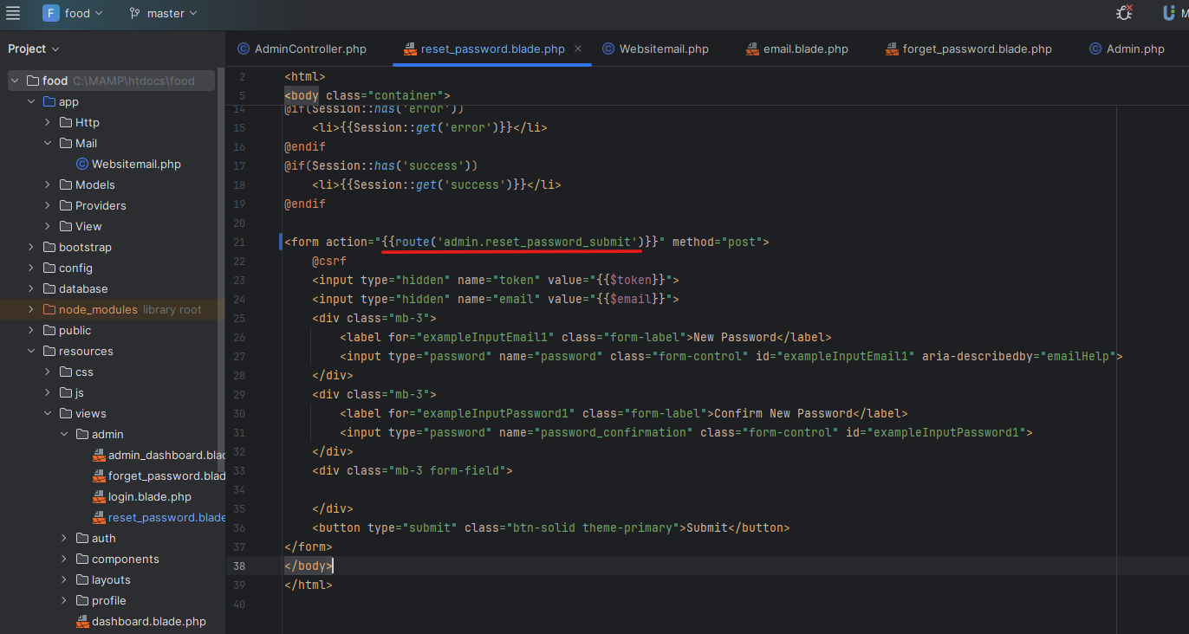

Enter the route in web.php as shown below:
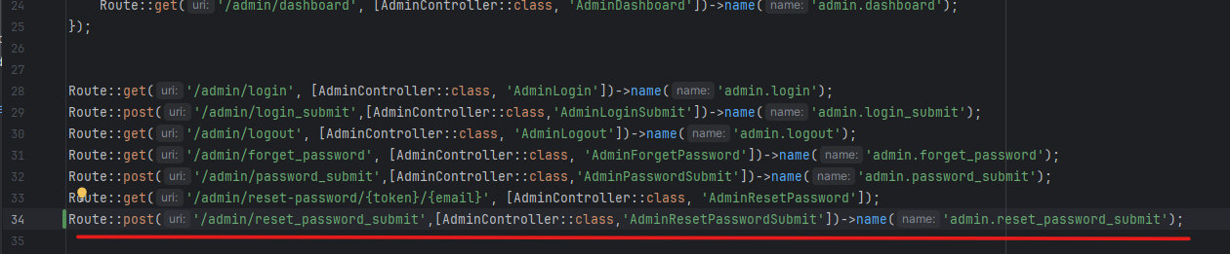

Now we need to create AdminResetPasswordSubmit method inside AdminController.
public function AdminResetPasswordSubmit(Request $request){

}
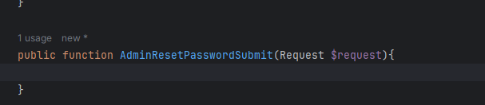

Now we need to validate data and to do that enter the following code:
$request->validate([
'password'=>'required',
'password_confirmation'=>'required|same:password',
]);
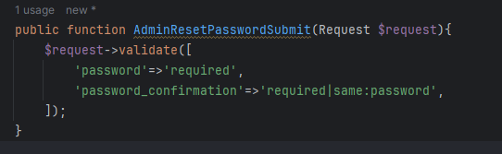

After this we need to match the email and token field from the database to the requested email and token. To do that we need to enter the following code in wer function.
$admin_data= Admin::where('token',$request->token)->where('email',$request->email)->first();

Now we need to update the data and show the password reset successful message while redirecting to the login page, to do that we need to enter the following code:
$admin_data->password = Hash::make($request->password);
$admin_data->token = "";
$admin_data->update();
return redirect()->route('admin.login')->with('success','Password reset successfully');

After this go to the reset_password page by clicking on the reset password link or button from the mail. There we need to enter the password and confirm password. If not matched it will throw error else it will change the password as shown below:

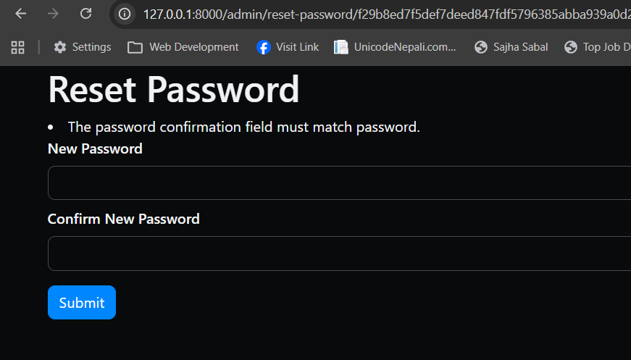

When password is not matched above picture shows what happens.

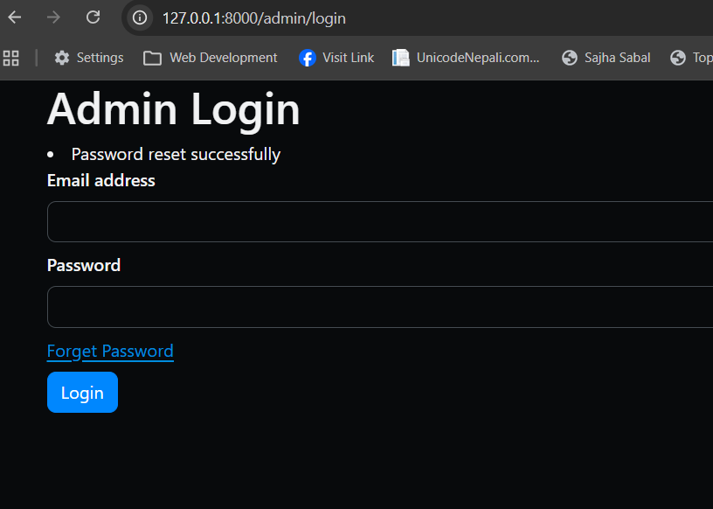

The above message is displayed when the password is matched.

¥¥¥¥¥¥¥¥¥¥¥¥¥¥¥¥¥¥¥¥¥¥¥¥¥¥¥¥¥¥¥¥¥¥¥¥¥¥¥¥¥¥¥¥¥¥¥¥¥¥¥¥¥¥¥¥¥¥¥¥¥¥¥¥¥¥¥¥¥¥¥¥¥¥

- Admin Template Setup

First we need to download the template. Here, we have a template downloaded. Then we need to copy the asset folder from the downloaded file and create a folder named ‘backend’ inside htocs->food->public. Inside the ‘backend’ folder we need to paste the asset folder.

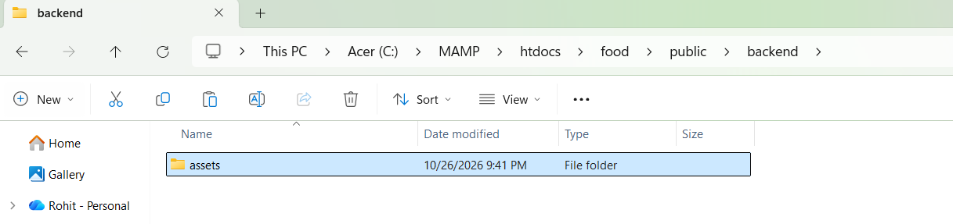

Now from the downloaded file find index.html and copy the overall code and go to the ‘admin_dashboard’ file and paste the following code.

Note: Before removing overall code copy the code of session and logout and save it somewhere temporarily.

<!doctype html>
<html lang="en" >

<head>

<meta charset="utf-8" />
<title>Admin Dashboard</title>
<meta name="viewport" content="width=device-width, initial-scale=1.0">
<meta content="Premium Multipurpose Admin & Dashboard Template" name="description" />
<meta content="Themesbrand" name="author" />
<!-- App favicon -->
<link rel="shortcut icon" href="assets/images/favicon.ico">

<!-- plugin css -->
<link href="assets/libs/admin-resources/jquery.vectormap/jquery-jvectormap-1.2.2.css" rel="stylesheet" type="text/css" />

<!-- preloader css -->
<link rel="stylesheet" href="assets/css/preloader.min.css" type="text/css" />

<!-- Bootstrap Css -->
<link href="assets/css/bootstrap.min.css" id="bootstrap-style" rel="stylesheet" type="text/css" />
<!-- Icons Css -->
<link href="assets/css/icons.min.css" rel="stylesheet" type="text/css" />
<!-- App Css-->
<link href="assets/css/app.min.css" id="app-style" rel="stylesheet" type="text/css" />

</head>

<body>

<!-- <body data-lawet="horizontal"> -->

<!-- Begin page -->
<div id="lawet-wrapper">

<header id="page-topbar">
<div class="navbar-header">
<div class="d-flex">
<!-- LOGO -->
<div class="navbar-brand-box">
<a href="index.html" class="logo logo-dark">
<span class="logo-sm">
<img src="assets/images/logo-sm.svg" alt="" height="24">
</span>
<span class="logo-lg">
<img src="assets/images/logo-sm.svg" alt="" height="24"> <span class="logo-txt">Minia</span>
</span>
</a>

<a href="index.html" class="logo logo-light">
<span class="logo-sm">
<img src="assets/images/logo-sm.svg" alt="" height="24">
</span>
<span class="logo-lg">
<img src="assets/images/logo-sm.svg" alt="" height="24"> <span class="logo-txt">Minia</span>
</span>
</a>
</div>

<button type="button" class="btn btn-sm px-3 font-size-16 header-item" id="vertical-menu-btn">
<i class="fa fa-fw fa-bars"></i>
</button>

<!-- App Search-->
<form class="app-search d-none d-lg-block">
<div class="position-relative">
<input type="text" class="form-control" placeholder="Search...">
<button class="btn btn-primary" type="button"><i class="bx bx-search-alt align-middle"></i></button>
</div>
</form>
</div>

<div class="d-flex">

<div class="dropdown d-inline-block d-lg-none ms-2">
<button type="button" class="btn header-item" id="page-header-search-dropdown"
data-bs-toggle="dropdown" aria-haspopup="true" aria-expanded="false">
<i data-feather="search" class="icon-lg"></i>
</button>
<div class="dropdown-menu dropdown-menu-lg dropdown-menu-end p-0"
aria-labelledby="page-header-search-dropdown">

<form class="p-3">
<div class="form-group m-0">
<div class="input-group">
<input type="text" class="form-control" placeholder="Search ..." aria-label="Search Result">

<button class="btn btn-primary" type="submit"><i class="mdi mdi-magnify"></i></button>
</div>
</div>
</form>
</div>
</div>

<div class="dropdown d-none d-sm-inline-block">
<button type="button" class="btn header-item"
data-bs-toggle="dropdown" aria-haspopup="true" aria-expanded="false">
<img id="header-lang-img" src="assets/images/flags/us.jpg" alt="Header Language" height="16">
</button>
<div class="dropdown-menu dropdown-menu-end">

<!-- item-->
<a href="javascript:void(0);" class="dropdown-item notify-item language" data-lang="en">
<img src="assets/images/flags/us.jpg" alt="user-image" class="me-1" height="12"> <span class="align-middle">English</span>
</a>
<!-- item-->
<a href="javascript:void(0);" class="dropdown-item notify-item language" data-lang="sp">
<img src="assets/images/flags/spain.jpg" alt="user-image" class="me-1" height="12"> <span class="align-middle">Spanish</span>
</a>

<!-- item-->
<a href="javascript:void(0);" class="dropdown-item notify-item language" data-lang="gr">
<img src="assets/images/flags/germany.jpg" alt="user-image" class="me-1" height="12"> <span class="align-middle">German</span>
</a>

<!-- item-->
<a href="javascript:void(0);" class="dropdown-item notify-item language" data-lang="it">
<img src="assets/images/flags/italy.jpg" alt="user-image" class="me-1" height="12"> <span class="align-middle">Italian</span>
</a>

<!-- item-->
<a href="javascript:void(0);" class="dropdown-item notify-item language" data-lang="ru">
<img src="assets/images/flags/russia.jpg" alt="user-image" class="me-1" height="12"> <span class="align-middle">Russian</span>
</a>
</div>
</div>

<div class="dropdown d-none d-sm-inline-block">
<button type="button" class="btn header-item" id="mode-setting-btn">
<i data-feather="moon" class="icon-lg lawet-mode-dark"></i>
<i data-feather="sun" class="icon-lg lawet-mode-light"></i>
</button>
</div>

<div class="dropdown d-none d-lg-inline-block ms-1">
<button type="button" class="btn header-item"
data-bs-toggle="dropdown" aria-haspopup="true" aria-expanded="false">
<i data-feather="grid" class="icon-lg"></i>
</button>
<div class="dropdown-menu dropdown-menu-lg dropdown-menu-end">
<div class="p-2">
<div class="row g-0">
<div class="col">
<a class="dropdown-icon-item" href="index.html#">
<img src="assets/images/brands/github.png" alt="Github">
<span>GitHub</span>
</a>
</div>
<div class="col">
<a class="dropdown-icon-item" href="index.html#">
<img src="assets/images/brands/bitbucket.png" alt="bitbucket">
<span>Bitbucket</span>
</a>
</div>
<div class="col">
<a class="dropdown-icon-item" href="index.html#">
<img src="assets/images/brands/dribbble.png" alt="dribbble">
<span>Dribbble</span>
</a>
</div>
</div>

<div class="row g-0">
<div class="col">
<a class="dropdown-icon-item" href="index.html#">
<img src="assets/images/brands/dropbox.png" alt="dropbox">
<span>Dropbox</span>
</a>
</div>
<div class="col">
<a class="dropdown-icon-item" href="index.html#">
<img src="assets/images/brands/mail_chimp.png" alt="mail_chimp">
<span>Mail Chimp</span>
</a>
</div>
<div class="col">
<a class="dropdown-icon-item" href="index.html#">
<img src="assets/images/brands/slack.png" alt="slack">
<span>Slack</span>
</a>
</div>
</div>
</div>
</div>
</div>

<div class="dropdown d-inline-block">
<button type="button" class="btn header-item noti-icon position-relative" id="page-header-notifications-dropdown"
data-bs-toggle="dropdown" aria-haspopup="true" aria-expanded="false">
<i data-feather="bell" class="icon-lg"></i>
<span class="badge bg-danger rounded-pill">5</span>
</button>
<div class="dropdown-menu dropdown-menu-lg dropdown-menu-end p-0"
aria-labelledby="page-header-notifications-dropdown">
<div class="p-3">
<div class="row align-items-center">
<div class="col">
<h6 class="m-0"> Notifications </h6>
</div>
<div class="col-auto">
<a href="index.html#!" class="small text-reset text-decoration-underline"> Unread (3)</a>
</div>
</div>
</div>
<div data-simplebar style="max-height: 230px;">
<a href="index.html#!" class="text-reset notification-item">
<div class="d-flex">
<div class="flex-shrink-0 me-3">
<img src="assets/images/users/avatar-3.jpg" class="rounded-circle avatar-sm" alt="user-pic">
</div>
<div class="flex-grow-1">
<h6 class="mb-1">James Lemire</h6>
<div class="font-size-13 text-muted">
<p class="mb-1">It will seem like simplified English.</p>
<p class="mb-0"><i class="mdi mdi-clock-outline"></i> <span>1 hour ago</span></p>
</div>
</div>
</div>
</a>
<a href="index.html#!" class="text-reset notification-item">
<div class="d-flex">
<div class="flex-shrink-0 avatar-sm me-3">
<span class="avatar-title bg-primary rounded-circle font-size-16">
<i class="bx bx-cart"></i>
</span>
</div>
<div class="flex-grow-1">
<h6 class="mb-1">wer order is placed</h6>
<div class="font-size-13 text-muted">
<p class="mb-1">If several languages coalesce the grammar</p>
<p class="mb-0"><i class="mdi mdi-clock-outline"></i> <span>3 min ago</span></p>
</div>
</div>
</div>
</a>
<a href="index.html#!" class="text-reset notification-item">
<div class="d-flex">
<div class="flex-shrink-0 avatar-sm me-3">
<span class="avatar-title bg-success rounded-circle font-size-16">
<i class="bx bx-badge-check"></i>
</span>
</div>
<div class="flex-grow-1">
<h6 class="mb-1">wer item is shipped</h6>
<div class="font-size-13 text-muted">
<p class="mb-1">If several languages coalesce the grammar</p>
<p class="mb-0"><i class="mdi mdi-clock-outline"></i> <span>3 min ago</span></p>
</div>
</div>
</div>
</a>

<a href="index.html#!" class="text-reset notification-item">
<div class="d-flex">
<div class="flex-shrink-0 me-3">
<img src="assets/images/users/avatar-6.jpg" class="rounded-circle avatar-sm" alt="user-pic">
</div>
<div class="flex-grow-1">
<h6 class="mb-1">Salena Layfield</h6>
<div class="font-size-13 text-muted">
<p class="mb-1">As a skeptical Cambridge friend of mine occidental.</p>
<p class="mb-0"><i class="mdi mdi-clock-outline"></i> <span>1 hour ago</span></p>
</div>
</div>
</div>
</a>
</div>
<div class="p-2 border-top d-grid">
<a class="btn btn-sm btn-link font-size-14 text-center" href="javascript:void(0)">
<i class="mdi mdi-arrow-right-circle me-1"></i> <span>View More..</span>
</a>
</div>
</div>
</div>

<div class="dropdown d-inline-block">
<button type="button" class="btn header-item right-bar-toggle me-2">
<i data-feather="settings" class="icon-lg"></i>
</button>
</div>

<div class="dropdown d-inline-block">
<button type="button" class="btn header-item bg-light-subtle border-start border-end" id="page-header-user-dropdown"
data-bs-toggle="dropdown" aria-haspopup="true" aria-expanded="false">
<img class="rounded-circle header-profile-user" src="assets/images/users/avatar-1.jpg"
alt="Header Avatar">
<span class="d-none d-xl-inline-block ms-1 fw-medium">Shawn L.</span>
<i class="mdi mdi-chevron-down d-none d-xl-inline-block"></i>
</button>
<div class="dropdown-menu dropdown-menu-end">
<!-- item-->
<a class="dropdown-item" href="apps-contacts-profile.html"><i class="mdi mdi mdi-face-man font-size-16 align-middle me-1"></i> Profile</a>
<a class="dropdown-item" href="auth-lock-screen.html"><i class="mdi mdi-lock font-size-16 align-middle me-1"></i> Lock Screen</a>
<div class="dropdown-divider"></div>
<a class="dropdown-item" href="auth-logout.html"><i class="mdi mdi-logout font-size-16 align-middle me-1"></i> Logout</a>
</div>
</div>

</div>
</div>
</header>

<!-- ========== Left Sidebar Start ========== -->
<div class="vertical-menu">

<div data-simplebar class="h-100">

<!--- Sidemenu -->
<div id="sidebar-menu">
<!-- Left Menu Start -->
<ul class="metismenu list-unstyled" id="side-menu">
<li class="menu-title" data-key="t-menu">Menu</li>

<li>
<a href="index.html">
<i data-feather="home"></i>
<span data-key="t-dashboard">Dashboard</span>
</a>
</li>

<li>
<a href="javascript: void(0);" class="has-arrow">
<i data-feather="grid"></i>
<span data-key="t-apps">Apps</span>
</a>
<ul class="sub-menu" aria-expanded="false">
<li>
<a href="apps-calendar.html">
<span data-key="t-calendar">Calendar</span>
</a>
</li>

<li>
<a href="apps-chat.html">
<span data-key="t-chat">Chat</span>
</a>
</li>

<li>
<a href="javascript: void(0);" class="has-arrow">
<span data-key="t-email">Email</span>
</a>
<ul class="sub-menu" aria-expanded="false">
<li><a href="apps-email-inbox.html" data-key="t-inbox">Inbox</a></li>
<li><a href="apps-email-read.html" data-key="t-read-email">Read Email</a></li>
</ul>
</li>
<li>
<a href="javascript: void(0);" class="has-arrow">
<span data-key="t-invoices">Invoices</span>
</a>
<ul class="sub-menu" aria-expanded="false">
<li><a href="apps-invoices-list.html" data-key="t-invoice-list">Invoice List</a></li>
<li><a href="apps-invoices-detail.html" data-key="t-invoice-detail">Invoice Detail</a></li>
</ul>
</li>
<li>
<a href="javascript: void(0);" class="has-arrow">
<span data-key="t-contacts">Contacts</span>
</a>
<ul class="sub-menu" aria-expanded="false">
<li><a href="apps-contacts-grid.html" data-key="t-user-grid">User Grid</a></li>
<li><a href="apps-contacts-list.html" data-key="t-user-list">User List</a></li>
<li><a href="apps-contacts-profile.html" data-key="t-profile">Profile</a></li>
</ul>
</li>
<li>
<a href="javascript: void(0);" class="">
<span data-key="t-blog">Blog</span>
<span class="badge rounded-pill badge-soft-danger float-end" key="t-new">New</span>
</a>
<ul class="sub-menu" aria-expanded="false">
<li><a href="apps-blog-grid.html" data-key="t-blog-grid">Blog Grid</a></li>
<li><a href="apps-blog-list.html" data-key="t-blog-list">Blog List</a></li>
<li><a href="apps-blog-detail.html" data-key="t-blog-details">Blog Details</a></li>
</ul>
</li>
</ul>
</li>

<li>
<a href="javascript: void(0);" class="has-arrow">
<i data-feather="users"></i>
<span data-key="t-authentication">Authentication</span>
</a>
<ul class="sub-menu" aria-expanded="false">
<li><a href="auth-login.html" data-key="t-login">Login</a></li>
<li><a href="auth-register.html" data-key="t-register">Register</a></li>
<li><a href="auth-recoverpw.html" data-key="t-recover-password">Recover Password</a></li>
<li><a href="auth-lock-screen.html" data-key="t-lock-screen">Lock Screen</a></li>
<li><a href="auth-logout.html" data-key="t-logout">Log Out</a></li>
<li><a href="auth-confirm-mail.html" data-key="t-confirm-mail">Confirm Mail</a></li>
<li><a href="auth-email-verification.html" data-key="t-email-verification">Email Verification</a></li>
<li><a href="auth-two-step-verification.html" data-key="t-two-step-verification">Two Step Verification</a></li>
</ul>
</li>

<li>
<a href="javascript: void(0);" class="has-arrow">
<i data-feather="file-text"></i>
<span data-key="t-pages">Pages</span>
</a>
<ul class="sub-menu" aria-expanded="false">
<li><a href="pages-starter.html" data-key="t-starter-page">Starter Page</a></li>
<li><a href="pages-maintenance.html" data-key="t-maintenance">Maintenance</a></li>
<li><a href="pages-comingsoon.html" data-key="t-coming-soon">Coming Soon</a></li>
<li><a href="pages-timeline.html" data-key="t-timeline">Timeline</a></li>
<li><a href="pages-faqs.html" data-key="t-faqs">FAQs</a></li>
<li><a href="pages-pricing.html" data-key="t-pricing">Pricing</a></li>
<li><a href="pages-404.html" data-key="t-error-404">Error 404</a></li>
<li><a href="pages-500.html" data-key="t-error-500">Error 500</a></li>
</ul>
</li>

<li>
<a href="lawets-horizontal.html">
<i data-feather="lawet"></i>
<span data-key="t-horizontal">Horizontal</span>
</a>
</li>

<li class="menu-title mt-2" data-key="t-components">Elements</li>

<li>
<a href="javascript: void(0);" class="has-arrow">
<i data-feather="briefcase"></i>
<span data-key="t-components">Components</span>
</a>
<ul class="sub-menu" aria-expanded="false">
<li><a href="ui-alerts.html" data-key="t-alerts">Alerts</a></li>
<li><a href="ui-buttons.html" data-key="t-buttons">Buttons</a></li>
<li><a href="ui-cards.html" data-key="t-cards">Cards</a></li>
<li><a href="ui-carousel.html" data-key="t-carousel">Carousel</a></li>
<li><a href="ui-dropdowns.html" data-key="t-dropdowns">Dropdowns</a></li>
<li><a href="ui-grid.html" data-key="t-grid">Grid</a></li>
<li><a href="ui-images.html" data-key="t-images">Images</a></li>
<li><a href="ui-modals.html" data-key="t-modals">Modals</a></li>
<li><a href="ui-offcanvas.html" data-key="t-offcanvas">Offcanvas</a></li>
<li><a href="ui-progressbars.html" data-key="t-progress-bars">Progress Bars</a></li>
<li><a href="ui-placeholders.html" data-key="t-progress-bars">Placeholders</a></li>
<li><a href="ui-tabs-accordions.html" data-key="t-tabs-accordions">Tabs & Accordions</a></li>
<li><a href="ui-typography.html" data-key="t-typography">Typography</a></li>
<li><a href="ui-toasts.html" data-key="t-typography">Toasts</a></li>
<li><a href="ui-video.html" data-key="t-video">Video</a></li>
<li><a href="ui-general.html" data-key="t-general">General</a></li>
<li><a href="ui-colors.html" data-key="t-colors">Colors</a></li>
<li><a href="ui-utilities.html" data-key="t-colors">Utilities</a></li>
</ul>
</li>

<li>
<a href="javascript: void(0);" class="has-arrow">
<i data-feather="gift"></i>
<span data-key="t-ui-elements">Extended</span>
</a>
<ul class="sub-menu" aria-expanded="false">
<li><a href="extended-lightbox.html" data-key="t-lightbox">Lightbox</a></li>
<li><a href="extended-rangeslider.html" data-key="t-range-slider">Range Slider</a></li>
<li><a href="extended-sweet-alert.html" data-key="t-sweet-alert">SweetAlert 2</a></li>
<li><a href="extended-session-timeout.html" data-key="t-session-timeout">Session Timeout</a></li>
<li><a href="extended-rating.html" data-key="t-rating">Rating</a></li>
<li><a href="extended-notifications.html" data-key="t-notifications">Notifications</a></li>
</ul>
</li>

<li>
<a href="javascript: void(0);">
<i data-feather="box"></i>
<span class="badge rounded-pill badge-soft-danger text-danger float-end">7</span>
<span data-key="t-forms">Forms</span>
</a>
<ul class="sub-menu" aria-expanded="false">
<li><a href="form-elements.html" data-key="t-form-elements">Basic Elements</a></li>
<li><a href="form-validation.html" data-key="t-form-validation">Validation</a></li>
<li><a href="form-advanced.html" data-key="t-form-advanced">Advanced Plugins</a></li>
<li><a href="form-editors.html" data-key="t-form-editors">Editors</a></li>
<li><a href="form-uploads.html" data-key="t-form-upload">File Upload</a></li>
<li><a href="form-wizard.html" data-key="t-form-wizard">Wizard</a></li>
<li><a href="form-mask.html" data-key="t-form-mask">Mask</a></li>
</ul>
</li>

<li>
<a href="javascript: void(0);" class="has-arrow">
<i data-feather="sliders"></i>
<span data-key="t-tables">Tables</span>
</a>
<ul class="sub-menu" aria-expanded="false">
<li><a href="tables-basic.html" data-key="t-basic-tables">Bootstrap Basic</a></li>
<li><a href="tables-datatable.html" data-key="t-data-tables">DataTables</a></li>
<li><a href="tables-responsive.html" data-key="t-responsive-table">Responsive</a></li>
<li><a href="tables-editable.html" data-key="t-editable-table">Editable</a></li>
</ul>
</li>

<li>
<a href="javascript: void(0);" class="has-arrow">
<i data-feather="pie-chart"></i>
<span data-key="t-charts">Charts</span>
</a>
<ul class="sub-menu" aria-expanded="false">
<li><a href="charts-apex.html" data-key="t-apex-charts">Apexcharts</a></li>
<li><a href="charts-echart.html" data-key="t-e-charts">Echarts</a></li>
<li><a href="charts-chartjs.html" data-key="t-chartjs-charts">Chartjs</a></li>
<li><a href="charts-knob.html" data-key="t-knob-charts">Jquery Knob</a></li>
<li><a href="charts-sparkline.html" data-key="t-sparkline-charts">Sparkline</a></li>
</ul>
</li>

<li>
<a href="javascript: void(0);" class="has-arrow">
<i data-feather="cpu"></i>
<span data-key="t-icons">Icons</span>
</a>
<ul class="sub-menu" aria-expanded="false">
<li><a href="icons-boxicons.html" data-key="t-boxicons">Boxicons</a></li>
<li><a href="icons-materialdesign.html" data-key="t-material-design">Material Design</a></li>
<li><a href="icons-dripicons.html" data-key="t-dripicons">Dripicons</a></li>
<li><a href="icons-fontawesome.html" data-key="t-font-awesome">Font Awesome 5</a></li>
</ul>
</li>

<li>
<a href="javascript: void(0);" class="has-arrow">
<i data-feather="map"></i>
<span data-key="t-maps">Maps</span>
</a>
<ul class="sub-menu" aria-expanded="false">
<li><a href="maps-google.html" data-key="t-g-maps">Google</a></li>
<li><a href="maps-vector.html" data-key="t-v-maps">Vector</a></li>
<li><a href="maps-leaflet.html" data-key="t-l-maps">Leaflet</a></li>
</ul>
</li>

<li>
<a href="javascript: void(0);" class="has-arrow">
<i data-feather="share-2"></i>
<span data-key="t-multi-level">Multi Level</span>
</a>
<ul class="sub-menu" aria-expanded="true">
<li><a href="javascript: void(0);" data-key="t-level-1-1">Level 1.1</a></li>
<li>
<a href="javascript: void(0);" class="has-arrow" data-key="t-level-1-2">Level 1.2</a>
<ul class="sub-menu" aria-expanded="true">
<li><a href="javascript: void(0);" data-key="t-level-2-1">Level 2.1</a></li>
<li><a href="javascript: void(0);" data-key="t-level-2-2">Level 2.2</a></li>
</ul>
</li>
</ul>
</li>

</ul>

<div class="card sidebar-alert border-0 text-center mx-4 mb-0 mt-5">
<div class="card-body">
<img src="assets/images/giftbox.png" alt="">
<div class="mt-4">
<h5 class="alertcard-title font-size-16">Unlimited Access</h5>
<p class="font-size-13">Upgrade wer plan from a Free trial, to select ‘Business Plan’.</p>
<a href="index.html#!" class="btn btn-primary mt-2">Upgrade Now</a>
</div>
</div>
</div>
</div>
<!-- Sidebar -->
</div>
</div>
<!-- Left Sidebar End -->

<!-- ============================================================== -->
<!-- Start right Content here -->
<!-- ============================================================== -->
<div class="main-content">

<div class="page-content">
<div class="container-fluid">

<!-- start page title -->
<div class="row">
<div class="col-12">
<div class="page-title-box d-sm-flex align-items-center justify-content-between">
<h4 class="mb-sm-0 font-size-18">Dashboard</h4>

<div class="page-title-right">
<ol class="breadcrumb m-0">
<li class="breadcrumb-item"><a href="javascript: void(0);">Dashboard</a></li>
<li class="breadcrumb-item active">Dashboard</li>
</ol>
</div>

</div>
</div>
</div>
<!-- end page title -->

<div class="row">
<div class="col-xl-3 col-md-6">
<!-- card -->
<div class="card card-h-100">
<!-- card body -->
<div class="card-body">
<div class="row align-items-center">
<div class="col-6">
<span class="text-muted mb-3 lh-1 d-block text-truncate">My Wallet</span>
<h4 class="mb-3">
$<span class="counter-value" data-target="865.2">0</span>k
</h4>
</div>

<div class="col-6">
<div id="mini-chart1" data-colors='["#5156be"]' class="apex-charts mb-2"></div>
</div>
</div>
<div class="text-nowrap">
<span class="badge bg-success-subtle text-success">+$20.9k</span>
<span class="ms-1 text-muted font-size-13">Since last week</span>
</div>
</div><!-- end card body -->
</div><!-- end card -->
</div><!-- end col -->

<div class="col-xl-3 col-md-6">
<!-- card -->
<div class="card card-h-100">
<!-- card body -->
<div class="card-body">
<div class="row align-items-center">
<div class="col-6">
<span class="text-muted mb-3 lh-1 d-block text-truncate">Number of Trades</span>
<h4 class="mb-3">
<span class="counter-value" data-target="6258">0</span>
</h4>
</div>
<div class="col-6">
<div id="mini-chart2" data-colors='["#5156be"]' class="apex-charts mb-2"></div>
</div>
</div>
<div class="text-nowrap">
<span class="badge bg-danger-subtle text-danger">-29 Trades</span>
<span class="ms-1 text-muted font-size-13">Since last week</span>
</div>
</div><!-- end card body -->
</div><!-- end card -->
</div><!-- end col-->

<div class="col-xl-3 col-md-6">
<!-- card -->
<div class="card card-h-100">
<!-- card body -->
<div class="card-body">
<div class="row align-items-center">
<div class="col-6">
<span class="text-muted mb-3 lh-1 d-block text-truncate">Invested Amount</span>
<h4 class="mb-3">
$<span class="counter-value" data-target="4.32">0</span>M
</h4>
</div>
<div class="col-6">
<div id="mini-chart3" data-colors='["#5156be"]' class="apex-charts mb-2"></div>
</div>
</div>
<div class="text-nowrap">
<span class="badge bg-success-subtle text-success">+ $2.8k</span>
<span class="ms-1 text-muted font-size-13">Since last week</span>
</div>
</div><!-- end card body -->
</div><!-- end card -->
</div><!-- end col -->

<div class="col-xl-3 col-md-6">
<!-- card -->
<div class="card card-h-100">
<!-- card body -->
<div class="card-body">
<div class="row align-items-center">
<div class="col-6">
<span class="text-muted mb-3 lh-1 d-block text-truncate">Profit Ration</span>
<h4 class="mb-3">
<span class="counter-value" data-target="12.57">0</span>%
</h4>
</div>
<div class="col-6">
<div id="mini-chart4" data-colors='["#5156be"]' class="apex-charts mb-2"></div>
</div>
</div>
<div class="text-nowrap">
<span class="badge bg-success-subtle text-success">+2.95%</span>
<span class="ms-1 text-muted font-size-13">Since last week</span>
</div>
</div><!-- end card body -->
</div><!-- end card -->
</div><!-- end col -->
</div><!-- end row-->

<div class="row">
<div class="col-xl-5">
<!-- card -->
<div class="card card-h-100">
<!-- card body -->
<div class="card-body">
<div class="d-flex flex-wrap align-items-center mb-4">
<h5 class="card-title me-2">Wallet Balance</h5>
<div class="ms-auto">
<div>
<button type="button" class="btn btn-soft-secondary btn-sm">
ALL
</button>
<button type="button" class="btn btn-soft-primary btn-sm">
1M
</button>
<button type="button" class="btn btn-soft-secondary btn-sm">
6M
</button>
<button type="button" class="btn btn-soft-secondary btn-sm">
1Y
</button>
</div>
</div>
</div>

<div class="row align-items-center">
<div class="col-sm">
<div id="wallet-balance" data-colors='["#777aca", "#5156be", "#a8aada"]' class="apex-charts"></div>
</div>
<div class="col-sm align-self-center">
<div class="mt-4 mt-sm-0">
<div>
<p class="mb-2"><i class="mdi mdi-circle align-middle font-size-10 me-2 text-success"></i> Bitcoin</p>
<h6>0.4412 BTC = <span class="text-muted font-size-14 fw-normal">$ 4025.32</span></h6>
</div>

<div class="mt-4 pt-2">
<p class="mb-2"><i class="mdi mdi-circle align-middle font-size-10 me-2 text-primary"></i> Ethereum</p>
<h6>4.5701 ETH = <span class="text-muted font-size-14 fw-normal">$ 1123.64</span></h6>
</div>

<div class="mt-4 pt-2">
<p class="mb-2"><i class="mdi mdi-circle align-middle font-size-10 me-2 text-info"></i> Litecoin</p>
<h6>35.3811 LTC = <span class="text-muted font-size-14 fw-normal">$ 2263.09</span></h6>
</div>
</div>
</div>
</div>
</div>
</div>
<!-- end card -->
</div>
<!-- end col -->
<div class="col-xl-7">
<div class="row">
<div class="col-xl-8">
<!-- card -->
<div class="card card-h-100">
<!-- card body -->
<div class="card-body">
<div class="d-flex flex-wrap align-items-center mb-4">
<h5 class="card-title me-2">Invested Overview</h5>
<div class="ms-auto">
<select class="form-select form-select-sm">
<option value="MAY" selected="">May</option>
<option value="AP">April</option>
<option value="MA">March</option>
<option value="FE">February</option>
<option value="JA">January</option>
<option value="DE">December</option>
</select>
</div>
</div>

<div class="row align-items-center">
<div class="col-sm">
<div id="invested-overview" data-colors='["#5156be", "#34c38f"]' class="apex-charts"></div>
</div>
<div class="col-sm align-self-center">
<div class="mt-4 mt-sm-0">
<p class="mb-1">Invested Amount</p>
<h4>$ 6134.39</h4>

<p class="text-muted mb-4"> + 0.0012.23 ( 0.2 % ) <i class="mdi mdi-arrow-up ms-1 text-success"></i></p>

<div class="row g-0">
<div class="col-6">
<div>
<p class="mb-2 text-muted text-uppercase font-size-11">Income</p>
<h5 class="fw-medium">$ 2632.46</h5>
</div>
</div>
<div class="col-6">
<div>
<p class="mb-2 text-muted text-uppercase font-size-11">Expenses</p>
<h5 class="fw-medium">-$ 924.38</h5>
</div>
</div>
</div>

<div class="mt-2">
<a href="index.html#" class="btn btn-primary btn-sm">View more <i class="mdi mdi-arrow-right ms-1"></i></a>
</div>
</div>
</div>
</div>
</div>
</div>
</div>
<!-- end col -->

<div class="col-xl-4">
<!-- card -->
<div class="card bg-primary text-white shadow-primary card-h-100">
<!-- card body -->
<div class="card-body p-0">
<div id="carouselExampleCaptions" class="carousel slide text-center widget-carousel" data-bs-ride="carousel">
<div class="carousel-inner">
<div class="carousel-item active">
<div class="text-center p-4">
<i class="mdi mdi-bitcoin widget-box-1-icon"></i>
<div class="avatar-md m-auto">
<span class="avatar-title rounded-circle bg-light-subtle text-white font-size-24">
<i class="mdi mdi-currency-btc"></i>
</span>
</div>
<h4 class="mt-3 lh-base fw-normal text-white"><b>Bitcoin</b> News</h4>
<p class="text-white-50 font-size-13">Bitcoin prices fell sharply amid the global sell-off in equities. Negative news
over the Bitcoin past week has dampened Bitcoin basics
sentiment for bitcoin. </p>
<button type="button" class="btn btn-light btn-sm">View details <i class="mdi mdi-arrow-right ms-1"></i></button>
</div>
</div>
<!-- end carousel-item -->
<div class="carousel-item">
<div class="text-center p-4">
<i class="mdi mdi-ethereum widget-box-1-icon"></i>
<div class="avatar-md m-auto">
<span class="avatar-title rounded-circle bg-light-subtle text-white font-size-24">
<i class="mdi mdi-ethereum"></i>
</span>
</div>
<h4 class="mt-3 lh-base fw-normal text-white"><b>ETH</b> News</h4>
<p class="text-white-50 font-size-13">Bitcoin prices fell sharply amid the global sell-off in equities. Negative news
over the Bitcoin past week has dampened Bitcoin basics
sentiment for bitcoin. </p>
<button type="button" class="btn btn-light btn-sm">View details <i class="mdi mdi-arrow-right ms-1"></i></button>
</div>
</div>
<!-- end carousel-item -->
<div class="carousel-item">
<div class="text-center p-4">
<i class="mdi mdi-litecoin widget-box-1-icon"></i>
<div class="avatar-md m-auto">
<span class="avatar-title rounded-circle bg-light-subtle text-white font-size-24">
<i class="mdi mdi-litecoin"></i>
</span>
</div>
<h4 class="mt-3 lh-base fw-normal text-white"><b>Litecoin</b> News</h4>
<p class="text-white-50 font-size-13">Bitcoin prices fell sharply amid the global sell-off in equities. Negative news
over the Bitcoin past week has dampened Bitcoin basics
sentiment for bitcoin. </p>
<button type="button" class="btn btn-light btn-sm">View details <i class="mdi mdi-arrow-right ms-1"></i></button>
</div>
</div>
<!-- end carousel-item -->
</div>
<!-- end carousel-inner -->

<div class="carousel-indicators carousel-indicators-rounded">
<button type="button" data-bs-target="#carouselExampleCaptions" data-bs-slide-to="0" class="active"
aria-current="true" aria-label="Slide 1"></button>
<button type="button" data-bs-target="#carouselExampleCaptions" data-bs-slide-to="1" aria-label="Slide 2"></button>
<button type="button" data-bs-target="#carouselExampleCaptions" data-bs-slide-to="2" aria-label="Slide 3"></button>
</div>
<!-- end carousel-indicators -->
</div>
<!-- end carousel -->
</div>
<!-- end card body -->
</div>
<!-- end card -->
</div>
<!-- end col -->
</div>
<!-- end row -->
</div>
<!-- end col -->
</div> <!-- end row-->

<div class="row">
<div class="col-xl-8">
<!-- card -->
<div class="card">
<!-- card body -->
<div class="card-body">
<div class="d-flex flex-wrap align-items-center mb-4">
<h5 class="card-title me-2">Market Overview</h5>
<div class="ms-auto">
<div>
<button type="button" class="btn btn-soft-primary btn-sm">
ALL
</button>
<button type="button" class="btn btn-soft-secondary btn-sm">
1M
</button>
<button type="button" class="btn btn-soft-secondary btn-sm">
6M
</button>
<button type="button" class="btn btn-soft-secondary btn-sm">
1Y
</button>
</div>
</div>
</div>

<div class="row align-items-center">
<div class="col-xl-8">
<div>
<div id="market-overview" data-colors='["#5156be", "#34c38f"]' class="apex-charts"></div>
</div>
</div>
<div class="col-xl-4">
<div class="p-4">
<div class="mt-0">
<div class="d-flex align-items-center">
<div class="avatar-sm m-auto">
<span class="avatar-title rounded-circle bg-light-subtle text-dark font-size-16">
1
</span>
</div>
<div class="flex-grow-1 ms-3">
<span class="font-size-16">Coinmarketcap</span>
</div>

<div class="flex-shrink-0">
<span class="badge rounded-pill bg-success-subtle text-success font-size-12 fw-medium">+2.5%</span>
</div>
</div>
</div>

<div class="mt-3">
<div class="d-flex align-items-center">
<div class="avatar-sm m-auto">
<span class="avatar-title rounded-circle bg-light-subtle text-dark font-size-16">
2
</span>
</div>
<div class="flex-grow-1 ms-3">
<span class="font-size-16">Binance</span>
</div>

<div class="flex-shrink-0">
<span class="badge rounded-pill bg-success-subtle text-success font-size-12 fw-medium">+8.3%</span>
</div>
</div>
</div>

<div class="mt-3">
<div class="d-flex align-items-center">
<div class="avatar-sm m-auto">
<span class="avatar-title rounded-circle bg-light-subtle text-dark font-size-16">
3
</span>
</div>
<div class="flex-grow-1 ms-3">
<span class="font-size-16">Coinbase</span>
</div>

<div class="flex-shrink-0">
<span class="badge rounded-pill bg-danger-subtle text-danger font-size-12 fw-medium">-3.6%</span>
</div>
</div>
</div>

<div class="mt-3">
<div class="d-flex align-items-center">
<div class="avatar-sm m-auto">
<span class="avatar-title rounded-circle bg-light-subtle text-dark font-size-16">
4
</span>
</div>
<div class="flex-grow-1 ms-3">
<span class="font-size-16">Yobit</span>
</div>

<div class="flex-shrink-0">
<span class="badge rounded-pill bg-success-subtle text-success font-size-12 fw-medium">+7.1%</span>
</div>
</div>
</div>

<div class="mt-3">
<div class="d-flex align-items-center">
<div class="avatar-sm m-auto">
<span class="avatar-title rounded-circle bg-light-subtle text-dark font-size-16">
5
</span>
</div>
<div class="flex-grow-1 ms-3">
<span class="font-size-16">Bitfinex</span>
</div>

<div class="flex-shrink-0">
<span class="badge rounded-pill bg-danger-subtle text-danger font-size-12 fw-medium">-0.9%</span>
</div>
</div>
</div>
<div class="mt-4 pt-2">
<a href="" class="btn btn-primary w-100">See All Balances <i
class="mdi mdi-arrow-right ms-1"></i></a>
</div>

</div>
</div>
</div>
</div>
<!-- end card -->
</div>
<!-- end col -->
</div>
<!-- end row-->

<div class="col-xl-4">
<!-- card -->
<div class="card">
<!-- card body -->
<div class="card-body">
<div class="d-flex flex-wrap align-items-center mb-4">
<h5 class="card-title me-2">Sales by Locations</h5>
<div class="ms-auto">
<div class="dropdown">
<a class="dropdown-toggle text-reset" href="index.html#" id="dropdownMenuButton1" data-bs-toggle="dropdown" aria-haspopup="true" aria-expanded="false">
<span class="text-muted font-size-12">Sort By:</span> <span class="fw-medium">World<i class="mdi mdi-chevron-down ms-1"></i></span>
</a>

<div class="dropdown-menu dropdown-menu-end" aria-labelledby="dropdownMenuButton1">
<a class="dropdown-item" href="index.html#">USA</a>
<a class="dropdown-item" href="index.html#">Russia</a>
<a class="dropdown-item" href="index.html#">Australia</a>
</div>
</div>
</div>
</div>

<div id="sales-by-locations" data-colors='["#5156be"]' style="height: 250px"></div>

<div class="px-2 py-2">
<p class="mb-1">USA <span class="float-end">75%</span></p>
<div class="progress mt-2" style="height: 6px;">
<div class="progress-bar progress-bar-striped bg-primary" role="progressbar"
style="width: 75%" aria-valuenow="75" aria-valuemin="0" aria-valuemax="75">
</div>
</div>

<p class="mt-3 mb-1">Russia <span class="float-end">55%</span></p>
<div class="progress mt-2" style="height: 6px;">
<div class="progress-bar progress-bar-striped bg-primary" role="progressbar"
style="width: 55%" aria-valuenow="55" aria-valuemin="0" aria-valuemax="55">
</div>
</div>

<p class="mt-3 mb-1">Australia <span class="float-end">85%</span></p>
<div class="progress mt-2" style="height: 6px;">
<div class="progress-bar progress-bar-striped bg-primary" role="progressbar"
style="width: 85%" aria-valuenow="85" aria-valuemin="0" aria-valuemax="85">
</div>
</div>
</div>
</div>
<!-- end card body -->
</div>
<!-- end card -->
</div>
<!-- end col -->
</div>
<!-- end row-->

<div class="row">
<div class="col-xl-4">
<div class="card">
<div class="card-header align-items-center d-flex">
<h4 class="card-title mb-0 flex-grow-1">Trading</h4>
<div class="flex-shrink-0">
<ul class="nav nav-tabs-custom card-header-tabs" role="tablist">
<li class="nav-item">
<a class="nav-link active" data-bs-toggle="tab" href="index.html#buy-tab" role="tab">Buy</a>
</li>
<li class="nav-item">
<a class="nav-link" data-bs-toggle="tab" href="index.html#sell-tab" role="tab">Sell</a>
</li>
</ul>
</div>
</div><!-- end card header -->

<div class="card-body">
<div class="tab-content">
<div class="tab-pane active" id="buy-tab" role="tabpanel">
<div class="float-end ms-2">
<h5 class="font-size-14"><i class="bx bx-wallet text-primary font-size-16 align-middle me-1"></i> <a href="index.html#!" class="text-reset text-decoration-underline">$4335.23</a></h5>
</div>
<h5 class="font-size-14 mb-4">Buy Coins</h5>
<div>
<div class="form-group mb-3">
<label>Payment method :</label>
<select class="form-select">
<option>Direct Bank Payment</option>
<option>Credit / Debit Card</option>
<option>Paypal</option>
<option>Payoneer</option>
<option>Stripe</option>
</select>
</div>

<div>
<label>Add Amount :</label>
<div class="input-group mb-3">
<label class="input-group-text">Amount</label>
<select class="form-select" style="max-width: 90px;">
<option value="BT" selected>BTC</option>
<option value="ET">ETH</option>
<option value="LT">LTC</option>
</select>
<input type="text" class="form-control" placeholder="0.00121255">
</div>

<div class="input-group mb-3">
<label class="input-group-text">Price</label>
<input type="text" class="form-control" placeholder="$58,245">
<label class="input-group-text">$</label>
</div>

<div class="input-group mb-3">
<label class="input-group-text">Total</label>
<input type="text" class="form-control" placeholder="$36,854.25">
</div>
</div>

<div class="text-center">
<button type="button" class="btn btn-success w-md">Buy Coin</button>
</div>
</div>
</div>
<!-- end tab pane -->
<div class="tab-pane" id="sell-tab" role="tabpanel">
<div class="float-end ms-2">
<h5 class="font-size-14"><i class="bx bx-wallet text-primary font-size-16 align-middle me-1"></i> <a href="index.html#!" class="text-reset text-decoration-underline">$4235.23</a></h5>
</div>
<h5 class="font-size-14 mb-4">Sell Coins</h5>

<div>

<div class="form-group mb-3">
<label>Wallet ID :</label>
<input type="email" class="form-control" placeholder="1cvb254ugxvfcd280ki">
</div>

<div>
<label>Add Amount :</label>
<div class="input-group mb-3">
<label class="input-group-text">Amount</label>

<select class="form-select" style="max-width: 90px;">
<option value="BT" selected>BTC</option>
<option value="ET">ETH</option>
<option value="LT">LTC</option>
</select>
<input type="text" class="form-control" placeholder="0.00121255">
</div>

<div class="input-group mb-3">

<label class="input-group-text">Price</label>

<input type="text" class="form-control" placeholder="$23,754.25">

<label class="input-group-text">$</label>
</div>

<div class="input-group mb-3">
<label class="input-group-text">Total</label>
<input type="text" class="form-control" placeholder="$6,852.41">
</div>
</div>

<div class="text-center">
<button type="button" class="btn btn-danger w-md">Sell Coin</button>
</div>
</div>
</div>
<!-- end tab pane -->
</div>
<!-- end tab content -->
</div>
<!-- end card body -->
</div>
<!-- end card -->
</div>
<!-- end col -->

<div class="col-xl-4">
<div class="card">
<div class="card-header align-items-center d-flex">
<h4 class="card-title mb-0 flex-grow-1">Transactions</h4>
<div class="flex-shrink-0">
<ul class="nav justify-content-end nav-tabs-custom rounded card-header-tabs" role="tablist">
<li class="nav-item">
<a class="nav-link active" data-bs-toggle="tab" href="index.html#transactions-all-tab" role="tab">
All
</a>
</li>
<li class="nav-item">
<a class="nav-link" data-bs-toggle="tab" href="index.html#transactions-buy-tab" role="tab">
Buy
</a>
</li>
<li class="nav-item">
<a class="nav-link" data-bs-toggle="tab" href="index.html#transactions-sell-tab" role="tab">
Sell
</a>
</li>
</ul>
<!-- end nav tabs -->
</div>
</div><!-- end card header -->

<div class="card-body px-0">
<div class="tab-content">
<div class="tab-pane active" id="transactions-all-tab" role="tabpanel">
<div class="table-responsive px-3" data-simplebar style="max-height: 352px;">
<table class="table align-middle table-nowrap table-borderless">
<tbody>
<tr>
<td style="width: 50px;">
<div class="font-size-22 text-success">
<i class="bx bx-down-arrow-circle d-block"></i>
</div>
</td>

<td>
<div>
<h5 class="font-size-14 mb-1">Buy BTC</h5>
<p class="text-muted mb-0 font-size-12">14 Mar, 2021</p>
</div>
</td>

<td>
<div class="text-end">
<h5 class="font-size-14 mb-0">0.016 BTC</h5>
<p class="text-muted mb-0 font-size-12">Coin Value</p>
</div>
</td>

<td>
<div class="text-end">
<h5 class="font-size-14 text-muted mb-0">$125.20</h5>
<p class="text-muted mb-0 font-size-12">Amount</p>
</div>
</td>
</tr>

<tr>
<td>
<div class="font-size-22 text-danger">
<i class="bx bx-up-arrow-circle d-block"></i>
</div>
</td>

<td>
<div>
<h5 class="font-size-14 mb-1">Sell ETH</h5>
<p class="text-muted mb-0 font-size-12">15 Mar, 2021</p>
</div>
</td>

<td>
<div class="text-end">
<h5 class="font-size-14 mb-0">0.56 ETH</h5>
<p class="text-muted mb-0 font-size-12">Coin Value</p>
</div>
</td>

<td>
<div class="text-end">
<h5 class="font-size-14 text-muted mb-0">$112.34</h5>
<p class="text-muted mb-0 font-size-12">Amount</p>
</div>
</td>
</tr>

<tr>
<td>
<div class="font-size-22 text-success">
<i class="bx bx-down-arrow-circle d-block"></i>
</div>
</td>

<td>
<div>
<h5 class="font-size-14 mb-1">Buy LTC</h5>
<p class="text-muted mb-0 font-size-12">16 Mar, 2021</p>
</div>
</td>

<td>
<div class="text-end">
<h5 class="font-size-14 mb-0">1.88 LTC</h5>
<p class="text-muted mb-0 font-size-12">Coin Value</p>
</div>
</td>

<td>
<div class="text-end">
<h5 class="font-size-14 text-muted mb-0">$94.22</h5>
<p class="text-muted mb-0 font-size-12">Amount</p>
</div>
</td>
</tr>

<tr>
<td>
<div class="font-size-22 text-success">
<i class="bx bx-down-arrow-circle d-block"></i>
</div>
</td>

<td>
<div>
<h5 class="font-size-14 mb-1">Buy ETH</h5>
<p class="text-muted mb-0 font-size-12">17 Mar, 2021</p>
</div>
</td>

<td>
<div class="text-end">
<h5 class="font-size-14 mb-0">0.42 ETH</h5>
<p class="text-muted mb-0 font-size-12">Coin Value</p>
</div>
</td>

<td>
<div class="text-end">
<h5 class="font-size-14 text-muted mb-0">$84.32</h5>
<p class="text-muted mb-0 font-size-12">Amount</p>
</div>
</td>
</tr>

<tr>
<td>
<div class="font-size-22 text-danger">
<i class="bx bx-up-arrow-circle d-block"></i>
</div>
</td>

<td>
<div>
<h5 class="font-size-14 mb-1">Sell BTC</h5>
<p class="text-muted mb-0 font-size-12">18 Mar, 2021</p>
</div>
</td>

<td>
<div class="text-end">
<h5 class="font-size-14 mb-0">0.018 BTC</h5>
<p class="text-muted mb-0 font-size-12">Coin Value</p>
</div>
</td>

<td>
<div class="text-end">
<h5 class="font-size-14 text-muted mb-0">$145.80</h5>
<p class="text-muted mb-0 font-size-12">Amount</p>
</div>
</td>
</tr>

<tr>
<td style="width: 50px;">
<div class="font-size-22 text-success">
<i class="bx bx-down-arrow-circle d-block"></i>
</div>
</td>

<td>
<div>
<h5 class="font-size-14 mb-1">Buy BTC</h5>
<p class="text-muted mb-0 font-size-12">14 Mar, 2021</p>
</div>
</td>

<td>
<div class="text-end">
<h5 class="font-size-14 mb-0">0.016 BTC</h5>
<p class="text-muted mb-0 font-size-12">Coin Value</p>
</div>
</td>

<td>
<div class="text-end">
<h5 class="font-size-14 text-muted mb-0">$125.20</h5>
<p class="text-muted mb-0 font-size-12">Amount</p>
</div>
</td>
</tr>

<tr>
<td>
<div class="font-size-22 text-danger">
<i class="bx bx-up-arrow-circle d-block"></i>
</div>
</td>

<td>
<div>
<h5 class="font-size-14 mb-1">Sell ETH</h5>
<p class="text-muted mb-0 font-size-12">15 Mar, 2021</p>
</div>
</td>

<td>
<div class="text-end">
<h5 class="font-size-14 mb-0">0.56 ETH</h5>
<p class="text-muted mb-0 font-size-12">Coin Value</p>
</div>
</td>

<td>
<div class="text-end">
<h5 class="font-size-14 text-muted mb-0">$112.34</h5>
<p class="text-muted mb-0 font-size-12">Amount</p>
</div>
</td>
</tr>
</tbody>
</table>
</div>
</div>
<!-- end tab pane -->
<div class="tab-pane" id="transactions-buy-tab" role="tabpanel">
<div class="table-responsive px-3" data-simplebar style="max-height: 352px;">
<table class="table align-middle table-nowrap table-borderless">
<tbody>
<tr>
<td style="width: 50px;">
<div class="font-size-22 text-success">
<i class="bx bx-down-arrow-circle d-block"></i>
</div>
</td>

<td>
<div>
<h5 class="font-size-14 mb-1">Buy BTC</h5>
<p class="text-muted mb-0 font-size-12">14 Mar, 2021</p>
</div>
</td>

<td>
<div class="text-end">
<h5 class="font-size-14 mb-0">0.016 BTC</h5>
<p class="text-muted mb-0 font-size-12">Coin Value</p>
</div>
</td>

<td>
<div class="text-end">
<h5 class="font-size-14 text-muted mb-0">$125.20</h5>
<p class="text-muted mb-0 font-size-12">Amount</p>
</div>
</td>
</tr>

<tr>
<td>
<div class="font-size-22 text-success">
<i class="bx bx-down-arrow-circle d-block"></i>
</div>
</td>

<td>
<div>
<h5 class="font-size-14 mb-1">Buy BTC</h5>
<p class="text-muted mb-0 font-size-12">18 Mar, 2021</p>
</div>
</td>

<td>
<div class="text-end">
<h5 class="font-size-14 mb-0">0.018 BTC</h5>
<p class="text-muted mb-0 font-size-12">Coin Value</p>
</div>
</td>

<td>
<div class="text-end">
<h5 class="font-size-14 text-muted mb-0">$145.80</h5>
<p class="text-muted mb-0 font-size-12">Amount</p>
</div>
</td>
</tr>

<tr>
<td>
<div class="font-size-22 text-success">
<i class="bx bx-down-arrow-circle d-block"></i>
</div>
</td>

<td>
<div>
<h5 class="font-size-14 mb-1">Buy LTC</h5>
<p class="text-muted mb-0 font-size-12">16 Mar, 2021</p>
</div>
</td>

<td>
<div class="text-end">
<h5 class="font-size-14 mb-0">1.88 LTC</h5>
<p class="text-muted mb-0 font-size-12">Coin Value</p>
</div>
</td>

<td>
<div class="text-end">
<h5 class="font-size-14 text-muted mb-0">$94.22</h5>
<p class="text-muted mb-0 font-size-12">Amount</p>
</div>
</td>
</tr>

<tr>
<td>
<div class="font-size-22 text-success">
<i class="bx bx-down-arrow-circle d-block"></i>
</div>
</td>

<td>
<div>
<h5 class="font-size-14 mb-1">Buy ETH</h5>
<p class="text-muted mb-0 font-size-12">15 Mar, 2021</p>
</div>
</td>

<td>
<div class="text-end">
<h5 class="font-size-14 mb-0">0.56 ETH</h5>
<p class="text-muted mb-0 font-size-12">Coin Value</p>
</div>
</td>

<td>
<div class="text-end">
<h5 class="font-size-14 text-muted mb-0">$112.34</h5>
<p class="text-muted mb-0 font-size-12">Amount</p>
</div>
</td>
</tr>

<tr>
<td>
<div class="font-size-22 text-success">
<i class="bx bx-down-arrow-circle d-block"></i>
</div>
</td>

<td>
<div>
<h5 class="font-size-14 mb-1">Buy ETH</h5>
<p class="text-muted mb-0 font-size-12">17 Mar, 2021</p>
</div>
</td>

<td>
<div class="text-end">
<h5 class="font-size-14 mb-0">0.42 ETH</h5>
<p class="text-muted mb-0 font-size-12">Coin Value</p>
</div>
</td>

<td>
<div class="text-end">
<h5 class="font-size-14 text-muted mb-0">$84.32</h5>
<p class="text-muted mb-0 font-size-12">Amount</p>
</div>
</td>
</tr>

<tr>
<td>
<div class="font-size-22 text-success">
<i class="bx bx-down-arrow-circle d-block"></i>
</div>
</td>

<td>
<div>
<h5 class="font-size-14 mb-1">Buy ETH</h5>
<p class="text-muted mb-0 font-size-12">15 Mar, 2021</p>
</div>
</td>

<td>
<div class="text-end">
<h5 class="font-size-14 mb-0">0.56 ETH</h5>
<p class="text-muted mb-0 font-size-12">Coin Value</p>
</div>
</td>

<td>
<div class="text-end">
<h5 class="font-size-14 text-muted mb-0">$112.34</h5>
<p class="text-muted mb-0 font-size-12">Amount</p>
</div>
</td>
</tr>

<tr>
<td style="width: 50px;">
<div class="font-size-22 text-success">
<i class="bx bx-down-arrow-circle d-block"></i>
</div>
</td>

<td>
<div>
<h5 class="font-size-14 mb-1">Buy BTC</h5>
<p class="text-muted mb-0 font-size-12">14 Mar, 2021</p>
</div>
</td>

<td>
<div class="text-end">
<h5 class="font-size-14 mb-0">0.016 BTC</h5>
<p class="text-muted mb-0 font-size-12">Coin Value</p>
</div>
</td>

<td>
<div class="text-end">
<h5 class="font-size-14 text-muted mb-0">$125.20</h5>
<p class="text-muted mb-0 font-size-12">Amount</p>
</div>
</td>
</tr>

</tbody>
</table>
</div>
</div>
<!-- end tab pane -->
<div class="tab-pane" id="transactions-sell-tab" role="tabpanel">
<div class="table-responsive px-3" data-simplebar style="max-height: 352px;">
<table class="table align-middle table-nowrap table-borderless">
<tbody>
<tr>
<td>
<div class="font-size-22 text-danger">
<i class="bx bx-up-arrow-circle d-block"></i>
</div>
</td>

<td>
<div>
<h5 class="font-size-14 mb-1">Sell ETH</h5>
<p class="text-muted mb-0 font-size-12">15 Mar, 2021</p>
</div>
</td>

<td>
<div class="text-end">
<h5 class="font-size-14 mb-0">0.56 ETH</h5>
<p class="text-muted mb-0 font-size-12">Coin Value</p>
</div>
</td>

<td>
<div class="text-end">
<h5 class="font-size-14 text-muted mb-0">$112.34</h5>
<p class="text-muted mb-0 font-size-12">Amount</p>
</div>
</td>
</tr>

<tr>
<td style="width: 50px;">
<div class="font-size-22 text-danger">
<i class="bx bx-up-arrow-circle d-block"></i>
</div>
</td>

<td>
<div>
<h5 class="font-size-14 mb-1">Sell BTC</h5>
<p class="text-muted mb-0 font-size-12">14 Mar, 2021</p>
</div>
</td>

<td>
<div class="text-end">
<h5 class="font-size-14 mb-0">0.016 BTC</h5>
<p class="text-muted mb-0 font-size-12">Coin Value</p>
</div>
</td>

<td>
<div class="text-end">
<h5 class="font-size-14 text-muted mb-0">$125.20</h5>
<p class="text-muted mb-0 font-size-12">Amount</p>
</div>
</td>
</tr>

<tr>
<td>
<div class="font-size-22 text-danger">
<i class="bx bx-up-arrow-circle d-block"></i>
</div>
</td>

<td>
<div>
<h5 class="font-size-14 mb-1">Sell BTC</h5>
<p class="text-muted mb-0 font-size-12">18 Mar, 2021</p>
</div>
</td>

<td>
<div class="text-end">
<h5 class="font-size-14 mb-0">0.018 BTC</h5>
<p class="text-muted mb-0 font-size-12">Coin Value</p>
</div>
</td>

<td>
<div class="text-end">
<h5 class="font-size-14 text-muted mb-0">$145.80</h5>
<p class="text-muted mb-0 font-size-12">Amount</p>
</div>
</td>
</tr>

<tr>
<td>
<div class="font-size-22 text-danger">
<i class="bx bx-up-arrow-circle d-block"></i>
</div>
</td>

<td>
<div>
<h5 class="font-size-14 mb-1">Sell ETH</h5>
<p class="text-muted mb-0 font-size-12">15 Mar, 2021</p>
</div>
</td>

<td>
<div class="text-end">
<h5 class="font-size-14 mb-0">0.56 ETH</h5>
<p class="text-muted mb-0 font-size-12">Coin Value</p>
</div>
</td>

<td>
<div class="text-end">
<h5 class="font-size-14 text-muted mb-0">$112.34</h5>
<p class="text-muted mb-0 font-size-12">Amount</p>
</div>
</td>
</tr>

<tr>
<td>
<div class="font-size-22 text-danger">
<i class="bx bx-up-arrow-circle d-block"></i>
</div>
</td>

<td>
<div>
<h5 class="font-size-14 mb-1">Sell LTC</h5>
<p class="text-muted mb-0 font-size-12">16 Mar, 2021</p>
</div>
</td>

<td>
<div class="text-end">
<h5 class="font-size-14 mb-0">1.88 LTC</h5>
<p class="text-muted mb-0 font-size-12">Coin Value</p>
</div>
</td>

<td>
<div class="text-end">
<h5 class="font-size-14 text-muted mb-0">$94.22</h5>
<p class="text-muted mb-0 font-size-12">Amount</p>
</div>
</td>
</tr>

<tr>
<td>
<div class="font-size-22 text-danger">
<i class="bx bx-up-arrow-circle d-block"></i>
</div>
</td>

<td>
<div>
<h5 class="font-size-14 mb-1">Sell ETH</h5>
<p class="text-muted mb-0 font-size-12">17 Mar, 2021</p>
</div>
</td>

<td>
<div class="text-end">
<h5 class="font-size-14 mb-0">0.42 ETH</h5>
<p class="text-muted mb-0 font-size-12">Coin Value</p>
</div>
</td>

<td>
<div class="text-end">
<h5 class="font-size-14 text-muted mb-0">$84.32</h5>
<p class="text-muted mb-0 font-size-12">Amount</p>
</div>
</td>
</tr>

<tr>
<td style="width: 50px;">
<div class="font-size-22 text-danger">
<i class="bx bx-up-arrow-circle d-block"></i>
</div>
</td>

<td>
<div>
<h5 class="font-size-14 mb-1">Sell BTC</h5>
<p class="text-muted mb-0 font-size-12">14 Mar, 2021</p>
</div>
</td>

<td>
<div class="text-end">
<h5 class="font-size-14 mb-0">0.016 BTC</h5>
<p class="text-muted mb-0 font-size-12">Coin Value</p>
</div>
</td>

<td>
<div class="text-end">
<h5 class="font-size-14 text-muted mb-0">$125.20</h5>
<p class="text-muted mb-0 font-size-12">Amount</p>
</div>
</td>
</tr>
</tbody>
</table>
</div>
</div>
<!-- end tab pane -->
</div>
<!-- end tab content -->
</div>
<!-- end card body -->
</div>
<!-- end card -->
</div>
<!-- end col -->

<div class="col-xl-4">
<div class="card">
<div class="card-header align-items-center d-flex">
<h4 class="card-title mb-0 flex-grow-1">Recent Activity</h4>
<div class="flex-shrink-0">
<select class="form-select form-select-sm mb-0 my-n1">
<option value="Today" selected="">Today</option>
<option value="Yesterday">Yesterday</option>
<option value="Week">Last Week</option>
<option value="Month">Last Month</option>
</select>
</div>
</div><!-- end card header -->

<div class="card-body px-0">
<div class="px-3" data-simplebar style="max-height: 352px;">
<ul class="list-unstyled activity-wid mb-0">

<li class="activity-list activity-border">
<div class="activity-icon avatar-md">
<span class="avatar-title bg-warning-subtle text-warning rounded-circle">
<i class="bx bx-bitcoin font-size-24"></i>
</span>
</div>
<div class="timeline-list-item">
<div class="d-flex">
<div class="flex-grow-1 overflow-hidden me-4">
<h5 class="font-size-14 mb-1">24/05/2021, 18:24:56</h5>
<p class="text-truncate text-muted font-size-13">0xb77ad0099e21d4fca87fa4ca92dda1a40af9e05d205e53f38bf026196fa2e431</p>
</div>
<div class="flex-shrink-0 text-end me-3">
<h6 class="mb-1">+0.5 BTC</h6>
<div class="font-size-13">$178.53</div>
</div>

<div class="flex-shrink-0 text-end">
<div class="dropdown">
<a class="text-muted dropdown-toggle font-size-24" role="button" data-bs-toggle="dropdown" aria-haspopup="true">
<i class="mdi mdi-dots-vertical"></i>
</a>

<div class="dropdown-menu dropdown-menu-end">
<a class="dropdown-item" href="index.html#">Action</a>
<a class="dropdown-item" href="index.html#">Another action</a>
<a class="dropdown-item" href="index.html#">Something else here</a>
<div class="dropdown-divider"></div>
<a class="dropdown-item" href="index.html#">Separated link</a>
</div>
</div>
</div>
</div>
</div>
</li>

<li class="activity-list activity-border">
<div class="activity-icon avatar-md">
<span class="avatar-title bg-primary-subtle text-primary rounded-circle">
<i class="mdi mdi-ethereum font-size-24"></i>
</span>
</div>
<div class="timeline-list-item">
<div class="d-flex">
<div class="flex-grow-1 overflow-hidden me-4">
<h5 class="font-size-14 mb-1">24/05/2021, 18:24:56</h5>
<p class="text-truncate text-muted font-size-13">0xb77ad0099e21d4fca87fa4ca92dda1a40af9e05d205e53f38bf026196fa2e431</p>
</div>
<div class="flex-shrink-0 text-end me-3">
<h6 class="mb-1">-20.5 ETH</h6>
<div class="font-size-13">$3541.45</div>
</div>

<div class="flex-shrink-0 text-end">
<div class="dropdown">
<a class="text-muted dropdown-toggle font-size-24" role="button" data-bs-toggle="dropdown" aria-haspopup="true">
<i class="mdi mdi-dots-vertical"></i>
</a>

<div class="dropdown-menu dropdown-menu-end">
<a class="dropdown-item" href="index.html#">Action</a>
<a class="dropdown-item" href="index.html#">Another action</a>
<a class="dropdown-item" href="index.html#">Something else here</a>
<div class="dropdown-divider"></div>
<a class="dropdown-item" href="index.html#">Separated link</a>
</div>
</div>
</div>
</div>
</div>
</li>

<li class="activity-list activity-border">
<div class="activity-icon avatar-md">
<span class="avatar-title bg-warning-subtle text-warning rounded-circle">
<i class="bx bx-bitcoin font-size-24"></i>
</span>
</div>
<div class="timeline-list-item">
<div class="d-flex">
<div class="flex-grow-1 overflow-hidden me-4">
<h5 class="font-size-14 mb-1">24/05/2021, 18:24:56</h5>
<p class="text-truncate text-muted font-size-13">0xb77ad0099e21d4fca87fa4ca92dda1a40af9e05d205e53f38bf026196fa2e431</p>
</div>
<div class="flex-shrink-0 text-end me-3">
<h6 class="mb-1">+0.5 BTC</h6>
<div class="font-size-13">$5791.45</div>
</div>

<div class="flex-shrink-0 text-end">
<div class="dropdown">
<a class="text-muted dropdown-toggle font-size-24" role="button" data-bs-toggle="dropdown" aria-haspopup="true">
<i class="mdi mdi-dots-vertical"></i>
</a>

<div class="dropdown-menu dropdown-menu-end">
<a class="dropdown-item" href="index.html#">Action</a>
<a class="dropdown-item" href="index.html#">Another action</a>
<a class="dropdown-item" href="index.html#">Something else here</a>
<div class="dropdown-divider"></div>
<a class="dropdown-item" href="index.html#">Separated link</a>
</div>
</div>
</div>
</div>
</div>
</li>

<li class="activity-list activity-border">
<div class="activity-icon avatar-md">
<span class="avatar-title bg-primary-subtle text-primary rounded-circle">
<i class="mdi mdi-litecoin font-size-24"></i>
</span>
</div>
<div class="timeline-list-item">
<div class="d-flex">
<div class="flex-grow-1 overflow-hidden me-4">
<h5 class="font-size-14 mb-1">24/05/2021, 18:24:56</h5>
<p class="text-truncate text-muted font-size-13">0xb77ad0099e21d4fca87fa4ca92dda1a40af9e05d205e53f38bf026196fa2e431</p>
</div>
<div class="flex-shrink-0 text-end me-3">
<h6 class="mb-1">-1.5 LTC</h6>
<div class="font-size-13">$5791.45</div>
</div>

<div class="flex-shrink-0 text-end">
<div class="dropdown">
<a class="text-muted dropdown-toggle font-size-24" role="button" data-bs-toggle="dropdown" aria-haspopup="true">
<i class="mdi mdi-dots-vertical"></i>
</a>

<div class="dropdown-menu dropdown-menu-end">
<a class="dropdown-item" href="index.html#">Action</a>
<a class="dropdown-item" href="index.html#">Another action</a>
<a class="dropdown-item" href="index.html#">Something else here</a>
<div class="dropdown-divider"></div>
<a class="dropdown-item" href="index.html#">Separated link</a>
</div>
</div>
</div>
</div>
</div>
</li>

<li class="activity-list activity-border">
<div class="activity-icon avatar-md">
<span class="avatar-title bg-warning-subtle text-warning rounded-circle">
<i class="bx bx-bitcoin font-size-24"></i>
</span>
</div>
<div class="timeline-list-item">
<div class="d-flex">
<div class="flex-grow-1 overflow-hidden me-4">
<h5 class="font-size-14 mb-1">24/05/2021, 18:24:56</h5>
<p class="text-truncate text-muted font-size-13">0xb77ad0099e21d4fca87fa4ca92dda1a40af9e05d205e53f38bf026196fa2e431</p>
</div>
<div class="flex-shrink-0 text-end me-3">
<h6 class="mb-1">+0.5 BTC</h6>
<div class="font-size-13">$5791.45</div>
</div>

<div class="flex-shrink-0 text-end">
<div class="dropdown">
<a class="text-muted dropdown-toggle font-size-24" role="button" data-bs-toggle="dropdown" aria-haspopup="true">
<i class="mdi mdi-dots-vertical"></i>
</a>

<div class="dropdown-menu dropdown-menu-end">
<a class="dropdown-item" href="index.html#">Action</a>
<a class="dropdown-item" href="index.html#">Another action</a>
<a class="dropdown-item" href="index.html#">Something else here</a>
<div class="dropdown-divider"></div>
<a class="dropdown-item" href="index.html#">Separated link</a>
</div>
</div>
</div>
</div>
</div>
</li>

<li class="activity-list">
<div class="activity-icon avatar-md">
<span class="avatar-title bg-primary-subtle text-primary rounded-circle">
<i class="mdi mdi-litecoin font-size-24"></i>
</span>
</div>
<div class="timeline-list-item">
<div class="d-flex">
<div class="flex-grow-1 overflow-hidden me-4">
<h5 class="font-size-14 mb-1">24/05/2021, 18:24:56</h5>
<p class="text-truncate text-muted font-size-13">0xb77ad0099e21d4fca87fa4ca92dda1a40af9e05d205e53f38bf026196fa2e431</p>
</div>
<div class="flex-shrink-0 text-end me-3">
<h6 class="mb-1">+.55 LTC</h6>
<div class="font-size-13">$91.45</div>
</div>

<div class="flex-shrink-0 text-end">
<div class="dropdown">
<a class="text-muted dropdown-toggle font-size-24" role="button" data-bs-toggle="dropdown" aria-haspopup="true">
<i class="mdi mdi-dots-vertical"></i>
</a>

<div class="dropdown-menu dropdown-menu-end">
<a class="dropdown-item" href="index.html#">Action</a>
<a class="dropdown-item" href="index.html#">Another action</a>
<a class="dropdown-item" href="index.html#">Something else here</a>
<div class="dropdown-divider"></div>
<a class="dropdown-item" href="index.html#">Separated link</a>
</div>
</div>
</div>
</div>
</div>
</li>
</ul>
</div>
</div>
<!-- end card body -->
</div>
<!-- end card -->
</div>
<!-- end col -->
</div><!-- end row -->
</div>
<!-- container-fluid -->
</div>
<!-- End Page-content -->

<footer class="footer">
<div class="container-fluid">
<div class="row">
<div class="col-sm-6">
<script>document.write(new Date().getFullYear())</script> © Minia.
</div>
<div class="col-sm-6">
<div class="text-sm-end d-none d-sm-block">
Design & Develop by <a href="index.html#!" class="text-decoration-underline">Themesbrand</a>
</div>
</div>
</div>
</div>
</footer>
</div>
<!-- end main content-->

</div>
<!-- END lawet-wrapper -->

<!-- Right Sidebar -->
<div class="right-bar">
<div data-simplebar class="h-100">
<div class="rightbar-title d-flex align-items-center p-3">

<h5 class="m-0 me-2">Theme Customizer</h5>

<a href="javascript:void(0);" class="right-bar-toggle ms-auto">
<i class="mdi mdi-close noti-icon"></i>
</a>
</div>

<!-- Settings -->
<hr class="m-0" />

<div class="p-4">
<h6 class="mb-3">Lawet</h6>
<div class="form-check form-check-inline">
<input class="form-check-input" type="radio" name="lawet"
id="lawet-vertical" value="vertical">
<label class="form-check-label" for="lawet-vertical">Vertical</label>
</div>
<div class="form-check form-check-inline">
<input class="form-check-input" type="radio" name="lawet"
id="lawet-horizontal" value="horizontal">
<label class="form-check-label" for="lawet-horizontal">Horizontal</label>
</div>

<h6 class="mt-4 mb-3 pt-2">Lawet Mode</h6>

<div class="form-check form-check-inline">
<input class="form-check-input" type="radio" name="lawet-mode"
id="lawet-mode-light" value="light">
<label class="form-check-label" for="lawet-mode-light">Light</label>
</div>
<div class="form-check form-check-inline">
<input class="form-check-input" type="radio" name="lawet-mode"
id="lawet-mode-dark" value="dark">
<label class="form-check-label" for="lawet-mode-dark">Dark</label>
</div>

<h6 class="mt-4 mb-3 pt-2">Lawet Width</h6>

<div class="form-check form-check-inline">
<input class="form-check-input" type="radio" name="lawet-width"
id="lawet-width-fuild" value="fuild" onchange="document.body.setAttribute('data-lawet-size', 'fluid')">
<label class="form-check-label" for="lawet-width-fuild">Fluid</label>
</div>
<div class="form-check form-check-inline">
<input class="form-check-input" type="radio" name="lawet-width"
id="lawet-width-boxed" value="boxed" onchange="document.body.setAttribute('data-lawet-size', 'boxed')">
<label class="form-check-label" for="lawet-width-boxed">Boxed</label>
</div>

<h6 class="mt-4 mb-3 pt-2">Lawet Position</h6>

<div class="form-check form-check-inline">
<input class="form-check-input" type="radio" name="lawet-position"
id="lawet-position-fixed" value="fixed" onchange="document.body.setAttribute('data-lawet-scrollable', 'false')">
<label class="form-check-label" for="lawet-position-fixed">Fixed</label>
</div>
<div class="form-check form-check-inline">
<input class="form-check-input" type="radio" name="lawet-position"
id="lawet-position-scrollable" value="scrollable" onchange="document.body.setAttribute('data-lawet-scrollable', 'true')">
<label class="form-check-label" for="lawet-position-scrollable">Scrollable</label>
</div>

<h6 class="mt-4 mb-3 pt-2">Topbar Color</h6>

<div class="form-check form-check-inline">
<input class="form-check-input" type="radio" name="topbar-color"
id="topbar-color-light" value="light" onchange="document.body.setAttribute('data-topbar', 'light')">
<label class="form-check-label" for="topbar-color-light">Light</label>
</div>
<div class="form-check form-check-inline">
<input class="form-check-input" type="radio" name="topbar-color"
id="topbar-color-dark" value="dark" onchange="document.body.setAttribute('data-topbar', 'dark')">
<label class="form-check-label" for="topbar-color-dark">Dark</label>
</div>

<h6 class="mt-4 mb-3 pt-2 sidebar-setting">Sidebar Size</h6>

<div class="form-check sidebar-setting">
<input class="form-check-input" type="radio" name="sidebar-size"
id="sidebar-size-default" value="default" onchange="document.body.setAttribute('data-sidebar-size', 'lg')">
<label class="form-check-label" for="sidebar-size-default">Default</label>
</div>
<div class="form-check sidebar-setting">
<input class="form-check-input" type="radio" name="sidebar-size"
id="sidebar-size-compact" value="compact" onchange="document.body.setAttribute('data-sidebar-size', 'md')">
<label class="form-check-label" for="sidebar-size-compact">Compact</label>
</div>
<div class="form-check sidebar-setting">
<input class="form-check-input" type="radio" name="sidebar-size"
id="sidebar-size-small" value="small" onchange="document.body.setAttribute('data-sidebar-size', 'sm')">
<label class="form-check-label" for="sidebar-size-small">Small (Icon View)</label>
</div>

<h6 class="mt-4 mb-3 pt-2 sidebar-setting">Sidebar Color</h6>

<div class="form-check sidebar-setting">
<input class="form-check-input" type="radio" name="sidebar-color"
id="sidebar-color-light" value="light" onchange="document.body.setAttribute('data-sidebar', 'light')">
<label class="form-check-label" for="sidebar-color-light">Light</label>
</div>
<div class="form-check sidebar-setting">
<input class="form-check-input" type="radio" name="sidebar-color"
id="sidebar-color-dark" value="dark" onchange="document.body.setAttribute('data-sidebar', 'dark')">
<label class="form-check-label" for="sidebar-color-dark">Dark</label>
</div>
<div class="form-check sidebar-setting">
<input class="form-check-input" type="radio" name="sidebar-color"
id="sidebar-color-brand" value="brand" onchange="document.body.setAttribute('data-sidebar', 'brand')">
<label class="form-check-label" for="sidebar-color-brand">Brand</label>
</div>

<h6 class="mt-4 mb-3 pt-2">Direction</h6>

<div class="form-check form-check-inline">
<input class="form-check-input" type="radio" name="lawet-direction"
id="lawet-direction-ltr" value="ltr">
<label class="form-check-label" for="lawet-direction-ltr">LTR</label>
</div>
<div class="form-check form-check-inline">
<input class="form-check-input" type="radio" name="lawet-direction"
id="lawet-direction-rtl" value="rtl">
<label class="form-check-label" for="lawet-direction-rtl">RTL</label>
</div>

</div>

</div> <!-- end slimscroll-menu-->
</div>
<!-- /Right-bar -->

<!-- Right bar overlay-->
<div class="rightbar-overlay"></div>

<!-- JAVASCRIPT -->
<script src="assets/libs/jquery/jquery.min.js"></script>
<script src="assets/libs/bootstrap/js/bootstrap.bundle.min.js"></script>
<script src="assets/libs/metismenu/metisMenu.min.js"></script>
<script src="assets/libs/simplebar/simplebar.min.js"></script>
<script src="assets/libs/node-waves/waves.min.js"></script>
<script src="assets/libs/feather-icons/feather.min.js"></script>
<!-- pace js -->
<script src="assets/libs/pace-js/pace.min.js"></script>

<!-- apexcharts -->
<script src="assets/libs/apexcharts/apexcharts.min.js"></script>

<!-- Plugins js-->
<script src="assets/libs/admin-resources/jquery.vectormap/jquery-jvectormap-1.2.2.min.js"></script>
<script src="assets/libs/admin-resources/jquery.vectormap/maps/jquery-jvectormap-world-mill-en.js"></script>
<!-- dashboard init -->
<script src="assets/js/pages/dashboard.init.js"></script>

<script src="assets/js/app.js"></script>

</body>

</html>

After that we need to update all the asset file in the above code with {{asset(‘backend/asset/…)}}. The following picture will give we the idea on how to do it.

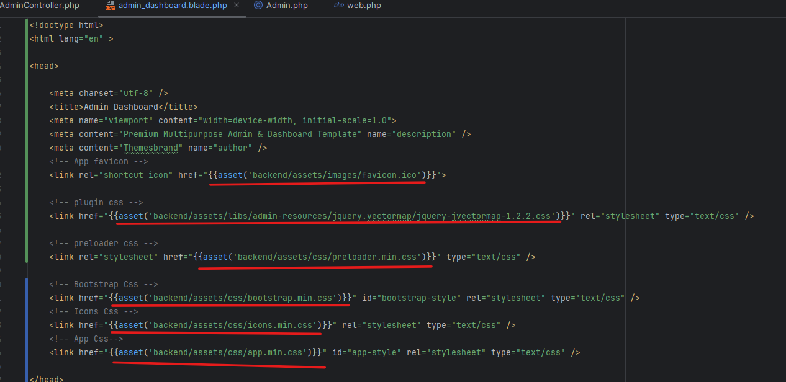

Note: Doing this will let us load the files inside assets folder. Here, we have loaded css and js files. The following page is displayed after css and js file is loaded.

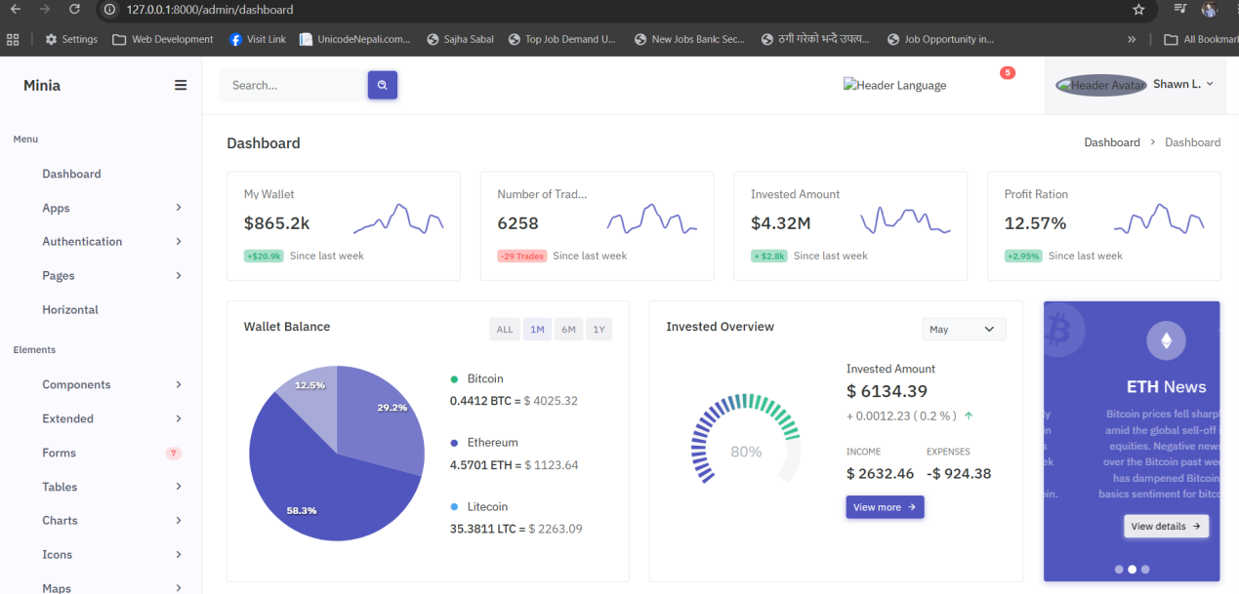

Now we need to create a file named ‘index.blade.php’ inside views(resources->views->admin. Also we need to create a folder inside admin folder named ‘body’. Inside body folder we need to add three files ‘header.blade.php’, ‘footer.blade.php’ and ‘sidebar.blade.php’.
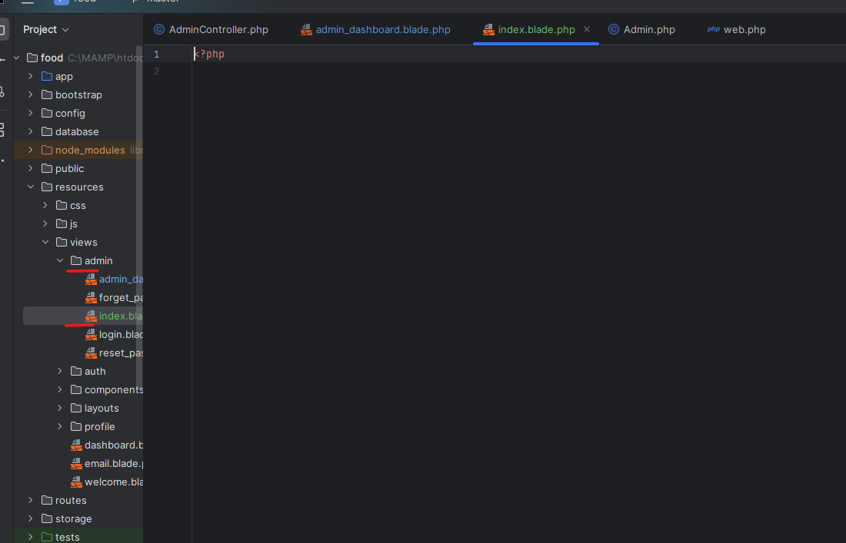

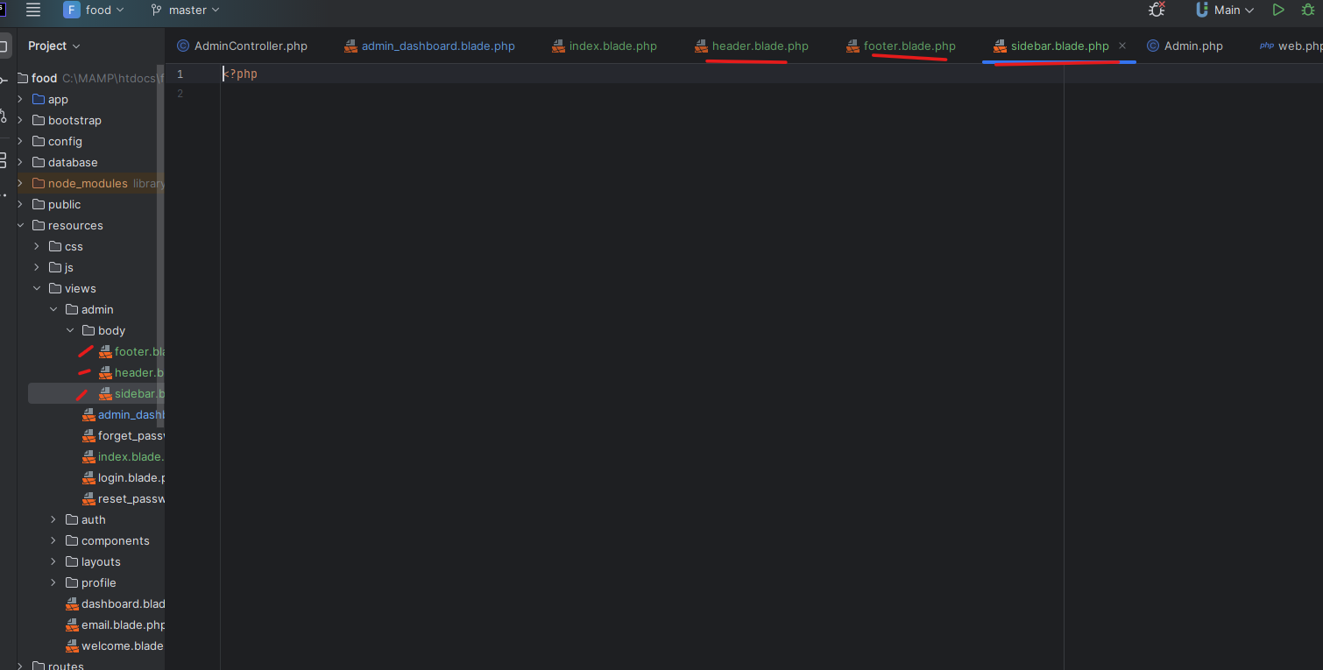

Now go to the admin_dashboard.blade.php file and copy the header section and paste it inside the header.blade.php.

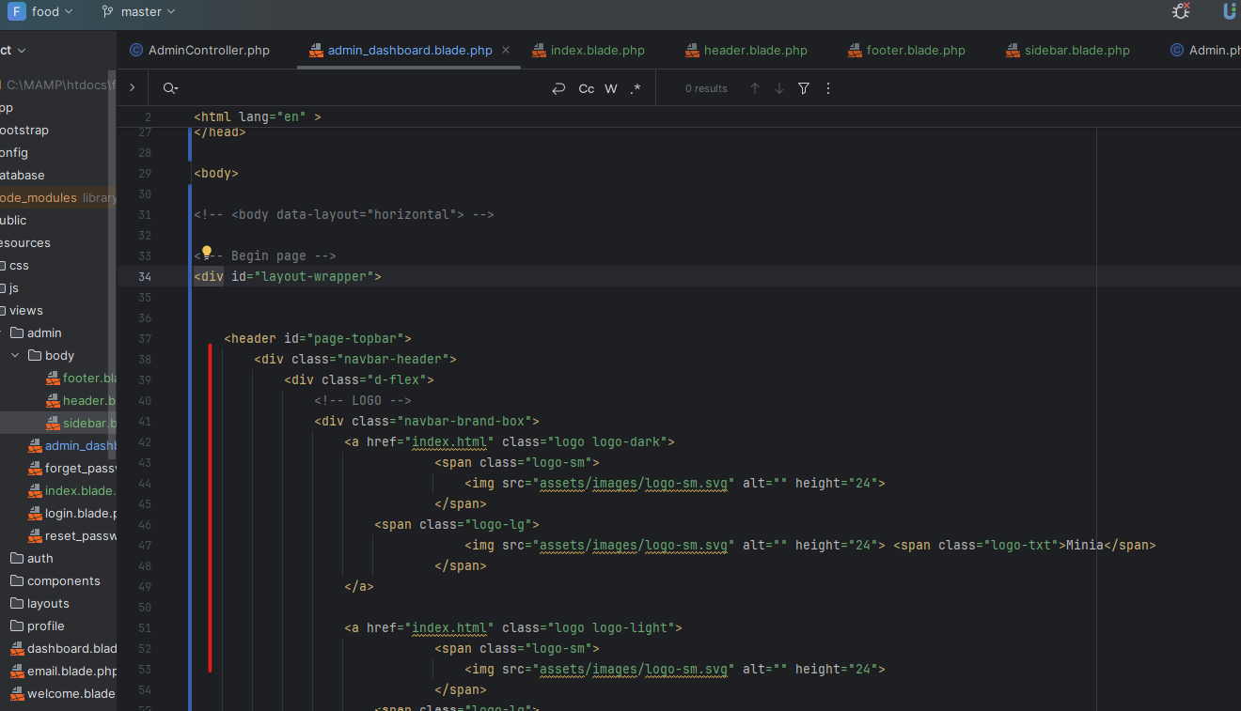

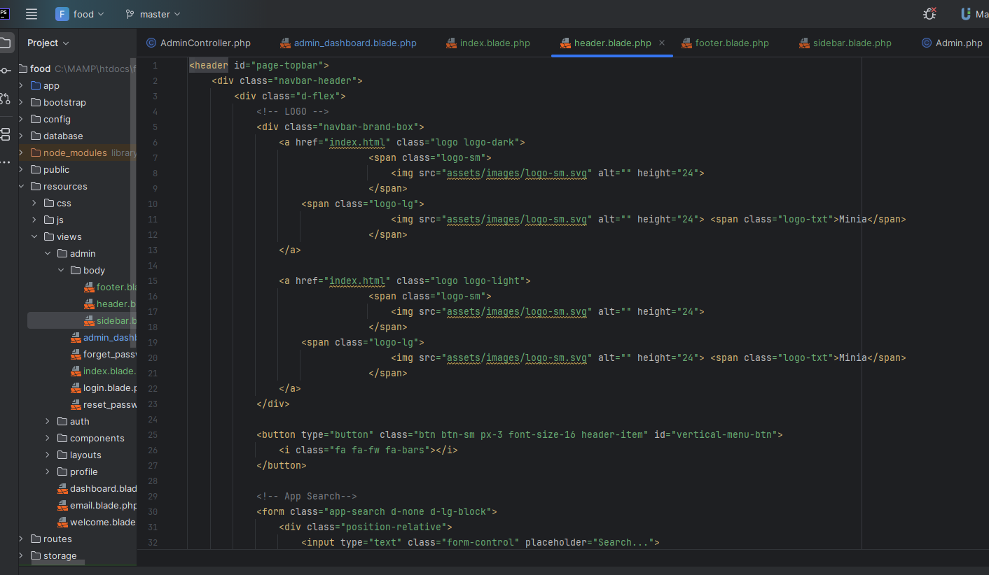

Then we need to go to the admin_dashboard.blade.php file and in the place where there was header tag we need to add the following code:

@include(‘admin.body.header’)
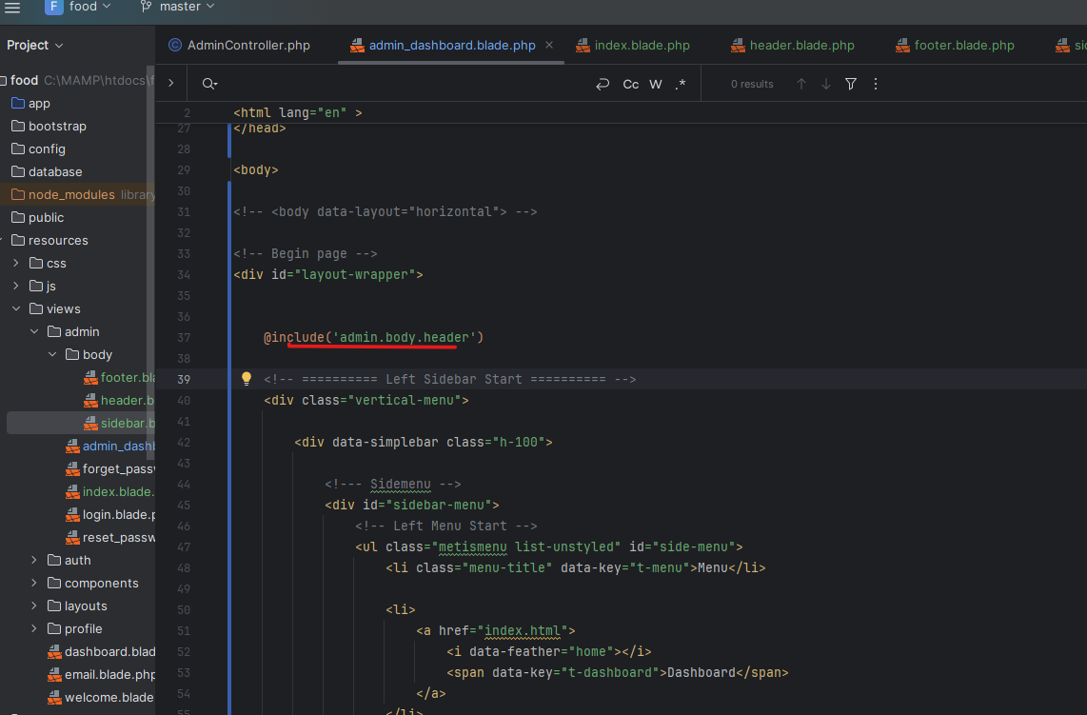

The above code will include the contents of the header.blade.php in the admin_dashboard.blade.php file.

we should do similar process for sidebar and footer. Copy the code of sidebar and footer and paste it to the file named ‘sidebar.blade.php’ and ‘footer.blade.php’.

For Sidebar

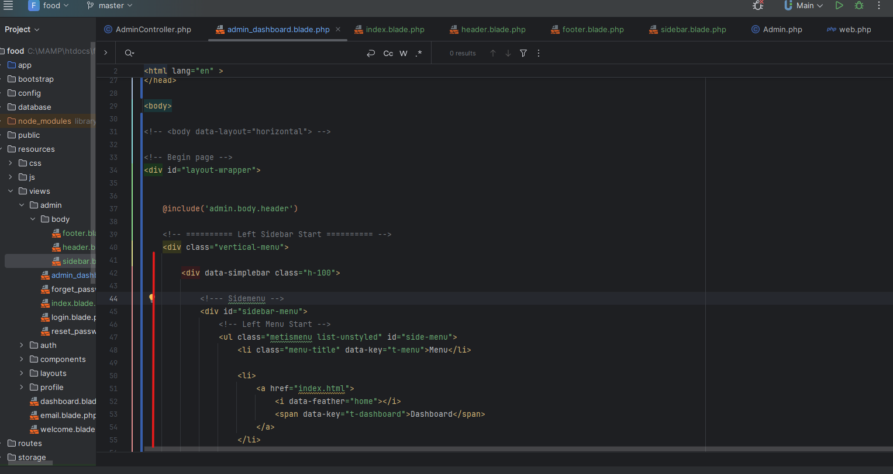

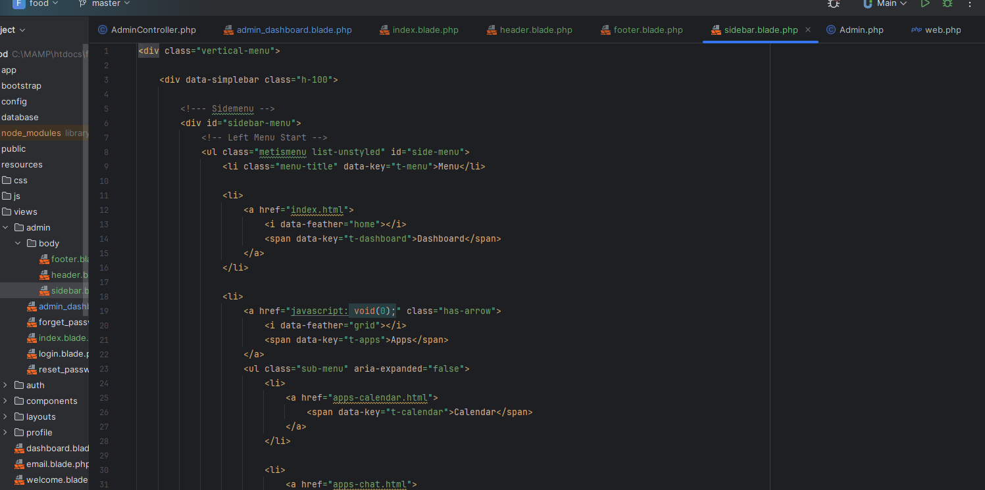

For Footer
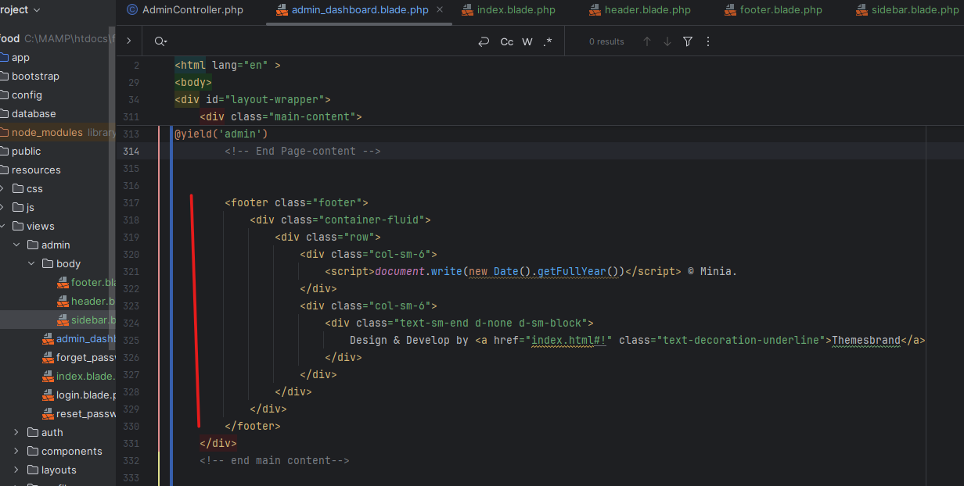

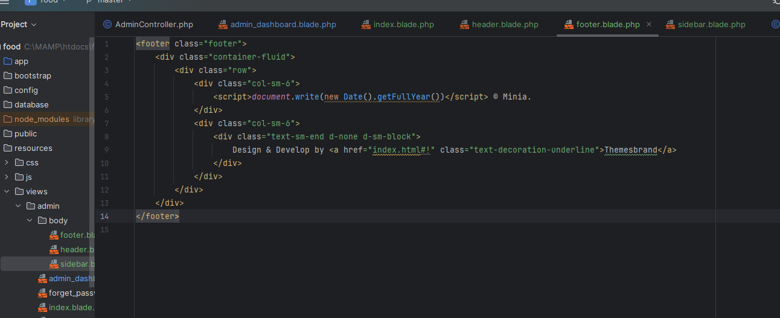
Note: we have also added rightside.blade.php and did the same process as of header and footer.

Now we need to copy the overall content of the body. To do that we need to do the same as above copy the body section and paste it in the index.blade.php.
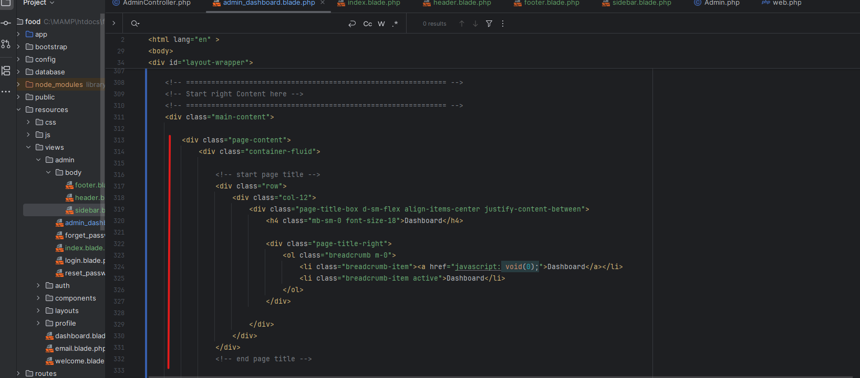

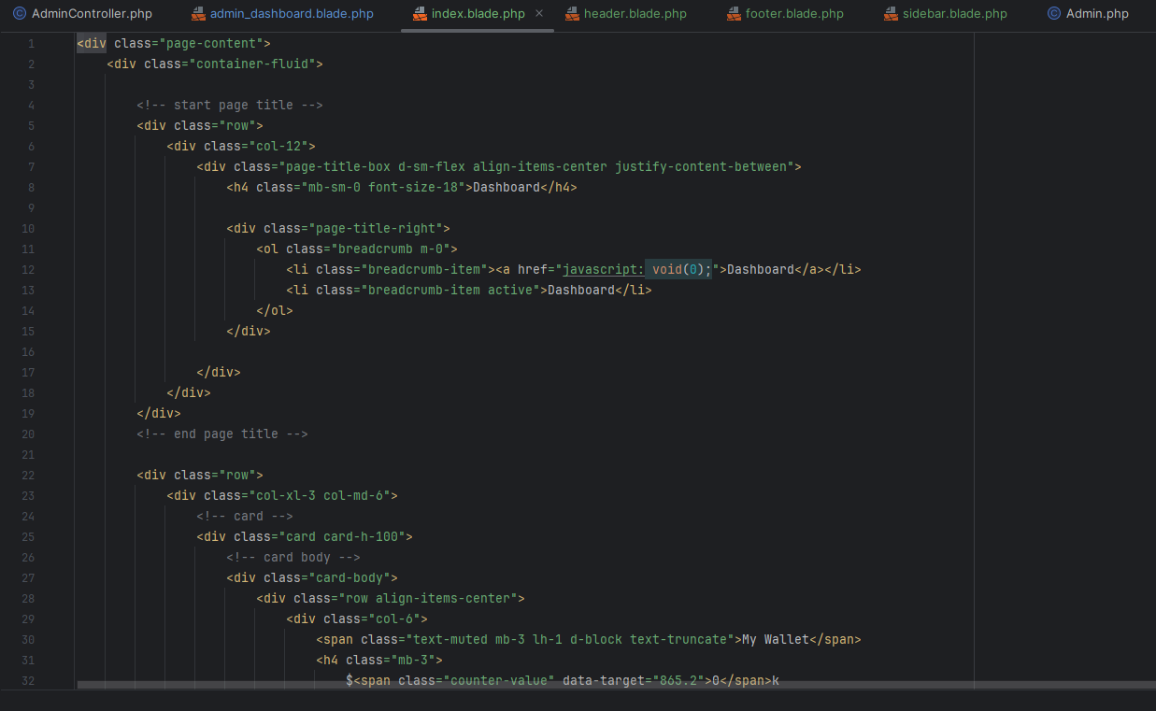

But when we write the code to call the index page we need to write following code instead of ‘include’ as it is dynamic in ‘admin_dashboard.blde.php’.
@yield(admin)
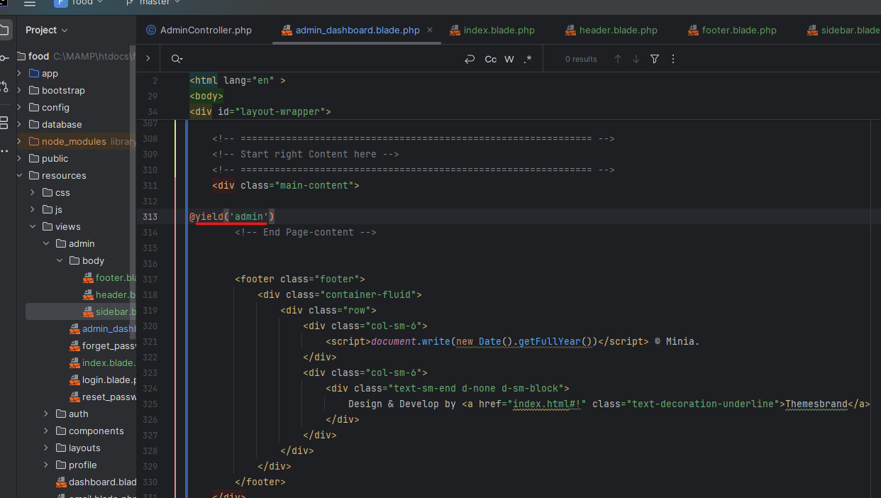

Here admin is the section id.

Now in the index.blade.php we need to add the following code at the top and at last.
@extends(‘admin.admin_dashboard) === Extension from admin_dashboard.blade.php
@section(‘admin’) == pointing to the admin section of the admin_dashboard.
@endsection written at last
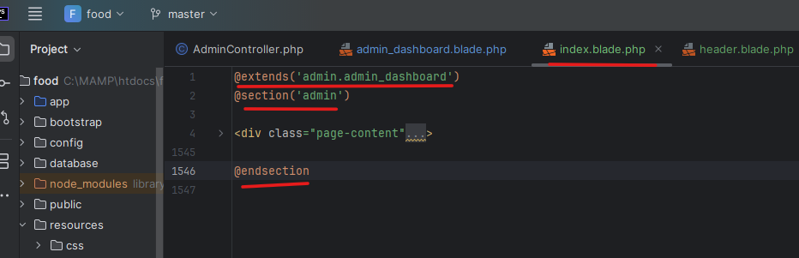

After this when you load the admin dashboard in the browser you will get the following screen.
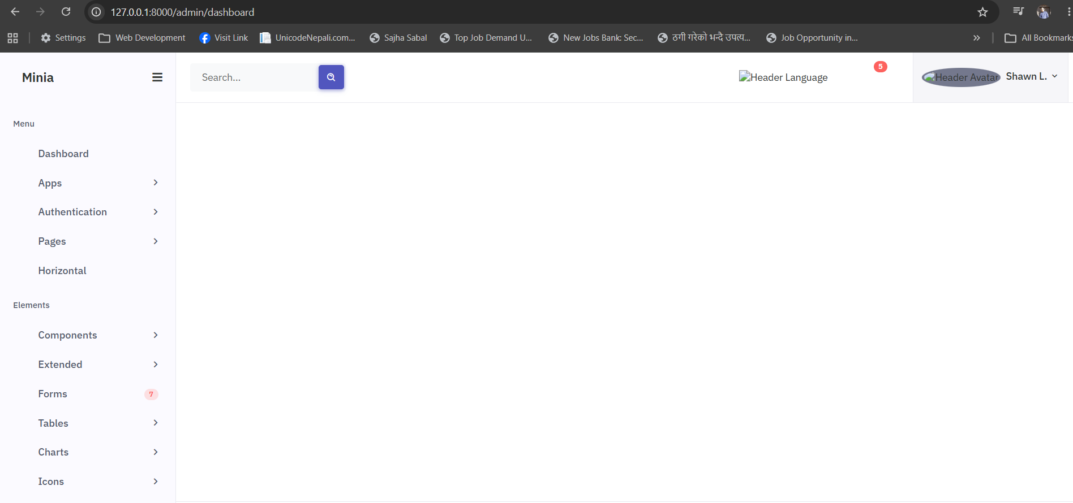

Here you can see that everything is loaded but the content of index.blade.php file is not shown. It is due to the route in Admin Controller.

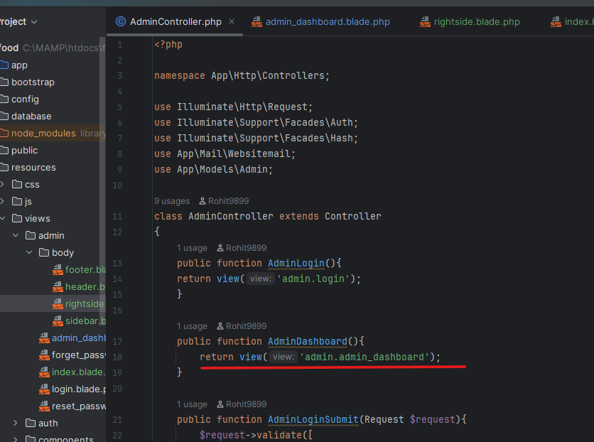

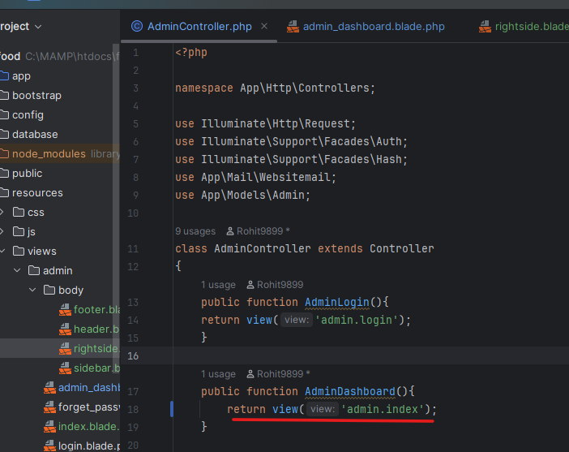

Now when you have done the above changes and load the admin_dasboard page bow you will see the below changes.

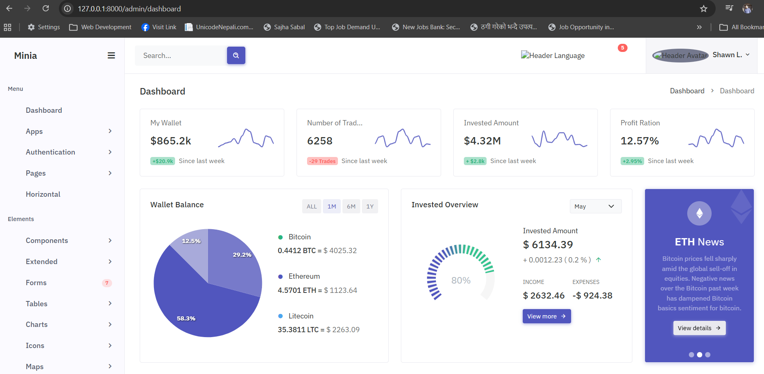

17: Admin Logout Option:

Now we need to make the logout functionality work in our new design. To do that go to the Logout section and in href tag enter the following code:

<a href="{{route('admin.logout')}}">Loggout</a>
