1. To render templates from the templates folder created earlier you need to make following changes in settings.py file to let it know from
2. where to render templates.

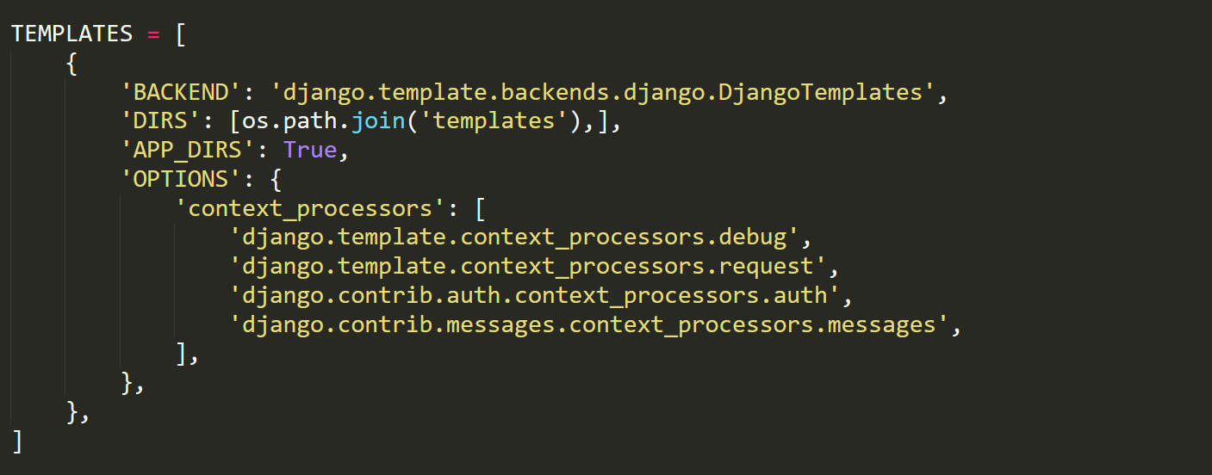

Use os module to join your ‘templates’ folder.

1. Aside from the HTML generated by the server, web applications generally need to serve additional files — such as images, JavaScript, or CSS — necessary to render the complete web page.We refer to these files as “static files”.

Similarly to load static files following changes has to be done in settings.py file

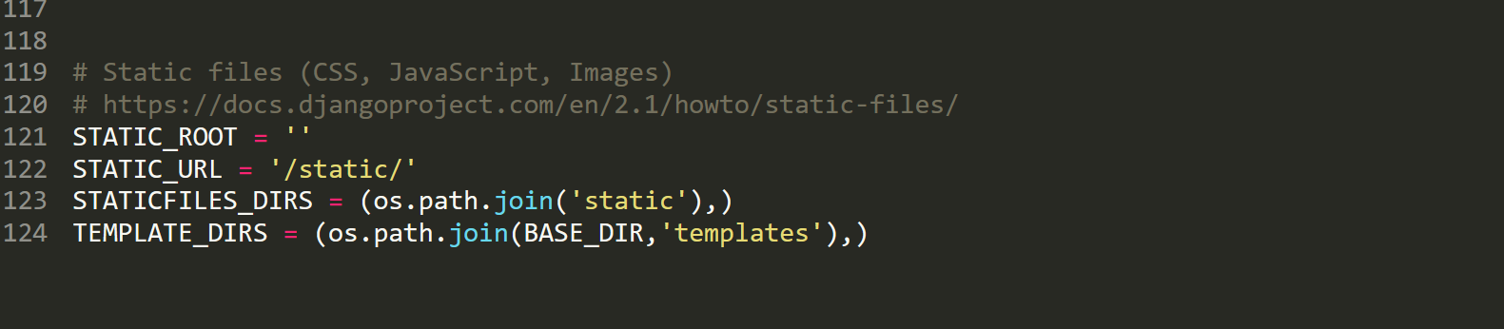

In above file STATIC_ROOT = ‘ ’ refers to the folder we are working in i.e project1 folder.

And the path for BASE_DIR is defined above.

1. To render template from views.py file render module is used.

It will render the request with the template passed as its second argument.

Make the ‘app1’ folder inside the templates folder to distinguish the templates for different apps. Inside the app1 folder all the templates of app1 are kept similary you can do for app2 and so on.

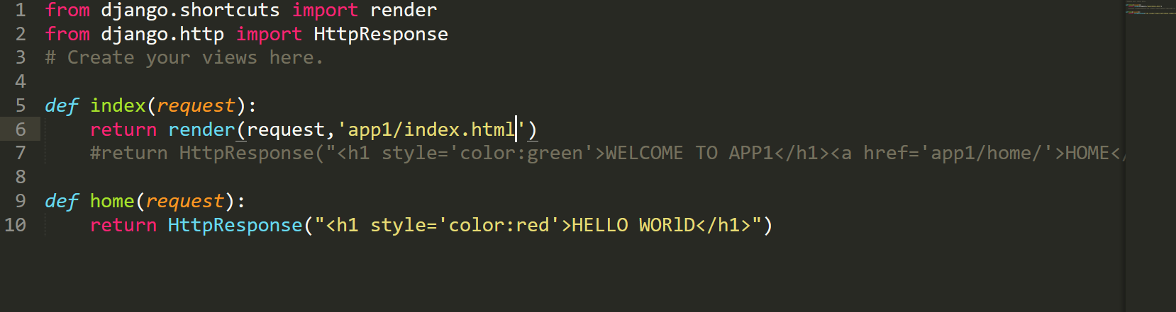

The template will be searched in ‘templates/app1/’. In this case the template will be rendered from ‘templates/app1/index.html’

In app1 folder you can put all your templates of app1

1. if you had a static file with the same name in a different application, Django would be unable to distinguish between them. We need to be able to point Django at the right one, and the easiest way to ensure this is by namespacingthem. That is, by putting those static files inside another directory named for the application itself.

In static folder an ‘app1’ folder is created to put all the static files of app1 in that folder.

In the file below ‘main.css’ file in liked which is in ‘static/app1’ folder.

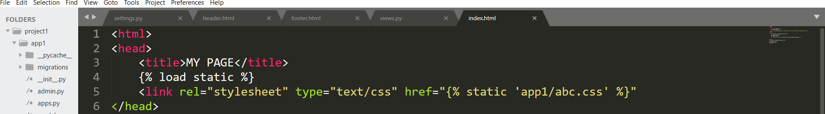

1. Every html page or template has a header and a footer.

So we will create two templates i.e ‘header.html’ and ‘footer.html’ in ‘templates/app1’ folder.

Use jinja language to create blocks.

In ‘header.html’ ‘block head’ is defined using jinja language

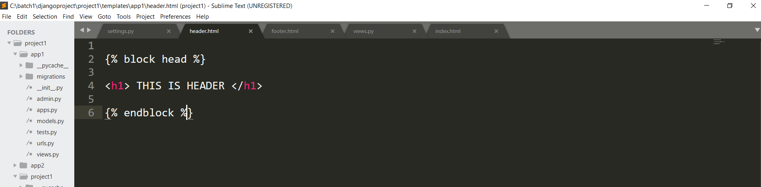

Similarly create ‘footer.html’ in ‘templates/app1’. Create ‘block foot’ using jinja

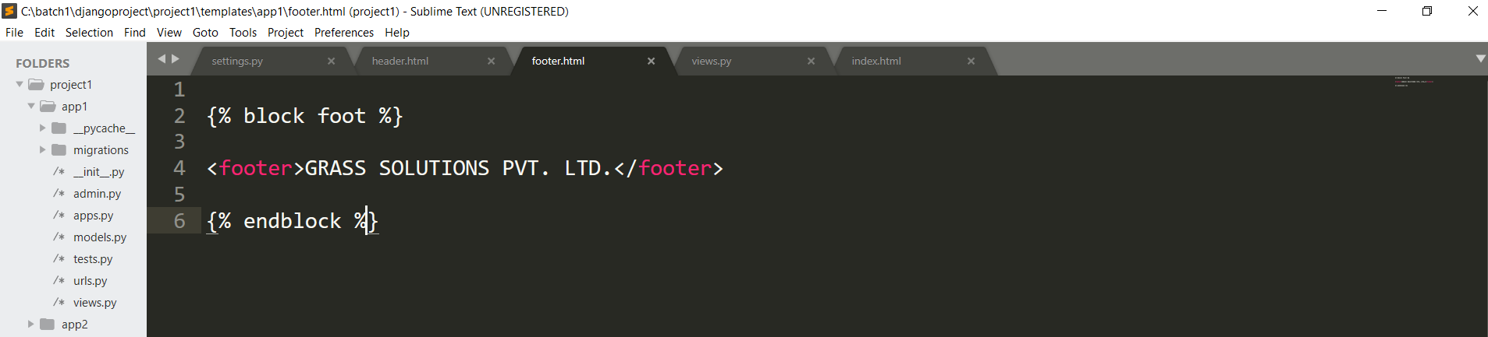

1. Now to include those header.html and footer.html in rest of the html files following syntax is used:  
   {% include ‘path_of_file’ %}

{% block name %}

{% endblock %}

In the below code 2 blocks are included that are head and foot block

